OpenS2P
The Linux of Procurement AI
Customer Migration Guide
Migrating from SAP Ariba / Coupa to OpenS2P
Version 2.0 — Candidate
A Phased Migration Playbook — SAP Activate–Style Methodology
Classification: Customer / Partner Confidential

Document Control

Revision History
Version | Date | Author | Summary of Changes
1.0 | [ASSIGN] | OpenS2P Architecture Team | Initial skeleton — placeholder structure only
2.0 Candidate | [ASSIGN] | OpenS2P Architecture Team | Full rewrite to SAP Activate–style playbook: phased methodology, RACI, Migration Accelerator, module mapping, diagrams, timeline

Reviewers & Approvers
Role | Name | Status
Project Lead & Architect | [ASSIGN] | [ASSIGN]
Customer Migration Lead | [ASSIGN] | [ASSIGN]
Security & Compliance Reviewer | [ASSIGN] | [ASSIGN]
ERP Integration Lead | [ASSIGN] | [ASSIGN]

Purpose & Audience
This document is the customer-facing migration playbook for organizations moving from SAP Ariba or Coupa to OpenS2P. It is written for customer program sponsors, procurement operations leads, IT/integration teams, and OpenS2P implementation partners. It defines the phased methodology, deliverables, roles, data and functional mapping, cutover approach, and post-go-live support model used on every OpenS2P migration engagement.
Companion artifacts referenced throughout this guide — the detailed field-level mapping workbook, architecture diagrams, and RACI matrix — are distributed alongside this document and are listed in Appendix A.

Table of Contents
1. Executive Summary
2. Current Landscape Assessment
3. Reference Architecture
4. Migration Methodology & Strategy
5. Migration Accelerator
6. Module & Feature Mapping
7. Supplier Migration
8. Sourcing Migration
9. Contract Migration
10. PR/PO Migration
11. Invoice Migration
12. Data Migration Approach
13. Integration Migration
14. Security & Compliance
15. AI Migration Assistant
16. Testing Strategy
17. Cutover and Go-Live
18. Hypercare and Post Go-Live Support
19. Migration Timeline
Appendix A: Detailed Mapping Spreadsheets
Appendix B: Templates & Checklists Index
Page numbers omitted from this static contents listing pending final pagination pass; see Section headings for navigation.

1. Executive Summary

1.1 The OpenS2P Value Proposition
OpenS2P is an open-source, AI-native Source-to-Pay platform built to give mid-market and enterprise procurement organizations the functional depth of SAP Ariba or Coupa without the licensing model, configuration rigidity, or opaque AI that come with legacy suites. AI capabilities — retrieval-augmented generation, LLM-driven agents, human-in-the-loop (HITL) approval workflows, and Model Context Protocol (MCP) tool exposure — are first-class architectural components rather than bolted-on features, meaning every module (Supplier, Sourcing, Contract, Procurement, Invoice) is AI-addressable and automatable out of the box.
Because the platform is open-source at its core, customers own their deployment, their data model, and their roadmap. There is no per-module upsell, no proprietary object licensing, and no vendor-controlled release cadence gating access to new AI capability.

1.2 Target Customer Profile
Attribute | Typical Profile
Company size | $200M – $5B annual revenue; 500 – 10,000 employees
Procurement spend under management | $100M – $2B annually
Current platform | SAP Ariba (Buying & Invoicing, Sourcing, Contracts) or Coupa (BSM Platform)
Deployment model | Single ERP or 2–3 ERP landscape (SAP S/4HANA, ECC, Oracle Fusion, Workday, or Dynamics)
Motivation profile | Cost-out on renewal, AI-capability gap, need for deployment flexibility, or M&A-driven consolidation

1.3 Why Customers Migrate from Ariba / Coupa
- Cost structure: per-transaction and per-object licensing on legacy suites compounds as spend and supplier volume grow; OpenS2P's self-hosted or single-tenant SaaS model decouples cost from transaction volume.
- AI transparency: legacy AI features (guided buying suggestions, invoice matching) are closed models with limited explainability; OpenS2P exposes RAG retrieval context and agent reasoning through the HITL queue.
- Configuration agility: workflow and approval rule changes on Ariba/Coupa typically require partner-led change requests; OpenS2P's configuration is version-controlled and directly editable by customer admins.
- Integration flexibility: the pluggable connector framework (Python SDK) supports SAP, Oracle, Workday, and Dynamics without proprietary middleware licensing.
- Data portability and vendor lock-in avoidance: an open schema (13 named PostgreSQL schema boundaries) with documented extraction paths removes the historical “data hostage” risk of suite migrations.

1.4 How to Use This Guide
Sections 2–4 establish current-state assessment and the phased methodology. Sections 5–16 walk through module-by-module migration guidance in delivery order. Sections 17–19 cover testing, cutover, and hypercare. Section 20 presents the reference timeline, and the appendices index the companion mapping workbook, templates, and checklists used by the delivery team.

2. Current Landscape Assessment
Every migration engagement begins with a structured assessment of the customer's existing landscape. This section defines the assessment scope and the standard discovery questionnaire used during the Discovery phase (Section 4).

2.1 Existing Modules In Use
Assessment Area | What the Team Captures
Active modules | Which Ariba/Coupa modules are licensed and actively used (Sourcing, CLM, Guided Buying, Invoicing, Supplier Risk, Analytics)
Usage depth | Percent of spend under managed sourcing events; percent of POs auto-approved vs. manually routed
User population | Named users by role (requester, approver, buyer, sourcing manager, AP clerk, admin)
Transaction volume | Annual PO count, invoice count, sourcing event count, active contract count

2.2 Integrations & Customizations Inventory
- ERP integration inventory: connection type (CIG, iDoc, REST, flat file), direction, frequency, and object scope for each connected ERP instance.
- Custom fields and forms: catalog of customer-added fields on supplier, PO, invoice, and contract objects, with data type and validation rules.
- Custom workflow rules: approval matrices, routing conditions, and delegation-of-authority logic that deviate from out-of-box configuration.
- Reporting and analytics: custom reports, scheduled exports, and BI tool connections (Power BI, Tableau) dependent on the legacy data model.
- Third-party bolt-ons: supplier risk, e-invoicing compliance, or tax engines integrated into the current suite.

2.3 Common Pain Points Documented During Assessment
Pain Point Category | Typical Symptom
Cost | Per-transaction or per-supplier-record fees increasing faster than spend under management
Change velocity | Multi-week partner change-request cycle for approval rule or workflow updates
AI opacity | Guided buying/matching suggestions with no visible reasoning or override audit trail
Integration brittleness | Point-to-point integrations that break silently on ERP version upgrades
Data access | Limited or costly bulk data export options complicating reporting and migration

The completed assessment output feeds directly into the Migration Strategy decision (Section 4.2) and the Functional Mapping baseline (Section 6).

3. Reference Architecture
The diagrams below summarize the architectural shift from the legacy suite-plus-bolt-ons landscape to the unified OpenS2P platform. They are the standard “before/after” slides used in customer and investor discussions and are provided as standalone image assets alongside this document.

3.1 Before: Legacy Ariba / Coupa Landscape
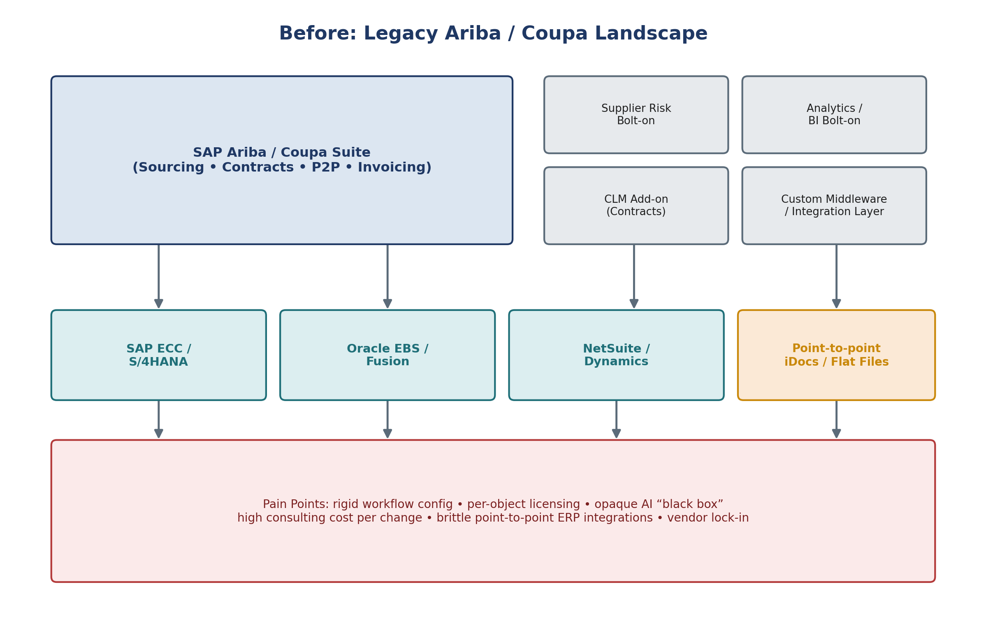
Figure 1. Legacy landscape: suite core, point bolt-ons, and brittle point-to-point ERP integration.

3.2 After: OpenS2P + ERP + AI Services
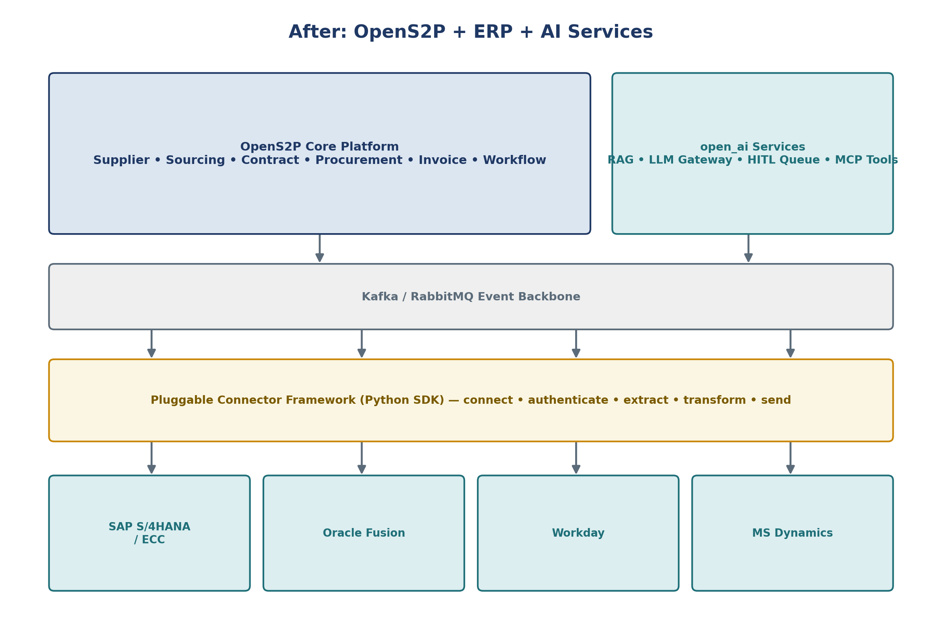
Figure 2. Target-state landscape: unified OpenS2P core, first-class AI services, event backbone, and pluggable connector framework.

3.3 What Changes Structurally
Layer | Before | After
Core suite | Ariba/Coupa modules, licensed per object/user | OpenS2P core platform, single deployment
AI | Vendor black-box suggestions | open_ai services: RAG, LLM gateway, HITL queue, MCP tools
Integration | Point-to-point iDocs/flat files/custom middleware | Kafka/RabbitMQ event backbone + pluggable connector framework
Extensibility | Partner-mediated configuration change requests | Customer-owned, version-controlled configuration and open connector SDK

4. Migration Methodology & Strategy
OpenS2P migrations follow a five-phase methodology modeled on SAP Activate: Discover, Prepare, Explore, Realize, and Deploy, followed by a standing Run phase (Hypercare, Section 19). Each phase has a fixed set of deliverables, a named accountable owner, and an exit gate reviewed jointly by the customer program sponsor and the OpenS2P delivery lead.

4.1 The Five Phases
Phase | Objective | Key Deliverables
Discover | Validate business case and target scope | Current-state assessment, discovery questionnaire, fit-gap summary
Prepare | Mobilize team, finalize scope and plan | Project charter, RACI, environment provisioning, kickoff
Explore | Configure and validate against requirements | Fit-gap workshops, solution design, mapping workbook sign-off
Realize | Build, migrate data, integrate, test | Configured environment, migrated data, integrations, SIT/UAT results
Deploy | Cut over and go live | Cutover runbook execution, go-live checklist, production validation
Run (Hypercare) | Stabilize and transition to steady-state support | Hypercare log, issue burn-down, transition-to-support sign-off

4.2 Big Bang vs. Phased Rollout
The rollout strategy is decided at the end of the Discover phase based on landscape complexity, risk tolerance, and business calendar constraints.
Dimension | Big Bang | Phased (by Module or Business Unit)
Best fit | Single ERP, single business unit, < $500M spend, clean data | Multi-ERP, multi-business-unit, > $500M spend, or high customization
Timeline | Compressed — typically 8–12 weeks (see Section 20) | Extended — modules or units sequenced over 4–12 months
Risk profile | Higher cutover risk, concentrated in one weekend | Lower per-wave risk; issues isolated to a single module/unit
Parallel run | Not typically required | Often run in parallel with legacy suite during transition waves
Typical sequence | All modules simultaneously | Supplier → Sourcing → Contracts → P2P → Invoicing, or by business unit
Rollback complexity | Higher — single rollback point | Lower — rollback isolated to current wave

Recommendation default: Big Bang for single-ERP mid-market customers; Phased-by-module for enterprise or multi-ERP landscapes. The Discover-phase fit-gap assessment produces a documented recommendation, not an assumption.

4.3 Consolidated RACI — Migration Program
Activity | Customer Sponsor | Customer Ops Lead | OpenS2P Delivery Lead | ERP/IT Team
Current-state assessment | A | R | C | C
Migration strategy decision (4.2) | A | C | R | I
Solution design & mapping sign-off | I | A | R | C
Data extraction & cleansing | I | C | R | R
Configuration build | I | C | R | I
Integration build & test | I | I | R | A
SIT / UAT execution | I | A | R | C
Cutover go/no-go decision | A | R | R | C
Hypercare issue resolution | I | R | A | C

R = Responsible · A = Accountable · C = Consulted · I = Informed. Full activity-level RACI is maintained in the companion workbook (Appendix A).

5. Migration Accelerator
The Migration Accelerator is OpenS2P's differentiated toolset for compressing the Explore and Realize phases. It is what separates an OpenS2P migration from a generic re-implementation: rather than starting from a blank configuration, the accelerator ingests the customer's existing Ariba/Coupa configuration and data directly.

5.1 Ariba Template Importer
Parses exported Ariba configuration packages (sourcing event templates, approval flow XML, supplier questionnaire templates) and generates a first-pass OpenS2P configuration draft.
- Inputs: Ariba sourcing event templates, RFX question libraries, approval flow exports, supplier registration questionnaires.
- Output: OpenS2P workflow and template definitions pre-populated for Explore-phase review, with a gap log for constructs that have no direct OpenS2P equivalent.

5.2 Coupa Object Mapper
Maps Coupa's object model (Requisitions, Purchase Orders, Suppliers, Contracts, Invoices, and custom fields) to the corresponding OpenS2P schema boundaries, resolving field-level naming and type differences automatically where a direct match exists.
- Handles Coupa custom field groups and forms by proposing an OpenS2P `open_extension` schema mapping for anything without a native equivalent.
- Flags Coupa approval-chain constructs (e.g., dynamic approval chains based on custom formulas) that require manual translation into OpenS2P workflow rules.

5.3 AI-Assisted Configuration Conversion
An LLM-driven agent, running through the same open_ai model-gateway used in production, reviews imported configuration and data alongside the target OpenS2P schema and proposes:
- Field-mapping recommendations with a confidence score, routed to a human reviewer via the HITL queue for anything below the confidence threshold.
- Approval-rule translation from legacy conditional logic into OpenS2P workflow rule syntax.
- Commodity/category code crosswalk suggestions based on description-text similarity when no exact code match exists.
All AI-proposed mappings are surfaced for human review before being committed — the accelerator proposes, it does not silently apply.

5.4 Data Validation Engine
Runs automated validation passes against extracted legacy data before it is loaded into OpenS2P staging tables.
Validation Class | Example Checks
Completeness | Required fields present (tax ID, remit-to address, GL account)
Referential integrity | PO references a valid supplier; invoice references a valid PO/contract
Duplicate detection | Fuzzy-matched duplicate supplier records across legacy and target
Format & type conformance | Date formats, currency codes, numeric field ranges
Business rule conformance | Contract end date after start date; approval limits within policy bounds

Validation results are written to the exception report referenced throughout Sections 6–13, and no record proceeds to production load with an open critical exception.

6. Module & Feature Mapping
This section is the summary fit-gap view used in Explore-phase workshops. The complete field-level mapping (supplier fields, approval rules, commodity codes, accounting fields, contract metadata, and user roles) is maintained in the companion mapping workbook — see Appendix A.

6.1 Supplier Management
Capability | SAP Ariba | Coupa | OpenS2P | Migration Note
Supplier master record | Ariba Network profile | Coupa Supplier record | `open_supplier.supplier` | Direct field mapping; see Section 7
Supplier onboarding workflow | Ariba registration questionnaire | Coupa Supplier Actionable Notifications | `open_supplier` onboarding workflow + HITL review | Questionnaire logic converted via Accelerator (5.1/5.2)
Supplier risk scoring | Ariba Supplier Risk (add-on) | Coupa Risk Assess (add-on) | `open_ai` risk-scoring agent (native) | Native replaces third-party add-on
Supplier diversity tracking | Custom fields | Custom fields | Native supplier attribute fields | Direct migration, no gap

6.2 Sourcing
Capability | SAP Ariba | Coupa | OpenS2P | Migration Note
RFx events | Ariba Sourcing | Coupa Sourcing | `open_sourcing.event` | Templates imported via Accelerator (5.1)
Bid comparison / scoring | Ariba scorecards | Coupa scorecards | `open_sourcing` scoring engine | Direct mapping
Reverse auctions | Ariba auction module | Coupa auctions | Planned — Phase 2 roadmap item | Flag as gap; use manual RFx in interim
Bid history & attachments | Ariba document repository | Coupa attachments | `open_sourcing.attachment` + object storage | See Section 8

6.3 Contracts
Capability | SAP Ariba | Coupa | OpenS2P | Migration Note
Contract repository | Ariba CLM | Coupa Contracts | `open_contract.contract` | Metadata + documents migrated together, Section 9
Clause library | Ariba clause library | Coupa clause library (limited) | `open_contract.clause_library` | Manual clause taxonomy review recommended
Contract approval workflow | Ariba approval flow | Coupa approval chains | `open_workflow` engine | Converted via Accelerator (5.3)
Renewal/expiration alerts | Native | Native | Native + AI-driven risk flagging | OpenS2P adds AI-surfaced renewal risk

6.4 Procurement (PR/PO)
Capability | SAP Ariba | Coupa | OpenS2P | Migration Note
Requisitioning | Ariba Buying | Coupa Requisitions | `open_procurement.requisition` | Direct mapping
Guided buying / catalogs | Ariba Guided Buying | Coupa Catalogs | Native catalog + AI-assisted item suggestion | See Section 10
PO approval workflow | Ariba approval flow | Coupa approval chains | `open_workflow` engine | Converted via Accelerator (5.3)
Receiving | Ariba receiving | Coupa receiving | `open_procurement.receipt` | Direct mapping; open POs migrated with receipt history

6.5 Invoicing
Capability | SAP Ariba | Coupa | OpenS2P | Migration Note
Invoice capture | Ariba Invoice, network e-invoicing | Coupa Invoicing | `open_invoice.invoice` + Document AI capture | See Section 11
Three-way match | Ariba matching engine | Coupa matching | `open_invoice` matching engine | Direct mapping
Payment status tracking | ERP-synced (SAP/Oracle) | ERP-synced | `open_invoice` + connector framework sync | See Section 14
Dispute management | Ariba dispute workflow | Coupa dispute workflow | `open_workflow` dispute template | Converted via Accelerator (5.3)

Gaps identified during fit-gap workshops (e.g., reverse auctions in 6.2) are logged in the solution design document with a disposition: build, defer to roadmap, or accept as out-of-scope. No gap is silently dropped.

7. Supplier Migration

7.1 Supplier Master Fields
The core supplier master field set migrated in every engagement is summarized below; the complete field-level list (including custom fields) lives in the mapping workbook, Appendix A.
Field Group | Representative Fields
Identification | Legal name, DBA name, tax ID / VAT number, DUNS number, supplier status
Contact & address | Remit-to address, ship-from address, primary contact, phone/email
Banking | Bank account, IBAN/SWIFT, payment method, currency
Classification | Commodity/category codes, diversity classification, supplier tier/segment
Compliance | W-9/W-8BEN status, insurance certificates, sanctions screening result
Risk | Risk score, risk category, last assessment date

7.2 Onboarding Process Migration
- Legacy self-registration questionnaires are converted into OpenS2P onboarding workflow templates via the Ariba Template Importer or Coupa Object Mapper (Section 5.1/5.2).
- In-flight registrations (suppliers mid-onboarding at cutover) are migrated with their current questionnaire state preserved so the supplier resumes rather than restarts.
- Approval routing for new supplier requests is rebuilt in `open_workflow` and validated against the legacy approval matrix during Explore-phase sign-off.

7.3 Questionnaire Migration
Questionnaire migration is a three-step process:
- 1. Extract legacy questionnaire structure (question text, response type, conditional logic, scoring weight).
- 2. AI-assisted conversion maps each question to an OpenS2P questionnaire field type, flagging any conditional-logic construct without a direct equivalent.
- 3. Historical responses are migrated as read-only supplier attachments/records so audit history is preserved even where live re-scoring isn't required.

8. Sourcing Migration

8.1 Events & Templates
Sourcing event templates (RFI/RFP/RFQ structures, question sets, weighting schemes) are migrated via the Ariba Template Importer / Coupa Object Mapper. Active (in-flight) events at cutover are migrated with full bid state so bidders are not disrupted mid-event.

8.2 Bid History
- Completed event results, supplier responses, and award decisions are migrated as historical records for reporting and audit continuity.
- Scoring formulas and weighting schemes are re-validated against a sample of historical events to confirm the OpenS2P scoring engine reproduces equivalent rankings.

8.3 Attachments
Event attachments (RFx documents, supplier bid submissions, scoring backup) are migrated to object storage and linked to the corresponding `open_sourcing.event` record, preserving original filenames, upload timestamps, and uploader identity for audit purposes.

9. Contract Migration

9.1 Metadata
Core contract metadata migrated for every contract record:
Field Group | Representative Fields
Identification | Contract number, title, type, status, parent/child relationship
Parties | Supplier, internal owner, legal entity, counter-signatory
Commercial | Total contract value, currency, payment terms, renewal terms
Dates | Effective date, expiration date, renewal notice date, termination date
Governance | Approval status, approval history, associated clauses

9.2 Documents
Executed contract documents and amendments are migrated to object storage with version history preserved. Each document version retains its original execution date and signatory metadata rather than adopting the migration date.

9.3 Clauses
Clause libraries are migrated as structured text linked to a clause taxonomy in `open_contract.clause_library`. Because Coupa's clause library support is limited relative to Ariba CLM, Coupa customers typically require a manual clause taxonomy review during Explore — flagged in Section 6.3.

9.4 Approvals
Historical approval chains (who approved, when, at what version) are migrated as an immutable audit trail attached to the contract record; they are not re-executed in OpenS2P workflow — only new approval actions post-migration run through the live `open_workflow` engine.

10. PR/PO Migration

10.1 Open Requisitions and Purchase Orders
Open (not yet fully received/invoiced) requisitions and POs at cutover are migrated with full line-item detail, current approval state, and linked budget/cost-center data so downstream receiving and invoicing continue uninterrupted.

10.2 Receiving History
Receipt history for open POs is migrated so that partial-receipt POs land in OpenS2P with the correct remaining quantity/amount, avoiding duplicate receiving on already-fulfilled lines.

10.3 Approval Flows
- PO approval matrices (dollar thresholds, category-based routing, delegation of authority) are rebuilt in `open_workflow` via the AI-assisted configuration conversion (Section 5.3).
- In-flight approvals at cutover are migrated at their current approval step, not restarted from step one, unless the customer explicitly requests a re-approval pass for control reasons.

10.4 Cutover Treatment of Open POs
Open POs are frozen in the legacy system at a defined cutover timestamp (see Section 18), extracted, validated, and loaded into OpenS2P before the legacy system is set to read-only. No new PO activity occurs in either system during the freeze window.

11. Invoice Migration

11.1 Open Invoices
Unpaid or partially paid invoices at cutover are migrated with full line-item detail, matching status (matched/unmatched/disputed), and linked PO/contract references.

11.2 Payment Status
Payment status is sourced from the ERP, not the legacy S2P suite, since the ERP is the system of record for actual payment execution. The connector framework (Section 14) reconciles payment status post-migration on a defined sync cadence.

11.3 ERP Reconciliation
- A reconciliation pass compares migrated open-invoice totals (count and amount) in OpenS2P against the ERP AP sub-ledger before go-live sign-off.
- Any variance above the agreed tolerance threshold is investigated and resolved before the cutover go/no-go decision (Section 18.4).
- Historical (closed/paid) invoices are migrated as read-only records for audit and reporting continuity; they do not re-trigger matching or payment logic.

12. Data Migration Approach

12.1 Extraction Templates
Each object type (Supplier, Sourcing Event, Contract, PO, Invoice) has a standard extraction template defining the source fields, source system query/export method, and target schema mapping. Templates are pre-built for Ariba and Coupa exports and adapted per customer during Explore.

12.2 Cleansing Rules
Cleansing Rule Type | Example
Standardization | Normalize address formats, phone number formats, currency codes
De-duplication | Fuzzy-match supplier records by tax ID and name similarity; merge or flag for manual review
Enrichment | Fill missing commodity codes using AI-assisted classification (Section 5.3) with confidence threshold
Truncation/expansion handling | Resolve legacy field length limits that clipped data (e.g., truncated supplier legal names)

12.3 Validation
All extracted and cleansed data passes through the Data Validation Engine (Section 5.4) before loading into OpenS2P staging. Validation runs in three passes:
- Pass 1 — Structural: required fields present, correct data types, referential integrity.
- Pass 2 — Business rule: values conform to OpenS2P business logic (e.g., approval limits, date sequencing).
- Pass 3 — Reconciliation: record counts and key financial totals reconciled against source system extracts.
Records failing validation are routed to an exception report for manual remediation; nothing loads to production with an open critical exception.

13. Integration Migration

13.1 ERP Connections
OpenS2P ships with pre-built connectors for the ERP platforms most commonly paired with Ariba/Coupa deployments. Each connector implements the same nine-method lifecycle interface (connect, authenticate, validate, extract, transform, send, receive, handle_error, log_status).
ERP | Integration Pattern | Migration Note
SAP S/4HANA | Sync, schema-rich (OData/RFC) | Reference connector — highest interface coverage
SAP ECC | Sync, schema-rich (iDoc/RFC) | Supported via same connector family as S/4HANA with ECC-specific adapters
Oracle Fusion | Sync, REST-based | Standard connector; validated against Fusion Procurement Cloud objects
Oracle EBS | Sync, batch/interface tables | Supported via batch adapter pattern
Workday | Sync, REST-based | Used primarily for supplier and financial master data
Microsoft Dynamics | Sync, REST-based | Standard connector for mid-market Dynamics 365 deployments

13.2 APIs
- All OpenS2P modules expose REST APIs conforming to the platform's API Standards document (v2.1 Enterprise SaaS Standard); legacy Ariba/Coupa API consumers (custom scripts, BI extracts) are re-pointed during Realize.
- Webhooks/event subscriptions replace legacy polling-based integrations where the Kafka/RabbitMQ event backbone supports a native event type.
- API-level authentication is migrated to OAuth 2.0 / API-key patterns consistent with the platform's Security & Compliance model (Section 15).

13.3 Cutover Sequencing for Integrations
Integration cutover follows a parallel-run-then-switch pattern: new connectors run in shadow mode against production ERP data during Realize, results are reconciled against the legacy integration output, and the switch to OpenS2P as the integration system of record happens at the cutover weekend (Section 18).

14. Security & Compliance

14.1 Roles & Permissions
Legacy role definitions (Ariba groups, Coupa roles) are mapped to OpenS2P's role-based access control model. Role mapping is a required Explore-phase deliverable, reviewed and signed off by the customer security owner before any user account migration.
Legacy Construct | OpenS2P Equivalent
Ariba group / Coupa role | `open_identity` role with scoped permissions
Delegation of authority | Workflow-level delegate assignment with effective date range
Approval limit by role | Policy-bound approval threshold on the role definition
Segregation-of-duties rule | Configurable SoD constraint enforced at workflow execution time

14.2 Single Sign-On
OpenS2P supports SAML 2.0 and OIDC federation. Existing IdP configurations (Okta, Azure AD, Ping) are reconfigured to trust OpenS2P as a new service provider; no separate credential migration is required since authentication remains federated.

14.3 Audit Logs
- Legacy audit trail exports (who approved what, when, configuration change history) are migrated as immutable historical records into `open_audit`.
- Post-cutover, all new activity is captured natively in `open_audit` with full before/after state capture for workflow, configuration, and master-data changes.

14.4 Compliance Status
SOC 2, ISO 27001, and GDPR compliance status for the target deployment are documented per customer in the engagement's compliance annex. [ASSIGN — current attestation status to be confirmed with customer security/legal review prior to distribution.]

15. AI Migration Assistant
The AI Migration Assistant is the runtime counterpart to the Migration Accelerator (Section 5): where the Accelerator performs the bulk configuration/data conversion during Explore and Realize, the Assistant is the conversational and agentic interface delivery teams and customer admins use throughout the engagement.

15.1 Configuration Conversion Assistance
- Answers natural-language questions about how a specific legacy configuration construct maps to OpenS2P (e.g., “How does our current three-tier approval matrix translate to OpenS2P workflow rules?”).
- Generates a first draft of workflow rule definitions from a plain-language description of the desired approval logic, routed through HITL review before activation.

15.2 Data Conversion Assistance
- Surfaces and explains data validation exceptions (Section 5.4) in plain language, with a suggested remediation for common patterns (e.g., missing tax ID, ambiguous duplicate match).
- Assists with commodity/category code crosswalks by proposing matches and explaining the basis for each suggestion (description similarity, historical spend pattern).

15.3 Guardrails
Every AI-proposed configuration or data change routes through the HITL workflow queue before being committed to a production environment. The Assistant proposes; a named human reviewer approves. This mirrors the platform-wide AI governance model documented in the AI Engineering Handbook.

16. Testing Strategy

16.1 System Integration Testing (SIT)
SIT validates that OpenS2P correctly integrates with connected ERPs and that migrated data flows correctly through end-to-end object lifecycles (e.g., PO → receipt → invoice → payment reconciliation).
- Executed by the OpenS2P delivery team with customer IT participation.
- Covers connector lifecycle methods (Section 13.1), event backbone message delivery, and error-handling paths.

16.2 User Acceptance Testing (UAT)
UAT validates business processes from the end-user perspective, executed by customer business users against a defined script derived from the fit-gap mapping (Section 6).
UAT Track | Representative Scenarios
Supplier | New supplier onboarding, questionnaire submission, risk score review
Sourcing | Create RFx, submit and score bids, award and convert to contract
Contract | Create contract, route for approval, execute, track renewal
Procurement | Create requisition, route approval, convert to PO, receive goods
Invoice | Submit invoice, three-way match, resolve dispute, confirm payment sync

16.3 Regression Testing
A core regression suite runs before every cutover rehearsal and again immediately before the production cutover weekend, covering the critical-path scenarios above plus previously identified defect scenarios from earlier test cycles.

16.4 Exit Criteria
- Zero open Severity 1 defects; documented mitigation plan for any open Severity 2 defects.
- 100% of UAT scripts executed with customer business-owner sign-off per track.
- Data reconciliation variance within agreed tolerance (Section 11.3, 12.3).

17. Cutover and Go-Live

17.1 Weekend Migration Plan
Production cutover is executed over a defined freeze window, typically a weekend, to minimize business disruption. The standard runbook sequence:
Step | Activity | Owner
1 | Freeze legacy system (Ariba/Coupa set to read-only); notify all users | Customer Ops Lead
2 | Final delta extraction — open POs, invoices, in-flight approvals since last sync | OpenS2P Delivery Lead
3 | Run Data Validation Engine (5.4) against final extract | OpenS2P Delivery Lead
4 | Load validated data into OpenS2P production | OpenS2P Delivery Lead
5 | Cut over ERP connectors from legacy integration to OpenS2P connector framework | ERP/IT Team
6 | Execute production smoke test (critical-path scenarios from Section 16.2) | Customer Ops Lead + OpenS2P
7 | Go/no-go decision | Customer Sponsor + OpenS2P Delivery Lead
8 | Open OpenS2P to end users; decommission legacy write access | Customer Ops Lead

17.2 Rollback Plan
A rollback decision point exists after Step 6 (smoke test) and before Step 8 (opening to end users). If critical smoke-test failures are found:
- Legacy system remains in read-only freeze rather than being reopened immediately, to avoid data divergence while the rollback decision is made.
- If rollback is invoked: legacy system is returned to read-write, OpenS2P production is not opened to end users, and the delta extracted in Step 2 is preserved for reconciliation and root-cause analysis before a rescheduled cutover.
- Rollback authority sits with the Customer Sponsor jointly with the OpenS2P Delivery Lead, per the RACI in Section 4.3.
For phased rollouts (Section 4.2), rollback is scoped to the current wave only — prior waves already in production are not affected.

17.3 Go-Live Checklist (Summary)
- All UAT exit criteria met (Section 16.4).
- Cutover rehearsal completed at least once with results within tolerance.
- Hypercare team staffed and support model communicated to end users (Section 18).
- Communication sent to all users confirming go-live date, freeze window, and legacy system decommission date.

18. Hypercare and Post Go-Live Support

18.1 Hypercare Support Model
Hypercare is a defined, time-boxed period (typically 2–4 weeks post go-live, extended for phased rollouts per wave) with elevated support coverage before transitioning to steady-state support.
Aspect | Hypercare | Steady-State (Post-Hypercare)
Support coverage | OpenS2P delivery team on-call, daily standup with customer | Standard support tier per customer contract
Issue triage | Same-day triage, Severity 1 response within agreed SLA | Standard ticket SLA
Change control | Delivery team can apply configuration fixes directly, logged in hypercare log | Standard change management process resumes
Reporting cadence | Daily issue burn-down report to Customer Sponsor | Standard account reporting cadence

18.2 Exit Criteria for Hypercare
- Issue volume trending down and stabilized at steady-state levels for at least one full business cycle (e.g., one full invoice cycle).
- No open Severity 1 issues; Severity 2 issues have an agreed resolution plan under standard support.
- Customer Ops Lead formally signs off transition to steady-state support.

18.3 Legacy System Decommission
Legacy Ariba/Coupa access is typically retained in read-only mode for a defined retention period (commonly 90 days, subject to customer audit/compliance requirements) before full decommission, to support any post-cutover audit trace-back needs.

19. Migration Timeline
The illustrative 10-week timeline below reflects a Big Bang, single-ERP, mid-market rollout (Section 4.2). Phased or multi-ERP engagements extend Configuration and Data Migration proportionally per wave; see the engagement-specific project plan maintained alongside this guide.
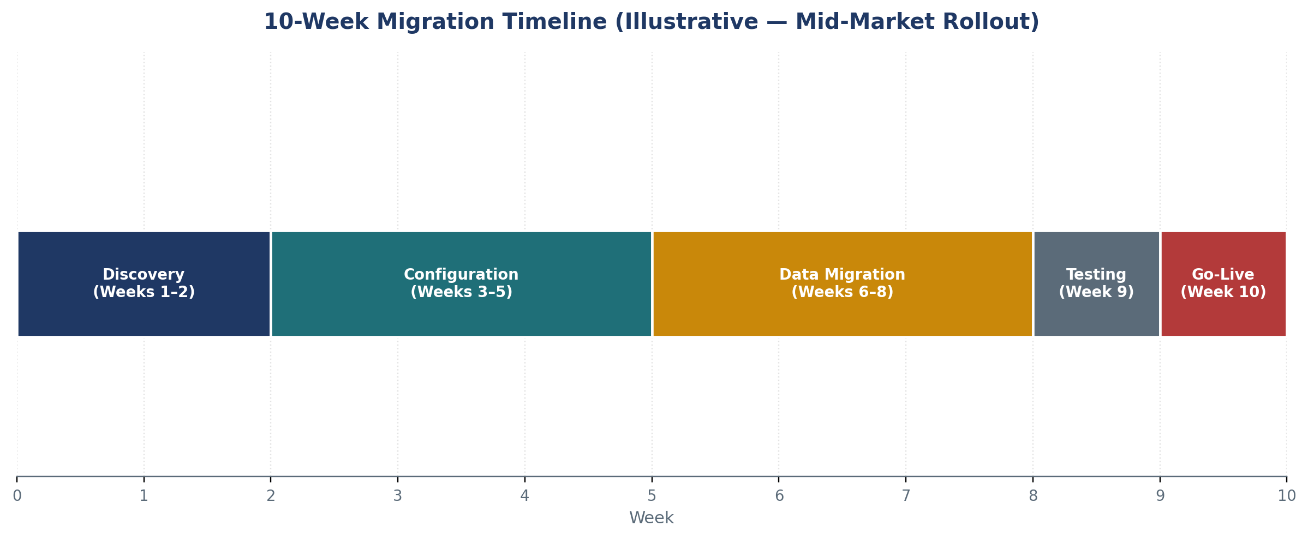
Figure 3. Illustrative 10-week Big Bang migration timeline.
Week(s) | Phase | Key Activities
1–2 | Discovery | Current-state assessment (Section 2), fit-gap workshops, strategy decision (4.2)
3–5 | Configuration | Solution design, workflow/approval build, Migration Accelerator conversion runs (Section 5)
6–8 | Data Migration | Extraction, cleansing, validation (Section 12), reconciliation against source
9 | Testing | SIT, UAT, regression (Section 16), cutover rehearsal
10 | Go-Live | Cutover weekend execution (Section 17), hypercare begins (Section 18)

Appendix A: Detailed Mapping Spreadsheets
Field-level mapping detail is maintained in a companion workbook, distributed alongside this guide, rather than inline in this document, so it can be updated per engagement without re-issuing the full playbook. The workbook contains the following tabs:
Workbook Tab | Contents
Supplier Fields | Full supplier master field list, source system field name, target `open_supplier` field, data type, transformation rule
Approval Rules | Legacy approval matrix conditions mapped to OpenS2P `open_workflow` rule definitions
Commodity / Category Codes | Legacy commodity code crosswalk to OpenS2P category taxonomy, including AI-suggested matches (Section 5.3) and confidence scores
Accounting Fields | GL account, cost center, and tax code mapping between legacy chart of accounts references and ERP-synced values
Contract Metadata | Full contract metadata field list and mapping, including clause taxonomy cross-reference (Section 9.3)
User Roles | Legacy role/group to OpenS2P role mapping, including permission-level detail (Section 14.1)

File reference: OpenS2P_Migration_Mapping_Workbook.xlsx (companion to this guide).

Appendix B: Templates & Checklists Index
Template / Checklist | Used In | Owner
Current-State Discovery Questionnaire | Section 2 | OpenS2P Delivery Lead
Fit-Gap Workshop Template | Section 6 | OpenS2P Delivery Lead
Migration Mapping Workbook | Appendix A | OpenS2P Delivery Lead + Customer Ops Lead
Data Validation Exception Report Template | Sections 5.4, 12.3 | OpenS2P Delivery Lead
RACI Matrix (full activity-level) | Section 4.3 | Customer Sponsor + OpenS2P Delivery Lead
UAT Script Template | Section 16.2 | Customer Ops Lead
Cutover Runbook | Section 17.1 | OpenS2P Delivery Lead
Rollback Decision Log | Section 17.2 | Customer Sponsor + OpenS2P Delivery Lead
Hypercare Daily Issue Log | Section 18 | OpenS2P Delivery Lead

[ASSIGN — confirm final template repository location and access permissions before external distribution.]

