06 API Standards for OpenS2P
Document Owner: OpenS2P Platform Engineering & Architecture Council
Classification: Internal — Enterprise Standard
Version: 2.1 (Enterprise SaaS Standard)
Status: Approved

Purpose
This standard defines the mandatory API design, integration, security, naming, and governance requirements for all services within the OpenS2P (Source-to-Pay) platform. It establishes a single, enterprise-grade contract that every internal team, partner, and third-party integrator must follow when building, consuming, or exposing APIs across the OpenS2P ecosystem.
Compliance with this standard is mandatory for all new API development and is the baseline against which architecture review, security review, and production readiness gates are evaluated.

Scope
This standard applies to:
- All internal microservices exposing REST or event-driven APIs within OpenS2P.
- All partner and third-party integrations (ERP systems, supplier networks, tax engines, banking and payment providers).
- All AI/ML services exposed as APIs, including agentic and MCP-based integrations.
- Internal platform APIs consumed by the OpenS2P web application, mobile clients, and reporting/analytics layers.
This standard does not cover UI-layer state management, database schema design (covered under the Data Standards document), or infrastructure-as-code conventions (covered under the DevOps Standards document).

API Design Principles
All OpenS2P APIs must adhere to the following core principles:
- Contract-first design — the OpenAPI 3.1 specification is authored and reviewed before implementation begins.
- Consistency over cleverness — predictable, uniform patterns across every module take precedence over module-specific conventions.
- Backward compatibility by default — breaking changes require a major version increment and a published deprecation plan.
- Idempotency — all mutating operations that can be safely retried must support idempotency keys.
- Least privilege — every endpoint is scoped to the minimum data and actions required for its function.
- Observability by design — every request is traceable end-to-end via correlation IDs and structured logs.

API Architecture
OpenS2P APIs are built on a RESTful, stateless architecture using JSON as the primary payload format, with an event-driven layer for asynchronous and cross-module communication.

Architectural Pillars
- RESTful resource-oriented design with predictable URIs and HTTP semantics.
- Stateless request handling — no server-side session affinity; authentication context travels with each request.
- OpenAPI 3.1 as the single source of truth for contract, documentation, and code generation.
- Semantic versioning of all public and partner-facing contracts.
- Event-driven integration via a central event bus (Kafka) for cross-module and ERP synchronization.
- API Gateway as the single ingress point for authentication, rate limiting, routing, and traffic shaping.

Reference Architecture Layers
Layer | Responsibility | Representative Technology
API Gateway | AuthN/AuthZ enforcement, rate limiting, routing, request/response transformation | Kong / AWS API Gateway
Service Layer | Business logic, domain APIs, orchestration | FastAPI microservices
Integration Layer | ERP connectors, canonical data mapping, protocol translation | Middleware / iPaaS
Event Layer | Asynchronous events, webhooks, streaming | Kafka + Webhook dispatcher
Data Layer | Persistence and transactional integrity | PostgreSQL, MariaDB, MySQL

API Request Lifecycle
The diagram below illustrates the path of a typical request from client to system of record, including the asynchronous event and ERP integration branch.
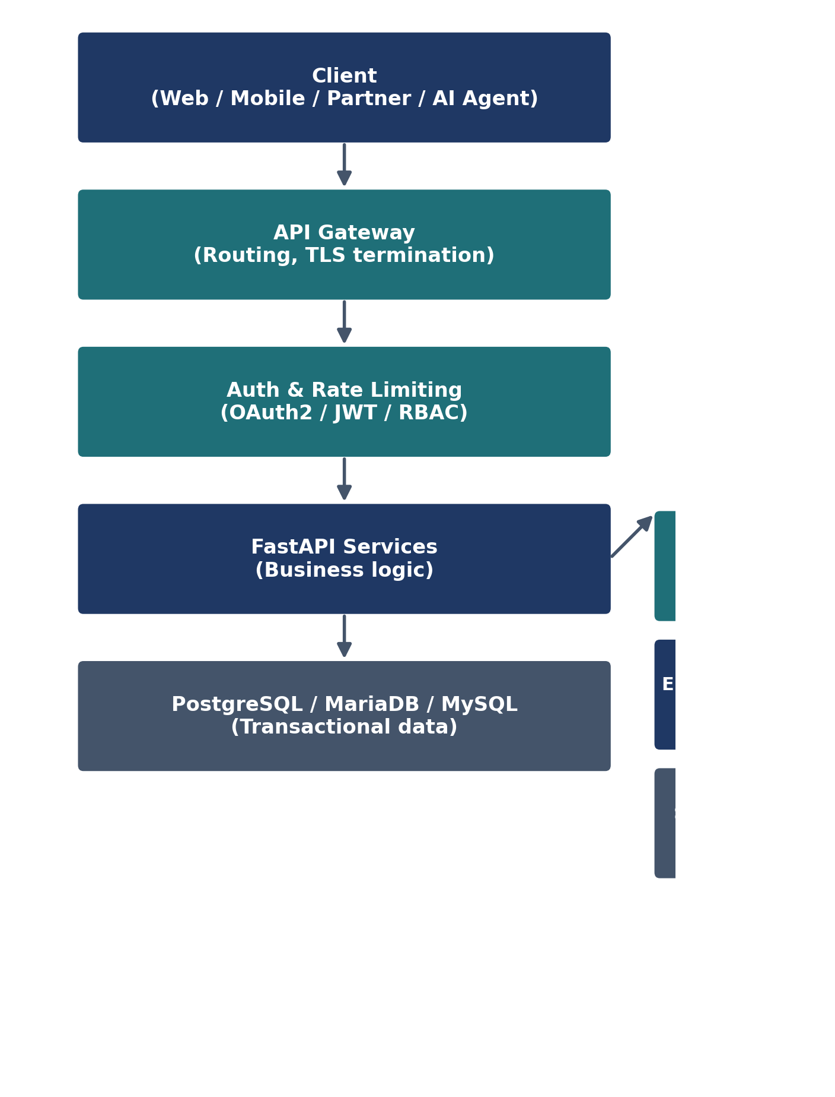

Technology Standards
The following technology stack is mandated for all OpenS2P API services to ensure consistency, maintainability, and enterprise support:
Category | Standard
API Framework | FastAPI (Python 3.11+)
Specification | OpenAPI 3.1 / Swagger UI + Redoc
ORM | SQLAlchemy 2.x with Alembic migrations
Databases | PostgreSQL (primary), MariaDB, MySQL (supported)
Messaging | Apache Kafka for events; Redis Streams for lightweight queues
Caching | Redis
Containerization | Docker, orchestrated via Kubernetes
CI/CD | Contract linting, automated OpenAPI diff, and security scanning on every pull request

Naming Standards
All endpoint URIs follow a consistent, predictable pattern:
Pattern: /api/{version}/{module}/{resource}
Example: /api/v1/procurement/purchase-orders

Naming Rules
- Resource names are plural nouns, lowercase, hyphen-separated (kebab-case).
- No verbs in resource paths — actions are expressed through HTTP methods, not path segments (e.g. avoid /createOrder).
- Nested resources reflect true ownership hierarchy: /suppliers/{supplierId}/documents.
- Query parameters use camelCase (e.g. ?sortBy=createdDate).
- JSON field names use camelCase; database column names use snake_case — mapping is handled at the ORM boundary.
- Module identifiers are fixed and reserved: supplier, sourcing, contract, procurement, ai.

Multi-Tenant SaaS API Standards
OpenS2P is designed to operate as a multi-tenant SaaS platform, where multiple customer organizations share the same platform instance while remaining fully isolated from one another. Every API request must carry explicit tenant context, and that context must be validated before any business logic executes.

Required Tenant Context Headers
Header | Description | Required
X-Tenant-ID | Unique identifier for the customer tenant | Yes
X-Organization-ID | Business unit or subsidiary within a tenant | Conditional (where sub-org hierarchy exists)
Authorization | Bearer token scoped to the tenant and user | Yes

Example Request
GET /api/v1/procurement/purchase-orders
Authorization: Bearer <token>
X-Tenant-ID: acme-corp

Tenant Isolation Rules
- Tenant validation occurs at the API Gateway before the request reaches any service — requests without a valid, resolvable tenant are rejected with 401 Unauthorized.
- All persisted records are scoped by tenant_id at the data layer; cross-tenant reads are blocked by row-level security, not application logic alone.
- Background jobs, webhooks, and AI agent invocations must propagate tenant context end-to-end — no shared or ambient tenant state is permitted.
- Tenant-level configuration (feature flags, approval thresholds, currency defaults) is resolved per request and never cached across tenants.

API Rate Limiting Standards
Rate limits are enforced at the API Gateway per API key / client, tiered by consumer type. Limits protect platform stability and ensure fair usage across tenants and partners.
Consumer Tier | Default Limit | Burst Allowance
Internal Services | 10,000 requests / minute | 2x for 10 seconds
Partner APIs | 1,000 requests / minute | 1.5x for 10 seconds
Supplier APIs | 500 requests / minute | 1.5x for 10 seconds
AI Agent / MCP Clients | 300 requests / minute | None — hard cap
Exceeding a limit returns 429 Too Many Requests with a Retry-After header. Sustained abuse beyond 5x the limit triggers automatic temporary suspension pending administrator review.

HTTP Methods and Status Codes
HTTP methods are used strictly according to their semantic definition:
Method | Usage | Idempotent
GET | Retrieve a resource or collection | Yes
POST | Create a new resource or trigger a non-idempotent action | No (unless Idempotency-Key supplied)
PUT | Full replacement update of a resource | Yes
PATCH | Partial update of a resource | Yes
DELETE | Logical (soft) delete of a resource | Yes

Standard Status Codes
Code | Meaning | Usage
200 OK | Success | Successful GET, PUT, PATCH
201 Created | Resource created | Successful POST
202 Accepted | Accepted for async processing | Long-running or queued operations
204 No Content | Success, no body | Successful DELETE
400 Bad Request | Validation failure | Malformed or invalid payload
401 Unauthorized | Missing/invalid credentials | Authentication failure
403 Forbidden | Insufficient permissions | RBAC denial
404 Not Found | Resource does not exist | Invalid resource ID
409 Conflict | State conflict | Duplicate or concurrency conflict
422 Unprocessable Entity | Semantic validation failure | Business rule violation
429 Too Many Requests | Rate limit exceeded | Throttling
500 Internal Server Error | Unhandled server fault | Unexpected failure
503 Service Unavailable | Downstream dependency down | Circuit breaker open

API Versioning Standards
- Versioning is expressed in the URI path (e.g. /api/v1/, /api/v2/) — never via headers alone, to preserve cache and gateway routing simplicity.
- A minimum 12-month deprecation window is guaranteed for any breaking change to a published major version.
- Non-breaking, additive changes (new optional fields, new endpoints) do not require a version increment.
- Deprecated versions return a Deprecation and Sunset HTTP header indicating the retirement date.

Request and Response Standards

Envelope Format
All responses use a consistent envelope:
- data — the primary payload (object or array).
- meta — pagination, timestamps, and request correlation metadata.
- errors — a structured array of error objects, present only on failure responses.

Error Object Structure
Every error follows RFC 9457 (Problem Details for HTTP APIs) conventions, extended with an OpenS2P-specific errorCode, a human-readable message, and a traceId for support correlation.

Pagination, Filtering, and Sorting
- Pagination is cursor-based for high-volume collections (e.g. transactions, audit logs) and offset-based (page, pageSize) for bounded reference data.
- Filtering uses explicit query parameters (e.g. ?status=active&region=EMEA); free-text search is exposed via a dedicated ?q= parameter.
- Sorting uses ?sortBy=field&sortOrder=asc|desc, with a documented default sort per resource.

Idempotency
All POST operations that create financial or transactional records (purchase orders, invoices, payments) must accept an Idempotency-Key header. The service persists the key and returns the original response for duplicate submissions within a 24-hour window.

API Catalog Overview
The OpenS2P API catalog is organized by business module. Each module exposes a coherent set of resources aligned to its domain boundary.

Supplier Management APIs
Supplier create/update/search, onboarding, qualification, risk, documents, and ERP synchronization APIs.
Endpoint | Method | Description
/api/v1/supplier/suppliers | GET, POST | Search and create suppliers
/api/v1/supplier/suppliers/{id} | GET, PATCH | Retrieve or update a supplier profile
/api/v1/supplier/suppliers/{id}/onboarding | POST | Initiate supplier onboarding workflow
/api/v1/supplier/suppliers/{id}/qualification | GET, POST | Manage qualification assessments
/api/v1/supplier/suppliers/{id}/risk | GET | Retrieve supplier risk score and factors
/api/v1/supplier/suppliers/{id}/documents | GET, POST | Manage compliance and certification documents
/api/v1/supplier/sync/erp | POST | Trigger bidirectional ERP supplier synchronization

Sourcing APIs
RFx creation, supplier invitation, bid submission, and award recommendation APIs.
Endpoint | Method | Description
/api/v1/sourcing/events | GET, POST | Create and list sourcing (RFx) events
/api/v1/sourcing/events/{id}/invitations | POST | Invite suppliers to a sourcing event
/api/v1/sourcing/events/{id}/bids | GET, POST | Submit or retrieve supplier bids
/api/v1/sourcing/events/{id}/award-recommendation | GET | Retrieve AI-generated award recommendation

Contract APIs
Template library, metadata import, lifecycle, approval, obligation tracking, and AI risk analysis APIs.
Endpoint | Method | Description
/api/v1/contract/templates | GET, POST | Manage the contract template library
/api/v1/contract/contracts | GET, POST | Create and search contracts
/api/v1/contract/contracts/{id}/lifecycle | GET, PATCH | Advance or inspect contract lifecycle state
/api/v1/contract/contracts/{id}/approvals | GET, POST | Manage approval routing
/api/v1/contract/contracts/{id}/obligations | GET | Track contractual obligations and milestones
/api/v1/contract/contracts/{id}/ai-risk-analysis | GET | Retrieve AI-generated clause risk analysis

Procurement APIs
Purchase Request, Approval Workflow, Purchase Order, Receipt, and Invoice APIs.
Endpoint | Method | Description
/api/v1/procurement/purchase-requests | GET, POST | Create and manage purchase requests
/api/v1/procurement/approval-workflows | GET | Inspect configured approval workflows
/api/v1/procurement/purchase-orders | GET, POST | Create and manage purchase orders
/api/v1/procurement/purchase-orders/{id}/receipts | GET, POST | Record goods/services receipt
/api/v1/procurement/invoices | GET, POST | Submit and reconcile invoices

AI Services APIs
Supplier recommendation, contract intelligence, spend insights, and AI assistant APIs.
Endpoint | Method | Description
/api/v1/ai/supplier-recommendations | GET | Retrieve AI-ranked supplier recommendations
/api/v1/ai/contract-intelligence | POST | Submit a contract for clause extraction and analysis
/api/v1/ai/spend-insights | GET | Retrieve AI-generated spend analytics
/api/v1/ai/assistant/query | POST | Submit a natural-language query to the OpenS2P AI assistant

AI Governance Controls
Every AI-generated recommendation or decision surfaced through these APIs is subject to platform-wide governance controls to ensure traceability, accountability, and human oversight:
- Prompt logging — all prompts and model inputs are logged with tenant and user context for audit and debugging.
- Model version tracking — every response identifies the exact model and version that produced it.
- Human approval checkpoints — AI recommendations affecting financial or contractual commitments require human sign-off before execution; no AI output posts directly to the ledger or contract of record.
- Confidence scoring — every recommendation includes a numeric confidence score so downstream consumers can apply their own risk thresholds.
- Explainability metadata — responses include the primary factors or evidence contributing to the recommendation.

Example AI Response
{
"recommendation": "Approve supplier",
"confidence": 0.92,
"model": "opens2p-risk-v1",
"explainability": {
"topFactors": ["clean compliance history", "on-time delivery rate 98%"]
}
}

Workflow and Approval APIs
Approval routing underpins procurement, contract, and invoice processes. These endpoints are shared across modules rather than duplicated within each one.
Endpoint | Method | Description
/api/v1/workflow/tasks | GET | Retrieve pending approval tasks for the current user
/api/v1/workflow/tasks/{id}/approve | POST | Approve a pending task
/api/v1/workflow/tasks/{id}/reject | POST | Reject a pending task with a required reason code
/api/v1/workflow/delegations | GET, POST | Manage approval delegation during absence or role transition

Master Data APIs
Reference data required for ERP alignment and financial posting is exposed through a dedicated, read-optimized master data module.
Endpoint | Method | Description
/api/v1/master-data/cost-centers | GET | Retrieve organizational cost center reference data
/api/v1/master-data/gl-accounts | GET | Retrieve general ledger account reference data
/api/v1/master-data/company-codes | GET | Retrieve legal entity / company code reference data
/api/v1/master-data/currencies | GET | Retrieve supported currencies and exchange rate metadata
/api/v1/master-data/users | GET | Retrieve platform user directory for assignment and approval routing

Document and Attachment APIs
A shared document service handles supplier certificates, contract files, and invoice attachments consistently across all modules, backed by object storage (Amazon S3, Azure Blob Storage, or MinIO for self-hosted deployments).
Endpoint | Method | Description
/api/v1/documents/upload | POST | Upload a document and receive a document ID and storage reference
/api/v1/documents/{id} | GET | Retrieve document metadata and a signed download URL
/api/v1/documents/{id} | DELETE | Logically delete a document, retaining it per retention policy

Security Standards
Security is enforced at every layer of the API stack — gateway, service, and data — using industry-standard, auditable controls.

Authentication and Authorization
- OAuth 2.0 (Authorization Code with PKCE for interactive clients; Client Credentials for service-to-service).
- JWT access tokens with a maximum 15-minute lifetime; refresh tokens rotated on use.
- Role-Based Access Control (RBAC) enforced at the API Gateway and re-validated at the service layer (defense in depth).
- Mutual TLS (mTLS) required for all server-to-server ERP and partner integrations.

Standard Roles
Role | Description | Representative Permissions
Buyer | Initiates and manages procurement transactions | Create purchase requests, view supplier catalogs, approve receipts
Supplier | External party responding to sourcing and fulfilling orders | Submit bids, view own POs and invoices, upload documents
Approver | Reviews and authorizes transactions and contracts | Approve/reject purchase requests, contracts, and invoices
Administrator | Configures platform, users, and integrations | Manage RBAC roles, ERP connections, and system configuration

Additional Controls
- Rate limiting per client/API key with tiered quotas (standard, partner, internal).
- Field-level encryption for sensitive data (banking details, tax identifiers, personal data).
- All API traffic transported over TLS 1.2 or higher; TLS 1.3 preferred.
- Secrets and credentials managed exclusively via a centralized secrets vault — never embedded in code or configuration files.

Integration Standards
OpenS2P integrates with enterprise systems of record and external ecosystems through standardized adapters that map external formats to the OpenS2P canonical data model.
- SAP S/4HANA — OData v2/v4 and IDoc-based synchronization.
- SAP ECC — RFC/BAPI and IDoc-based synchronization for legacy landscapes.
- Generic ERP — REST/SOAP adapters configured through the Integration Layer.
- Supplier networks — standards-based EDI and API connectivity for catalog and transaction exchange.
- Tax engines — real-time tax calculation calls embedded in the invoice and purchase order lifecycle.
- Document systems — content and e-signature integrations for contract and compliance artifacts.

ERP Canonical Objects
All ERP and external integrations map to the following canonical objects, ensuring consistent semantics regardless of source system:
Canonical Object | Description
Supplier | Master record for a trading partner, including identifiers, banking, and compliance data
Purchase Order (PO) | Authorized commitment to purchase goods or services from a supplier
Invoice | Supplier billing document reconciled against PO and receipt
Payment Status | Current settlement state of an invoice or PO
Cost Center | Organizational unit to which spend is allocated
GL Account | General ledger account used for financial posting
Material Master | Reference data describing purchasable goods and services

Webhook and Event Standards
Asynchronous state changes are published as events on the internal event bus and, where subscribed, delivered to external systems via signed webhooks.
Event | Trigger | Payload Summary
PO_CREATED | A new purchase order is issued | PO header, line items, supplier reference
CONTRACT_APPROVED | A contract completes its approval workflow | Contract ID, approver, effective date
SUPPLIER_UPDATED | A supplier profile or compliance document changes | Supplier ID, changed fields, timestamp
INVOICE_POSTED | An invoice is posted to the ledger | Invoice ID, PO reference, posting amount

Webhook Delivery Guarantees
- At-least-once delivery with exponential backoff retry (up to 24 hours).
- Every payload is signed with an HMAC-SHA256 signature in the X-OpenS2P-Signature header for receiver verification.
- Subscribers must expose an idempotent handler, since duplicate delivery is possible under retry conditions.

Performance Standards
Operation Type | Target Latency (p95) | Notes
Read APIs | < 500 ms | Includes cached and uncached reads
Write APIs | < 1 second | Synchronous create/update operations
Bulk/Batch Operations | Asynchronous | Processed via queue with status polling endpoint
Large ERP Integrations | Asynchronous | Async processing with webhook or polling-based completion notification
Services must publish latency, error rate, and throughput metrics to the platform observability stack, with alerting thresholds configured at 80% of the target SLA.

Audit Standards
Every mutating API operation must capture a complete audit trail sufficient to support compliance, financial, and security investigations:
- Created By / Created Date
- Updated By / Updated Date
- Source System (which client, integration, or automation initiated the change)
- Transaction ID (unique correlation identifier spanning the full request lifecycle)
Audit records are immutable, retained per the OpenS2P Data Retention Policy, and exposed through a dedicated read-only audit API for compliance reporting.

Observability and Monitoring
- Every inbound request is assigned a correlation ID (X-Correlation-Id) propagated across all downstream service and event calls.
- Structured JSON logging is mandatory; unstructured free-text logs are not permitted in production services.
- Distributed tracing (OpenTelemetry) is required for all service-to-service calls.
- Standard health endpoints (/health/live, /health/ready) are required on every service for orchestration and monitoring.

API Governance and Change Management
- Every new or modified API contract requires review and sign-off by the Architecture Council prior to production release.
- OpenAPI specifications are version-controlled and diffed automatically in CI; breaking changes fail the build unless explicitly approved.
- A published API changelog is maintained per module, summarizing additions, deprecations, and breaking changes.
- Partner-facing APIs require a minimum 30-day advance notice for any planned change, breaking or non-breaking.

MCP API Gateway Standards
As OpenS2P extends toward agentic and AI-assistant consumption, the platform exposes a dedicated Model Context Protocol (MCP) server layer sitting between AI assistants/agents and the underlying API services. This layer enforces the same authentication, tenancy, and governance controls as any other API consumer — AI agents are not granted a privileged bypass path.
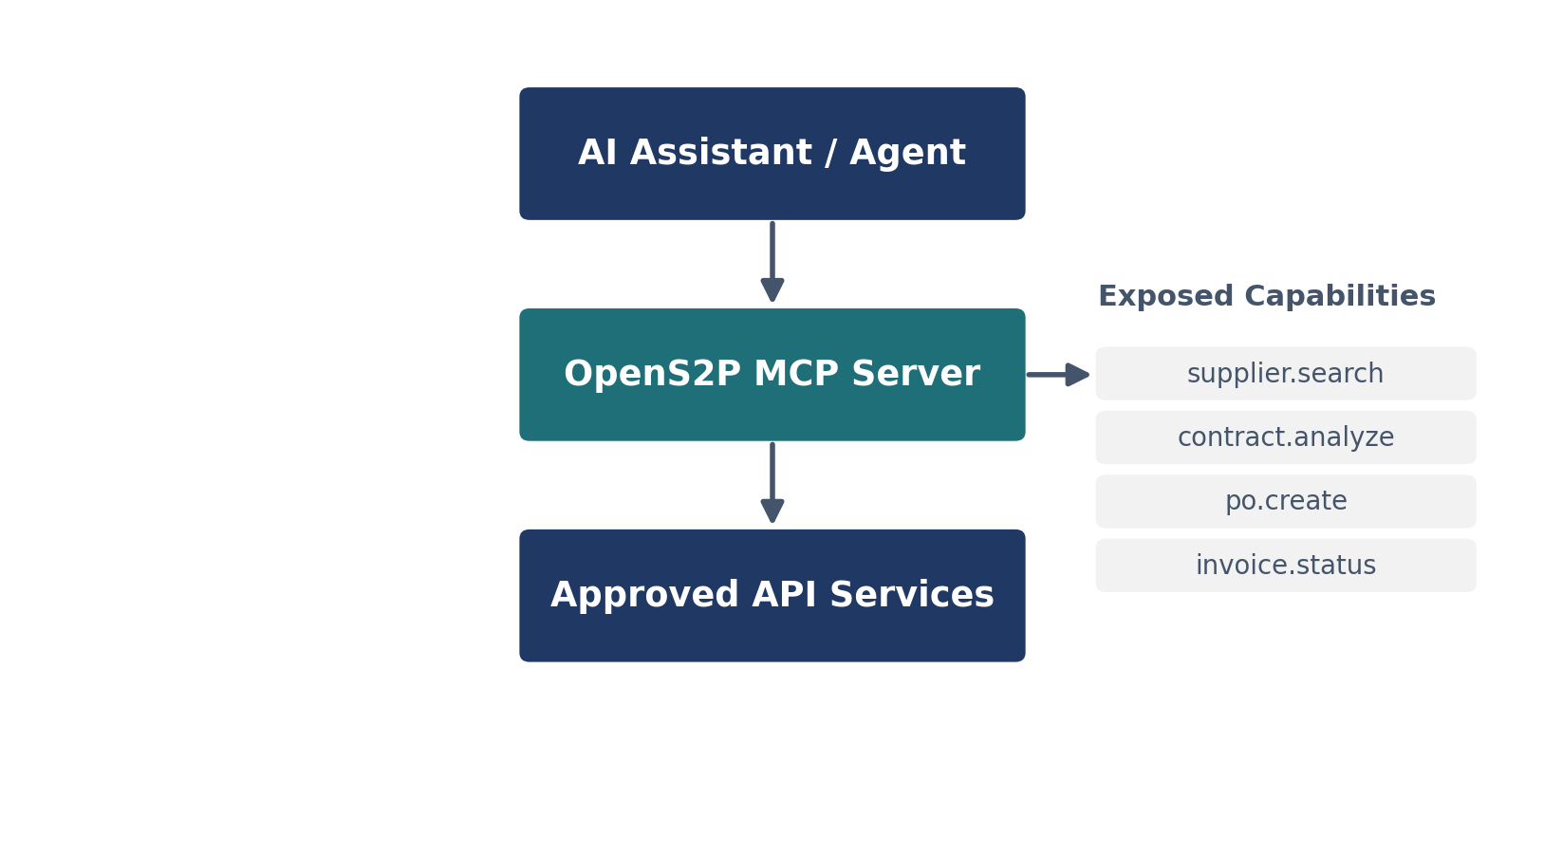

Exposed MCP Capabilities
- supplier.search — search and retrieve supplier records within RBAC and tenant scope.
- contract.analyze — submit a contract for AI clause extraction and risk analysis.
- po.create — create a purchase order, subject to the same approval workflow as any other channel.
- invoice.status — retrieve invoice and payment status.

MCP Governance Rules
- Every MCP capability maps to an existing, versioned REST endpoint — no capability is implemented exclusively for MCP.
- MCP clients authenticate via scoped OAuth2 client credentials and inherit the calling user's or service account's RBAC permissions.
- MCP requests are rate-limited under the AI Agent / MCP Clients tier defined in the Rate Limiting Standards section.
- All MCP capability invocations are logged with the same audit fields required of any mutating API call.

Future Roadmap
- API Marketplace — a curated catalog enabling partners and internal teams to discover and self-serve subscribe to OpenS2P APIs.
- Developer Portal — self-service API keys, interactive documentation, and sandbox environments.
- AI Agents — first-class support for autonomous agents consuming OpenS2P APIs under scoped, auditable permissions.
- MCP Readiness — native Model Context Protocol servers exposing OpenS2P capabilities to enterprise AI assistants.
- External Ecosystem Integrations — expanded standards-based connectivity to banking networks, logistics providers, and sustainability data sources.

Revision History
Version | Date | Description
1.0 | Initial Release | Baseline API standards for OpenS2P
2.0 | Prior | Enterprise-grade / gold standard revision — expanded architecture, security, governance, and API catalog detail
2.1 | Current | Enterprise SaaS Standard — added multi-tenancy, rate limiting, workflow/master-data/document APIs, expanded AI governance, MCP gateway, and architecture diagrams

API Testing Standards
All APIs require:
• Unit Test Coverage > 85%
• OpenAPI Contract Testing
• Security Testing
• Performance Testing
• Automated Regression Testing
Tools:
pytest, Postman/Newman, OWASP ZAP, k6/JMeter
OpenS2P Functional Error Code Catalog
AUTH_001 - Authentication failure
SUP_001 - Supplier validation failure
SRC_001 - Sourcing processing failure
CON_001 - Contract lifecycle failure
PO_001 - Purchase order failure
INV_001 - Invoice reconciliation failure
AI_001 - AI processing failure
Integration Monitoring APIs
GET /api/v1/integration/status
GET /api/v1/integration/messages
POST /api/v1/integration/retry
Tracks:
SAP S/4HANA failures
SAP ECC IDoc failures
Middleware failures
Webhook failures
AI service failures
API Environment Standards
DEV: /api/dev/v1
TEST: /api/test/v1
SANDBOX: /api/sandbox/v1
PROD: /api/v1
Developer Portal Standards
Capabilities:
• API Explorer
• Swagger Documentation
• Sandbox Tenant
• API Key Management
• Usage Analytics
• SDK Downloads
• Sample Payload Library
Revision History - Version 3.0 Enterprise Platform API Standard
Added Testing Governance, Error Catalog, Integration Monitoring,
Environment Standards and Developer Portal Standards.

