SOFTWARE ARCHITECTURE DOCUMENT
OpenS2P
Reference Implementation Guide
The Linux of Procurement AI — an open-source Source-to-Pay platform
Document Version | 1.1 (Publication Draft)
Status | Draft — Under Review
Classification | Internal / Partner Distribution
Date | July 2026
Prepared By | Kannan — OpenS2P Project

Document Control

Revision History
Version | Date | Author | Summary of Changes
1.0 | 2026 | Kannan | Initial implementation-ready draft covering 15 core services, APIs, events, and data models.
1.1 | July 2026 | Kannan | Structural review applied: document control, executive summary, architecture diagrams, service fact sheets, publication-quality formatting.

Review & Approval
Role | Name | Status
Author | Kannan | Complete
Technical Reviewer | TBD | Pending
Security Reviewer | TBD | Pending
Approving Authority | TBD | Pending

Related Documents
Document | Purpose
OpenS2P Architecture Vision v4.4 | Strategic intent, principles, ADR catalog
ADR Catalog (ADR-001 – ADR-016) | Decision rationales
OpenAPI Specifications | API contract definitions
AsyncAPI Specifications | Event contract definitions
Technology Radar | Technology selection status
Deployment Profiles | Reference sizing configurations

This Software Architecture Document (SAD) Version 1.1 Final is the authoritative technical reference for the OpenS2P platform.

Executive Summary
OpenS2P is an open-source, AI-native Source-to-Pay (S2P) platform positioned as a transparent, extensible alternative to incumbent suites such as SAP Ariba, Coupa, and Jaggaer. This document is the Software Architecture Document (SAD): the implementation-ready reference for every service, API, event contract, and data model that makes up the platform.

Business Goals
- Deliver end-to-end procurement functionality — sourcing, supplier management, contracts, purchasing, receiving, invoicing, and payment — as independently deployable services.
- Embed AI throughout the procurement lifecycle via a dedicated AI Orchestrator, Knowledge Service, and confidence-scored agent execution pipeline, rather than bolting AI on as an afterthought.
- Enable a plugin and connector ecosystem so implementation partners and customers can extend the platform without forking core services.
- Provide the same documentation and API rigor as Kubernetes or OpenTelemetry, so enterprise buyers can evaluate OpenS2P with the same diligence applied to incumbent platforms.

Major Architectural Decisions
- Fifteen core services organised into four layers — Presentation, Domain, AI, and Infrastructure — communicating over REST APIs and Kafka-based domain events.
- Domain-Driven Design throughout: each service owns clearly bounded aggregates (e.g. SourcingEvent, Supplier, Universal Contract, PurchaseOrder, Invoice) with explicit business rules and validation.
- AI capability is a first-class architectural layer (Knowledge Service, AI Orchestrator, Plugin Runtime, Connector Runtime) with human-in-the-loop gating and confidence scoring rather than unchecked automation.
- Multi-tenancy via schema-per-tenant PostgreSQL, with Keycloak for identity and JWT-based authorisation.

Deployment Model
Services are containerised and deployed on Kubernetes via Helm, with environment-specific value profiles for development, staging, and production. Observability is standardised on OpenTelemetry, with Prometheus-based alerting and defined performance targets per service. Full deployment topology, scaling guidance, and environment promotion practices are detailed in Section 25.

Table of Contents

1. Introduction

1.1 Document Purpose
This Software Architecture Document (SAD) provides the definitive, implementation-ready specification for every service, component, and integration point in the OpenS2P platform. Where the Architecture Vision defines what OpenS2P is and why decisions were made, this document defines how every service is built, deployed, and operated.
Audience:
- Service developers implementing new or existing services
- Platform engineers maintaining infrastructure
- Quality assurance teams validating implementations
- Security reviewers assessing service designs
- Technical leads reviewing architecture proposals

1.2 Document Scope
This document covers:
- Service contracts and APIs (both REST and event-driven)
- Data models and storage responsibilities
- Implementation patterns and code organisation
- Error handling, observability, and operational concerns
- Deployment-specific configuration and scaling
This document does NOT cover:
- Business capability strategy (see Architecture Vision)
- High-level architectural principles (see Architecture Vision)
- ADR rationales (see ADR Catalog)
- Developer workflow or contribution guidelines (see CONTRIBUTING.md)

1.3 Conventions
RFC 2119 Language: MUST, MUST NOT, SHOULD, SHOULD NOT, MAY as defined.
Service Naming Convention: Services are named as {domain}-service (e.g., purchasing-service).
API Versioning: All REST APIs follow v{major}.{minor} versioning. Breaking changes increment major version.
Event Naming Convention: Events are past-tense verbs: {Aggregate}{Verb}ed (e.g., PurchaseOrderIssued).
Path Conventions:
- Service source: services/{service}/src/
- Tests: services/{service}/tests/
- API specs: api/openapi/ and api/asyncapi/

1.4 Reference Documents
Document | Purpose
OpenS2P Architecture Vision v4.4 | Strategic intent, principles, ADR catalog
ADR Catalog (ADR-001 through ADR-016) | Decision rationales
OpenAPI Specifications | API contract definitions
AsyncAPI Specifications | Event contract definitions
Technology Radar | Technology selection status
Deployment Profiles | Reference sizing configurations

1.5 Architecture Principles
OpenS2P's design choices throughout this document trace back to a small set of principles, summarised here from the Architecture Vision:
- API First — every capability is exposed through a versioned, documented API before any UI consumes it.
- Event Driven — cross-domain state changes are communicated as Kafka domain events, not synchronous coupling.
- AI Native — AI orchestration, knowledge retrieval, and confidence scoring are first-class architectural layers, not add-ons.
- Zero Trust — every request is authenticated and authorised at the service boundary; no implicit trust between services.
- Multi-Tenant — tenant isolation is enforced at the data layer (schema-per-tenant) and the authorisation layer (tenant-scoped tokens).
- Domain-Driven Design — each service owns a bounded context with explicit aggregates, invariants, and ubiquitous language.
- Cloud Native — services are stateless, containerised, and horizontally scalable on Kubernetes.
- Open Standards — OpenAPI, AsyncAPI, OpenTelemetry, and OAuth2/OIDC are used in preference to proprietary protocols.

2. Architecture Overview
The diagram below is the single-page view of OpenS2P: how users and external systems reach the platform through the API Gateway, how the domain, workflow, and AI layers relate, and how everything is backed by Kafka and the data layer.

2.1 Master Architecture
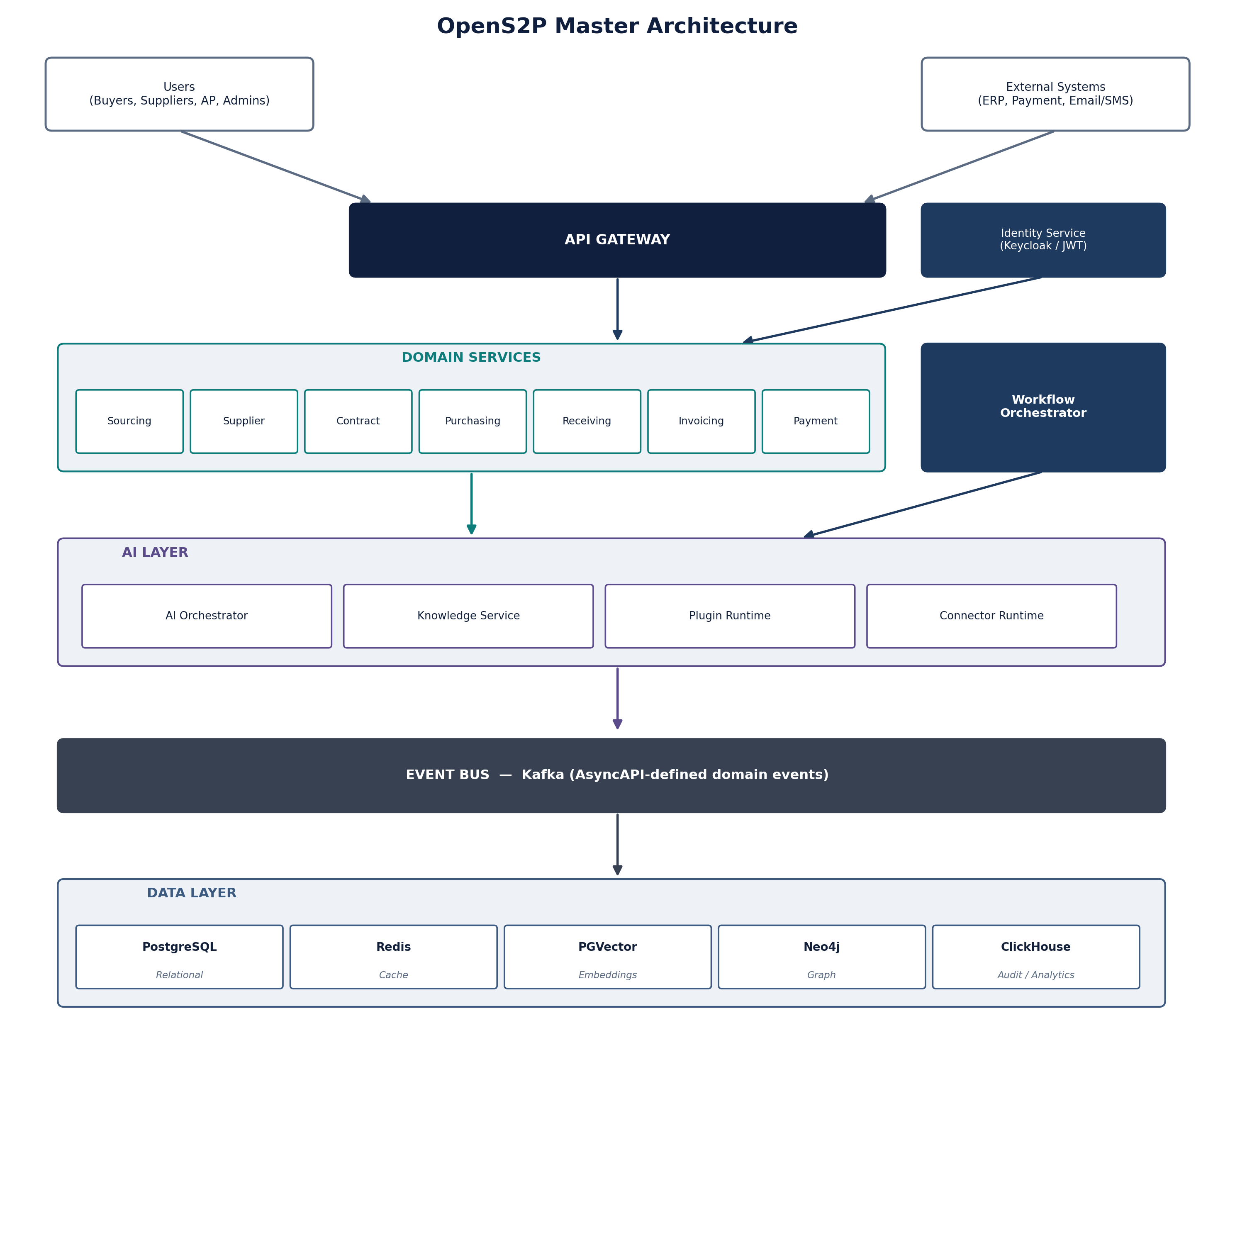
Figure 2.1 — OpenS2P Master Architecture

2.2 Service Topology
OpenS2P comprises 15 core services organised into four layers:

2.3 Service Communication Patterns
Pattern | When Used | Protocol
Event-Driven | Cross-domain state changes | Kafka + AsyncAPI
Request-Reply | Intra-domain queries, OHS calls | REST + OpenAPI
Event-Carried State Transfer | Self-contained event payloads (<1MB) | Kafka
Outbox Pattern | State change + event publishing | PostgreSQL + Debezium
CQRS | Complex read models | Domain events → Projections
Saga | Distributed transactions | Choreographed events

2.3.1 Choosing REST vs. Events
The patterns table above says when each pattern applies; this flowchart is the quick decision aid for a developer deciding how a new interaction should communicate.
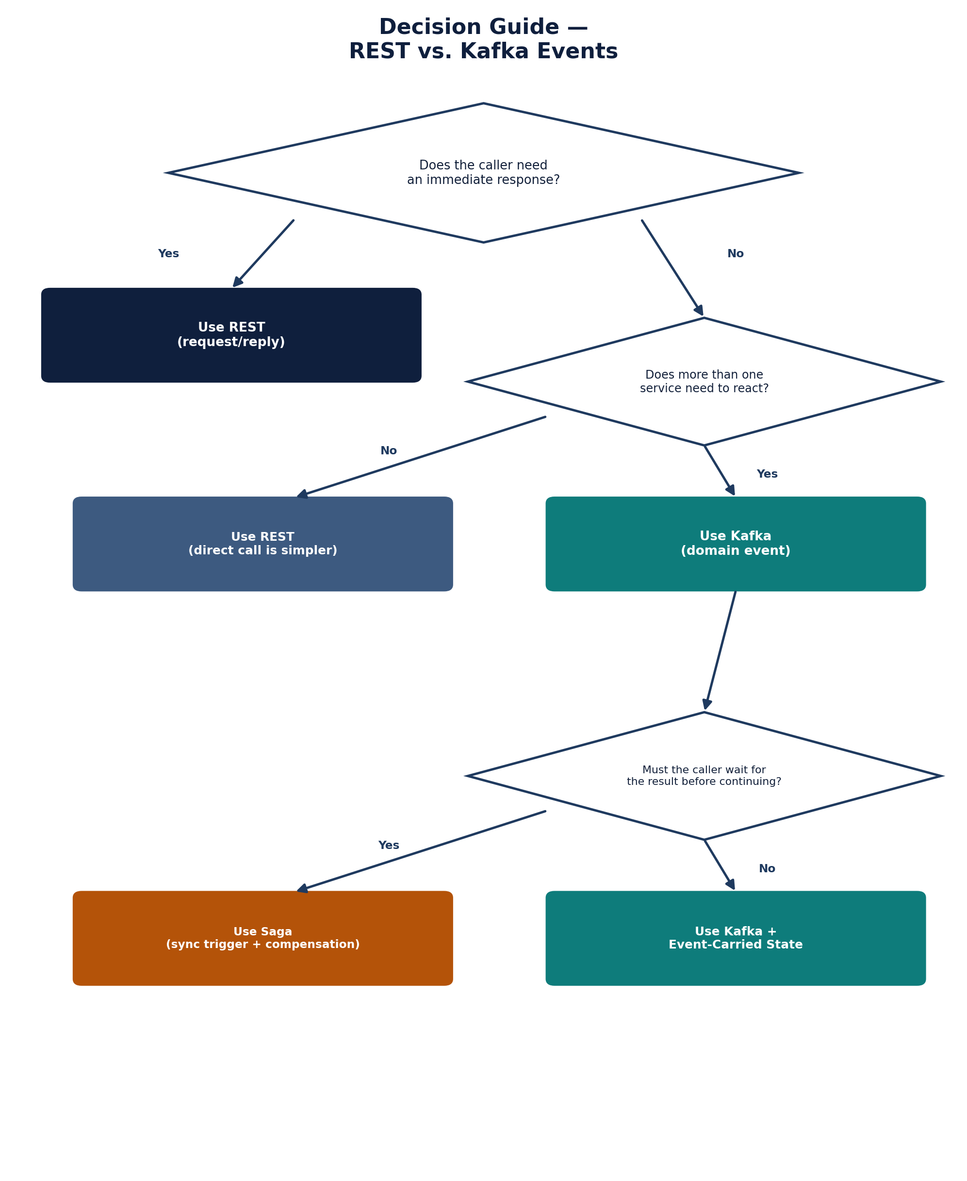
Figure 2.2 — Decision Guide: REST vs. Kafka Events

2.4 Technology Stack Summary
Layer | Technology | Version | ADR
Language (Domain) | TypeScript / Python | 5.x / 3.11+ | -
Orchestration | LangGraph | 0.6+ | ADR-003
REST API | FastAPI / Express | 0.115+ / 4.x | ADR-013
Events | Kafka | 3.5+ | ADR-002
Relational Store | PostgreSQL | 15+ | ADR-004
Vector Store | PGVector | 0.5+ | ADR-004
Graph Store | Neo4j | 5.x | ADR-004
Audit Store | ClickHouse | 23.x+ | ADR-009
Cache | Redis | 7.x | -
Authorisation | OPA | 1.0+ | ADR-008
Identity | Keycloak | 22.x+ | ADR-009
AI Inference | vLLM | 0.6+ | ADR-010
Observability | OpenTelemetry | 1.20+ | ADR-012
Container Runtime | Kubernetes | 1.28+ | C-01
Plugin Sandbox | Wasmtime | 14.x+ | ADR-007

2.4.1 Technology Lifecycle
Positioning each technology on a Trial → Adopt → Hold → Retire radar (the format used by the Technology Radar reference document) gives a one-glance view of platform maturity per component, separate from the version support question answered in Appendix I.
Technology | Radar Stage
Kubernetes, PostgreSQL, Kafka, Redis, Keycloak, OpenTelemetry | Adopt
LangGraph, vLLM, PGVector, Wasmtime, OPA | Adopt
Neo4j, ClickHouse | Trial
Distributed two-phase commit (explicitly not used, see 30.6) | Hold

2.5 Decision Traceability
Every major technology and architecture decision in this document is backed by a recorded ADR in the ADR Catalog. This table maps the most consequential decisions to their rationale record.
Decision | ADR | Summary
Kafka as the event backbone | ADR-002 | Event-driven communication over synchronous coupling
LangGraph for agent orchestration | ADR-003 | State-machine based agent workflow orchestration
PostgreSQL / PGVector / Neo4j / ClickHouse | ADR-004 | Polyglot persistence per data shape (relational, vector, graph, analytical)
Wasmtime plugin sandbox | ADR-007 | Safe, capability-scoped plugin execution
OPA for authorisation | ADR-008 | Externalised, declarative policy evaluation
Keycloak for identity | ADR-009 | Standards-based identity and session management
vLLM for AI inference | ADR-010 | Self-hostable, high-throughput model serving
OpenTelemetry for observability | ADR-012 | Vendor-neutral tracing, metrics, and logs
FastAPI / Express for REST APIs | ADR-013 | Language-idiomatic API frameworks with OpenAPI generation

2.6 ADR-to-SAD Traceability Matrix
Section 2.5 maps decisions to their ADR. This table is the reverse lookup — given an ADR, where in this document is it actually implemented — which is what a governance reviewer typically needs.
ADR | Implemented In
ADR-002 (Kafka event backbone) | Section 20 (Events), Section 20.2 Event Catalog, Chapter 29 sequence diagrams
ADR-003 (LangGraph orchestration) | Section 9 (Workflow Service), Section 10 (AI Orchestrator)
ADR-004 (Polyglot persistence) | Section 18 (Data Model), Section 2.4 Technology Stack Summary
ADR-007 (Wasmtime plugin sandbox) | Section 12 (Plugin Runtime), Figure 29.8 Plugin Execution Sequence
ADR-008 (OPA authorisation) | Section 27.2 (Authorisation)
ADR-009 (Keycloak identity) | Section 15 (Identity Service), Section 27.1 (Authentication)
ADR-010 (vLLM inference) | Section 10 (AI Orchestrator), Section 31.2 (Model Registry & Fallback)
ADR-012 (OpenTelemetry observability) | Section 23 (Monitoring)
ADR-013 (FastAPI / Express APIs) | Section 19 (APIs), Section 19.1 (API Design Standards)

2.7 Vision Principle → ADR → SAD Section
Sections 2.5 and 2.6 trace decisions and ADRs independently. This table closes the loop back to the Architecture Principles in 1.5, so a reviewer can confirm every stated principle actually has a decision and an implementation behind it, not just a mention.
Vision Principle | ADR | SAD Section
API First | ADR-013 | 19 (APIs), 19.1 (API Design Standards), 19.3 (API Catalog)
Event Driven | ADR-002 | 20 (Events), 20.2 (Event Catalog), 2.3.1 (REST vs. Events)
AI Native | ADR-003, ADR-010 | 10 (AI Orchestrator), 31 (AI Governance)
Zero Trust | ADR-008, ADR-009 | 27 (Security Architecture)
Multi-Tenant | ADR-004 | 27.3 (Multi-Tenancy & Data Isolation)
Domain-Driven Design | — | 4–17 (each service's Core Aggregates section)
Cloud Native | — | 25 (Deployment), 26.4 (C4 Deployment Diagram)
Open Standards | ADR-012, ADR-013 | 19 (APIs), 23 (Monitoring)

3. Service Catalogue

3.1 Service Inventory
Note on numbering: the service ID column below starts at 4 and runs to 19 in the original catalog; IDs 1–3 are not assigned to a service in this document. That range is presumed reserved for platform-level components documented elsewhere (e.g. UI, API Gateway, Identity infrastructure) rather than omitted services — this should be confirmed with the architecture team before publication, and the range either documented or the catalog renumbered to start at 1.
# | Service | Domain | Port | Description
4 | Sourcing Service | Sourcing | 8080 | RFx lifecycle, bid management
5 | Supplier Service | Supplier | 8081 | Supplier onboarding, qualification
6 | Contract Service | Contract | 8082 | CLM lifecycle, obligation tracking
7 | Purchasing Service | Purchasing | 8083 | PR/PO lifecycle, approvals
8 | Receiving Service | Receiving | 8084 | Goods receipt, discrepancy handling
9 | Invoicing Service | Invoicing | 8085 | Invoice capture, three-way match
10 | Payment Service | Payment | 8086 | Payment scheduling, ERP sync
11 | Workflow Service | Orchestration | 8090 | Workflow definition, execution
12 | AI Orchestrator | AI | 8091 | Agent orchestration, confidence scoring
13 | Knowledge Service | AI | 8092 | Document indexing, semantic search
14 | Plugin Runtime | Extension | 8093 | Plugin sandbox execution
15 | Connector Runtime | Integration | 8094 | External system integration
16 | Marketplace Service | Ecosystem | 8095 | Plugin publication, trust services
17 | Identity Service | Platform | 8096 | Authentication, session management
18 | Notification Service | Platform | 8097 | Email, webhook, internal notifications
19 | Search Service | Platform | 8098 | Global search across all domains

3.2 Service Dependencies
The diagram below shows which services call or are triggered by which others in the core procure-to-pay flow, plus the Workflow / AI Orchestrator relationship that spans domains.
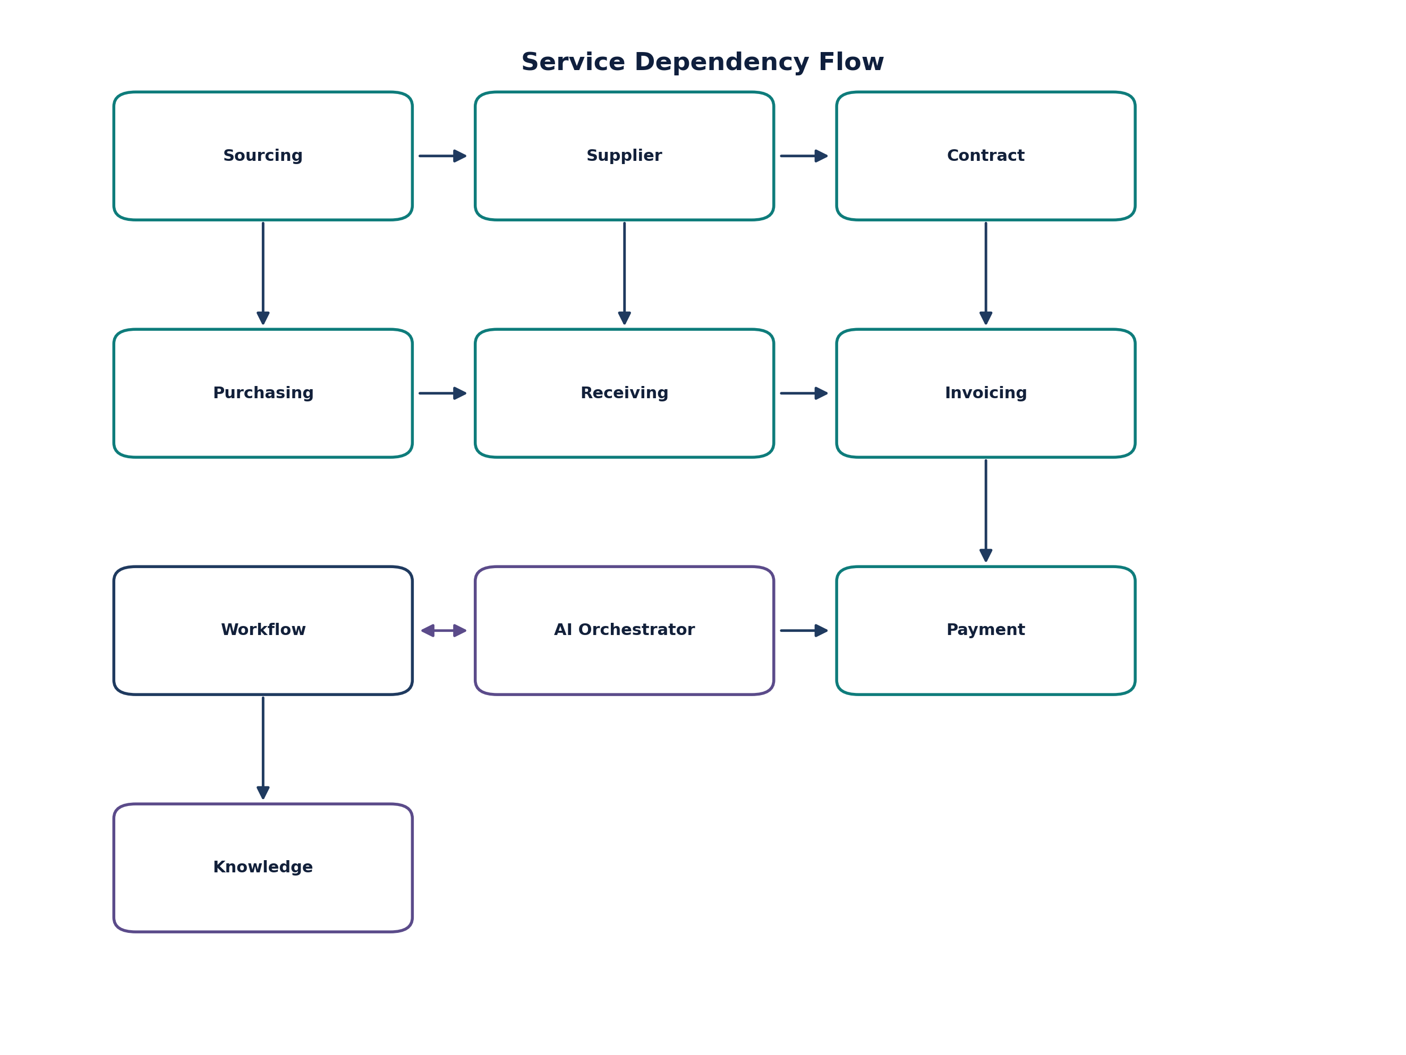
Figure 3.1 — Service Dependency Flow

3.3 Service Dependency Matrix
The same dependency information from Figure 3.1, in matrix form for easier scanning. Publishes/Consumes columns list the primary domain events per service; each service's own chapter has the complete event contract.
Service | Depends On | Publishes (primary) | Consumes (primary)
Sourcing | — | SourcingEventPublished, BidSubmitted, SourcingEventAwarded | SupplierQualified
Supplier | Sourcing | SupplierRegistered, SupplierQualified | SourcingEventAwarded
Contract | Supplier | ContractExecuted, ContractExpired | SupplierQualified, SourcingEventAwarded
Purchasing | Sourcing, Supplier | PurchaseRequisitionCreated, PurchaseOrderIssued | SourcingEventAwarded, SupplierQualified
Receiving | Purchasing, Supplier | GoodsReceiptRecorded | PurchaseOrderIssued
Invoicing | Receiving, Contract | InvoiceMatched, InvoiceApproved | GoodsReceiptRecorded, PurchaseOrderIssued
Payment | Invoicing | PaymentScheduled, PaymentIssued | InvoiceApproved
Workflow Orchestrator | AI Orchestrator | WorkflowStarted, WorkflowCompleted | (cross-domain, triggered by any service)
AI Orchestrator | Knowledge Service | AgentActionProposed, AgentActionApproved | WorkflowStarted

3.4 Domain Ownership Matrix
One row per service, pulling together the owning team (from each service's factsheet), its API base path (19.3), its primary published events (20.2), and its primary data store — the single table a new contributor or a governance reviewer needs to orient themselves.
Domain | Owner | API Base Path | Primary Events Published | Primary Data Store
Sourcing | Sourcing Team | /api/v1/sourcing | SourcingEventPublished, SourcingEventAwarded | PostgreSQL
Supplier | Supplier Team | /api/v1/suppliers | SupplierRegistered, SupplierQualified | PostgreSQL
Contract | Contract Team | /api/v1/contracts | ContractExecuted, ContractExpired | PostgreSQL
Purchasing | Purchasing Team | /api/v1/purchasing | PurchaseRequisitionCreated, PurchaseOrderIssued | PostgreSQL
Receiving | Purchasing Team | /api/v1/receiving | GoodsReceiptRecorded | PostgreSQL
Invoicing | Finance Team | /api/v1/invoicing | InvoiceMatched, InvoiceApproved | PostgreSQL
Payment | Finance Team | /api/v1/payments | PaymentScheduled, PaymentIssued | PostgreSQL
Workflow Orchestration | Platform Team | /api/v1/workflows | WorkflowStarted, WorkflowCompleted | PostgreSQL
AI Orchestrator | AI Team | /api/v1/ai | AgentActionProposed, AgentActionApproved | PostgreSQL + audit via ClickHouse
Knowledge | AI Team | /api/v1/knowledge | (read-heavy; indexing events internal) | PGVector + Neo4j
Plugin Runtime | Platform Team | /api/v1/plugins | PluginExecuted | PostgreSQL
Connector Runtime | Platform Team | /api/v1/connectors | ConnectorInvoked | PostgreSQL
Marketplace | Platform Team | /api/v1/marketplace | (publication/trust events, internal) | PostgreSQL
Identity | Platform Team | /api/v1/identity | (session events, internal) | Keycloak-managed store
Notification | Platform Team | /api/v1/notifications | (consumes broadly, publishes little) | PostgreSQL
Search | Platform Team | /api/v1/search | (read-only; no events published) | PostgreSQL + search index

4. Sourcing Service

4.1 Service Overview
Domain | Sourcing Management
Owning Team | Sourcing Team
Primary Responsibility | RFx lifecycle, bid management, award decisions, savings tracking

4.2 Core Aggregates

4.2.1 SourcingEvent (Aggregate Root)
TYPESCRIPT
interface SourcingEvent {
id: UUID;
eventType: 'RFI' | 'RFQ' | 'RFP' | 'RFx';
title: string;
description: string;
status: SourcingStatus;
timeline: {
issueDate: Date;
responseDeadline: Date;
evaluationPeriod: DateRange;
awardDate?: Date;
};
organisationId: UUID;
departmentId?: UUID;
projectCode: string;
createdBy: UserReference;
assignedBuyer: UserReference;
evaluationCriteria: EvaluationCriterion[];
technicalRequirements: TechnicalRequirement[];
commercialRequirements: CommercialRequirement[];
bids: Bid[];
attachments: DocumentReference[];
metadata: Map<string, any>;
createdAt: Date;
updatedAt: Date;
version: number;
}

type SourcingStatus =
| 'DRAFT'
| 'PUBLISHED'
| 'UNDER_EVALUATION'
| 'AWAITING_APPROVAL'
| 'AWARDED'
| 'CANCELLED'
| 'ARCHIVED';

4.2.2 Bid (Entity)
TYPESCRIPT
interface Bid {
id: UUID;
sourcingEventId: UUID;
supplierId: UUID;
submittedBy: UserReference;
submissionDate: Date;
technicalScore: number;
commercialScore: number;
totalScore: number;
lineItems: BidLineItem[];
documents: DocumentReference[];
terms: BidTerms;
status: BidStatus;
evaluationNotes: string;
isWinner: boolean;
createdAt: Date;
updatedAt: Date;
}

interface BidLineItem {
id: UUID;
description: string;
quantity: number;
unitPrice: number;
currency: string;
totalPrice: number;
deliveryDate: Date;
specifications: Map<string, any>;
}

4.3 API Specification

4.3.1 OpenAPI Contract
File: api/openapi/sourcing-service.yaml
YAML
openapi: 3.1.0
info:
title: Sourcing Service API
version: v1.0
description: RFx lifecycle, bid management, and award decisions

paths:
/api/v1/sourcing/events:
post:
summary: Create a new sourcing event
operationId: createSourcingEvent
requestBody:
required: true
content:
application/json:
schema:
$ref: '#/components/schemas/CreateSourcingEventRequest'
responses:
201:
description: Sourcing event created
content:
application/json:
schema:
$ref: '#/components/schemas/SourcingEventResponse'
400:
$ref: '#/components/responses/BadRequest'
401:
$ref: '#/components/responses/Unauthorised'

/api/v1/sourcing/events/{eventId}:
get:
summary: Get sourcing event by ID
operationId: getSourcingEvent
parameters:
- name: eventId
in: path
required: true
schema:
type: string
format: uuid
responses:
200:
description: Sourcing event found
content:
application/json:
schema:
$ref: '#/components/schemas/SourcingEventResponse'
404:
$ref: '#/components/responses/NotFound'

patch:
summary: Update sourcing event
operationId: updateSourcingEvent
parameters:
- name: eventId
in: path
required: true
schema:
type: string
format: uuid
requestBody:
required: true
content:
application/json:
schema:
$ref: '#/components/schemas/UpdateSourcingEventRequest'
responses:
200:
description: Sourcing event updated
content:
application/json:
schema:
$ref: '#/components/schemas/SourcingEventResponse'
409:
$ref: '#/components/responses/Conflict'

/api/v1/sourcing/events/{eventId}/publish:
post:
summary: Publish sourcing event to suppliers
operationId: publishSourcingEvent
parameters:
- name: eventId
in: path
required: true
schema:
type: string
format: uuid
responses:
202:
description: Publish initiated
403:
$ref: '#/components/responses/Forbidden'

/api/v1/sourcing/events/{eventId}/bids:
post:
summary: Submit a bid
operationId: submitBid
parameters:
- name: eventId
in: path
required: true
schema:
type: string
format: uuid
requestBody:
required: true
content:
application/json:
schema:
$ref: '#/components/schemas/SubmitBidRequest'
responses:
201:
description: Bid submitted
content:
application/json:
schema:
$ref: '#/components/schemas/BidResponse'
409:
description: Bid deadline passed

/api/v1/sourcing/events/{eventId}/evaluate:
post:
summary: Evaluate all bids for an event
operationId: evaluateBids
parameters:
- name: eventId
in: path
required: true
schema:
type: string
format: uuid
requestBody:
required: true
content:
application/json:
schema:
$ref: '#/components/schemas/EvaluateBidsRequest'
responses:
202:
description: Evaluation initiated
403:
$ref: '#/components/responses/Forbidden'

/api/v1/sourcing/events/{eventId}/award:
post:
summary: Award the sourcing event
operationId: awardSourcingEvent
parameters:
- name: eventId
in: path
required: true
schema:
type: string
format: uuid
requestBody:
required: true
content:
application/json:
schema:
$ref: '#/components/schemas/AwardRequest'
responses:
202:
description: Award approval requested
403:
$ref: '#/components/responses/Forbidden'

components:
schemas:
SourcingEventResponse:
type: object
properties:
id:
type: string
format: uuid
eventType:
type: string
enum: [RFI, RFQ, RFP, RFx]
title:
type: string
description:
type: string
status:
type: string
enum: [DRAFT, PUBLISHED, UNDER_EVALUATION, AWAITING_APPROVAL, AWARDED, CANCELLED, ARCHIVED]
timeline:
$ref: '#/components/schemas/Timeline'
organisationId:
type: string
format: uuid
createdBy:
$ref: '#/components/schemas/UserReference'
evaluationCriteria:
type: array
items:
$ref: '#/components/schemas/EvaluationCriterion'
bids:
type: array
items:
$ref: '#/components/schemas/BidSummary'
createdAt:
type: string
format: date-time
updatedAt:
type: string
format: date-time
version:
type: integer

CreateSourcingEventRequest:
type: object
required: [eventType, title, projectCode, timeline]
properties:
eventType:
type: string
enum: [RFI, RFQ, RFP, RFx]
title:
type: string
description:
type: string
projectCode:
type: string
departmentId:
type: string
format: uuid
timeline:
$ref: '#/components/schemas/TimelineInput'
evaluationCriteria:
type: array
items:
$ref: '#/components/schemas/EvaluationCriterionInput'
technicalRequirements:
type: array
items:
$ref: '#/components/schemas/TechnicalRequirementInput'
commercialRequirements:
type: array
items:
$ref: '#/components/schemas/CommercialRequirementInput'

Timeline:
type: object
properties:
issueDate:
type: string
format: date-time
responseDeadline:
type: string
format: date-time
evaluationPeriod:
$ref: '#/components/schemas/DateRange'
awardDate:
type: string
format: date-time

BidResponse:
type: object
properties:
id:
type: string
format: uuid
supplierId:
type: string
format: uuid
submissionDate:
type: string
format: date-time
lineItems:
type: array
items:
$ref: '#/components/schemas/BidLineItemResponse'
totalAmount:
type: number
currency:
type: string
status:
type: string
enum: [SUBMITTED, UNDER_REVIEW, REJECTED, ACCEPTED, WINNER]

4.4 Events Published

4.4.1 AsyncAPI Specification
File: api/asyncapi/sourcing-events.yaml
YAML
asyncapi: 3.0.0
info:
title: Sourcing Service Events
version: v1.0
description: Domain events emitted by Sourcing Service

channels:
sourcing:
address: sourcing-events
messages:
RFxPublished:
$ref: '#/components/messages/RFxPublished'
BidSubmitted:
$ref: '#/components/messages/BidSubmitted'
BidEvaluated:
$ref: '#/components/messages/BidEvaluated'
AwardApproved:
$ref: '#/components/messages/AwardApproved'
AwardRejected:
$ref: '#/components/messages/AwardRejected'
SourcingCancelled:
$ref: '#/components/messages/SourcingCancelled'

components:
messages:
RFxPublished:
summary: A sourcing event has been published to suppliers
payload:
type: object
required: [eventId, eventType, title, responseDeadline, organisationId]
properties:
eventId:
type: string
format: uuid
eventType:
type: string
enum: [RFI, RFQ, RFP, RFx]
title:
type: string
description:
type: string
responseDeadline:
type: string
format: date-time
organisationId:
type: string
format: uuid
publishedAt:
type: string
format: date-time
traceId:
type: string
correlationId:
type: string

BidSubmitted:
summary: A supplier has submitted a bid
payload:
type: object
required: [bidId, eventId, supplierId, submittedBy]
properties:
bidId:
type: string
format: uuid
eventId:
type: string
format: uuid
supplierId:
type: string
format: uuid
submittedBy:
$ref: '#/components/schemas/UserReference'
submittedAt:
type: string
format: date-time
bidSummary:
type: object
properties:
totalAmount:
type: number
lineItems:
type: integer
proposedDeliveryDate:
type: string
format: date
traceId:
type: string
correlationId:
type: string

4.5 Data Model

4.5.1 PostgreSQL Schema
SQL
-- Source: services/sourcing/src/infrastructure/schema/001_initial.sql

CREATE TABLE sourcing_events (
id UUID PRIMARY KEY DEFAULT gen_random_uuid(),
event_type VARCHAR(20) NOT NULL CHECK (event_type IN ('RFI', 'RFQ', 'RFP', 'RFx')),
title VARCHAR(255) NOT NULL,
description TEXT,
status VARCHAR(30) NOT NULL DEFAULT 'DRAFT',
timeline JSONB NOT NULL,
organisation_id UUID NOT NULL,
department_id UUID,
project_code VARCHAR(50) NOT NULL,
created_by JSONB NOT NULL,
assigned_buyer JSONB,
evaluation_criteria JSONB DEFAULT '[]',
technical_requirements JSONB DEFAULT '[]',
commercial_requirements JSONB DEFAULT '[]',
metadata JSONB DEFAULT '{}',
created_at TIMESTAMP WITH TIME ZONE DEFAULT CURRENT_TIMESTAMP,
updated_at TIMESTAMP WITH TIME ZONE DEFAULT CURRENT_TIMESTAMP,
version INTEGER DEFAULT 1,
tenant_id VARCHAR(50) NOT NULL
);

CREATE INDEX idx_sourcing_events_organisation ON sourcing_events (organisation_id);
CREATE INDEX idx_sourcing_events_status ON sourcing_events (status);
CREATE INDEX idx_sourcing_events_created_at ON sourcing_events (created_at DESC);
CREATE INDEX idx_sourcing_events_project_code ON sourcing_events (project_code);

CREATE TABLE bids (
id UUID PRIMARY KEY DEFAULT gen_random_uuid(),
sourcing_event_id UUID NOT NULL REFERENCES sourcing_events(id) ON DELETE CASCADE,
supplier_id UUID NOT NULL,
submitted_by JSONB NOT NULL,
submission_date TIMESTAMP WITH TIME ZONE DEFAULT CURRENT_TIMESTAMP,
technical_score DECIMAL(5,2),
commercial_score DECIMAL(5,2),
total_score DECIMAL(5,2),
line_items JSONB NOT NULL,
documents JSONB DEFAULT '[]',
terms JSONB,
status VARCHAR(20) NOT NULL DEFAULT 'SUBMITTED',
evaluation_notes TEXT,
is_winner BOOLEAN DEFAULT FALSE,
created_at TIMESTAMP WITH TIME ZONE DEFAULT CURRENT_TIMESTAMP,
updated_at TIMESTAMP WITH TIME ZONE DEFAULT CURRENT_TIMESTAMP,
tenant_id VARCHAR(50) NOT NULL
);

CREATE INDEX idx_bids_sourcing_event ON bids (sourcing_event_id);
CREATE INDEX idx_bids_supplier ON bids (supplier_id);
CREATE INDEX idx_bids_status ON bids (status);

-- RLS policies
ALTER TABLE sourcing_events ENABLE ROW LEVEL SECURITY;
ALTER TABLE bids ENABLE ROW LEVEL SECURITY;

CREATE POLICY tenant_isolation_sourcing_events ON sourcing_events
USING (tenant_id = current_setting('app.current_tenant'));

CREATE POLICY tenant_isolation_bids ON bids
USING (tenant_id = current_setting('app.current_tenant'));

4.6 Implementation Structure
CODE
services/sourcing/
├── src/
│ ├── domain/
│ │ ├── aggregates/
│ │ │ ├── SourcingEvent.ts
│ │ │ └── Bid.ts
│ │ ├── value-objects/
│ │ │ ├── Timeline.ts
│ │ │ ├── EvaluationCriterion.ts
│ │ │ └── UserReference.ts
│ │ ├── events/
│ │ │ ├── RFxPublished.ts
│ │ │ ├── BidSubmitted.ts
│ │ │ └── BidEvaluated.ts
│ │ └── repositories/
│ │ ├── ISourcingEventRepository.ts
│ │ └── IBidRepository.ts
│ ├── application/
│ │ ├── commands/
│ │ │ ├── CreateSourcingEvent.ts
│ │ │ ├── PublishSourcingEvent.ts
│ │ │ ├── SubmitBid.ts
│ │ │ └── AwardSourcingEvent.ts
│ │ ├── queries/
│ │ │ ├── GetSourcingEvent.ts
│ │ │ ├── ListSourcingEvents.ts
│ │ │ └── GetBidsForEvent.ts
│ │ └── handlers/
│ │ ├── CreateSourcingEventHandler.ts
│ │ ├── PublishSourcingEventHandler.ts
│ │ └── SubmitBidHandler.ts
│ ├── infrastructure/
│ │ ├── repositories/
│ │ │ ├── PostgresSourcingEventRepository.ts
│ │ │ └── PostgresBidRepository.ts
│ │ ├── messaging/
│ │ │ ├── KafkaEventPublisher.ts
│ │ │ └── SourcingEventSerializer.ts
│ │ ├── storage/
│ │ │ └── S3DocumentStore.ts
│ │ └── config/
│ │ ├── database.ts
│ │ ├── kafka.ts
│ │ └── opentelemetry.ts
│ └── presentation/
│ ├── controllers/
│ │ ├── SourcingEventController.ts
│ │ └── BidController.ts
│ ├── dto/
│ │ ├── CreateSourcingEventDTO.ts
│ │ └── SubmitBidDTO.ts
│ └── middleware/
│ ├── authentication.ts
│ ├── authorisation.ts
│ └── tenant-context.ts
├── tests/
│ ├── unit/
│ │ ├── domain/
│ │ │ └── SourcingEvent.test.ts
│ │ └── application/
│ │ └── CreateSourcingEvent.test.ts
│ ├── integration/
│ │ ├── repositories/
│ │ │ └── SourcingEventRepository.test.ts
│ │ └── messaging/
│ │ └── EventPublishing.test.ts
│ └── contract/
│ ├── pact/
│ │ └── SourcingServicePact.test.ts
│ └── asyncapi/
│ └── EventSchemaValidation.test.ts
├── openapi.yaml
├── asyncapi.yaml
├── Dockerfile
├── helm/
│ └── values.yaml
└── package.json

4.7 Business Rules

4.7.1 Validation Rules
TYPESCRIPT
// Source: services/sourcing/src/domain/rules/SourcingRules.ts

export class SourcingRules {
/**
* Ensure sourcing event is valid for publication
* @throws DomainError if validation fails
*/
static validateForPublication(event: SourcingEvent): void {
// Must have a response deadline
if (!event.timeline.responseDeadline) {
throw new DomainError('RESPONSE_DEADLINE_REQUIRED', 'Response deadline must be set before publication');
}

// Response deadline must be in the future
if (event.timeline.responseDeadline <= new Date()) {
throw new DomainError('RESPONSE_DEADLINE_PAST', 'Response deadline must be in the future');
}

// Must have at least one evaluation criterion
if (event.evaluationCriteria.length === 0) {
throw new DomainError('EVALUATION_CRITERIA_REQUIRED', 'At least one evaluation criterion must be defined');
}

// Weighted scores must sum to 100%
const totalWeight = event.evaluationCriteria.reduce((sum, c) => sum + c.weight, 0);
if (Math.abs(totalWeight - 100) > 0.01) {
throw new DomainError('INVALID_WEIGHT_TOTAL',
`Evaluation criteria weights must sum to 100%, currently ${totalWeight}%`);
}

// Required fields
if (!event.title || event.title.length < 3) {
throw new DomainError('INVALID_TITLE', 'Title must be at least 3 characters');
}

if (!event.projectCode) {
throw new DomainError('PROJECT_CODE_REQUIRED', 'Project code is required for publication');
}
}

/**
* Validate bid submission
*/
static validateBidSubmission(event: SourcingEvent, bid: Bid): void {
// Event must be published
if (event.status !== 'PUBLISHED' && event.status !== 'UNDER_EVALUATION') {
throw new DomainError('EVENT_NOT_OPEN',
`Event must be published to accept bids. Current status: ${event.status}`);
}

// Must be within response deadline
if (bid.submissionDate > event.timeline.responseDeadline) {
throw new DomainError('BID_DEADLINE_PASSED',
`Bid must be submitted by ${event.timeline.responseDeadline.toISOString()}`);
}

// Bid must have at least one line item
if (!bid.lineItems || bid.lineItems.length === 0) {
throw new DomainError('BID_LINE_ITEMS_REQUIRED', 'Bid must include at least one line item');
}

// All line items must have positive quantity and price
for (const item of bid.lineItems) {
if (item.quantity <= 0) {
throw new DomainError('INVALID_QUANTITY', `Line item ${item.id}: quantity must be positive`);
}
if (item.unitPrice < 0) {
throw new DomainError('INVALID_PRICE', `Line item ${item.id}: price cannot be negative`);
}
}

// Supplier cannot have existing winning bid for this event
// (Checked by repository)
}

/**
* Validate award decision
*/
static validateAward(event: SourcingEvent, winningBidId: UUID): void {
// Event must have all bids evaluated
if (event.status !== 'UNDER_EVALUATION') {
throw new DomainError('INVALID_AWARD_STATE',
`Event must be under evaluation to award. Current status: ${event.status}`);
}

// Winning bid must exist
const winningBid = event.bids.find(b => b.id === winningBidId);
if (!winningBid) {
throw new DomainError('BID_NOT_FOUND', `Bid ${winningBidId} not found in event`);
}

// Winning bid must be evaluated
if (winningBid.status !== 'EVALUATED') {
throw new DomainError('BID_NOT_EVALUATED', 'Winning bid must be evaluated before award');
}
}
}

4.7.2 Scoring Rules
TYPESCRIPT
// Source: services/sourcing/src/domain/rules/ScoringRules.ts

export class ScoringRules {
/**
* Calculate total score for a bid based on evaluation criteria
*/
static calculateBidScore(bid: Bid, criteria: EvaluationCriterion[]): BidScore {
let totalScore = 0;
const details: ScoringDetail[] = [];

for (const criterion of criteria) {
const score = this.evaluateCriterion(bid, criterion);
const weightedScore = (score / 100) * criterion.weight;
totalScore += weightedScore;

details.push({
criterionId: criterion.id,
criterionName: criterion.name,
rawScore: score,
weight: criterion.weight,
weightedScore: weightedScore,
justification: criterion.autoScore ? 'Automated evaluation' : 'Manual evaluation required'
});
}

return {
totalScore: totalScore,
maxScore: 100,
details: details,
confidence: this.calculateConfidence(details)
};
}

/**
* Evaluate a single criterion against the bid
*/
private static evaluateCriterion(bid: Bid, criterion: EvaluationCriterion): number {
switch (criterion.type) {
case 'PRICE':
return this.evaluatePriceCriterion(bid, criterion);
case 'TECHNICAL':
return this.evaluateTechnicalCriterion(bid, criterion);
case 'DELIVERY':
return this.evaluateDeliveryCriterion(bid, criterion);
case 'QUALITY':
return this.evaluateQualityCriterion(bid, criterion);
case 'COMPLIANCE':
return this.evaluateComplianceCriterion(bid, criterion);
default:
return 0;
}
}

/**
* Price scoring: lowest price gets maximum points
*/
private static evaluatePriceCriterion(bid: Bid, criterion: EvaluationCriterion): number {
const prices = bid.lineItems.map(item => item.totalPrice);
const totalPrice = prices.reduce((sum, p) => sum + p, 0);
// Scale: cheapest bid gets 100, most expensive gets 0
// This requires reference to all bids - handled at aggregate level
// Returns score 0-100
return 0; // Implementation details in full code
}
}

4.8 Error Handling
TYPESCRIPT
// Source: services/sourcing/src/infrastructure/errors/ErrorHandler.ts

export enum SourcingErrorCode {
// Domain errors
EVENT_NOT_FOUND = 'SRC-001',
BID_NOT_FOUND = 'SRC-002',
INVALID_EVENT_STATUS = 'SRC-003',
RESPONSE_DEADLINE_PASSED = 'SRC-004',
DUPLICATE_BID = 'SRC-005',
EVALUATION_CRITERIA_INCOMPLETE = 'SRC-006',

// Business rule errors
WEIGHT_TOTAL_ERROR = 'SRC-101',
INVALID_PROJECT_CODE = 'SRC-102',
BID_LINE_ITEMS_EMPTY = 'SRC-103',

// Authorization errors
UNAUTHORISED_TO_AWARD = 'SRC-201',
UNAUTHORISED_TO_EVALUATE = 'SRC-202',
UNAUTHORISED_TO_PUBLISH = 'SRC-203',

// Infrastructure errors
EVENT_PUBLISH_FAILED = 'SRC-301',
DOCUMENT_STORE_FAILURE = 'SRC-302',
REPOSITORY_ERROR = 'SRC-303'
}

export class SourcingError extends Error {
constructor(
public code: SourcingErrorCode,
message: string,
public details?: Record<string, any>
) {
super(message);
this.name = 'SourcingError';
}
}

export const errorHandler: ErrorRequestHandler = (err, req, res, next) => {
if (err instanceof SourcingError) {
return res.status(400).json({
error: {
code: err.code,
message: err.message,
details: err.details,
timestamp: new Date().toISOString(),
requestId: req.headers['x-request-id']
}
});
}

// Log unexpected errors
logger.error('Unhandled error', { error: err, requestId: req.headers['x-request-id'] });

return res.status(500).json({
error: {
code: 'INTERNAL_ERROR',
message: 'An unexpected error occurred',
timestamp: new Date().toISOString(),
requestId: req.headers['x-request-id']
}
});
};

5. Supplier Service

5.1 Service Overview
Domain | Supplier Management
Owning Team | Supplier Team
Primary Responsibility | Supplier onboarding, qualification, performance scoring, financial health monitoring

5.2 Core Aggregates
Suppliers move from registration through qualification to active status, with explicit rejection and suspension paths so a supplier can be taken out of an active sourcing pool without deleting its history.
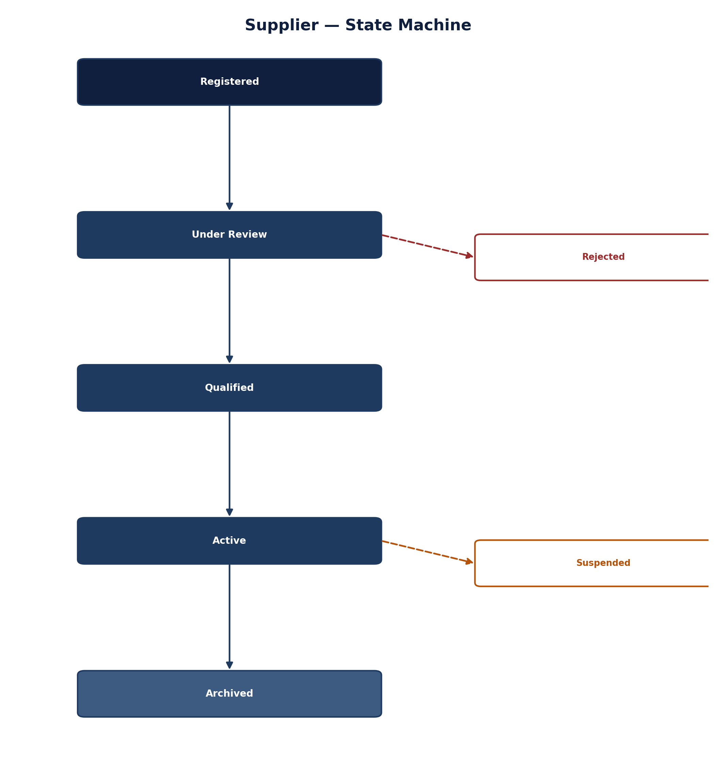
Figure 5.1 — Supplier State Machine

5.2.1 Supplier (Aggregate Root)
TYPESCRIPT
interface Supplier {
id: UUID;
legalName: string;
tradingName?: string;
registrationNumber: string;
taxId: string;
addresses: Address[];
contacts: Contact[];
classifications: SupplierClassification[];
certifications: Certification[];
financialProfile: FinancialProfile;
performanceScore: PerformanceScore;
riskProfile: RiskProfile;
status: SupplierStatus;
createdBy: UserReference;
createdAt: Date;
updatedAt: Date;
version: number;
}

interface Address {
id: UUID;
type: 'REGISTERED' | 'OPERATIONAL' | 'BILLING' | 'SHIPPING';
line1: string;
line2?: string;
city: string;
state: string;
country: string;
postalCode: string;
isDefault: boolean;
}

interface Contact {
id: UUID;
firstName: string;
lastName: string;
email: string;
phone: string;
role: 'PRIMARY' | 'FINANCE' | 'TECHNICAL' | 'OPERATIONS' | 'LEGAL';
isDefault: boolean;
}

interface FinancialProfile {
annualRevenue: number;
currency: string;
employeeCount: number;
fiscalYearEnd: string; // MM-DD
creditScore?: {
provider: 'DUN_BRADSTREET' | 'CREDITSAFE' | 'OTHER';
score: number;
scoreDate: Date;
rating: string;
};
bankruptcyFlag: boolean;
litigations: LitigationRecord[];
}

5.2.2 Qualification (Entity)
TYPESCRIPT
interface Qualification {
id: UUID;
supplierId: UUID;
type: 'FINANCIAL' | 'TECHNICAL' | 'COMPLIANCE' | 'ESG' | 'SECURITY';
status: 'PENDING' | 'IN_PROGRESS' | 'QUALIFIED' | 'DISQUALIFIED' | 'EXPIRED';
validFrom: Date;
validUntil: Date;
assessedBy: UserReference;
assessmentDate: Date;
criteria: QualificationCriterion[];
documents: DocumentReference[];
notes: string;
createdAt: Date;
updatedAt: Date;
}

5.3 Events Published
YAML
api/asyncapi/supplier-events.yaml
channels:
supplier:
address: supplier-events
messages:
SupplierRegistered:
summary: A new supplier has been registered
payload:
type: object
required: [supplierId, legalName, registrationNumber]
properties:
supplierId:
type: string
format: uuid
legalName:
type: string
registrationNumber:
type: string
taxId:
type: string
classification:
type: array
items:
type: string
registeredAt:
type: string
format: date-time
registeredBy:
$ref: '#/components/schemas/UserReference'
traceId:
type: string

QualificationApproved:
summary: A supplier qualification has been approved
payload:
type: object
required: [qualificationId, supplierId, type]
properties:
qualificationId:
type: string
format: uuid
supplierId:
type: string
format: uuid
type:
type: string
enum: [FINANCIAL, TECHNICAL, COMPLIANCE, ESG, SECURITY]
validFrom:
type: string
format: date-time
validUntil:
type: string
format: date-time
approvedBy:
$ref: '#/components/schemas/UserReference'
approvedAt:
type: string
format: date-time
traceId:
type: string

RiskFlagRaised:
summary: A risk flag has been raised for a supplier
payload:
type: object
required: [supplierId, riskType, severity]
properties:
supplierId:
type: string
format: uuid
riskType:
type: string
enum: [FINANCIAL, COMPLIANCE, REPUTATIONAL, OPERATIONAL, ESG]
severity:
type: string
enum: [LOW, MEDIUM, HIGH, CRITICAL]
description:
type: string
source:
type: string
detectedAt:
type: string
format: date-time
traceId:
type: string

5.4 Data Model
SQL
-- services/supplier/src/infrastructure/schema/001_initial.sql

CREATE TABLE suppliers (
id UUID PRIMARY KEY DEFAULT gen_random_uuid(),
legal_name VARCHAR(255) NOT NULL,
trading_name VARCHAR(255),
registration_number VARCHAR(50) NOT NULL,
tax_id VARCHAR(50),
addresses JSONB NOT NULL DEFAULT '[]',
contacts JSONB NOT NULL DEFAULT '[]',
classifications JSONB DEFAULT '[]',
certifications JSONB DEFAULT '[]',
financial_profile JSONB,
performance_score JSONB,
risk_profile JSONB,
status VARCHAR(30) NOT NULL DEFAULT 'ACTIVE',
created_by JSONB NOT NULL,
created_at TIMESTAMP WITH TIME ZONE DEFAULT CURRENT_TIMESTAMP,
updated_at TIMESTAMP WITH TIME ZONE DEFAULT CURRENT_TIMESTAMP,
version INTEGER DEFAULT 1,
tenant_id VARCHAR(50) NOT NULL,
UNIQUE(tenant_id, registration_number)
);

CREATE TABLE qualifications (
id UUID PRIMARY KEY DEFAULT gen_random_uuid(),
supplier_id UUID NOT NULL REFERENCES suppliers(id) ON DELETE CASCADE,
type VARCHAR(20) NOT NULL,
status VARCHAR(20) NOT NULL DEFAULT 'PENDING',
valid_from TIMESTAMP WITH TIME ZONE,
valid_until TIMESTAMP WITH TIME ZONE,
assessed_by JSONB,
assessment_date TIMESTAMP WITH TIME ZONE,
criteria JSONB NOT NULL,
documents JSONB DEFAULT '[]',
notes TEXT,
created_at TIMESTAMP WITH TIME ZONE DEFAULT CURRENT_TIMESTAMP,
updated_at TIMESTAMP WITH TIME ZONE DEFAULT CURRENT_TIMESTAMP,
tenant_id VARCHAR(50) NOT NULL
);

CREATE INDEX idx_suppliers_status ON suppliers (status);
CREATE INDEX idx_suppliers_legal_name ON suppliers (legal_name);
CREATE INDEX idx_suppliers_tenant ON suppliers (tenant_id);
CREATE INDEX idx_qualifications_supplier ON qualifications (supplier_id);
CREATE INDEX idx_qualifications_status ON qualifications (status);

-- Neo4j integration for supplier network
-- CREATE (s:Supplier {id: $id, name: $name, status: $status})
-- Relationship: (s)-[:HAS_CONTRACT]->(c:Contract)
-- Relationship: (s)-[:SUPPLIES]->(p:Product)

6. Contract Service

6.1 Service Overview
Domain | Contract Lifecycle Management
Owning Team | Contract Team
Primary Responsibility | Universal contract aggregate, obligation tracking, renewal management, risk scoring

6.2 Core Aggregates
A contract's lifecycle runs from drafting through negotiation, execution, and eventual expiry, with an explicit termination path distinct from natural expiry.
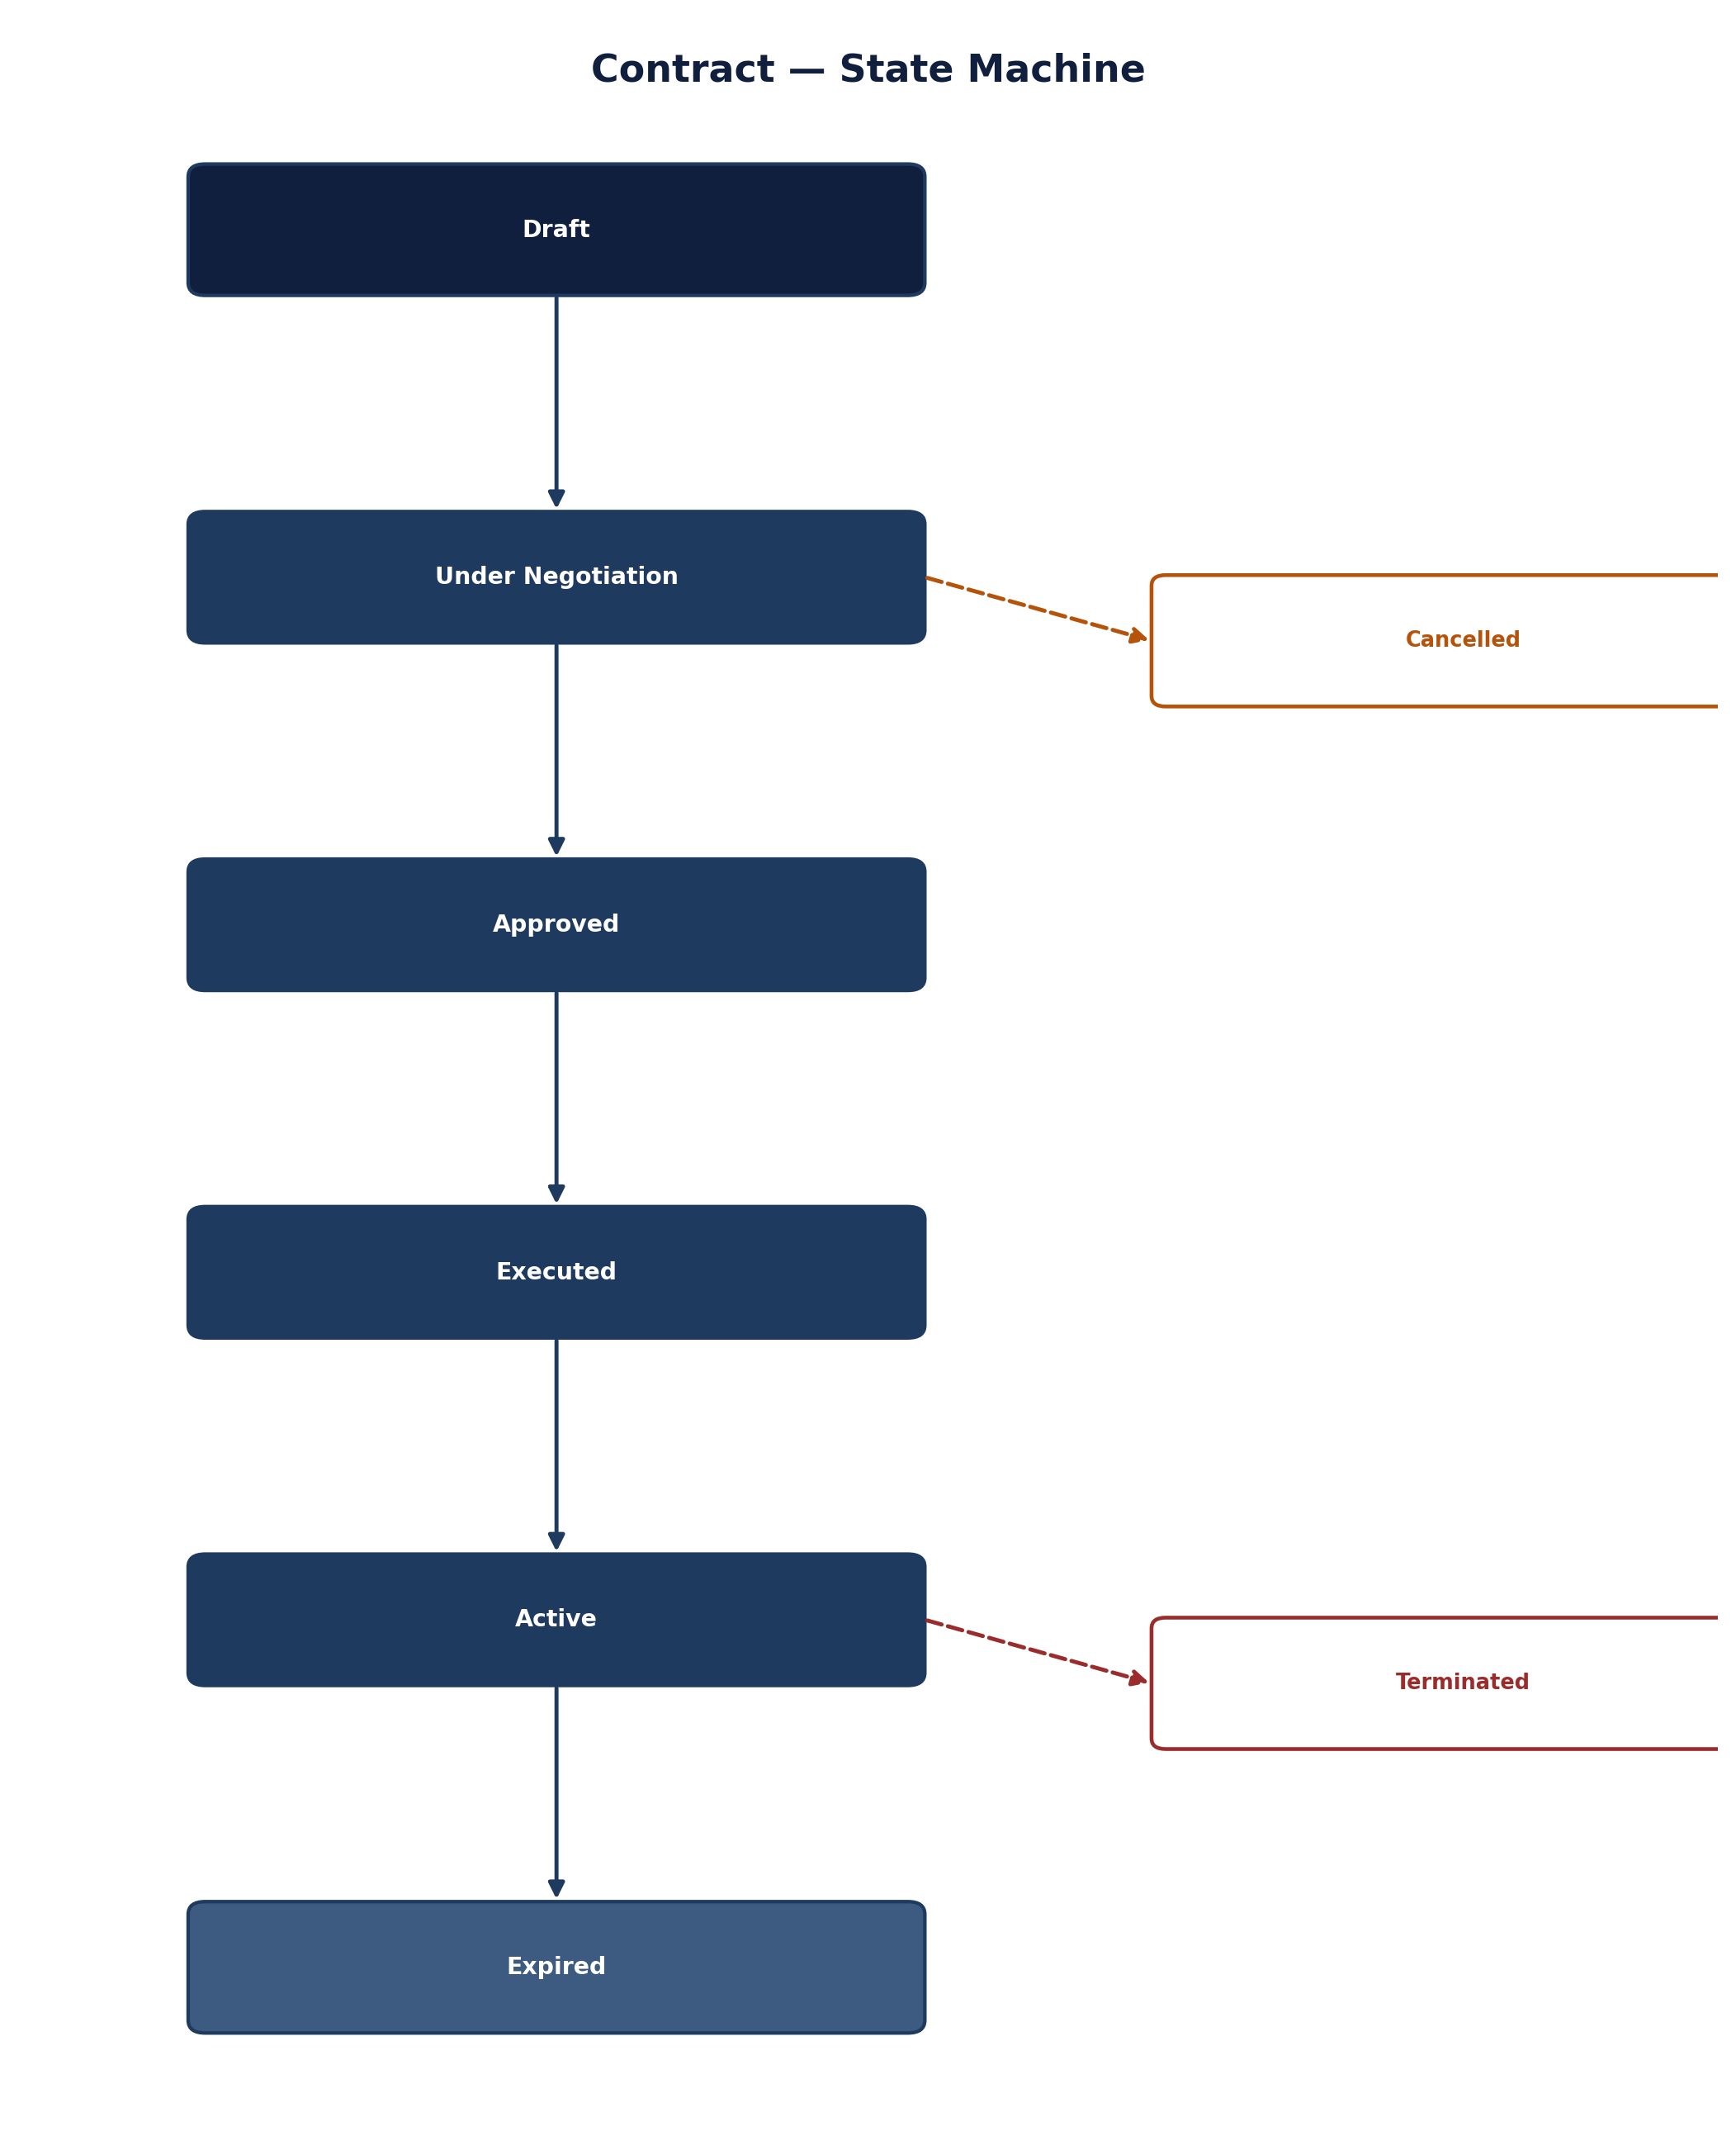
Figure 6.1 — Contract State Machine

6.2.1 Universal Contract (Aggregate Root)
TYPESCRIPT
interface Contract {
id: UUID;
contractType: ContractType;
title: string;
reference: string;
parties: ContractParty[];
effectiveDate: Date;
expiryDate: Date;
terms: ContractTerms;
obligations: Obligation[];
amendments: Amendment[];
documents: DocumentReference[];
riskScore: ContractRiskScore;
status: ContractStatus;
aiAnalysis?: ContractAIAnalysis;
version: number;
createdAt: Date;
updatedAt: Date;
}

type ContractType =
| 'MSA' // Master Services Agreement
| 'SOW' // Statement of Work
| 'NDA' // Non-Disclosure Agreement
| 'PURCHASE' // Purchase Agreement
| 'SALE' // Sales Agreement
| 'LICENSE' // License Agreement
| 'SERVICE' // Service Agreement
| 'EMPLOYMENT' // Employment Contract
| 'FRAMEWORK'; // Framework Agreement

interface ContractTerms {
paymentTerms: PaymentTerms;
deliveryTerms: DeliveryTerms;
serviceLevels: ServiceLevelAgreement[];
terminationClause: TerminationClause;
governingLaw: string;
jurisdiction: string;
confidentialityClause: ConfidentialityClause;
indemnityClause: IndemnityClause;
insuranceRequirements: InsuranceRequirement[];
customClauses: CustomClause[];
}

interface Obligation {
id: UUID;
type: ObligationType;
description: string;
responsibleParty: UUID; // Party ID
dueDate: Date;
status: ObligationStatus;
completionEvidence?: DocumentReference;
reminderSentAt: Date[];
escalatedAt: Date[];
aiDetectedSource: string; // Clause reference
createdAt: Date;
updatedAt: Date;
}

type ObligationType =
| 'RENEWAL'
| 'PAYMENT'
| 'DELIVERY'
| 'SERVICE_LEVEL'
| 'REPORTING'
| 'COMPLIANCE'
| 'INSURANCE'
| 'AUDIT'
| 'INDEMNITY'
| 'CONFIDENTIALITY';

6.3 Events Published
YAML
api/asyncapi/contract-events.yaml
channels:
contract:
address: contract-events
messages:
ContractDrafted:
summary: A new contract has been drafted
payload:
type: object
required: [contractId, contractType, title, parties]
properties:
contractId:
type: string
format: uuid
contractType:
type: string
enum: [MSA, SOW, NDA, PURCHASE, SALE, LICENSE, SERVICE, EMPLOYMENT, FRAMEWORK]
title:
type: string
reference:
type: string
parties:
type: array
items:
type: object
properties:
partyId:
type: string
format: uuid
role:
type: string
enum: [BUYER, SUPPLIER, COUNCIL]
name:
type: string
effectiveDate:
type: string
format: date
expiryDate:
type: string
format: date
draftedBy:
$ref: '#/components/schemas/UserReference'
traceId:
type: string

ContractSigned:
summary: A contract has been signed by all parties
payload:
type: object
required: [contractId, signedAt]
properties:
contractId:
type: string
format: uuid
signedAt:
type: string
format: date-time
signedBy:
type: array
items:
$ref: '#/components/schemas/UserReference'
signatureMethod:
type: string
enum: [ESIGN, WET_SIGN, DIGITAL]
traceId:
type: string

ObligationDue:
summary: A contract obligation is due
payload:
type: object
required: [obligationId, contractId, dueDate]
properties:
obligationId:
type: string
format: uuid
contractId:
type: string
format: uuid
type:
type: string
enum: [RENEWAL, PAYMENT, DELIVERY, SERVICE_LEVEL, REPORTING, COMPLIANCE, INSURANCE, AUDIT, INDEMNITY, CONFIDENTIALITY]
description:
type: string
dueDate:
type: string
format: date-time
responsiblePartyId:
type: string
format: uuid
traceId:
type: string

6.4 Data Model
SQL
-- services/contract/src/infrastructure/schema/001_initial.sql

CREATE TABLE contracts (
id UUID PRIMARY KEY DEFAULT gen_random_uuid(),
contract_type VARCHAR(20) NOT NULL,
title VARCHAR(255) NOT NULL,
reference VARCHAR(50),
parties JSONB NOT NULL,
effective_date DATE NOT NULL,
expiry_date DATE,
terms JSONB NOT NULL,
obligations JSONB DEFAULT '[]',
amendments JSONB DEFAULT '[]',
documents JSONB DEFAULT '[]',
risk_score JSONB,
ai_analysis JSONB,
status VARCHAR(20) NOT NULL DEFAULT 'DRAFT',
version INTEGER DEFAULT 1,
created_at TIMESTAMP WITH TIME ZONE DEFAULT CURRENT_TIMESTAMP,
updated_at TIMESTAMP WITH TIME ZONE DEFAULT CURRENT_TIMESTAMP,
tenant_id VARCHAR(50) NOT NULL
);

CREATE TABLE obligations (
id UUID PRIMARY KEY DEFAULT gen_random_uuid(),
contract_id UUID NOT NULL REFERENCES contracts(id) ON DELETE CASCADE,
type VARCHAR(30) NOT NULL,
description TEXT NOT NULL,
responsible_party_id UUID NOT NULL,
due_date TIMESTAMP WITH TIME ZONE NOT NULL,
status VARCHAR(20) NOT NULL DEFAULT 'PENDING',
completion_evidence JSONB,
reminder_sent_at JSONB DEFAULT '[]',
escalated_at JSONB DEFAULT '[]',
ai_detected_source TEXT,
created_at TIMESTAMP WITH TIME ZONE DEFAULT CURRENT_TIMESTAMP,
updated_at TIMESTAMP WITH TIME ZONE DEFAULT CURRENT_TIMESTAMP,
tenant_id VARCHAR(50) NOT NULL
);

CREATE INDEX idx_contracts_status ON contracts (status);
CREATE INDEX idx_contracts_effective_date ON contracts (effective_date);
CREATE INDEX idx_contracts_expiry_date ON contracts (expiry_date);
CREATE INDEX idx_obligations_contract ON obligations (contract_id);
CREATE INDEX idx_obligations_due_date ON obligations (due_date);
CREATE INDEX idx_obligations_status ON obligations (status);

6.5 Vector Store Integration
TYPESCRIPT
// services/contract/src/infrastructure/vector/ContractEmbedding.ts

import { embeddingService } from '@opens2p/knowledge-service';

export class ContractEmbeddingService {
/**
* Generate embeddings for contract clauses
*/
async embedContract(contractId: UUID): Promise<void> {
const contract = await this.repository.findById(contractId);
if (!contract) {
throw new ContractError('CONTRACT_NOT_FOUND', `Contract ${contractId} not found`);
}

// Extract clauses for embedding
const clauses = this.extractClauses(contract);
const chunks = await this.prepareEmbeddingChunks(clauses);

// Generate embeddings
const embeddings = await embeddingService.embedBatch(chunks);

// Store in PGVector
await this.vectorRepository.storeEmbeddings({
contractId,
embeddings: chunks.map((chunk, index) => ({
chunkId: chunk.id,
content: chunk.content,
embedding: embeddings[index],
metadata: {
contractId,
contractType: contract.contractType,
section: chunk.section,
clauseType: chunk.clauseType
}
}))
});
}

/**
* Search for similar clauses across contracts
*/
async searchSimilarClauses(
query: string,
contractType?: ContractType,
limit: number = 10
): Promise<SimilarClauseResult[]> {
const queryEmbedding = await embeddingService.embed(query);
return this.vectorRepository.search(queryEmbedding, {
filter: contractType ? { contractType } : undefined,
limit
});
}

private extractClauses(contract: Contract): ExtractedClause[] {
// Implementation: parse contract text, identify clauses
return [];
}

private async prepareEmbeddingChunks(
clauses: ExtractedClause[]
): Promise<EmbeddingChunk[]> {
// Implementation: prepare chunks for embedding
return [];
}
}

7. Purchasing Service

7.1 Service Overview
Domain | Procurement Operations
Owning Team | Procurement Team
Primary Responsibility | Purchase requisition and order lifecycle, catalogue management, approvals

7.2 Core Aggregates
A purchase order moves through a fixed set of states from creation to closure; rejection and cancellation are explicit exits rather than implicit dead ends.
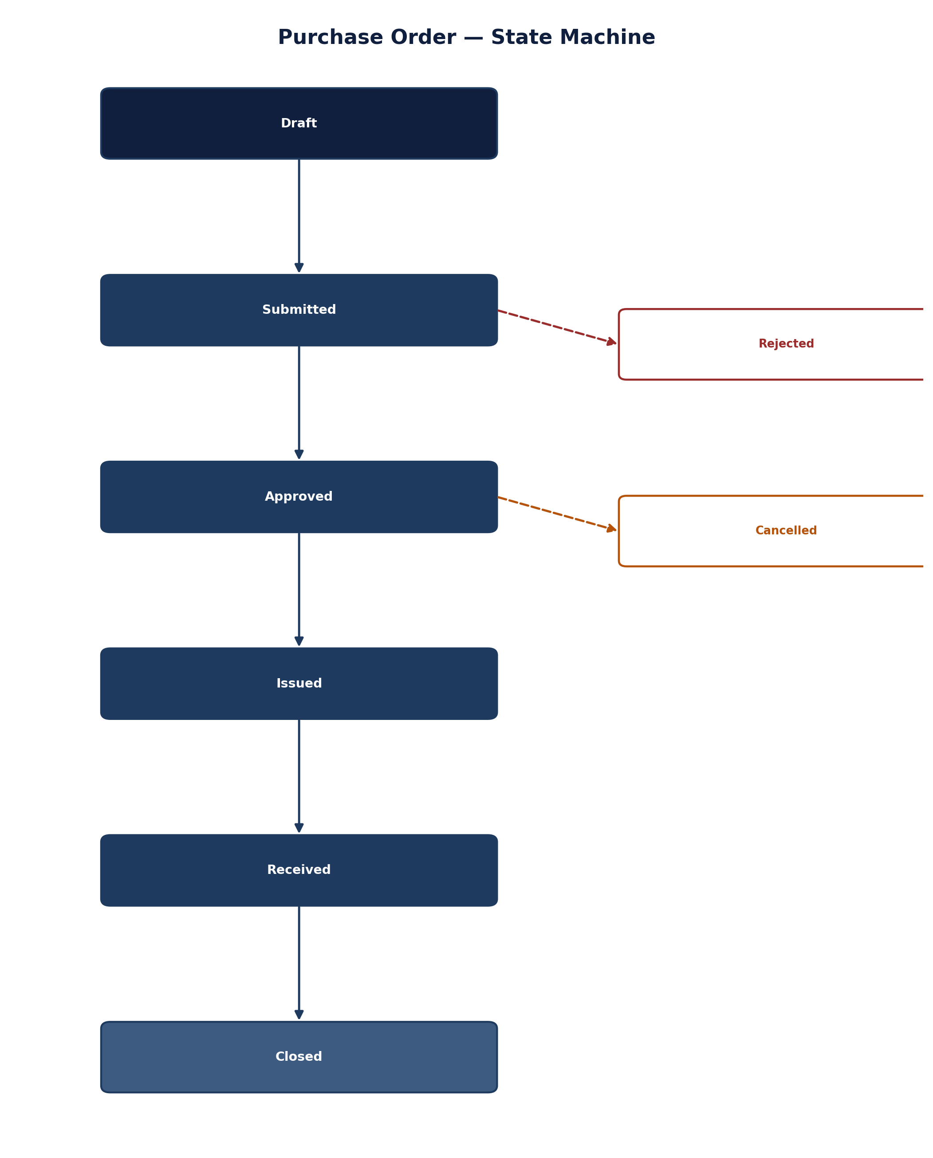
Figure 7.1 — Purchase Order State Machine

7.2.1 PurchaseRequisition (Aggregate Root)
TYPESCRIPT
interface PurchaseRequisition {
id: UUID;
requisitionNumber: string;
requester: UserReference;
departmentId: UUID;
costCentre: string;
budgetCode: string;
description: string;
lineItems: RequisitionLineItem[];
estimatedTotal: number;
currency: string;
requiredDate: Date;
deliveryLocation: Address;
supplierPreferences: SupplierPreference[];
attachments: DocumentReference[];
approvalStatus: ApprovalStatus;
approvalFlow: ApprovalFlow;
status: RequisitionStatus;
closedAt?: Date;
createdAt: Date;
updatedAt: Date;
version: number;
}

interface RequisitionLineItem {
id: UUID;
catalogueItemId?: UUID;
description: string;
quantity: number;
unitOfMeasure: string;
estimatedUnitPrice: number;
estimatedTotal: number;
budgetCode: string;
costAllocation: CostAllocation[];
specifications: Map<string, any>;
}

7.2.2 PurchaseOrder (Aggregate Root)
TYPESCRIPT
interface PurchaseOrder {
id: UUID;
orderNumber: string;
requisitionId: UUID;
supplierId: UUID;
supplierReference?: string;
orderDate: Date;
deliveryDate: Date;
lineItems: OrderLineItem[];
totalAmount: number;
currency: string;
paymentTerms: PaymentTerms;
deliveryTerms: DeliveryTerms;
status: PurchaseOrderStatus;
approvals: ApprovalRecord[];
documents: DocumentReference[];
issuedBy: UserReference;
issuedAt: Date;
acknowledgedAt?: Date;
cancelledAt?: Date;
version: number;
createdAt: Date;
updatedAt: Date;
}

interface OrderLineItem {
id: UUID;
requisitionLineId: UUID;
catalogueItemId?: UUID;
description: string;
quantity: number;
unitPrice: number;
totalPrice: number;
taxRate: number;
taxAmount: number;
netAmount: number;
grossAmount: number;
deliveryDate: Date;
status: OrderLineStatus;
receivedQuantity: number;
invoicedQuantity: number;
}

type PurchaseOrderStatus =
| 'DRAFT'
| 'PENDING_APPROVAL'
| 'APPROVED'
| 'ISSUED'
| 'ACKNOWLEDGED'
| 'PARTIALLY_RECEIVED'
| 'COMPLETED'
| 'CANCELLED'
| 'CLOSED';

7.3 Events Published
YAML
api/asyncapi/purchasing-events.yaml
channels:
purchasing:
address: purchasing-events
messages:
PRCreated:
summary: A purchase requisition has been created
payload:
type: object
required: [prId, requisitionNumber, requester, estimatedTotal]
properties:
prId:
type: string
format: uuid
requisitionNumber:
type: string
requester:
$ref: '#/components/schemas/UserReference'
departmentId:
type: string
format: uuid
estimatedTotal:
type: number
currency:
type: string
requiredDate:
type: string
format: date
createdAt:
type: string
format: date-time
traceId:
type: string

PRApproved:
summary: A purchase requisition has been approved
payload:
type: object
required: [prId, approvedBy, approvedAt]
properties:
prId:
type: string
format: uuid
approvedBy:
$ref: '#/components/schemas/UserReference'
approvedAt:
type: string
format: date-time
approvalLevel:
type: integer
traceId:
type: string

POIssued:
summary: A purchase order has been issued
payload:
type: object
required: [poId, orderNumber, supplierId, totalAmount]
properties:
poId:
type: string
format: uuid
orderNumber:
type: string
supplierId:
type: string
format: uuid
requisitionId:
type: string
format: uuid
orderDate:
type: string
format: date
deliveryDate:
type: string
format: date
totalAmount:
type: number
currency:
type: string
lineItems:
type: array
items:
type: object
properties:
lineId:
type: string
format: uuid
description:
type: string
quantity:
type: number
unitPrice:
type: number
totalPrice:
type: number
issuedBy:
$ref: '#/components/schemas/UserReference'
issuedAt:
type: string
format: date-time
traceId:
type: string

POAmended:
summary: A purchase order has been amended
payload:
type: object
required: [poId, amendmentReason]
properties:
poId:
type: string
format: uuid
amendmentReason:
type: string
amendedFields:
type: array
items:
type: string
amendedBy:
$ref: '#/components/schemas/UserReference'
amendedAt:
type: string
format: date-time
traceId:
type: string

7.4 Data Model
SQL
-- services/purchasing/src/infrastructure/schema/001_initial.sql

CREATE TABLE purchase_requisitions (
id UUID PRIMARY KEY DEFAULT gen_random_uuid(),
requisition_number VARCHAR(50) NOT NULL UNIQUE,
requester JSONB NOT NULL,
department_id UUID NOT NULL,
cost_centre VARCHAR(50) NOT NULL,
budget_code VARCHAR(50),
description TEXT,
line_items JSONB NOT NULL,
estimated_total DECIMAL(19,4) NOT NULL,
currency VARCHAR(3) NOT NULL DEFAULT 'USD',
required_date DATE NOT NULL,
delivery_location JSONB,
supplier_preferences JSONB DEFAULT '[]',
attachments JSONB DEFAULT '[]',
approval_status JSONB NOT NULL,
approval_flow JSONB NOT NULL,
status VARCHAR(20) NOT NULL DEFAULT 'DRAFT',
closed_at TIMESTAMP WITH TIME ZONE,
created_at TIMESTAMP WITH TIME ZONE DEFAULT CURRENT_TIMESTAMP,
updated_at TIMESTAMP WITH TIME ZONE DEFAULT CURRENT_TIMESTAMP,
version INTEGER DEFAULT 1,
tenant_id VARCHAR(50) NOT NULL
);

CREATE TABLE purchase_orders (
id UUID PRIMARY KEY DEFAULT gen_random_uuid(),
order_number VARCHAR(50) NOT NULL UNIQUE,
requisition_id UUID REFERENCES purchase_requisitions(id),
supplier_id UUID NOT NULL,
supplier_reference VARCHAR(50),
order_date DATE NOT NULL DEFAULT CURRENT_DATE,
delivery_date DATE NOT NULL,
line_items JSONB NOT NULL,
total_amount DECIMAL(19,4) NOT NULL,
currency VARCHAR(3) NOT NULL DEFAULT 'USD',
payment_terms JSONB NOT NULL,
delivery_terms JSONB NOT NULL,
status VARCHAR(20) NOT NULL DEFAULT 'DRAFT',
approvals JSONB DEFAULT '[]',
documents JSONB DEFAULT '[]',
issued_by JSONB,
issued_at TIMESTAMP WITH TIME ZONE,
acknowledged_at TIMESTAMP WITH TIME ZONE,
cancelled_at TIMESTAMP WITH TIME ZONE,
created_at TIMESTAMP WITH TIME ZONE DEFAULT CURRENT_TIMESTAMP,
updated_at TIMESTAMP WITH TIME ZONE DEFAULT CURRENT_TIMESTAMP,
version INTEGER DEFAULT 1,
tenant_id VARCHAR(50) NOT NULL
);

CREATE INDEX idx_pr_requester ON purchase_requisitions (requester);
CREATE INDEX idx_pr_status ON purchase_requisitions (status);
CREATE INDEX idx_pr_required_date ON purchase_requisitions (required_date);
CREATE INDEX idx_po_supplier ON purchase_orders (supplier_id);
CREATE INDEX idx_po_status ON purchase_orders (status);
CREATE INDEX idx_po_order_date ON purchase_orders (order_date);
CREATE INDEX idx_po_delivery_date ON purchase_orders (delivery_date);

7.5 Approval Workflow
TYPESCRIPT
// services/purchasing/src/domain/workflow/ApprovalWorkflow.ts

export class ApprovalWorkflow {
/**
* Determine the approval workflow based on requisition attributes
*/
static determineWorkflow(pr: PurchaseRequisition): ApprovalFlow {
const workflow: ApprovalFlow = {
stages: [],
currentStage: 0
};

// Basic rule: approval based on estimated total
if (pr.estimatedTotal < 5000) {
// Low value: manager approval only
workflow.stages.push({
level: 1,
requiredRoles: ['PROCUREMENT_MANAGER'],
autoApprove: false,
timeoutHours: 48,
escalationAfter: 72
});
} else if (pr.estimatedTotal < 50000) {
// Medium value: manager + director
workflow.stages.push({
level: 1,
requiredRoles: ['PROCUREMENT_MANAGER'],
autoApprove: false,
timeoutHours: 48,
escalationAfter: 72
});
workflow.stages.push({
level: 2,
requiredRoles: ['PROCUREMENT_DIRECTOR'],
autoApprove: false,
timeoutHours: 24,
escalationAfter: 48
});
} else {
// High value: manager + director + CFO
workflow.stages.push({
level: 1,
requiredRoles: ['PROCUREMENT_MANAGER'],
autoApprove: false,
timeoutHours: 48,
escalationAfter: 72
});
workflow.stages.push({
level: 2,
requiredRoles: ['PROCUREMENT_DIRECTOR'],
autoApprove: false,
timeoutHours: 24,
escalationAfter: 48
});
workflow.stages.push({
level: 3,
requiredRoles: ['CFO'],
autoApprove: false,
timeoutHours: 24,
escalationAfter: 48
});
}

// Additional checks
if (this.hasSensitiveCategory(pr)) {
// Add compliance approval for sensitive categories
workflow.stages.push({
level: 4,
requiredRoles: ['COMPLIANCE_OFFICER'],
autoApprove: false,
timeoutHours: 48,
escalationAfter: 72
});
}

return workflow;
}

private static hasSensitiveCategory(pr: PurchaseRequisition): boolean {
const sensitiveCategories = ['IT', 'LEGAL', 'CONSULTING', 'SECURITY'];
return pr.lineItems.some(item =>
sensitiveCategories.some(cat => item.description.includes(cat))
);
}
}

8. Invoice Service

8.1 Service Overview
Domain | Invoice Management
Owning Team | AP Team
Primary Responsibility | Invoice capture, three-way matching, exception management, early payment programs

8.2 Core Aggregates
An invoice moves from receipt through three-way matching to payment; a matching exception or a post-approval dispute are modelled as explicit states rather than error codes alone.
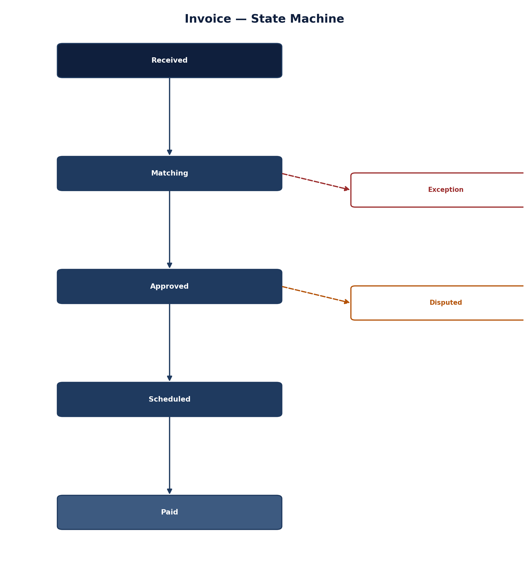
Figure 8.1 — Invoice State Machine

8.2.1 Invoice (Aggregate Root)
TYPESCRIPT
interface Invoice {
id: UUID;
invoiceNumber: string;
supplierId: UUID;
purchaseOrderId: UUID;
invoiceDate: Date;
dueDate: Date;
lineItems: InvoiceLineItem[];
subtotal: number;
taxAmount: number;
totalAmount: number;
currency: string;
status: InvoiceStatus;
matchingResult: ThreeWayMatchResult;
exceptionFlags: ExceptionFlag[];
payments: PaymentAllocation[];
documents: DocumentReference[];
createdAt: Date;
updatedAt: Date;
version: number;
}

interface InvoiceLineItem {
id: UUID;
poLineId: UUID;
description: string;
quantity: number;
unitPrice: number;
totalPrice: number;
taxRate: number;
taxAmount: number;
matchStatus: MatchStatus;
}

type InvoiceStatus =
| 'RECEIVED'
| 'PROCESSING'
| 'MATCHING'
| 'MATCHED'
| 'EXCEPTION'
| 'APPROVED'
| 'REJECTED'
| 'PAID'
| 'CANCELLED';

8.2.2 ThreeWayMatch
TYPESCRIPT
interface ThreeWayMatchResult {
status: MatchResultStatus;
poMatch: MatchDetail;
receiptMatch: MatchDetail;
overallMatch: 'COMPLETE' | 'PARTIAL' | 'NONE';
discrepancies: Discrepancy[];
matchDate: Date;
matchedBy: 'AUTO' | 'MANUAL';
confidence: number; // 0-1 for AI-assisted matching
}

interface MatchDetail {
status: 'MATCH' | 'PARTIAL' | 'MISMATCH';
toleranceThreshold: number;
variance: number;
lineMatches: LineMatch[];
}

interface Discrepancy {
type: 'QUANTITY' | 'PRICE' | 'TAX' | 'ITEM' | 'SUPPLIER' | 'DATE';
severity: 'LOW' | 'MEDIUM' | 'HIGH';
description: string;
expectedValue: number | string;
actualValue: number | string;
resolution?: string;
}

8.3 Events Published
YAML
api/asyncapi/invoice-events.yaml
channels:
invoice:
address: invoice-events
messages:
InvoiceReceived:
summary: A new invoice has been received
payload:
type: object
required: [invoiceId, invoiceNumber, supplierId, totalAmount]
properties:
invoiceId:
type: string
format: uuid
invoiceNumber:
type: string
supplierId:
type: string
format: uuid
purchaseOrderId:
type: string
format: uuid
invoiceDate:
type: string
format: date
dueDate:
type: string
format: date
totalAmount:
type: number
currency:
type: string
receivedAt:
type: string
format: date-time
source:
type: string
enum: [EMAIL, EDI, OCR, API, PORTAL]
traceId:
type: string

MatchFailed:
summary: A three-way match has failed
payload:
type: object
required: [invoiceId, discrepancies]
properties:
invoiceId:
type: string
format: uuid
purchaseOrderId:
type: string
format: uuid
discrepancies:
type: array
items:
type: object
properties:
type:
type: string
severity:
type: string
description:
type: string
expectedValue:
type: string
actualValue:
type: string
exceptionRaisedAt:
type: string
format: date-time
traceId:
type: string

ExceptionRaised:
summary: An exception has been raised on an invoice
payload:
type: object
required: [invoiceId, exceptionType]
properties:
invoiceId:
type: string
format: uuid
exceptionType:
type: string
enum: [MATCH_FAILURE, MISSING_PO, DUPLICATE, APPROVAL_REQUIRED, PRICE_DIFFERENCE, QUANTITY_DIFFERENCE, TAX_MISMATCH, SUPPLIER_MISMATCH]
description:
type: string
severity:
type: string
enum: [LOW, MEDIUM, HIGH]
escalatedTo:
type: string
format: uuid
traceId:
type: string

8.4 Three-Way Matching Implementation
TYPESCRIPT
// services/invoicing/src/domain/rules/ThreeWayMatchingRules.ts

export class ThreeWayMatchingRules {
/**
* Execute three-way match between invoice, PO, and goods receipt
*/
static executeMatch(
invoice: Invoice,
po: PurchaseOrder,
receipt: GoodsReceipt
): ThreeWayMatchResult {
const lineMatches: LineMatch[] = [];
const discrepancies: Discrepancy[] = [];
let overallMatch: 'COMPLETE' | 'PARTIAL' | 'NONE' = 'COMPLETE';

for (const invoiceLine of invoice.lineItems) {
const poLine = po.lineItems.find(l => l.id === invoiceLine.poLineId);
const receiptLine = receipt.lineItems.find(l => l.poLineId === invoiceLine.poLineId);

const match = this.matchLine(invoiceLine, poLine, receiptLine);
lineMatches.push(match);

if (!match.isMatch) {
overallMatch = 'PARTIAL';
discrepancies.push(...match.discrepancies);
}
}

// Determine overall match result
const poMatch = this.calculatePoMatch(lineMatches);
const receiptMatch = this.calculateReceiptMatch(lineMatches);

const result: ThreeWayMatchResult = {
status: this.determineResultStatus(discrepancies),
poMatch,
receiptMatch,
overallMatch: this.determineOverallMatch(lineMatches),
discrepancies,
matchDate: new Date(),
matchedBy: 'AUTO',
confidence: this.calculateConfidence(lineMatches)
};

return result;
}

private static matchLine(
invoiceLine: InvoiceLineItem,
poLine: OrderLineItem,
receiptLine: ReceiptLineItem
): LineMatch {
const discrepancies: Discrepancy[] = [];

// Check quantity
const qtyTolerance = 0.05; // 5% tolerance
const qtyVariance = Math.abs(invoiceLine.quantity - poLine.quantity) / poLine.quantity;
const qtyMatch = qtyVariance <= qtyTolerance;

if (!qtyMatch) {
discrepancies.push({
type: 'QUANTITY',
severity: 'HIGH',
description: `Invoice quantity ${invoiceLine.quantity} does not match PO quantity ${poLine.quantity}`,
expectedValue: poLine.quantity,
actualValue: invoiceLine.quantity
});
}

// Check price
const priceTolerance = 0.02; // 2% tolerance
const priceVariance = Math.abs(invoiceLine.unitPrice - poLine.unitPrice) / poLine.unitPrice;
const priceMatch = priceVariance <= priceTolerance;

if (!priceMatch) {
discrepancies.push({
type: 'PRICE',
severity: 'HIGH',
description: `Invoice price ${invoiceLine.unitPrice} does not match PO price ${poLine.unitPrice}`,
expectedValue: poLine.unitPrice,
actualValue: invoiceLine.unitPrice
});
}

// Check receipt if available
let receiptMatch = false;
if (receiptLine) {
const receiptVariance = Math.abs(invoiceLine.quantity - receiptLine.receivedQuantity) / receiptLine.receivedQuantity;
receiptMatch = receiptVariance <= qtyTolerance;
if (!receiptMatch) {
discrepancies.push({
type: 'QUANTITY',
severity: 'MEDIUM',
description: `Invoice quantity ${invoiceLine.quantity} does not match receipt quantity ${receiptLine.receivedQuantity}`,
expectedValue: receiptLine.receivedQuantity,
actualValue: invoiceLine.quantity
});
}
}

return {
invoiceLineId: invoiceLine.id,
poLineId: poLine.id,
receiptLineId: receiptLine?.id,
isMatch: qtyMatch && priceMatch && (receiptLine ? receiptMatch : true),
qtyMatch,
priceMatch,
receiptMatch: receiptLine ? receiptMatch : false,
discrepancies
};
}
}

9. Workflow Service

9.1 Service Overview
Domain | Workflow Orchestration
Owning Team | Platform Team
Primary Responsibility | Workflow definition management, execution orchestration, state persistence

9.2 Core Components
Every workflow instance — regardless of which business process it's driving — follows this same state machine, which is what lets the Workflow Orchestrator manage approvals generically across services.
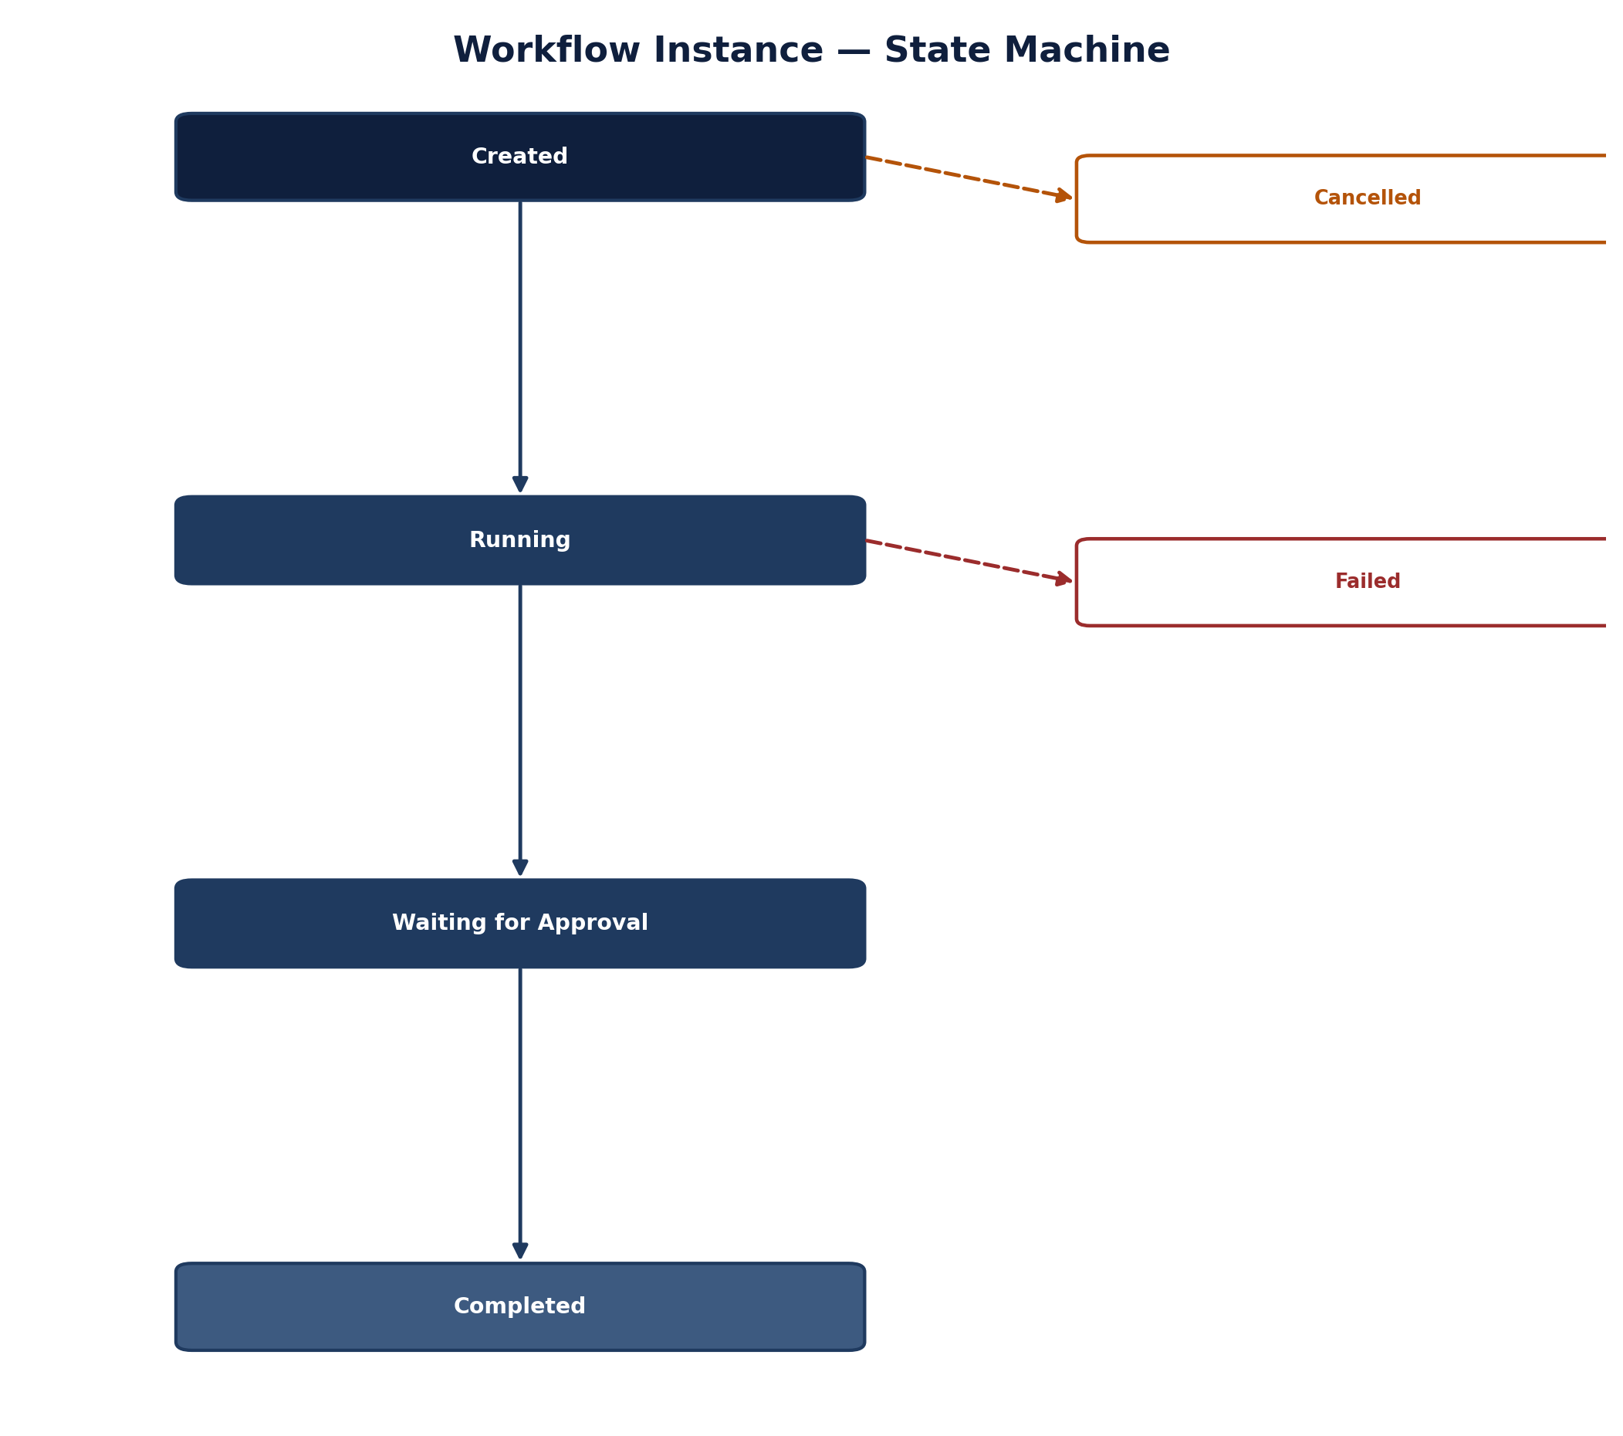
Figure 9.1 — Workflow Instance State Machine

9.2.1 Workflow Definition
TYPESCRIPT
interface WorkflowDefinition {
id: UUID;
name: string;
version: string;
description: string;
graph: WorkflowGraph;
metadata: WorkflowMetadata;
status: 'DRAFT' | 'ACTIVE' | 'DEPRECATED' | 'ARCHIVED';
createdAt: Date;
updatedAt: Date;
}

interface WorkflowGraph {
nodes: WorkflowNode[];
edges: WorkflowEdge[];
}

interface WorkflowNode {
id: string;
type: 'START' | 'PROCESS' | 'DECISION' | 'GATE' | 'PARALLEL' | 'END';
label: string;
config: NodeConfig;
position?: { x: number; y: number };
}

interface WorkflowEdge {
id: string;
source: string;
target: string;
condition?: EdgeCondition;
label?: string;
}

interface NodeConfig {
// Based on node type
process?: {
handler: string; // Service/function to call
timeout: number;
retry: {
maxAttempts: number;
backoff: number;
};
};
decision?: {
expression: string;
branches: {
condition: string;
target: string;
}[];
};
gate?: {
type: 'HUMAN' | 'AUTO';
threshold?: number;
approvers?: string[];
};
parallel?: {
branches: string[]; // Node IDs to execute in parallel
};
}

9.2.2 Workflow Execution
TYPESCRIPT
interface WorkflowExecution {
id: UUID;
workflowId: UUID;
workflowVersion: string;
status: ExecutionStatus;
context: ExecutionContext;
currentNodes: string[];
history: ExecutionStep[];
state: Record<string, any>;
startedAt: Date;
completedAt?: Date;
error?: WorkflowError;
}

interface ExecutionContext {
tenantId: string;
userId: UUID;
correlationId: string;
inputs: Record<string, any>;
variables: Record<string, any>;
}

9.3 LangGraph Integration
TYPESCRIPT
// services/workflow/src/application/langgraph/WorkflowEngine.ts

import { StateGraph, MemorySaver, State } from '@langchain/langgraph';
import { ChatOpenAI } from '@langchain/openai';

export class WorkflowEngine {
private graphRegistry: Map<string, StateGraph<any>> = new Map();
private memorySaver = new MemorySaver();

/**
* Register a workflow definition as a LangGraph
*/
async registerWorkflow(definition: WorkflowDefinition): Promise<void> {
const graph = new StateGraph({
channels: {
// Define state schema
}
});

// Add nodes
for (const node of definition.graph.nodes) {
switch (node.type) {
case 'PROCESS':
graph.addNode(node.id, this.createProcessNode(node));
break;
case 'DECISION':
graph.addNode(node.id, this.createDecisionNode(node));
break;
case 'GATE':
graph.addNode(node.id, this.createGateNode(node));
break;
case 'PARALLEL':
graph.addNode(node.id, this.createParallelNode(node));
break;
}
}

// Add edges
for (const edge of definition.graph.edges) {
if (edge.condition) {
graph.addConditionalEdges(edge.source, (state: State) => {
return this.evaluateCondition(edge.condition, state);
});
} else {
graph.addEdge(edge.source, edge.target);
}
}

graph.setEntryPoint(definition.graph.nodes.find(n => n.type === 'START')?.id || '');
graph.setFinishPoint(definition.graph.nodes.find(n => n.type === 'END')?.id || '');

this.graphRegistry.set(`${definition.id}:${definition.version}`, graph.compile({
checkpointer: this.memorySaver
}));
}

/**
* Execute a workflow
*/
async executeWorkflow(
workflowId: UUID,
version: string,
inputs: Record<string, any>
): Promise<WorkflowExecution> {
const key = `${workflowId}:${version}`;
const graph = this.graphRegistry.get(key);

if (!graph) {
throw new WorkflowError('WORKFLOW_NOT_FOUND', `Workflow ${key} not found`);
}

const execution: WorkflowExecution = {
id: uuidv4(),
workflowId,
workflowVersion: version,
status: 'RUNNING',
context: {
tenantId: this.getCurrentTenant(),
userId: this.getCurrentUser(),
correlationId: this.getCorrelationId(),
inputs,
variables: {}
},
currentNodes: [],
history: [],
state: {},
startedAt: new Date()
};

try {
const result = await graph.invoke(
{
...inputs,
__execution: execution
},
{
configurable: {
thread_id: execution.id
}
}
);

execution.status = 'COMPLETED';
execution.completedAt = new Date();
execution.state = result;

return execution;
} catch (error) {
execution.status = 'FAILED';
execution.error = {
code: 'EXECUTION_ERROR',
message: error.message,
stack: error.stack
};
throw error;
}
}

/**
* Resume a suspended workflow (HITL gate)
*/
async resumeWorkflow(
executionId: UUID,
decision: GateDecision
): Promise<WorkflowExecution> {
// Resume the workflow with the gate decision
// Implementation details
}
}

10. AI Orchestrator

10.1 Service Overview
Domain | AI Agent Orchestration
Owning Team | AI Platform Team
Primary Responsibility | Agent lifecycle management, confidence scoring, HITL gating, evaluation

10.2 Core Components
The state view of the same pipeline shown in Figures 10.1 and 10.2: an agent run is either completed automatically, routed to human approval, or marked failed — there is no silent partial-completion state.
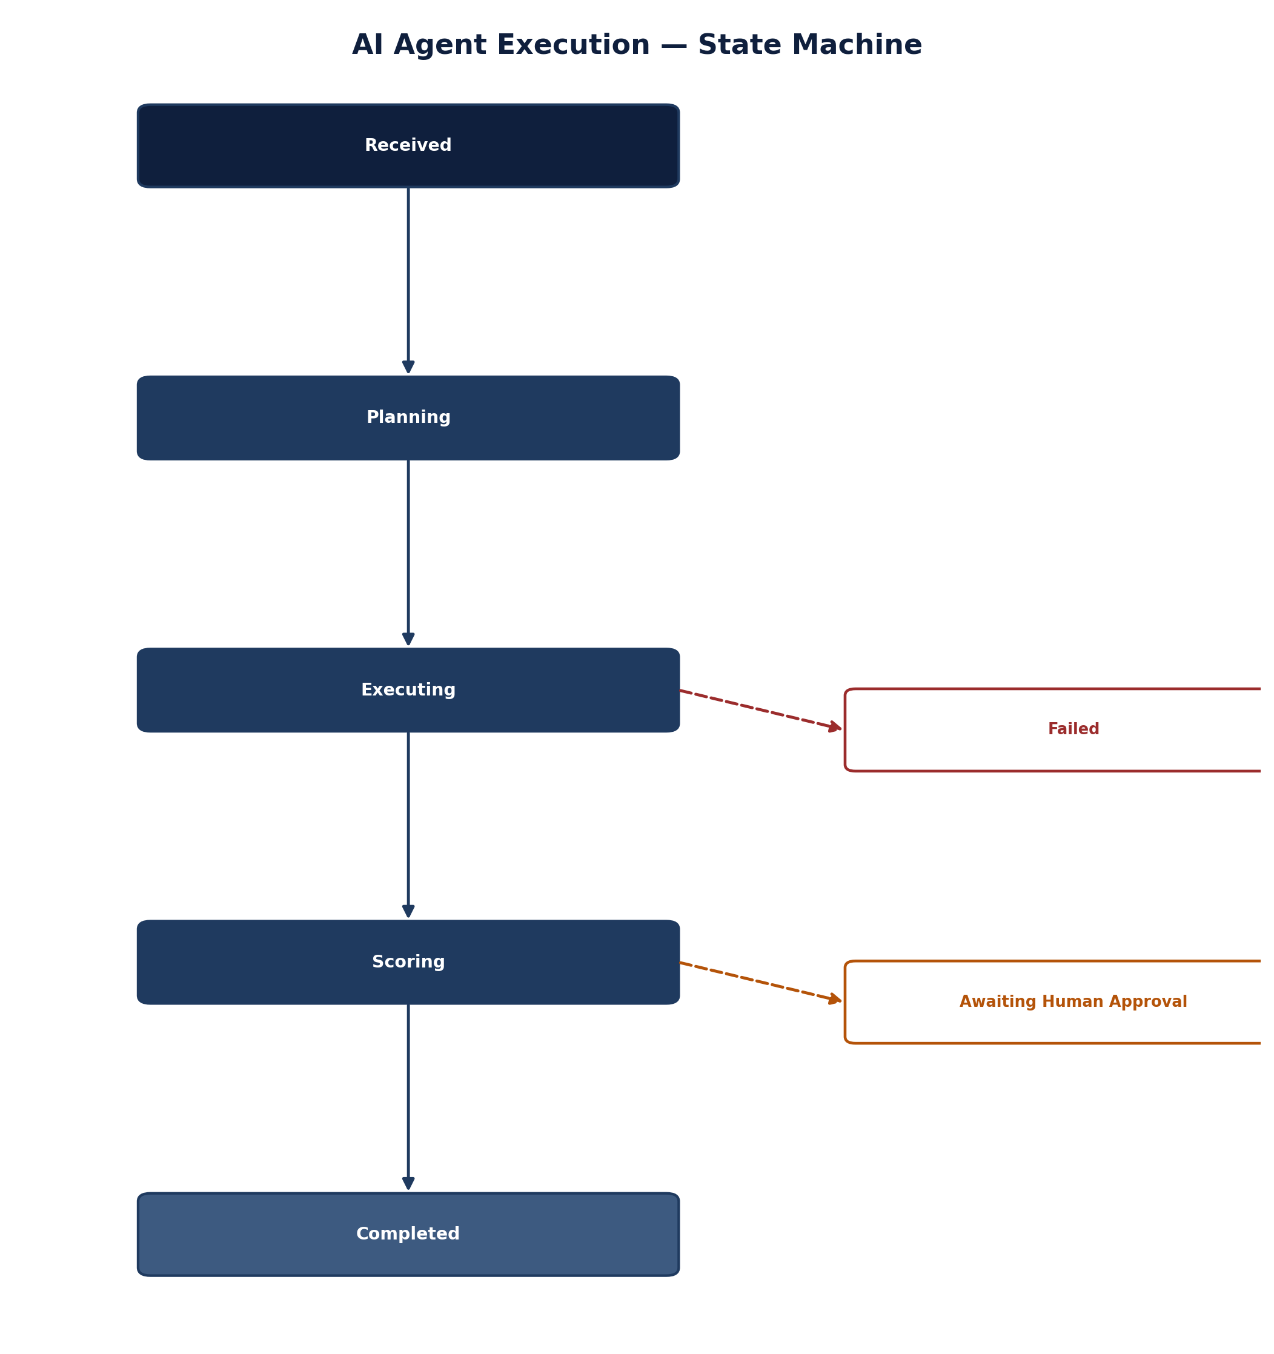
Figure 10.3 — AI Agent Execution State Machine

10.2.1 Agent Configuration
TYPESCRIPT
interface AgentConfig {
id: UUID;
name: string;
type: AgentType;
description: string;
systemPrompt: PromptReference;
tools: ToolDefinition[];
confidenceThreshold: number; // 0-1
memoryConfig: MemoryConfig;
modelConfig: ModelConfig;
evaluationConfig: EvaluationConfig;
status: 'DRAFT' | 'ACTIVE' | 'DEPRECATED';
version: string;
createdAt: Date;
updatedAt: Date;
}

type AgentType =
| 'SOURCING_ASSISTANT'
| 'CONTRACT_ANALYZER'
| 'SUPPLIER_DISCOVERY'
| 'PO_GENERATOR'
| 'INVOICE_MATCHER'
| 'RISK_ANALYZER'
| 'SPEND_ANALYZER';

interface ToolDefinition {
id: string;
name: string;
description: string;
parameters: JSONSchema;
handler: string; // Service:method
allowedScopes: string[];
}

10.2.2 Agent Invocation
TYPESCRIPT
interface AgentInvocation {
id: UUID;
agentId: UUID;
input: Record<string, any>;
confidence: number;
status: 'PENDING' | 'PROCESSING' | 'COMPLETED' | 'GATE_WAITING' | 'FAILED';
result?: AgentResult;
traceId: string;
startedAt: Date;
completedAt?: Date;
}

interface AgentResult {
output: Record<string, any>;
confidence: number;
citations: Citation[];
toolCalls: ToolCall[];
evaluation: EvaluationResult;
metadata: Record<string, any>;
}

interface Citation {
sourceId: string;
sourceType: 'CONTRACT' | 'SUPPLIER' | 'POLICY' | 'REGULATION' | 'PO' | 'INVOICE';
reference: string;
excerpt: string;
confidence: number;
}

10.3 Agent Execution Pipeline
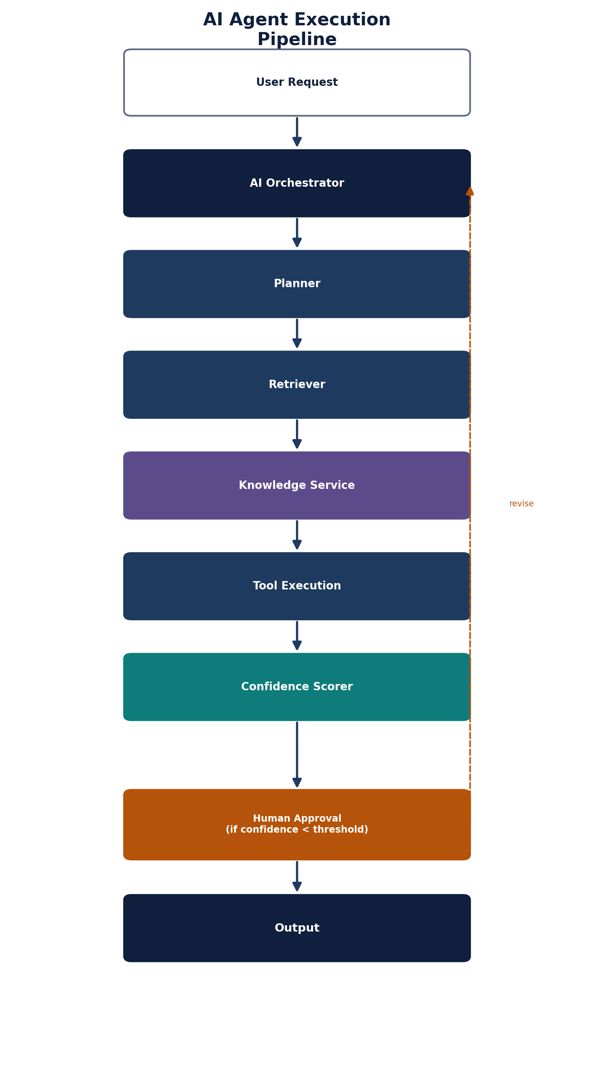
Figure 10.1 — AI Agent Execution Pipeline
TYPESCRIPT
// services/ai-orchestrator/src/application/agent/AgentExecutionPipeline.ts

export class AgentExecutionPipeline {
private agentRegistry: AgentRegistry;
private promptService: PromptService;
private confidenceScorer: ConfidenceScorer;
private gateService: GateService;
private auditService: AuditService;

/**
* Execute an agent invocation through the 9-stage pipeline
*/
async execute(invocation: AgentInvocation): Promise<AgentResult> {
// Stage 1: Input Trigger (already handled)
this.auditService.record('AGENT_STARTED', invocation);

// Stage 2: Planner
const plan = await this.plan(invocation);

// Stage 3: Retriever
const context = await this.retrieve(plan);

// Stage 4: Reasoner
const reasoning = await this.reason(plan, context);

// Stage 5: Tool Calls
const toolResults = await this.executeTools(reasoning);

// Stage 6: Validator
const validation = await this.validate(toolResults);

// Stage 7: Confidence Scorer
const confidence = await this.scoreConfidence(validation);

// Stage 8: Approval Gate
const gateResult = await this.applyGate(confidence, invocation);

// Stage 9: Output & Audit
const result = await this.produceOutput(gateResult, invocation);

this.auditService.record('AGENT_COMPLETED', {
invocationId: invocation.id,
result
});

return result;
}

private async plan(invocation: AgentInvocation): Promise<Plan> {
const agent = await this.agentRegistry.findById(invocation.agentId);
const prompt = await this.promptService.getSystemPrompt(agent.systemPrompt);

// Decompose task and select tools
const plan = await this.llmService.invoke({
prompt: prompt,
input: invocation.input,
tools: agent.tools
});

return plan;
}

private async retrieve(plan: Plan): Promise<Context> {
// Vector search, graph traversal, document fetch
const context = await this.knowledgeService.query({
query: plan.searchQuery,
filters: plan.filters,
maxResults: 20
});

return context;
}

private async scoreConfidence(validation: ValidationResult): Promise<ConfidenceScore> {
const score = await this.confidenceScorer.calculate({
evidenceQuality: validation.evidenceQuality,
modelUncertainty: validation.modelUncertainty,
policyCompliance: validation.policyCompliance,
riskSignals: validation.riskSignals
});

return score;
}

private async applyGate(
confidence: ConfidenceScore,
invocation: AgentInvocation
): Promise<GateResult> {
const agent = await this.agentRegistry.findById(invocation.agentId);

if (confidence.score >= agent.confidenceThreshold) {
return { approved: true, confidence };
}

// Below threshold - escalate to human
const gateRequest = await this.gateService.createGateRequest({
invocationId: invocation.id,
agentId: invocation.agentId,
confidence: confidence.score,
output: invocation.result,
reason: confidence.reasons
});

return { approved: false, gateRequest };
}
}

10.4 Confidence Scorer
TYPESCRIPT
// services/ai-orchestrator/src/domain/confidence/ConfidenceScorer.ts

export class ConfidenceScorer {
/**
* Calculate aggregate confidence score
*/
async calculate(
factors: ConfidenceFactors
): Promise<ConfidenceScore> {
const scores: ScoreComponent[] = [];

// Evidence quality
const evidenceScore = this.scoreEvidence(factors.evidenceQuality);
scores.push({
component: 'EVIDENCE',
weight: 0.30,
score: evidenceScore,
reasoning: this.getEvidenceReasoning(factors.evidenceQuality)
});

// Model uncertainty
const modelScore = this.scoreModelUncertainty(factors.modelUncertainty);
scores.push({
component: 'MODEL',
weight: 0.25,
score: modelScore,
reasoning: this.getModelReasoning(factors.modelUncertainty)
});

// Policy compliance
const policyScore = this.scorePolicyCompliance(factors.policyCompliance);
scores.push({
component: 'POLICY',
weight: 0.25,
score: policyScore,
reasoning: this.getPolicyReasoning(factors.policyCompliance)
});

// Risk signals
const riskScore = this.scoreRiskSignals(factors.riskSignals);
scores.push({
component: 'RISK',
weight: 0.20,
score: riskScore,
reasoning: this.getRiskReasoning(factors.riskSignals)
});

// Aggregate
const aggregate = scores.reduce((sum, s) => sum + (s.score * s.weight), 0);

return {
score: aggregate,
components: scores,
threshold: this.determineThreshold(aggregate),
reasons: this.generateReasons(scores)
};
}

private scoreEvidence(evidence: EvidenceQuality): number {
// Count citations, assess relevance
const citationCount = evidence.citations.length;
const relevanceScore = evidence.relevanceScore;
const completeness = evidence.completeness;

return (citationCount * 0.3 + relevanceScore * 0.4 + completeness * 0.3);
}

private scoreModelUncertainty(uncertainty: ModelUncertainty): number {
// Convert uncertainty to confidence
return 1 - uncertainty.entropy;
}

private scorePolicyCompliance(compliance: PolicyCompliance): number {
// Check policy adherence
const violations = compliance.violations.length;
return Math.max(0, 1 - (violations * 0.2));
}

private scoreRiskSignals(signals: RiskSignal[]): number {
// Assess risk signals
const highRisk = signals.filter(s => s.severity === 'HIGH').length;
const mediumRisk = signals.filter(s => s.severity === 'MEDIUM').length;

return Math.max(0, 1 - (highRisk * 0.5 + mediumRisk * 0.2));
}
}

10.5 AI Architecture Overview
Figure 10.1 shows the pipeline as a linear sequence; the diagram below shows the same components arranged by relationship rather than by step order, including the knowledge stores and audit trail. This is the view worth putting in front of a customer or investor to explain what makes OpenS2P's AI layer different from a chatbot bolted onto a procurement UI.
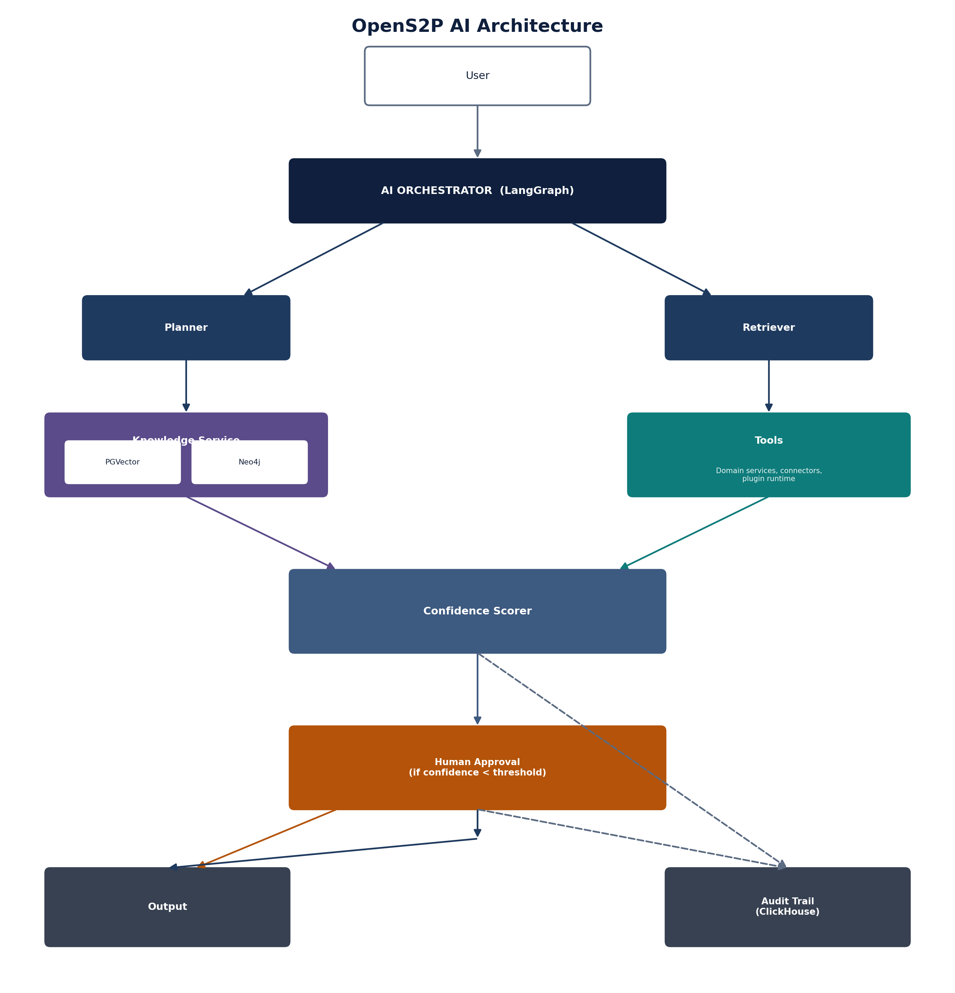
Figure 10.2 — OpenS2P AI Architecture

11. Knowledge Service

11.1 Service Overview
Domain | Knowledge Management
Owning Team | AI Platform Team
Primary Responsibility | Document indexing, semantic search, organisational memory

11.2 Core Components

11.2.1 Document Indexing
TYPESCRIPT
interface Document {
id: UUID;
source: DocumentSource;
type: DocumentType;
title: string;
content: string;
metadata: DocumentMetadata;
embeddings?: Embedding[];
status: 'PENDING' | 'INDEXED' | 'FAILED';
createdAt: Date;
updatedAt: Date;
}

type DocumentSource =
| 'CONTRACT'
| 'INVOICE'
| 'PO'
| 'SUPPLIER_PROFILE'
| 'POLICY'
| 'REGULATION'
| 'EMAIL'
| 'NOTE'
| 'UPLOADED';

interface DocumentMetadata {
tenantId: string;
ownerId: UUID;
departmentId: UUID;
tags: string[];
classification: DataClassification;
sourceId: string; // Original entity ID
sourceType: string;
version: number;
processedAt: Date;
}

interface Embedding {
id: UUID;
chunkId: UUID;
embedding: number[];
metadata: Record<string, any>;
}

11.2.2 Search
TYPESCRIPT
interface SearchRequest {
query: string;
filters?: SearchFilter[];
limit?: number;
minScore?: number;
searchType?: 'SEMANTIC' | 'KEYWORD' | 'HYBRID';
}

interface SearchResult {
documents: SearchHit[];
total: number;
took: number;
}

interface SearchHit {
documentId: UUID;
score: number;
content: string;
metadata: DocumentMetadata;
highlights: string[];
}

11.3 Implementation
TYPESCRIPT
// services/knowledge/src/application/search/SearchService.ts

import { EmbeddingService } from './EmbeddingService';
import { VectorStore } from '../infrastructure/vector/VectorStore';

export class SearchService {
private embeddingService: EmbeddingService;
private vectorStore: VectorStore;
private elasticsearch: ElasticsearchClient;

/**
* Execute hybrid search
*/
async search(request: SearchRequest): Promise<SearchResult> {
const [semanticResults, keywordResults] = await Promise.all([
this.semanticSearch(request),
this.keywordSearch(request)
]);

// Merge and rank results
return this.mergeResults(semanticResults, keywordResults, request);
}

private async semanticSearch(request: SearchRequest): Promise<SearchHit[]> {
const embedding = await this.embeddingService.embed(request.query);
const results = await this.vectorStore.search(embedding, {
filter: request.filters,
limit: request.limit || 20
});

return results.map(r => ({
documentId: r.id,
score: r.score,
content: r.content,
metadata: r.metadata,
highlights: []
}));
}

private async keywordSearch(request: SearchRequest): Promise<SearchHit[]> {
const results = await this.elasticsearch.search({
index: 'documents',
body: {
query: {
bool: {
must: [
{ match: { content: request.query } }
],
filter: this.buildFilters(request.filters)
}
},
size: request.limit || 20
}
});

return results.hits.hits.map(hit => ({
documentId: hit._id,
score: hit._score,
content: hit._source.content,
metadata: hit._source.metadata,
highlights: hit.highlight?.content || []
}));
}

private mergeResults(
semantic: SearchHit[],
keyword: SearchHit[],
request: SearchRequest
): SearchResult {
// Reciprocal Rank Fusion (RRF)
const scores: Map<string, number> = new Map();
const documents: Map<string, SearchHit> = new Map();

for (const [rank, result] of semantic.entries()) {
const id = result.documentId;
scores.set(id, (scores.get(id) || 0) + 1 / (rank + 60));
documents.set(id, result);
}

for (const [rank, result] of keyword.entries()) {
const id = result.documentId;
scores.set(id, (scores.get(id) || 0) + 1 / (rank + 60));
if (!documents.has(id)) {
documents.set(id, result);
}
}

// Sort by combined score
const combined = Array.from(scores.entries())
.sort((a, b) => b[1] - a[1])
.map(([id, score]) => ({
...documents.get(id)!,
score
}));

return {
documents: combined.slice(0, request.limit || 20),
total: combined.length,
took: 0 // Calculate actual time
};
}
}

11.4 Embedding Pipeline
TYPESCRIPT
// services/knowledge/src/application/indexing/EmbeddingPipeline.ts

export class EmbeddingPipeline {
private embeddingService: EmbeddingService;
private vectorStore: VectorStore;
private chunkingService: ChunkingService;

/**
* Process a document for embedding
*/
async indexDocument(document: Document): Promise<void> {
// 1. Chunk the document
const chunks = await this.chunkingService.chunk(document.content, {
chunkSize: 512,
overlap: 50,
minSize: 100
});

// 2. Generate embeddings
const embeddings = await this.embeddingService.embedBatch(
chunks.map(c => c.content)
);

// 3. Store in vector store
await this.vectorStore.upsert(
chunks.map((chunk, index) => ({
id: chunk.id,
content: chunk.content,
embedding: embeddings[index],
metadata: {
...document.metadata,
chunkIndex: index,
totalChunks: chunks.length
}
}))
);

// 4. Update document status
await this.updateDocumentStatus(document.id, 'INDEXED');
}

/**
* Refresh embeddings for changed documents
*/
async refreshEmbeddings(documentId: UUID): Promise<void> {
const document = await this.getDocument(documentId);
if (!document) {
throw new Error(`Document ${documentId} not found`);
}

// Delete old embeddings
await this.vectorStore.delete(documentId);

// Re-index
await this.indexDocument(document);
}
}

12. Plugin Runtime

12.1 Service Overview
Domain | Plugin Execution
Owning Team | Platform Team
Primary Responsibility | Plugin sandbox execution, capability enforcement, resource isolation

12.2 Core Components

12.2.1 Plugin Manifest
TYPESCRIPT
interface PluginManifest {
id: UUID;
name: string;
version: string; // SemVer
description: string;
publisher: PublisherInfo;
capabilities: CapabilityDeclaration[];
requirements: PluginRequirement[];
permissions: PermissionDeclaration[];
signature: PluginSignature;
platformCompatibility: string; // SemVer range
createdAt: Date;
updatedAt: Date;
}

interface CapabilityDeclaration {
type: 'TOOL' | 'WIDGET' | 'WORKFLOW_STEP' | 'APPROVAL_LOGIC' | 'INTEGRATION';
name: string;
description: string;
entrypoint: string;
parameters: JSONSchema;
}

interface PermissionDeclaration {
resource: string;
actions: ('READ' | 'WRITE' | 'EXECUTE')[];
scope: 'TENANT' | 'USER' | 'SYSTEM';
}

interface PluginRequirement {
type: 'STORAGE' | 'NETWORK' | 'MEMORY' | 'CPU';
value: number | string;
}

12.2.2 Plugin Execution
TYPESCRIPT
interface PluginExecutionRequest {
pluginId: UUID;
capability: string;
input: Record<string, any>;
context: ExecutionContext;
timeout: number; // milliseconds
}

interface PluginExecutionResult {
success: boolean;
output: Record<string, any>;
executionTime: number;
memoryUsed: number;
errors?: PluginError[];
}

12.3 Wasm Sandbox Implementation
TYPESCRIPT
// services/plugin-runtime/src/infrastructure/sandbox/WasmSandbox.ts

import { WasmRuntime, WasmInstance } from '@opens2p/wasm-runtime';

export class WasmSandbox {
private runtime: WasmRuntime;
private memoryLimit: number = 256 * 1024 * 1024; // 256MB
private cpuLimit: number = 10000; // 10 seconds
private allowedEgress: Set<string> = new Set();

/**
* Execute a plugin in the Wasm sandbox
*/
async execute(request: PluginExecutionRequest): Promise<PluginExecutionResult> {
const startTime = Date.now();

// 1. Load plugin
const plugin = await this.loadPlugin(request.pluginId);
const instance = await this.createInstance(plugin, request);

// 2. Validate permissions
await this.validatePermissions(plugin, request);

// 3. Execute with timeout
const result = await this.runWithTimeout(instance, request, this.cpuLimit);

const executionTime = Date.now() - startTime;

return {
success: result.success,
output: result.output,
executionTime,
memoryUsed: instance.getMemoryUsage(),
errors: result.errors
};
}

private async createInstance(
plugin: Plugin,
request: PluginExecutionRequest
): Promise<WasmInstance> {
// Configure Wasm instance with permissions
return this.runtime.createInstance({
module: plugin.wasmModule,
memory: {
maxPages: Math.ceil(this.memoryLimit / 65536)
},
imports: {
// Provide limited host functions
'host': {
'log': (message: string) => {
// Cap log size
},
'http_request': (url: string, method: string, body: Uint8Array) => {
// Validate URL against allowed egress
if (!this.isAllowedEgress(url)) {
throw new Error(`Egress to ${url} not allowed`);
}
// Execute HTTP request with timeout
return this.executeHttpRequest(url, method, body);
}
}
}
});
}

private async runWithTimeout(
instance: WasmInstance,
request: PluginExecutionRequest,
timeoutMs: number
): Promise<PluginResult> {
return new Promise((resolve, reject) => {
const timeout = setTimeout(() => {
instance.terminate();
reject(new Error('Plugin execution timed out'));
}, timeoutMs);

try {
const result = instance.execute(request.capability, request.input);
clearTimeout(timeout);
resolve(result);
} catch (error) {
clearTimeout(timeout);
reject(error);
}
});
}

private isAllowedEgress(url: string): boolean {
// Check against declared egress URLs
for (const allowed of this.allowedEgress) {
if (url.startsWith(allowed)) {
return true;
}
}
return false;
}
}

13. Connector Runtime

13.1 Service Overview
Domain | Integration
Owning Team | Platform Team
Primary Responsibility | External system integration, adapter management, data transformation

13.2 Core Components

13.2.1 Connector Configuration
TYPESCRIPT
interface ConnectorConfig {
id: UUID;
name: string;
type: ConnectorType;
version: string;
description: string;
protocol: 'HTTP' | 'SOAP' | 'JDBC' | 'FILE' | 'MQ' | 'EMAIL';
config: Record<string, any>;
credentials: CredentialReference;
rateLimit: RateLimitConfig;
retryPolicy: RetryPolicy;
mapping: DataMapping[];
status: 'DRAFT' | 'ACTIVE' | 'ERROR' | 'DISABLED';
createdAt: Date;
updatedAt: Date;
}

type ConnectorType =
| 'ERP' // SAP, Oracle, Microsoft
| 'CRM' // Salesforce, HubSpot
| 'SUPPLIER' // Supplier portals
| 'PAYMENT' // Payment rails
| 'BANK' // Banking systems
| 'REGULATORY' // Sanctions, AML
| 'CREDIT' // Credit bureaus
| 'DOCUMENT' // Document management
| 'WORKFLOW' // External workflow engines;

interface DataMapping {
sourceField: string;
targetField: string;
transformation: 'COPY' | 'MAP' | 'CONCAT' | 'SPLIT' | 'FORMAT' | 'CUSTOM';
defaultValue?: any;
required: boolean;
}

13.2.2 Connector Execution
TYPESCRIPT
interface ConnectorRequest {
connectorId: UUID;
operation: 'READ' | 'WRITE' | 'EXECUTE' | 'POLL' | 'SUBSCRIBE';
payload: Record<string, any>;
options: RequestOptions;
}

interface ConnectorResponse {
success: boolean;
data: any;
statusCode: number;
headers: Record<string, string>;
duration: number;
errors?: ConnectorError[];
}

13.3 Implementation
TYPESCRIPT
// services/connector-runtime/src/application/ConnectorService.ts

export class ConnectorService {
private connectorRegistry: ConnectorRegistry;
private credentialService: CredentialService;
private rateLimiter: RateLimiter;
private retryHandler: RetryHandler;

/**
* Execute a connector request
*/
async execute(request: ConnectorRequest): Promise<ConnectorResponse> {
const connector = await this.connectorRegistry.findById(request.connectorId);
if (!connector) {
throw new ConnectorError('CONNECTOR_NOT_FOUND', `Connector ${request.connectorId} not found`);
}

// Get credentials
const credentials = await this.credentialService.getCredentials(connector.credentials);

// Build adapter
const adapter = this.buildAdapter(connector);

// Rate limiting
await this.rateLimiter.check(connector.rateLimit);

// Execute with retry
const response = await this.retryHandler.execute(
() => adapter.execute(request, credentials),
connector.retryPolicy
);

// Transform response
const transformedData = this.transformResponse(response.data, connector.mapping);

return {
success: true,
data: transformedData,
statusCode: response.statusCode,
headers: response.headers,
duration: response.duration
};
}

private buildAdapter(connector: ConnectorConfig): ConnectorAdapter {
switch (connector.protocol) {
case 'HTTP':
return new HttpAdapter(connector.config);
case 'SOAP':
return new SoapAdapter(connector.config);
case 'JDBC':
return new JdbcAdapter(connector.config);
case 'FILE':
return new FileAdapter(connector.config);
default:
throw new ConnectorError('UNSUPPORTED_PROTOCOL', `Protocol ${connector.protocol} not supported`);
}
}
}

14. Marketplace Service

14.1 Service Overview
Domain | Plugin Marketplace
Owning Team | Platform Team
Primary Responsibility | Plugin publication, trust services, distribution, tenant installation

14.2 Core Components

14.2.1 Plugin Publication
TYPESCRIPT
interface PluginSubmission {
id: UUID;
pluginId: UUID;
publisherId: UUID;
manifest: PluginManifest;
packageUrl: string;
checksum: string;
status: 'SUBMITTED' | 'REVIEWING' | 'SCANNING' | 'APPROVED' | 'REJECTED' | 'PUBLISHED';
reviews: ReviewRecord[];
securityScan: SecurityScanResult;
submittedAt: Date;
updatedAt: Date;
}

interface SecurityScanResult {
status: 'PASSED' | 'FAILED' | 'WARNING';
issues: SecurityIssue[];
score: number;
scannedAt: Date;
}

interface SecurityIssue {
id: string;
severity: 'CRITICAL' | 'HIGH' | 'MEDIUM' | 'LOW';
type: 'VULNERABILITY' | 'MALWARE' | 'SECURITY' | 'CODE_QUALITY';
description: string;
recommendation: string;
cveReference?: string;
}

14.2.2 Trust Model
TYPESCRIPT
interface TrustEvaluation {
pluginId: UUID;
overallScore: number;
scores: {
codeQuality: number;
security: number;
reliability: number;
publisherReputation: number;
communityTrust: number;
};
trustTier: 'GOLD' | 'SILVER' | 'BRONZE' | 'UNTRUSTED';
evaluations: EvaluationRecord[];
expiresAt: Date;
}

14.3 Signing, Versioning & Dependency Resolution
This section covers the parts of the plugin lifecycle not shown in the publication and trust-model code in 14.2: how a package is verified as untampered, how plugin versions are resolved against a manifest's declared dependencies, and where billing fits (or doesn't yet).
- Signing: each published plugin package is signed by the publisher's registered key at submission time; the Marketplace verifies the signature (not just the checksum shown in 14.2) before a plugin can move from SCANNING to APPROVED, and the Plugin Runtime re-verifies the signature at install time on the tenant's cluster.
- Version management: plugins follow semantic versioning; a tenant installs a version range (e.g. ^2.1.0), and the Marketplace resolves the highest compatible published version at install and upgrade time.
- Dependency resolution: a plugin manifest declares its required OpenS2P API capabilities and minimum platform version; the Marketplace rejects installation if the target tenant's platform version doesn't satisfy the manifest, rather than allowing a runtime failure.
- Billing: not yet implemented. The PluginSubmission and trust-tier model in 14.2 are billing-agnostic by design so a billing layer (usage-based or listing-fee) can be added later without a schema migration, but no billing component exists in this version of the platform.

15. Identity Service

15.1 Service Overview
Domain | Identity Management
Owning Team | Platform Team
Primary Responsibility | Authentication, session management, user provisioning

15.2 Core Components

15.2.1 User Schema
TYPESCRIPT
interface User {
id: UUID;
username: string;
email: string;
firstName: string;
lastName: string;
tenantId: string;
roles: string[];
groups: string[];
attributes: Record<string, any>;
status: 'ACTIVE' | 'INACTIVE' | 'LOCKED';
lastLogin: Date;
createdAt: Date;
updatedAt: Date;
}

15.2.2 JWT Claims
TYPESCRIPT
interface JWTClaims {
sub: string; // User ID
iss: string; // Issuer
aud: string[]; // Audience
exp: number; // Expiry
iat: number; // Issued at
tenant: string;
roles: string[];
groups: string[];
permissions: string[];
name: string;
email: string;
}

15.3 Integration with Keycloak
TYPESCRIPT
// services/identity/src/infrastructure/keycloak/KeycloakService.ts

export class KeycloakService {
private adminClient: KeycloakAdminClient;

/**
* Create user in Keycloak
*/
async createUser(user: User): Promise<User> {
const keycloakUser = {
username: user.username,
email: user.email,
firstName: user.firstName,
lastName: user.lastName,
enabled: true,
attributes: {
tenantId: user.tenantId
}
};

const id = await this.adminClient.users.create(keycloakUser);

// Assign roles
await this.adminClient.users.addRealmRoleMappings({
id: id.id,
roles: user.roles.map(role => ({ name: role }))
});

return {
...user,
id: id.id
};
}

/**
* Validate JWT token
*/
async validateToken(token: string): Promise<JWTClaims> {
const payload = await this.adminClient.jwt.verify(token);
return {
sub: payload.sub,
iss: payload.iss,
aud: payload.aud,
exp: payload.exp,
iat: payload.iat,
tenant: payload.tenant,
roles: payload.realm_access?.roles || [],
groups: payload.groups || [],
permissions: payload.permissions || [],
name: payload.name,
email: payload.email
};
}
}

16. Notification Service

16.1 Service Overview
Domain | Notification Management
Owning Team | Platform Team
Primary Responsibility | Email, webhook, internal notifications

16.2 Core Components
TYPESCRIPT
interface Notification {
id: UUID;
type: 'EMAIL' | 'WEBHOOK' | 'PUSH' | 'SMS';
recipient: string | string[];
subject: string;
body: string;
template?: string;
data: Record<string, any>;
priority: 'LOW' | 'MEDIUM' | 'HIGH';
status: 'PENDING' | 'SENT' | 'FAILED';
attempts: number;
createdAt: Date;
sentAt?: Date;
}

17. Search Service

17.1 Service Overview
Domain | Global Search
Owning Team | Platform Team
Primary Responsibility | Unified search across all domains

17.2 Core Components
TYPESCRIPT
interface GlobalSearchRequest {
query: string;
types?: DocumentType[];
filters?: SearchFilter[];
sort?: SearchSort;
limit?: number;
offset?: number;
}

interface GlobalSearchResult {
hits: SearchHit[];
total: number;
facets: SearchFacet[];
took: number;
}

interface SearchHit {
id: UUID;
type: DocumentType;
title: string;
content: string;
score: number;
highlights: string[];
metadata: Record<string, any>;
url: string;
}

18. Data Model

18.1 Core Schema Definitions

18.1.1 Base Types
SQL
-- Infrastructure: shared base types
CREATE TYPE data_classification AS ENUM (
'PUBLIC',
'INTERNAL',
'CONFIDENTIAL',
'RESTRICTED'
);

CREATE TYPE approval_status AS ENUM (
'PENDING',
'APPROVED',
'REJECTED',
'REVIEWING'
);

CREATE TYPE user_reference AS (
id UUID,
name VARCHAR(255),
email VARCHAR(255)
);

18.1.2 Audit Log
SQL
-- ClickHouse audit table
CREATE TABLE audit_log (
timestamp DateTime64(9) DEFAULT now64(9),
event_type String,
tenant_id String,
user_id UUID,
session_id UUID,
correlation_id UUID,
trace_id String,
service_name String,
action String,
resource_type String,
resource_id UUID,
request_id String,
ip_address String,
user_agent String,
payload String,
status_code UInt16,
duration_ms UInt32,
is_error UInt8,
error_code String,
error_message String
) ENGINE = MergeTree()
ORDER BY (timestamp, tenant_id, event_type)
PARTITION BY toYYYYMM(timestamp)
TTL timestamp + INTERVAL 7 YEAR;

18.2 Schema-per-Tenant Implementation
SQL
-- Tenant isolation via schema per tenant
CREATE SCHEMA IF NOT EXISTS tenant_${TENANT_ID};

SET search_path TO tenant_${TENANT_ID};

-- Tables within tenant schema
CREATE TABLE sourcing_events ( ... );
CREATE TABLE purchase_requisitions ( ... );
-- etc.

19. APIs

19.1 API Design Standards

19.1.1 REST Standards
Aspect | Standard
URL Structure | /api/v{major}/{resource}
HTTP Methods | GET, POST, PUT, PATCH, DELETE
Status Codes | Standard HTTP semantics
Versioning | Path-based: /api/v1/
Pagination | limit, offset, total
Filtering | Query parameters
Sorting | sort parameter
Fields | fields for partial responses

19.1.2 Common Response Format
TYPESCRIPT
interface ApiResponse<T> {
data: T;
metadata: {
timestamp: string;
requestId: string;
version: string;
};
links?: {
self: string;
next?: string;
prev?: string;
};
}

interface ApiError {
error: {
code: string;
message: string;
details?: Record<string, any>;
timestamp: string;
requestId: string;
};
}

19.1.3 Error Codes by Service
Service | Prefix | Example
Sourcing | SRC | SRC-001: Event not found
Supplier | SUP | SUP-002: Supplier already exists
Contract | CTR | CTR-003: Contract expired
Purchasing | PUR | PUR-004: PO not found
Invoice | INV | INV-005: Three-way match failed
Workflow | WKF | WKF-006: Workflow not found
AI | AI | AI-007: Evaluation failed
Plugin | PLG | PLG-008: Plugin not signed
Connector | CON | CON-009: Connection failed

19.2.1 Gateway Responsibilities
- Authentication: validates the JWT on every request (27.1); requests without a valid token are rejected at the edge, never forwarded.
- Authorisation (coarse-grained): confirms the token's tenant and role claims are present and well-formed; fine-grained resource-level authorisation is delegated to OPA at the service (27.2) — the Gateway doesn't duplicate that logic.
- Rate limiting & throttling: per-tenant and per-route limits (see the rateLimit block in the routes configuration below) protect downstream services from both abuse and accidental overload.
- API versioning: routes requests to the correct service version per the v{major}.{minor} scheme (1.3), and attaches Deprecation/Sunset headers per the policy in 19.4.
- Request validation: rejects malformed requests (schema validation against the OpenAPI spec) before they consume a domain service's resources.
- WAF (Web Application Firewall): filters common attack patterns (injection, malformed headers, oversized payloads) at the edge, ahead of authentication — the one check that runs before token validation, since it protects the auth path itself.
- Caching: caches responses for explicitly cacheable, read-only routes (e.g. Search, read-only Knowledge queries) to reduce load on domain services; write routes are never cached.
Before the routing configuration below, this is what the API Gateway is architecturally responsible for — the contract every service can rely on being enforced before a request ever reaches it.

19.2 API Gateway Configuration
YAML
infrastructure/kubernetes/gateway/routes.yaml
routes:
- path: /api/v1/sourcing
service: sourcing-service
port: 8080
methods: [GET, POST, PUT, PATCH, DELETE]
rateLimit:
requestsPerSecond: 100
burst: 200
cors:
allowedOrigins: ["https://*.opens2p.io"]
allowedMethods: ["GET", "POST", "PUT", "PATCH", "DELETE", "OPTIONS"]
allowedHeaders: ["Authorization", "Content-Type", "X-Request-Id"]

- path: /api/v1/supplier
service: supplier-service
port: 8081
methods: [GET, POST, PUT, PATCH]
rateLimit:
requestsPerSecond: 50
burst: 100

... similar for all services

19.3 API Catalog
A service-level summary of every REST API surface. This is a navigation aid, not a replacement for the OpenAPI specification of each service (referenced in that service's "API Specification" section), which remains the source of truth for request/response schemas, idempotency keys, and full error codes.
Service | Base Path | Auth | Version | Idempotency
Sourcing | /api/v1/sourcing | JWT + OPA | v1 | Yes — Idempotency-Key header on POST
Supplier | /api/v1/suppliers | JWT + OPA | v1 | Yes
Contract | /api/v1/contracts | JWT + OPA | v1 | Yes
Purchasing | /api/v1/purchasing | JWT + OPA | v1 | Yes
Receiving | /api/v1/receiving | JWT + OPA | v1 | Yes
Invoicing | /api/v1/invoicing | JWT + OPA | v1 | Yes
Payment | /api/v1/payments | JWT + OPA | v1 | Yes
Workflow Orchestrator | /api/v1/workflows | JWT + OPA | v1 | Yes
AI Orchestrator | /api/v1/ai | JWT + OPA | v1 | Yes (agent run ID)
Knowledge Service | /api/v1/knowledge | JWT + OPA | v1 | N/A (read-heavy)
Plugin Runtime | /api/v1/plugins | JWT + OPA | v1 | Yes
Connector Runtime | /api/v1/connectors | JWT + OPA | v1 | Yes
Marketplace | /api/v1/marketplace | JWT + OPA | v1 | Yes
Identity | /api/v1/identity | OIDC / JWT | v1 | N/A
Search | /api/v1/search | JWT + OPA | v1 | N/A (read-only)
Notification | /api/v1/notifications | JWT + OPA | v1 | Yes

19.4 Versioning & Deprecation Policy
All REST APIs follow the v{major}.{minor} convention set out in 1.3. This section adds the lifecycle rules that convention implies but doesn't spell out.
- A new major version is introduced only for breaking changes (removed fields, changed semantics, incompatible auth changes); additive changes ship as the same major version.
- A deprecated API version is supported for a minimum of 6 months after its replacement ships, with the deprecation date and sunset date both published in the OpenAPI spec's deprecated and x-sunset fields.
- Deprecated endpoints return a Deprecation and Sunset HTTP header (RFC 8594) so API consumers can detect deprecation programmatically, not just via changelog.
- Breaking changes are announced in the Technology Radar (see Related Documents) before the deprecation window starts, not at the start of it.

20. Events

20.1 Event Standards

20.1.1 Event Envelope
TYPESCRIPT
interface DomainEventEnvelope {
id: UUID;
type: string;
version: string;
tenantId: string;
correlationId: UUID;
causationId: UUID;
timestamp: string;
traceId: string;
payload: Record<string, any>;
metadata: Record<string, any>;
}

20.1.2 Kafka Topic Naming
CODE
{domain}-events

Examples:
- sourcing-events
- supplier-events
- contract-events
- purchasing-events
- invoice-events

20.1.3 Event Schema Evolution
YAML
Event schema evolution rules
schemaEvolution:
majorVersion:
- Backward incompatible
- Requires new topic
- Dual-publish period: 6 months
minorVersion:
- Backward compatible
- Optional new fields
- Deprecated fields marked with @deprecated
patchVersion:
- Documentation only
- No schema changes

20.2 Event Catalog
The complete list of domain events referenced throughout this document, consolidated in one place. This is the events counterpart to the API Catalog in 19.3 — a navigation aid backed by the AsyncAPI specification of each publishing service.
Event | Publisher | Primary Subscribers
SourcingEventPublished | Sourcing | Supplier
BidSubmitted | Sourcing | Sourcing (self), Notification
SourcingEventAwarded | Sourcing | Supplier, Purchasing, Contract
SupplierRegistered | Supplier | Workflow, Search
SupplierQualified | Supplier | Sourcing, Purchasing, Contract, Notification
SupplierSuspended | Supplier | Purchasing, Sourcing
ContractExecuted | Contract | Invoicing, Search
ContractExpired | Contract | Notification, Workflow
PurchaseRequisitionCreated | Purchasing | Workflow
PurchaseRequisitionApproved | Purchasing | Notification
PurchaseOrderIssued | Purchasing | Receiving, Invoicing, Supplier-facing Notification
GoodsReceiptRecorded | Receiving | Invoicing
InvoiceMatched | Invoicing | Payment
InvoiceApproved | Invoicing | Payment, Notification
PaymentScheduled | Payment | Notification
PaymentIssued | Payment | Invoicing, Notification
WorkflowStarted | Workflow Orchestrator | AI Orchestrator, Notification
WorkflowCompleted | Workflow Orchestrator | Originating domain service, Notification
AgentActionProposed | AI Orchestrator | Workflow Orchestrator
AgentActionApproved | AI Orchestrator | Originating domain service
PluginExecuted | Plugin Runtime | Audit / ClickHouse sink
ConnectorInvoked | Connector Runtime | Audit / ClickHouse sink

Every event name follows the {Aggregate}{Verb}ed convention from 1.3; if you're adding a new event, checking this table first is the fastest way to confirm it doesn't already exist under a slightly different name.

21. Error Handling

21.1 Error Hierarchy
TYPESCRIPT
// Base error
class OpenS2PError extends Error {
constructor(
public code: string,
message: string,
public details?: Record<string, any>
) {
super(message);
this.name = this.constructor.name;
}
}

// Domain errors
class DomainError extends OpenS2PError { }
class AggregateNotFoundError extends DomainError { }
class BusinessRuleViolationError extends DomainError { }

// Infrastructure errors
class InfrastructureError extends OpenS2PError { }
class DatabaseError extends InfrastructureError { }
class MessagingError extends InfrastructureError { }

// Security errors
class SecurityError extends OpenS2PError { }
class UnauthorisedError extends SecurityError { }
class ForbiddenError extends SecurityError { }

21.2 Error Handling Middleware
TYPESCRIPT
export function errorHandler(): ErrorRequestHandler {
return (err: Error, req: Request, res: Response, next: NextFunction) => {
// Log error
logger.error('Request error', {
error: err.message,
stack: err.stack,
code: err instanceof OpenS2PError ? err.code : 'INTERNAL_ERROR',
path: req.path,
method: req.method,
requestId: req.headers['x-request-id']
});

// Determine response
if (err instanceof OpenS2PError) {
const status = this.getStatusCode(err);
return res.status(status).json({
error: {
code: err.code,
message: err.message,
details: err.details,
timestamp: new Date().toISOString(),
requestId: req.headers['x-request-id']
}
});
}

// Generic error
return res.status(500).json({
error: {
code: 'INTERNAL_ERROR',
message: 'An unexpected error occurred',
timestamp: new Date().toISOString(),
requestId: req.headers['x-request-id']
}
});
};
}

22. Logging

22.1 Logging Standards

22.1.1 Structured Logging
TYPESCRIPT
// Use structured logging throughout
logger.info('Purchase order created', {
orderId: po.id,
orderNumber: po.orderNumber,
supplierId: po.supplierId,
totalAmount: po.totalAmount,
tenantId: context.tenantId,
userId: context.userId,
traceId: context.traceId
});

22.1.2 Log Levels
Level | Usage
ERROR | System errors, exceptions
WARN | Business rule violations, security events
INFO | Important business events, state changes
DEBUG | Detailed debugging information (not in production)
TRACE | Very detailed tracing (not in production)

22.1.3 Log Field Standards
TYPESCRIPT
interface LogEntry {
timestamp: string;
level: string;
service: string;
message: string;
// Common fields
tenantId?: string;
userId?: UUID;
correlationId?: UUID;
traceId?: string;
// Business fields
entityType?: string;
entityId?: UUID;
action?: string;
// Error fields
errorCode?: string;
errorStack?: string;
// Performance fields
durationMs?: number;
// Custom fields
[key: string]: any;
}

23. Monitoring

23.1 Observability Stack
Component | Technology | Purpose
Metrics | Prometheus | Time-series metrics collection
Traces | OpenTelemetry | Distributed tracing
Logs | Loki | Log aggregation
Visualisation | Grafana | Dashboards and alerting
Alerting | AlertManager | Alert routing

23.2 Key Metrics

23.2.1 Service Metrics
YAML
metrics:
Request metrics
- name: http_requests_total
type: counter
labels: [service, method, path, status]
- name: http_request_duration_seconds
type: histogram
labels: [service, method, path]
- name: http_requests_in_flight
type: gauge
labels: [service]

Business metrics
- name: orders_created_total
type: counter
labels: [service, type]
- name: orders_processing_time_seconds
type: histogram
labels: [service]

AI metrics
- name: ai_invocations_total
type: counter
labels: [agent, model, success]
- name: ai_confidence_score
type: gauge
labels: [agent]
- name: ai_hallucination_rate
type: gauge
labels: [agent]
- name: ai_token_usage_total
type: counter
labels: [agent, model, type]

23.2.2 Infrastructure Metrics
YAML
infrastructure_metrics:
- name: kubernetes_pod_status
type: gauge
labels: [namespace, pod, status]
- name: kubernetes_node_cpu_usage
type: gauge
labels: [node]
- name: kubernetes_node_memory_usage
type: gauge
labels: [node]
- name: kafka_consumer_lag
type: gauge
labels: [topic, consumer_group]
- name: database_connections
type: gauge
labels: [database, pool]

23.3 Alerting Rules
YAML
Prometheus alert rules
groups:
- name: service_alerts
rules:
- alert: HighErrorRate
expr: rate(http_requests_total{status=~"5.."}[5m]) / rate(http_requests_total[5m]) > 0.05
for: 5m
labels:
severity: critical
annotations:
summary: "High error rate on {{ $labels.service }}"
description: "Error rate is {{ $value }} for {{ $labels.service }}"

- alert: ServiceDown
expr: up{service!="identity"} == 0
for: 1m
labels:
severity: critical
annotations:
summary: "Service {{ $labels.service }} is down"
description: "Service has been down for {{ $value }} minutes"

- alert: AILatencyHigh
expr: histogram_quantile(0.95, rate(ai_invocation_duration_seconds_bucket[5m])) > 30
for: 5m
labels:
severity: warning
annotations:
summary: "High AI latency on {{ $labels.agent }}"
description: "p95 latency is {{ $value }}s"

- alert: KafkaConsumerLag
expr: kafka_consumer_lag > 10000
for: 5m
labels:
severity: warning
annotations:
summary: "High Kafka consumer lag"
description: "Consumer lag is {{ $value }} for topic {{ $labels.topic }}"

24. Performance

24.1 Performance Targets
Metric | Target | Measurement
API p95 Latency | < 400ms | HTTP requests
API p99 Latency | < 1s | HTTP requests
AI Agent p95 Latency | < 30s | Agent invocations
Database Query p99 | < 100ms | SQL queries
Event Processing | < 100ms | Kafka consumers
Plugin Startup | < 1s | Wasm instances
Page Load | < 2s | UI requests

24.2 Performance Testing
TYPESCRIPT
// k6 load test script
import http from 'k6/http';
import { check, sleep } from 'k6';

export const options = {
stages: [
{ duration: '2m', target: 100 }, // Ramp up
{ duration: '5m', target: 100 }, // Steady state
{ duration: '2m', target: 200 }, // Spike
{ duration: '5m', target: 200 }, // Steady state
{ duration: '2m', target: 0 }, // Ramp down
],
thresholds: {
http_req_duration: ['p(95)<400'],
http_req_failed: ['rate<0.01'],
},
};

export default function () {
const url = `http://purchasing-service:8080/api/v1/purchase-orders`;

const response = http.get(url, {
headers: {
Authorization: `Bearer ${__ENV.JWT_TOKEN}`,
'X-Request-Id': `${Date.now()}-${Math.random()}`,
},
});

check(response, {
'status is 200': (r) => r.status === 200,
'response time < 400ms': (r) => r.timings.duration < 400,
});

sleep(1);
}

24.3 Scaling Guidelines
Component | Scaling Strategy
API Services | Horizontal pod autoscaling
Kafka | Partition count = max consumers
PostgreSQL | Read replicas for queries
ClickHouse | Distributed cluster
Neo4j | Read replicas for queries
Redis | Cluster mode for cache
AI GPU Pool | Horizontal scaling with GPU nodes
Plugin Runtime | Horizontal scaling for Wasm

24.4 Performance Budgets by Service
The platform-wide targets in 24.1 apply as a floor; some services have materially different latency and throughput profiles by nature of what they do (e.g. AI inference vs. a simple CRUD lookup), so this table sets service-specific budgets. These are design targets to validate under load testing (24.2), not measured production numbers.
Service | p95 Latency Target | Throughput Target
Purchasing | 200 ms | 500 req/s
Sourcing | 250 ms | 300 req/s
Supplier | 200 ms | 300 req/s
Contract | 300 ms | 150 req/s
Receiving | 200 ms | 400 req/s
Invoicing | 300 ms | 300 req/s
Payment | 300 ms | 200 req/s
Knowledge Service (hybrid search) | 1.5 s | 100 searches/s
AI Orchestrator (agent run) | 30 s | 50 concurrent runs
Identity Service (token validation) | 50 ms | 2000 req/s

25. Deployment

25.1 Container Configuration
DOCKERFILE
Multi-stage Dockerfile
FROM node:20-slim AS builder
WORKDIR /app
COPY package*.json ./
RUN npm ci --only=production
COPY . .
RUN npm run build

FROM gcr.io/distroless/nodejs20-debian12
WORKDIR /app
COPY --from=builder /app/dist ./dist
COPY --from=builder /app/node_modules ./node_modules
USER nonroot
EXPOSE 8080
CMD ["dist/index.js"]

25.2 Kubernetes Deployment
YAML
services/purchasing/helm/templates/deployment.yaml
apiVersion: apps/v1
kind: Deployment
metadata:
name: purchasing-service
namespace: opens2p
spec:
replicas: 3
selector:
matchLabels:
app: purchasing-service
strategy:
type: RollingUpdate
rollingUpdate:
maxUnavailable: 0
maxSurge: 1
template:
metadata:
labels:
app: purchasing-service
annotations:
prometheus.io/scrape: "true"
prometheus.io/port: "8080"
prometheus.io/path: "/metrics"
spec:
containers:
- name: purchasing-service
image: registry.opens2p.io/purchasing-service:{{ .Values.image.tag }}
ports:
- containerPort: 8080
name: http
env:
- name: DATABASE_URL
valueFrom:
secretKeyRef:
name: purchasing-db-secret
key: url
- name: KAFKA_BROKERS
value: "kafka-cluster.opens2p.svc:9092"
- name: REDIS_URL
value: "redis-cluster.opens2p.svc:6379"
- name: OTEL_ENDPOINT
value: "otel-collector.opens2p.svc:4317"
- name: LOG_LEVEL
value: "{{ .Values.logLevel }}"
resources:
requests:
memory: "256Mi"
cpu: "250m"
limits:
memory: "512Mi"
cpu: "500m"
livenessProbe:
httpGet:
path: /health
port: 8080
initialDelaySeconds: 30
periodSeconds: 10
readinessProbe:
httpGet:
path: /ready
port: 8080
initialDelaySeconds: 10
periodSeconds: 5
securityContext:
allowPrivilegeEscalation: false
runAsUser: 1000
runAsGroup: 1000
readOnlyRootFilesystem: true
serviceAccountName: purchasing-service
securityContext:
fsGroup: 1000

25.3 Helm Values
YAML
services/purchasing/helm/values.yaml
image:
repository: registry.opens2p.io/purchasing-service
tag: latest
pullPolicy: IfNotPresent

replicas: 3
logLevel: info

database:
host: postgres-primary
port: 5432
database: opens2p
maxConnections: 20

kafka:
brokers: kafka-cluster:9092
consumerGroup: purchasing-service

redis:
host: redis-cluster
port: 6379

resources:
requests:
memory: 256Mi
cpu: 250m
limits:
memory: 512Mi
cpu: 500m

autoscaling:
enabled: true
minReplicas: 3
maxReplicas: 10
targetCPUUtilizationPercentage: 70
targetMemoryUtilizationPercentage: 80

service:
type: ClusterIP
port: 8080
targetPort: 8080

ingress:
enabled: false

monitoring:
enabled: true
serviceMonitor:
enabled: true
interval: 30s

25.4 Environment Profiles
YAML
values-dev.yaml
replicas: 1
logLevel: debug
resources:
requests:
memory: 128Mi
cpu: 100m
limits:
memory: 256Mi
cpu: 200m
autoscaling:
enabled: false

values-staging.yaml
replicas: 2
logLevel: info
resources:
requests:
memory: 256Mi
cpu: 200m
limits:
memory: 512Mi
cpu: 500m
autoscaling:
enabled: true
minReplicas: 2
maxReplicas: 5

values-prod.yaml
replicas: 3
logLevel: info
resources:
requests:
memory: 256Mi
cpu: 250m
limits:
memory: 512Mi
cpu: 500m
autoscaling:
enabled: true
minReplicas: 3
maxReplicas: 10
targetCPUUtilizationPercentage: 70

25.5 Deployment Topology
For the visual end-to-end deployment topology — ingress through to the managed data tier — see Figure 26.4 (C4 Deployment Diagram) in Section 26.4, which is the canonical topology diagram for the platform rather than duplicating it here.

26. C4 Architecture Views
This chapter presents OpenS2P using the full C4 model — Context, Container, Component, and Deployment — to complement the layered views in Section 2.

26.1 Level 1 — System Context
The context diagram shows OpenS2P as a single system, the people who use it, and the external systems it integrates with. Actor and integration categories are illustrative of the platform's intended footprint; specific external system names (e.g. a given ERP or payment provider) are determined per deployment via the Connector Runtime.
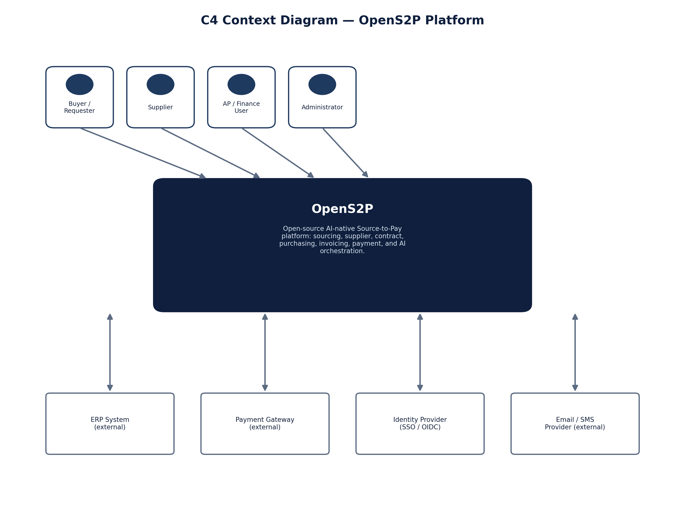
Figure 26.1 — C4 Context Diagram

26.2 Level 2 — Containers
The container diagram decomposes OpenS2P into its independently deployable units and the data stores each depends on, annotated with representative technology choices.
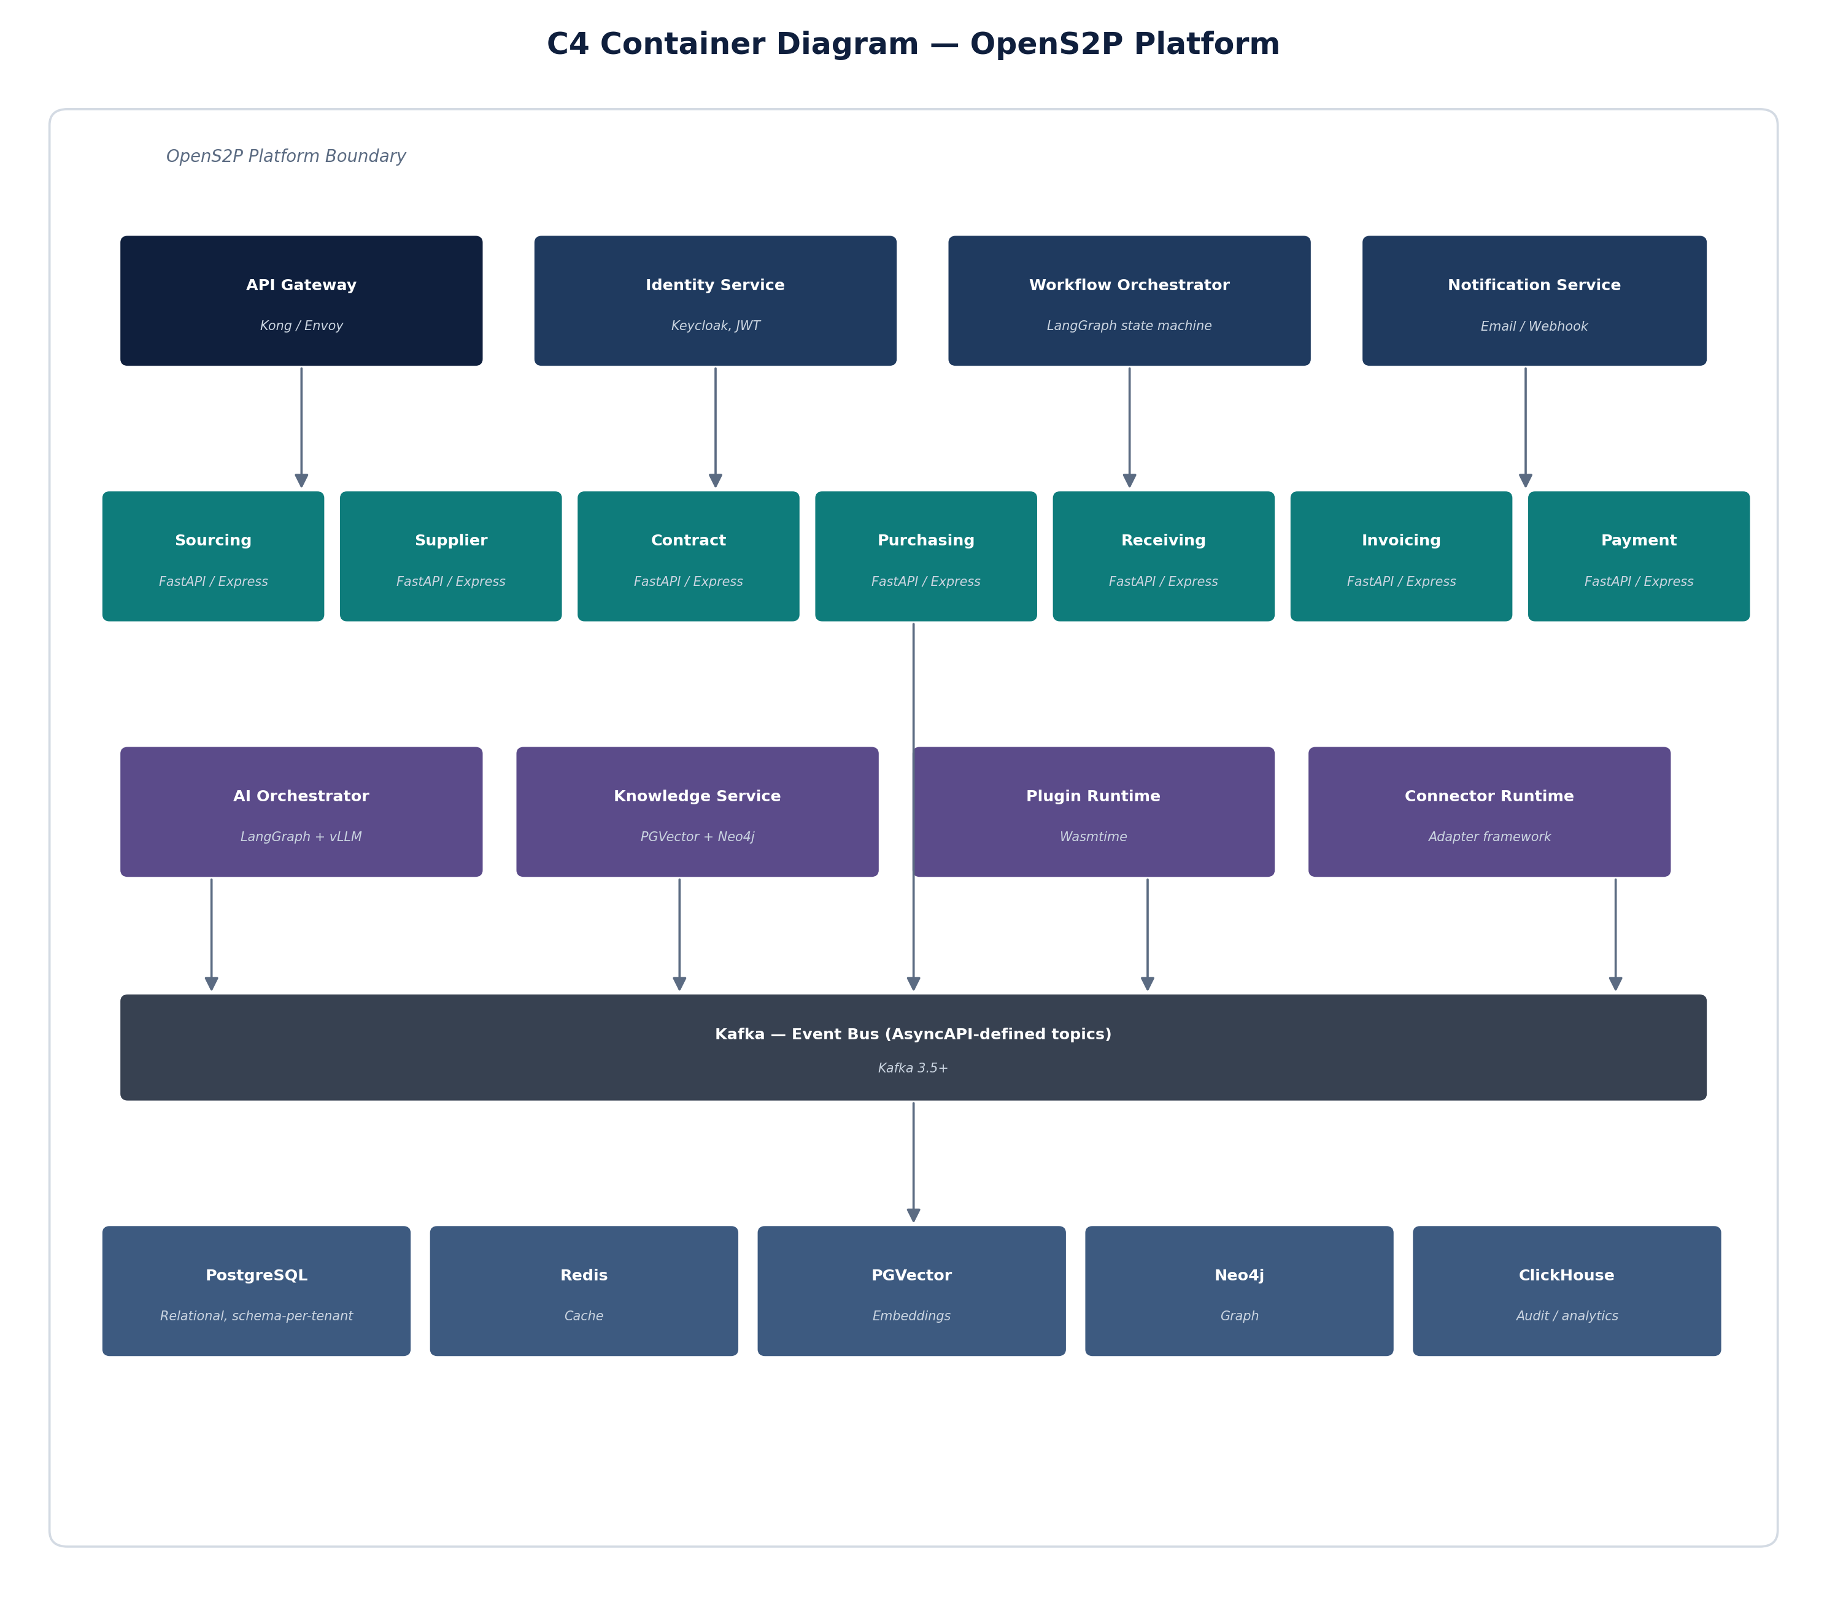
Figure 26.2 — C4 Container Diagram

26.3 Level 3 — Components
Rather than diagram all 16 services at component level, this section uses the Sourcing Service as a representative example — its internal structure (controllers, command/query handlers, aggregates, repositories) follows the same layered pattern used by every domain service in this document.
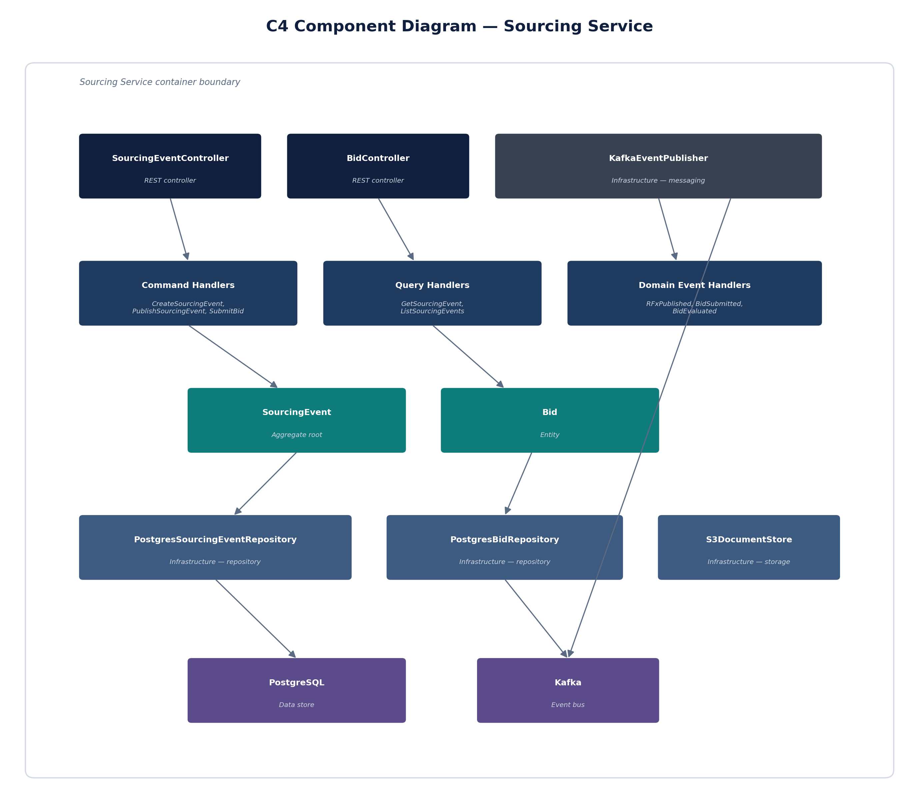
Figure 26.3 — C4 Component Diagram (Sourcing Service)

26.4 Level 4 — Deployment
The deployment diagram shows how containers map to Kubernetes: ingress and API Gateway at the edge, domain and AI/platform services grouped by namespace, Kafka as the event backbone, and the managed data tier. Section 25 (Deployment) covers the Helm and environment-profile detail behind this topology.
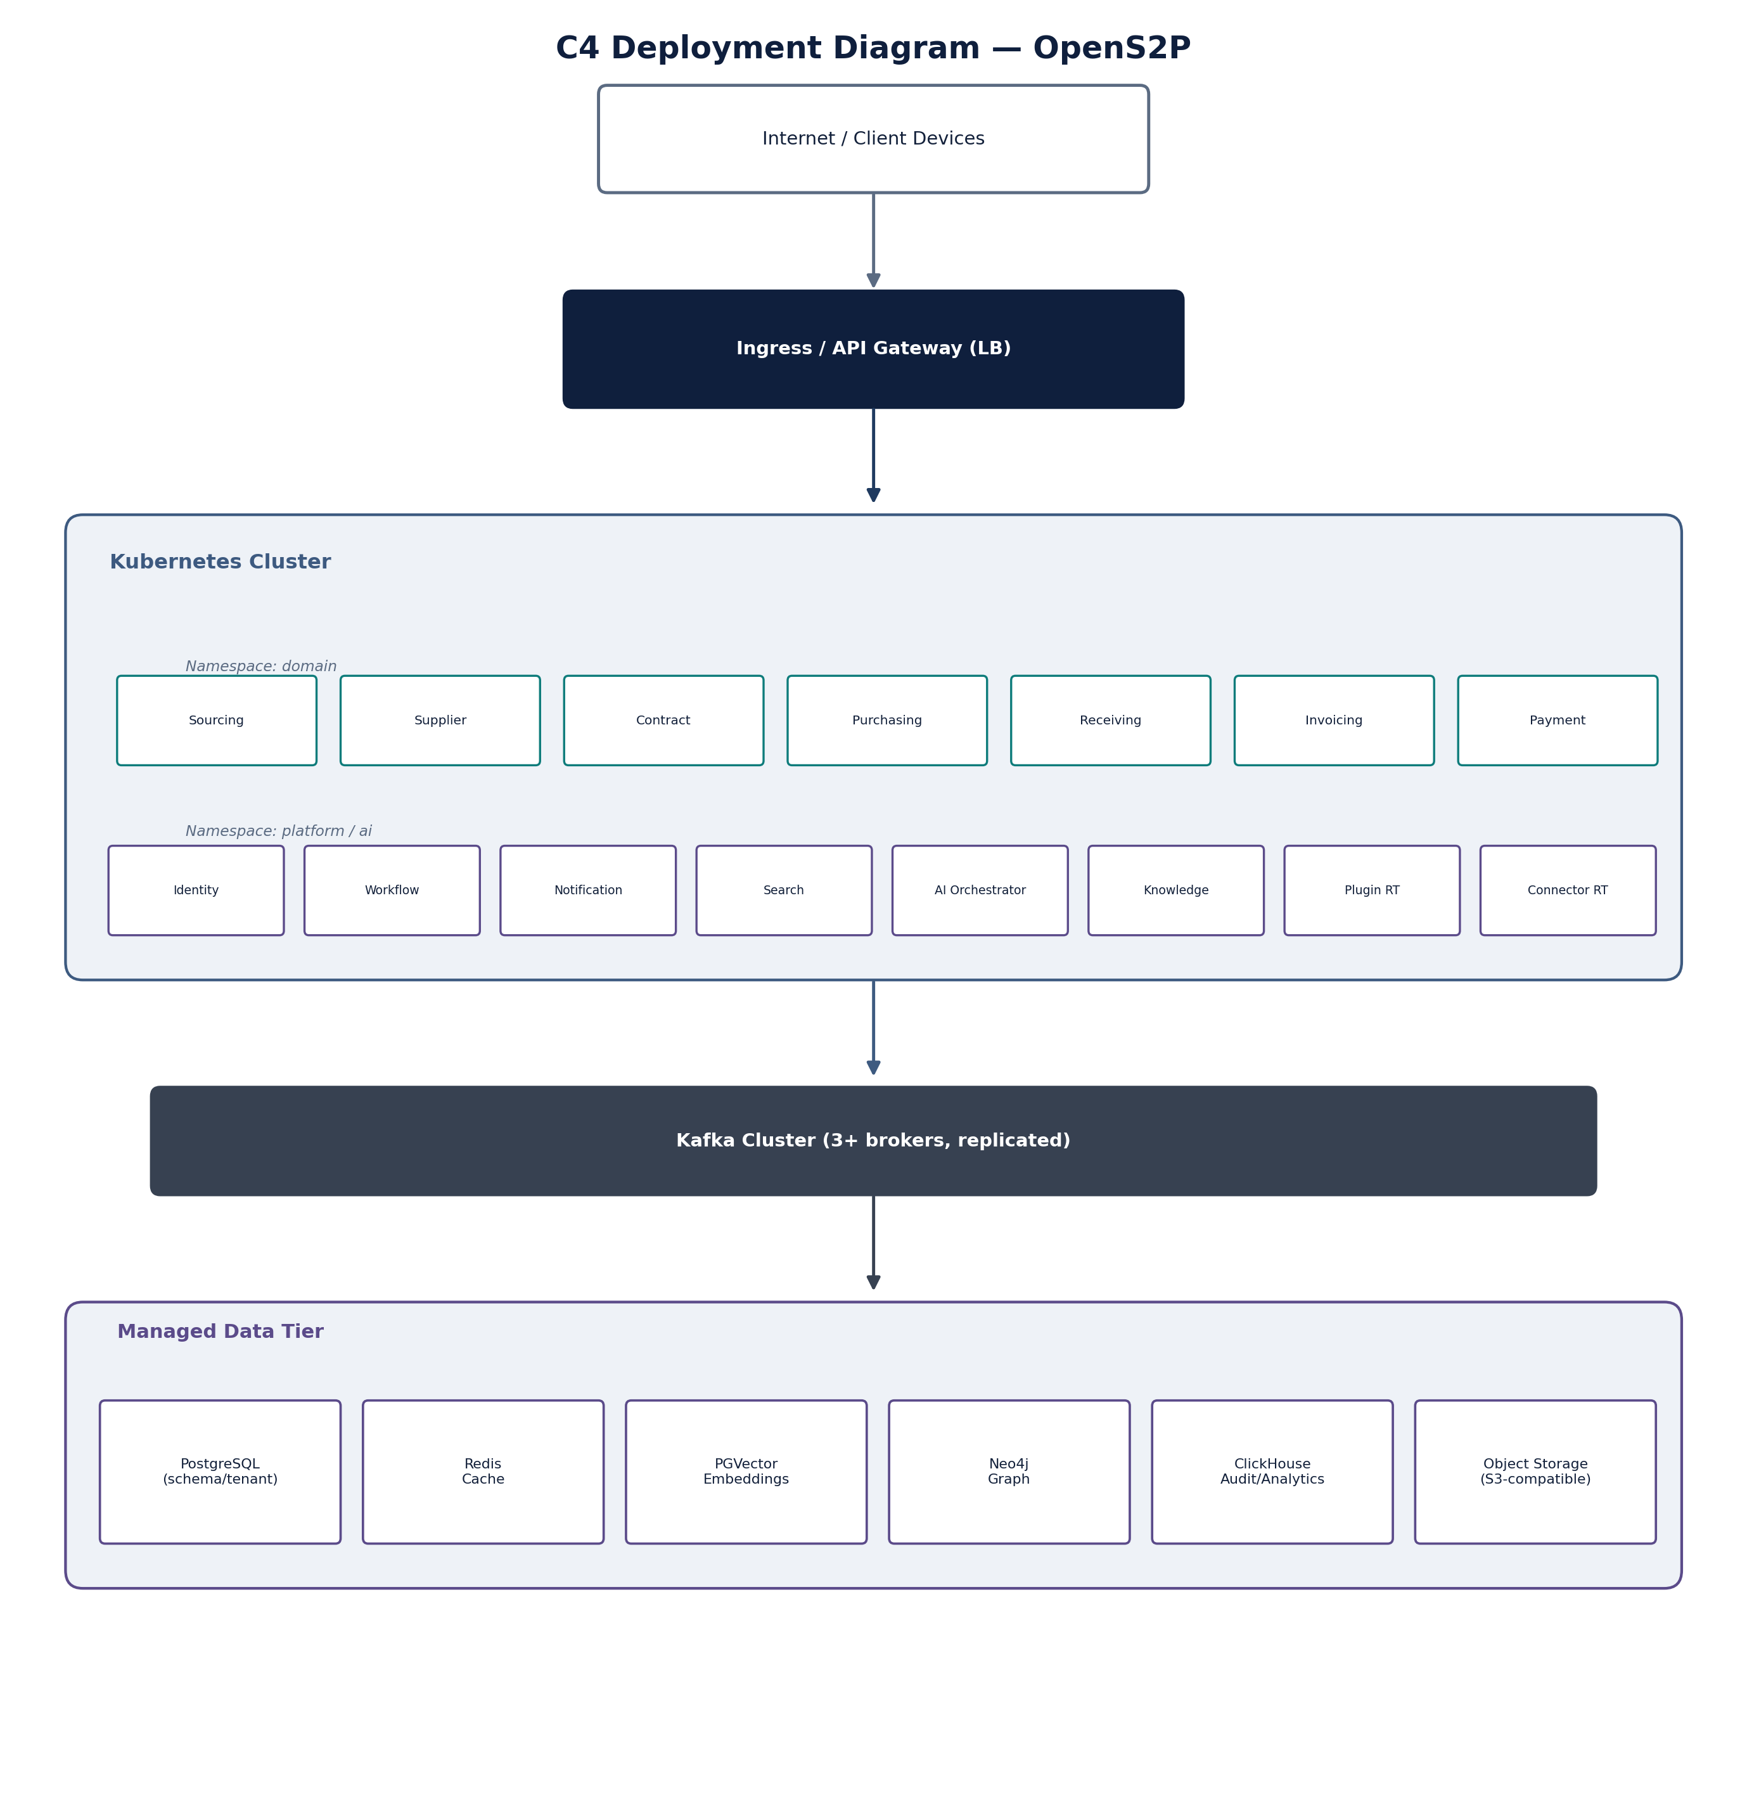
Figure 26.4 — C4 Deployment Diagram

27. Security Architecture
Security is addressed throughout this document at the service level; this chapter consolidates the platform-wide security model. Items marked (baseline, ratified) reflect decisions already established by the referenced ADRs. Items marked (recommended default — pending ratification) are proposed specifics, consistent with the stated technology stack, that still need sign-off from the security review rather than facts already decided; treat the numbers as a starting point for that discussion, not a commitment.

27.1 Authentication
- Recommended: service-to-service traffic inside the cluster uses mTLS (mesh-issued certificates) in addition to the JWT described above, so a compromised JWT alone is not sufficient to impersonate a service. (recommended default — pending ratification)
- Human user authentication uses the OAuth2 Authorization Code flow with PKCE via Keycloak; service accounts use the Client Credentials flow. Neither the Implicit flow nor Resource Owner Password Credentials flow is used, per current OAuth2 security best practice.
- Identity Service (Keycloak) issues OIDC-compliant tokens for all human users. (baseline, ratified — ADR-009)
- Service-to-service calls use short-lived JWTs validated at the API Gateway and re-validated by the receiving service. (baseline, ratified)
- Recommended token lifetimes: 15-minute access tokens, 7-day rotating refresh tokens, refresh reuse detection enabled. (recommended default — pending ratification)

27.2 Authorisation
- Fine-grained authorisation decisions are externalised to OPA (Open Policy Agent) rather than hard-coded per service. (baseline, ratified — ADR-008)
- Policies are evaluated per request using tenant, role, and resource attributes from the JWT claims. (baseline, ratified)
- Recommended policy workflow: Rego policies version-controlled alongside the service that owns them, reviewed via pull request, and rolled out through the same environment-promotion pipeline as code (Section 25.4). (recommended default — pending ratification)

27.3 Multi-Tenancy & Data Isolation
- Tenant data is isolated at the PostgreSQL schema level (schema-per-tenant). (baseline, ratified — ADR-004)
- All API requests carry a tenant context derived from the authenticated token; services must not accept a tenant identifier from an unauthenticated source. (baseline, ratified)
Schema-per-tenant covers relational isolation; the dimensions below make the full multi-tenant boundary explicit across every data store the platform uses.
- Row-level isolation: every table carries a tenant_id; application-layer repositories scope every query by the authenticated tenant, and PostgreSQL row-level security policies provide a second enforcement layer beneath the application code.
- Cache partitioning: Redis keys are namespaced by tenant ({tenant_id}:{key}) so a cache flush or eviction in one tenant cannot leak into or evict another's data.
- Vector index isolation: PGVector embeddings carry tenant_id as a filter predicate on every similarity search; the Knowledge Service does not run cross-tenant retrieval under any code path.
- Audit isolation: ClickHouse audit records are tenant-scoped and queried only with an explicit tenant filter; audit export/reporting tools enforce the same scoping.
- Backup isolation: because isolation is schema-level rather than database-level, backup and restore procedures (Appendix H) must support restoring a single tenant's schema without affecting others — this is a requirement on the backup tooling, not just the schema design.
- Tenant-aware routing: the API Gateway resolves tenant context from the authenticated token (not from the URL or a header a client could spoof) before any request reaches a domain service.
- RBAC: roles are tenant-scoped — a Buyer role in tenant A carries no permissions in tenant B, even for the same authenticated user, if that user belongs to multiple tenants.
- Quotas: per-tenant rate limits and resource quotas (API calls/min, AI agent runs/day, storage) are enforced at the API Gateway and AI Orchestrator respectively, so one tenant's usage spike cannot degrade service for others.

27.3.1 Tenant Lifecycle
- Provisioning: a new tenant is created by provisioning its PostgreSQL schema, a Redis key namespace, and a Keycloak realm (or realm partition) in one orchestrated operation — never as separate manual steps that could leave a tenant partially set up.
- Onboarding / offboarding: onboarding activates a tenant's schema and issues initial admin credentials via Identity Service; offboarding deactivates access immediately but retains data per the retention policy (Appendix H) rather than deleting it outright, pending an explicit data-deletion request.
- Tenant encryption keys: each tenant's data-at-rest encryption key is distinct (envelope encryption via the key management approach in 27.4), so revoking one tenant's key cannot be done accidentally when rotating another's.
- Tenant migration: moving a tenant between environments (e.g. staging to production, or between regions once multi-region exists — see Appendix H) is a schema export/import operation scoped to that tenant alone, consistent with the backup-isolation requirement in 27.3.

27.4 Secrets, Encryption & Key Management
- Data in transit is encrypted via TLS 1.2+ between all services and at the API Gateway edge. (baseline, ratified)
- Recommended secrets management: Kubernetes Secrets for local/dev profiles, an external secrets manager (e.g. Vault-compatible) for staging and production, mounted via a CSI driver rather than environment variables. (recommended default — pending ratification)
- Recommended key rotation: quarterly rotation for data-at-rest encryption keys, immediate rotation on suspected compromise, rotation events written to the audit store (Section 27.5). (recommended default — pending ratification)

27.5 Audit & Zero Trust
- Security-relevant events are written to the ClickHouse audit store referenced in Section 22 (Logging). (baseline, ratified)
- Zero-trust posture: no service trusts another purely on network location; every call is authenticated and authorised per the model above. (baseline principle, see Section 1.5)
- A starting threat model is provided in Appendix G; it should be extended into a full exercise (STRIDE per service, or equivalent) before public release. (recommended next step)

28. Quality Attribute Scenarios
Quality attribute scenarios make the non-functional requirements measurable. Each scenario follows the stimulus / response pattern used in enterprise architecture reviews. This is a representative starting set, not an exhaustive test plan.

28.1 Availability
- Scenario: A Purchasing Service pod fails during business hours. Response: Kubernetes detects the failed liveness probe and replaces the pod; in-flight requests to the failed pod are retried by the API Gateway against a healthy replica. Target: service restored within 30 seconds, zero data loss (state is persisted, not held in-memory).

28.2 Performance
- Scenario: 500 concurrent purchase order creations. Target: 95th-percentile API latency under 400ms, with the event publish to Kafka completing asynchronously and not blocking the API response.

28.3 Security
- Scenario: A request arrives with an expired JWT. Response: the API Gateway rejects the request with 401 Unauthorized before it reaches any domain service; no partial processing occurs.

28.4 Scalability
- Scenario: Sourcing event volume triples during a quarterly RFx cycle. Response: the Sourcing Service scales horizontally via Kubernetes HPA based on CPU and queue-depth metrics; PostgreSQL connection pooling (Appendix C) prevents connection exhaustion.

28.5 AI Governance
- Scenario: An AI agent proposes an action with a confidence score below the configured threshold. Response: the Agent Execution Pipeline (Figure 10.1) routes the action to Human Approval rather than executing it automatically.

28.6 NFR Traceability
This matrix maps each non-functional requirement category to where it is defined and measured in this document, so a reviewer can confirm coverage at a glance.
Requirement | Primary Section | Scenario / Detail
Availability | 28.1 | Pod failure / replacement scenario
Performance | 28.2, 24 | Latency targets, performance section
Security | 27, 28.3 | Security Architecture chapter + JWT expiry scenario
Scalability | 28.4, 24 | HPA scenario, performance section
Observability | 23 | Monitoring
AI Governance | 28.5, 10.4 | Confidence scorer scenario and component
Multi-Tenancy | 27.3 | Data isolation model
Disaster Recovery | Appendix H | Backup approach and recovery objectives per data store

29. Key Business Flows
The service and API chapters describe each capability in isolation. This chapter shows how four representative flows play out across services over time, as sequence diagrams, plus one data-flow view of the same underlying process for a complementary perspective.

29.0 Procure-to-Pay (End-to-End)
Before the individual flows below, this is the full procure-to-pay journey end to end — requisition through payment — showing how the individually-scoped sequences that follow fit together as one continuous process.
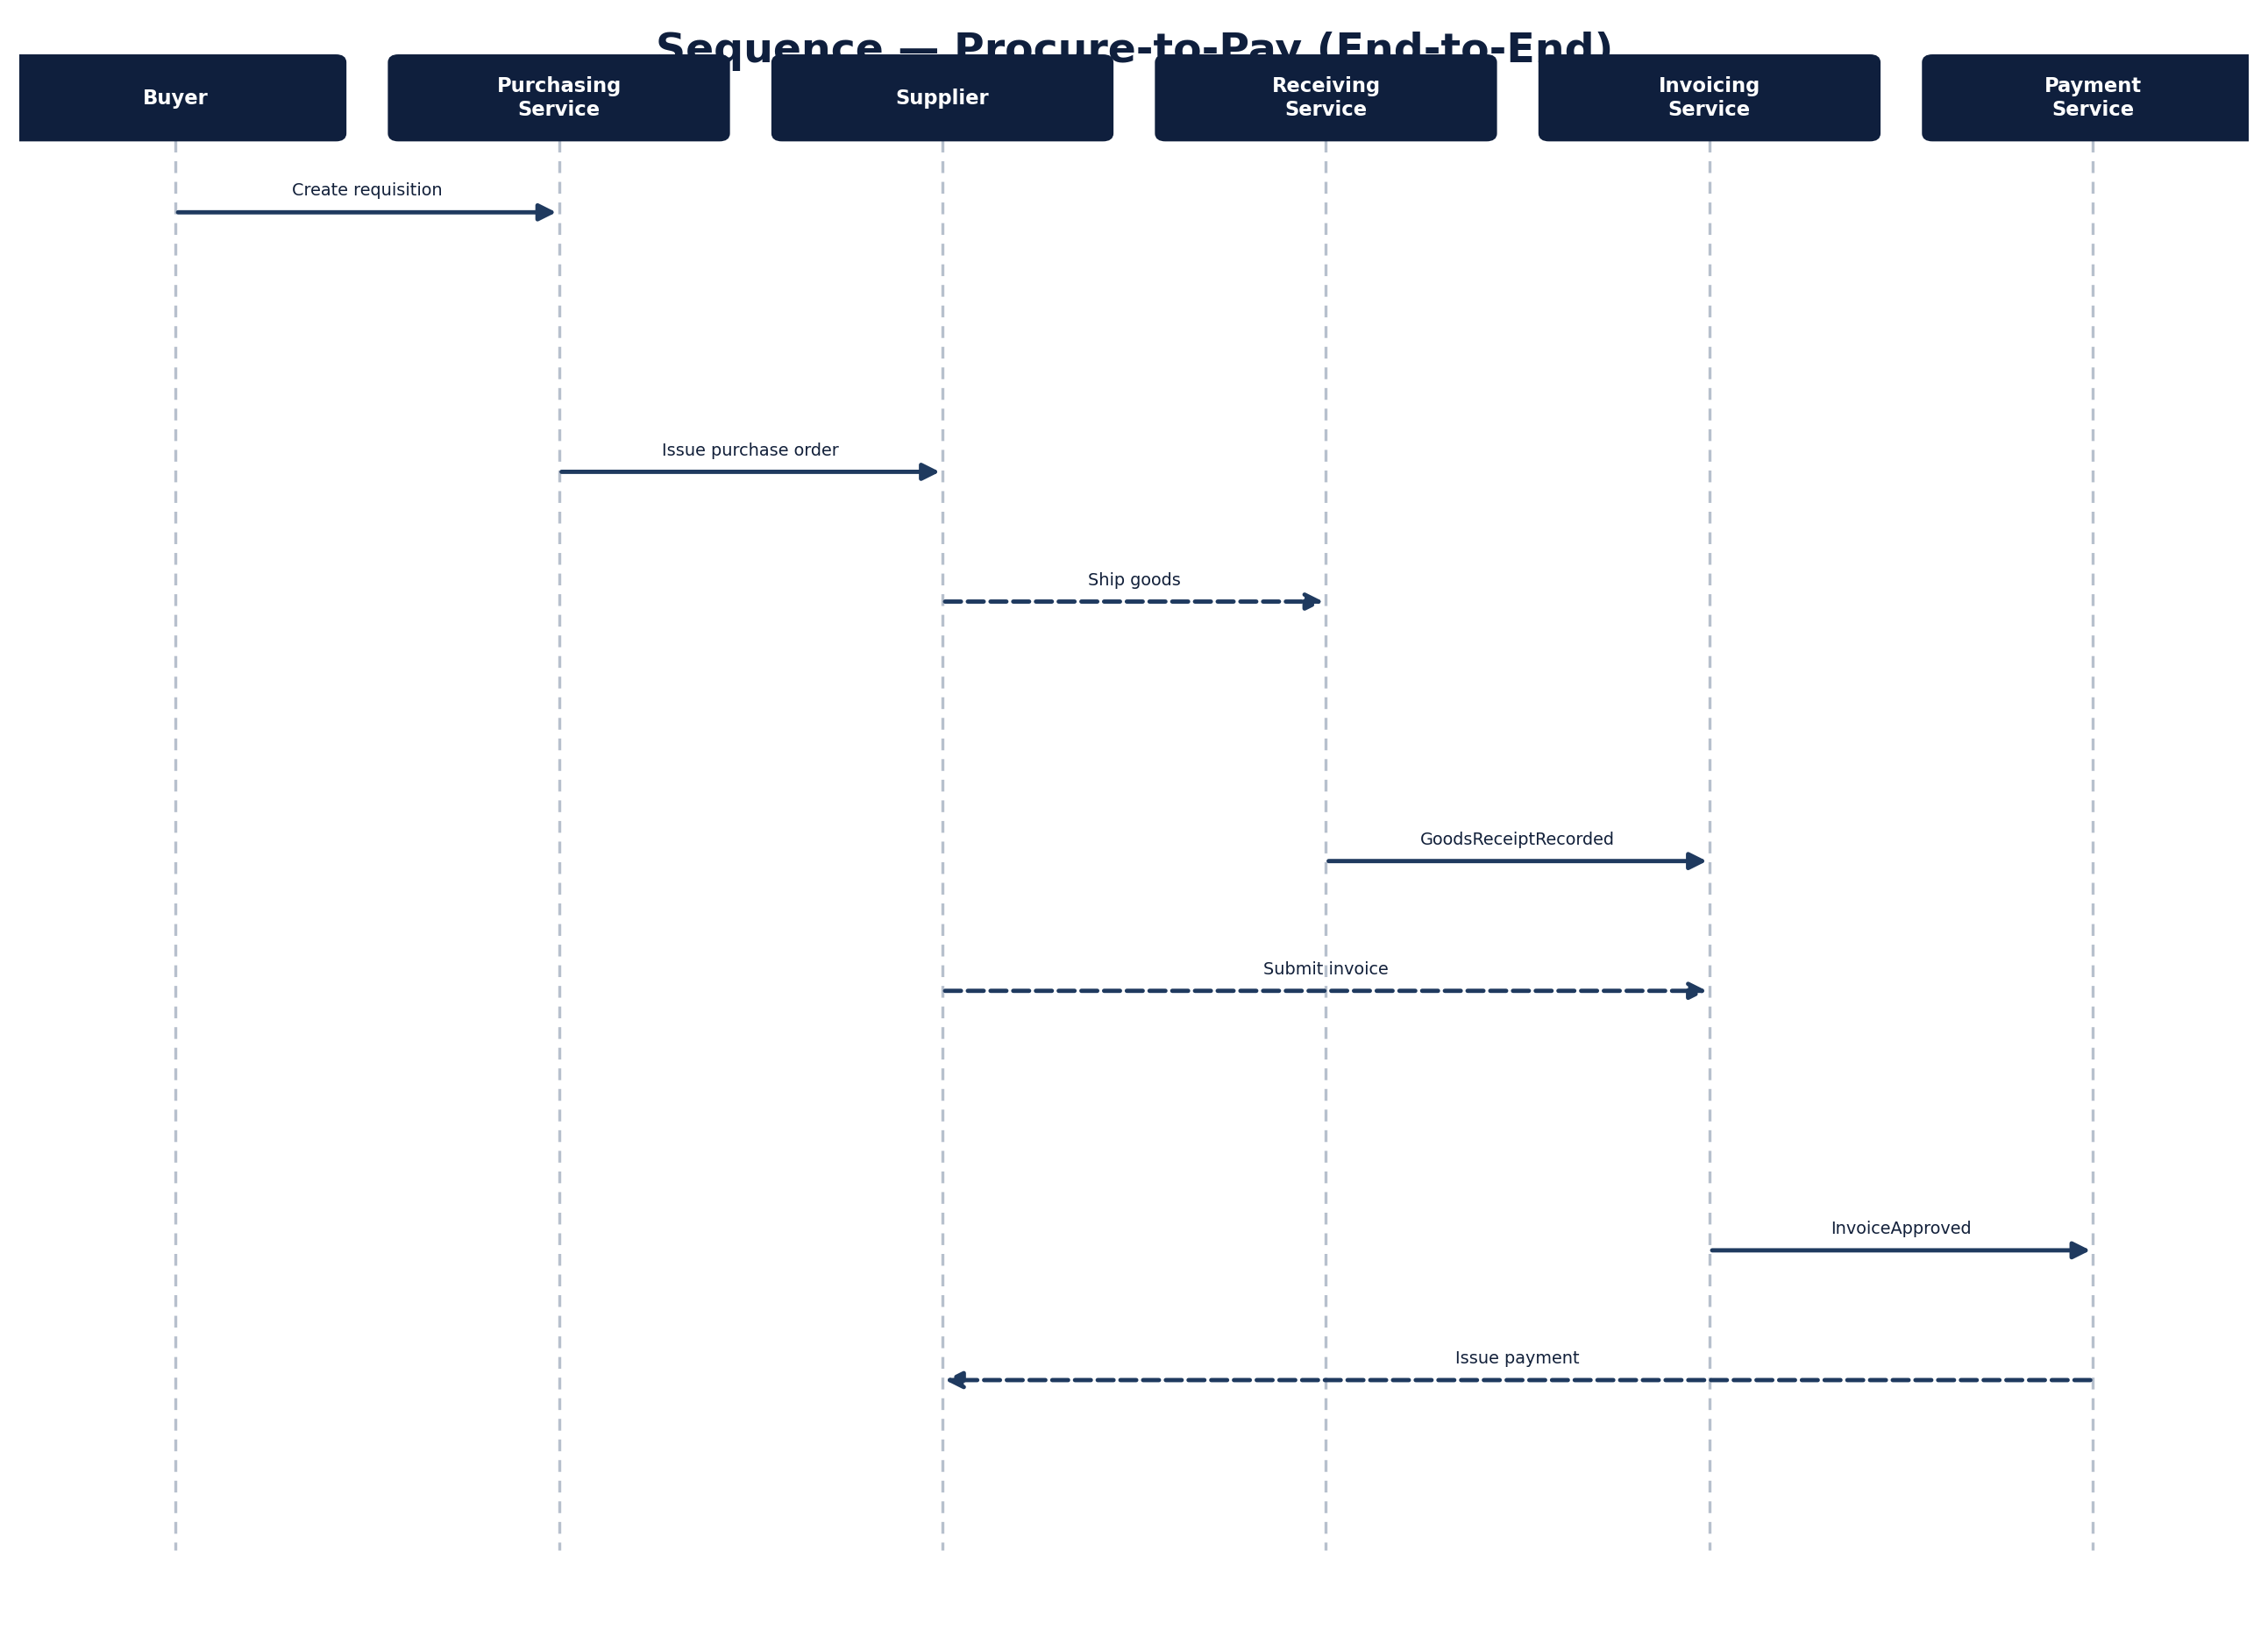
Figure 29.0 — Procure-to-Pay End-to-End Sequence

29.1 Purchase Requisition Approval
A buyer creates a purchase requisition; the Purchasing Service publishes a domain event and hands approval routing to the Workflow Orchestrator, which requests and receives approval before the requisition is marked approved.
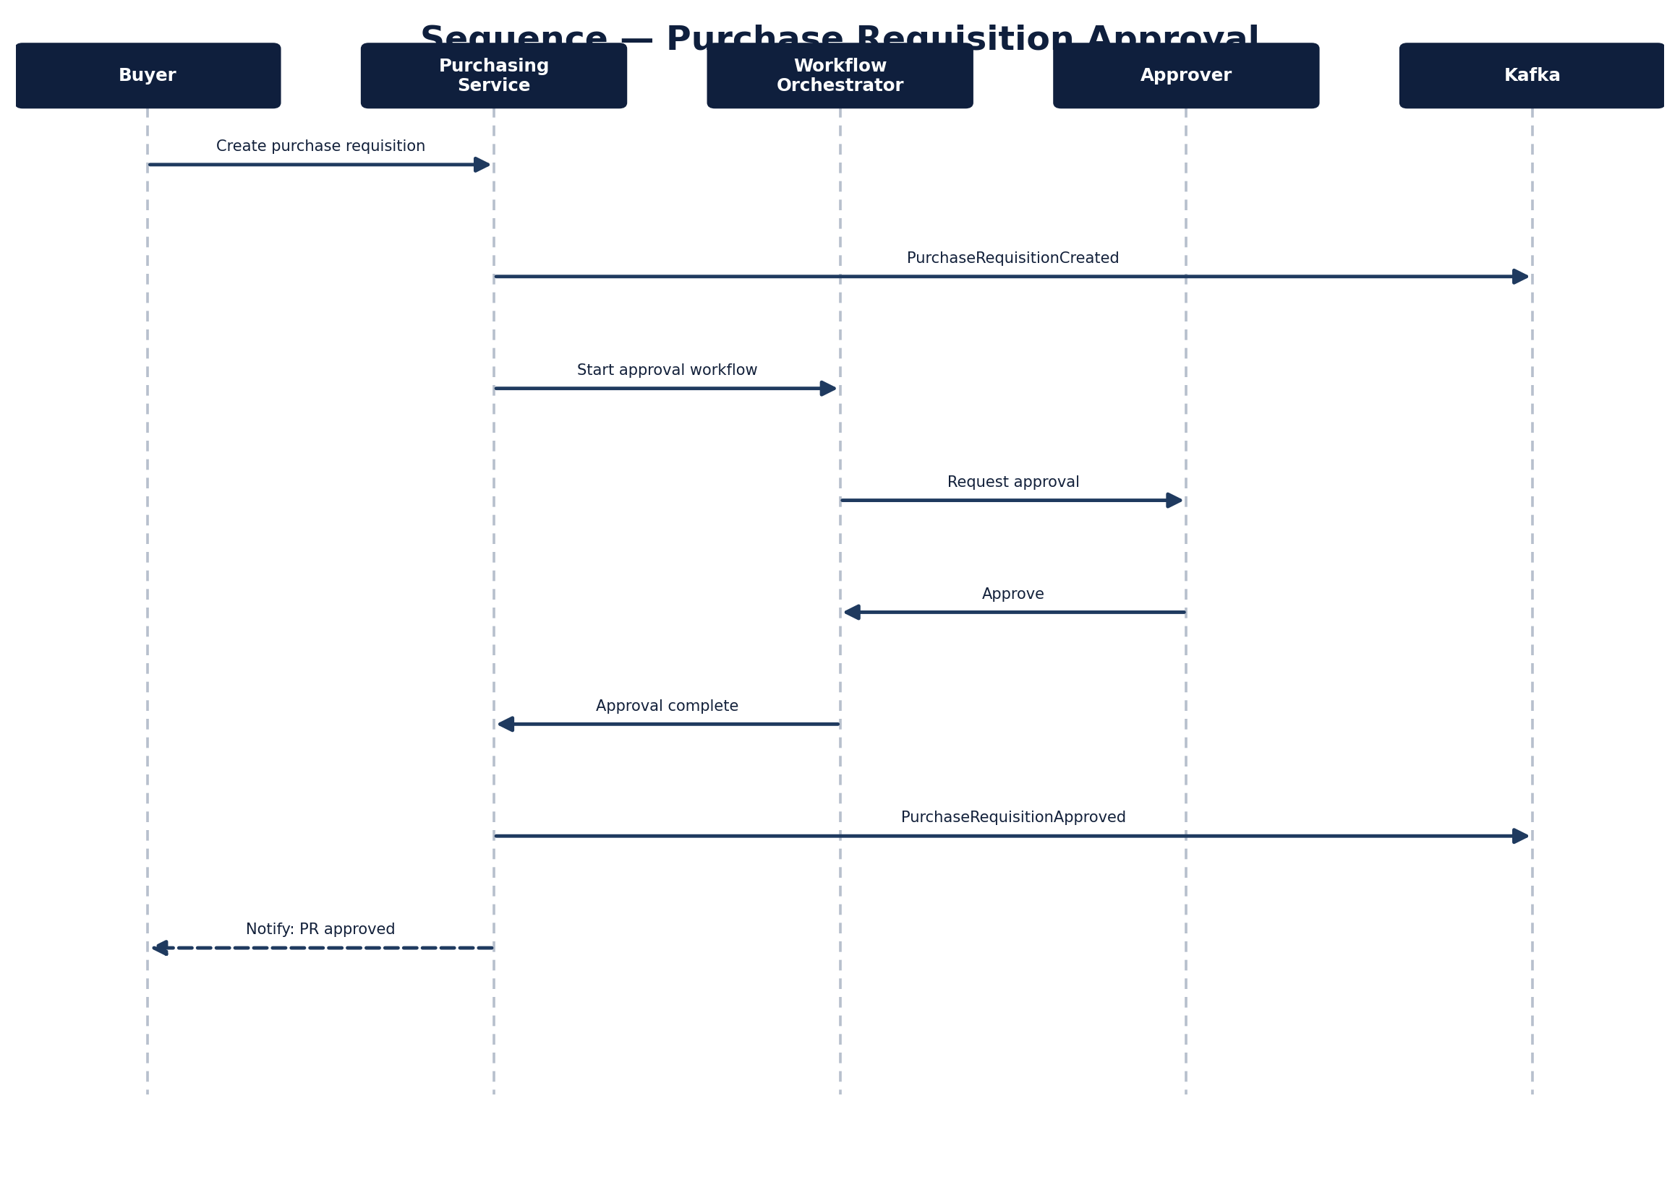
Figure 29.1 — Purchase Requisition Approval Sequence

29.2 Three-Way Match
The Invoicing Service reconciles a purchase order, goods receipt, and invoice before payment is authorised — the core control that prevents paying for goods never ordered or never received.
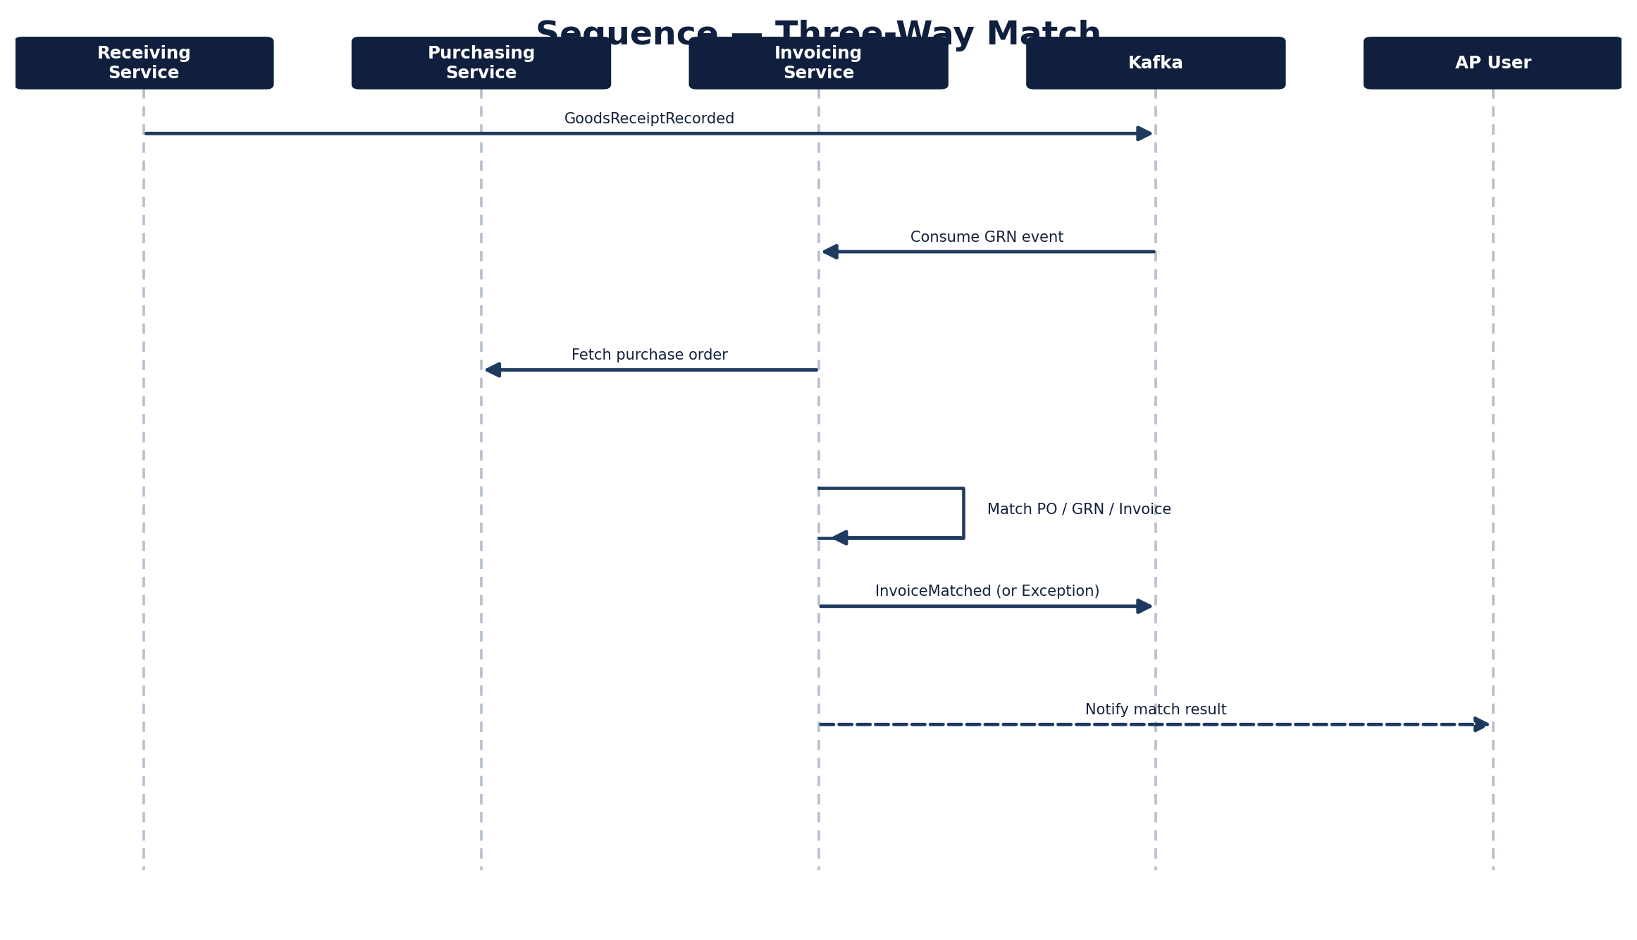
Figure 29.2 — Three-Way Match Sequence

29.3 Supplier Onboarding
A prospective supplier submits an onboarding application; the Workflow Orchestrator drives qualification, including indexing supplier documents into the Knowledge Service, before the supplier is marked qualified and notified. The data-flow view below shows the same process from the perspective of where the data goes rather than which service calls which.
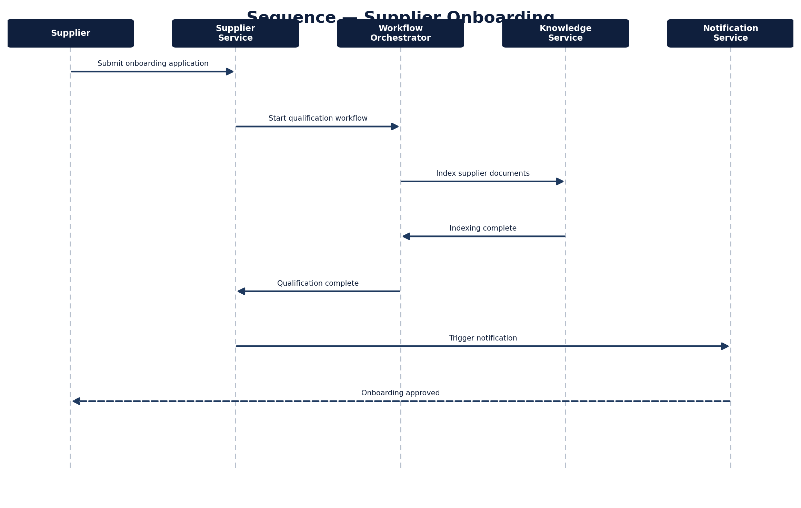
Figure 29.3 — Supplier Onboarding Sequence
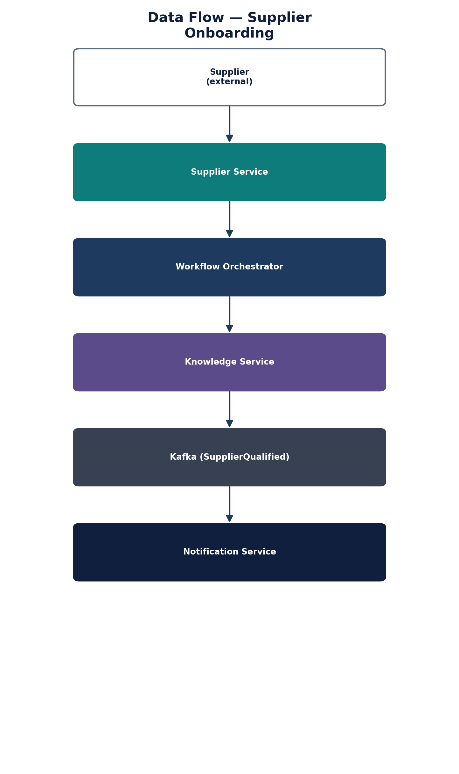
Figure 29.4 — Supplier Onboarding Data Flow

29.4 AI Agent Execution
A user request flows through the AI Orchestrator, which retrieves context from the Knowledge Service, proposes an action against a domain service, and routes low-confidence actions to a human approver before returning output — the same pipeline shown structurally in Figures 10.1 and 10.2, here shown as a time-ordered sequence.
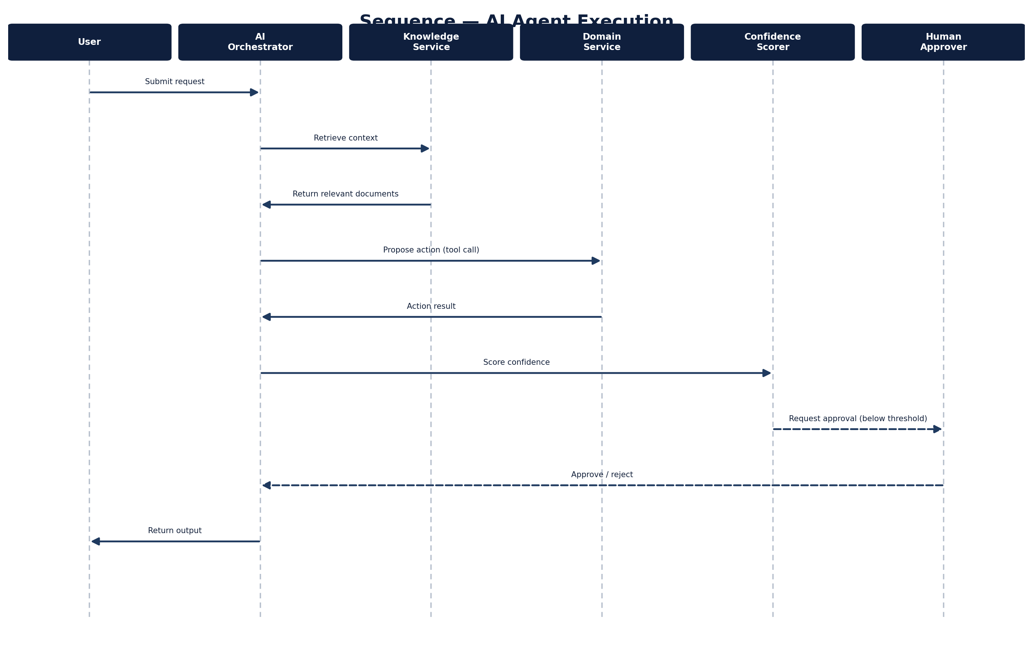
Figure 29.5 — AI Agent Execution Sequence

29.5 RFx Lifecycle
A buyer publishes an RFx; suppliers submit bids; the buyer evaluates and the Sourcing Service scores and ranks bids before recording an award.
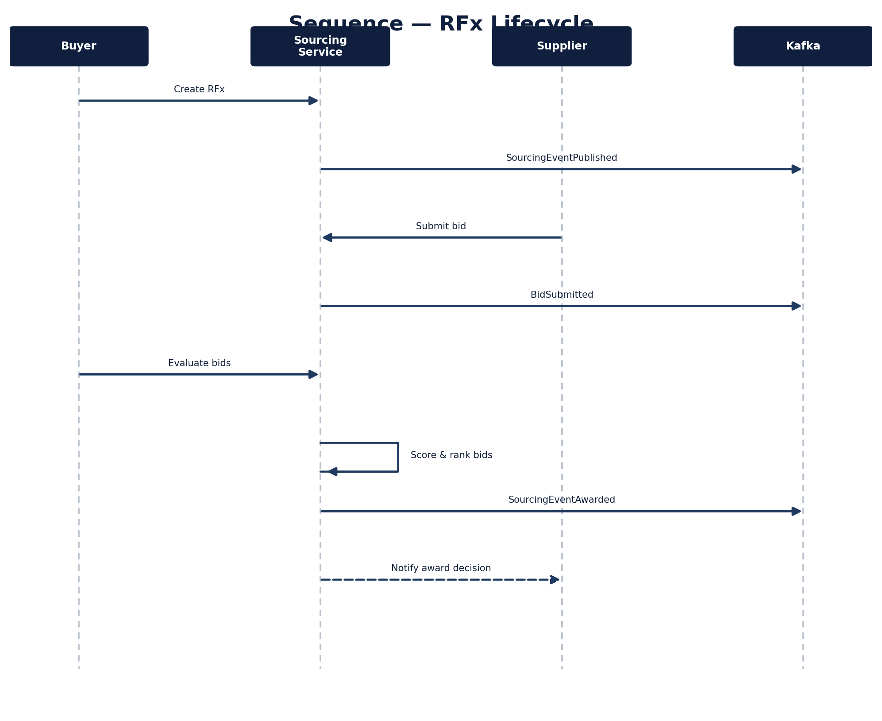
Figure 29.6 — RFx Lifecycle Sequence

29.6 AI-Assisted Contract Review
The Contract Service delegates clause analysis to the AI Orchestrator, which retrieves precedent clauses from the Knowledge Service before returning risk flags and suggestions for buyer review.
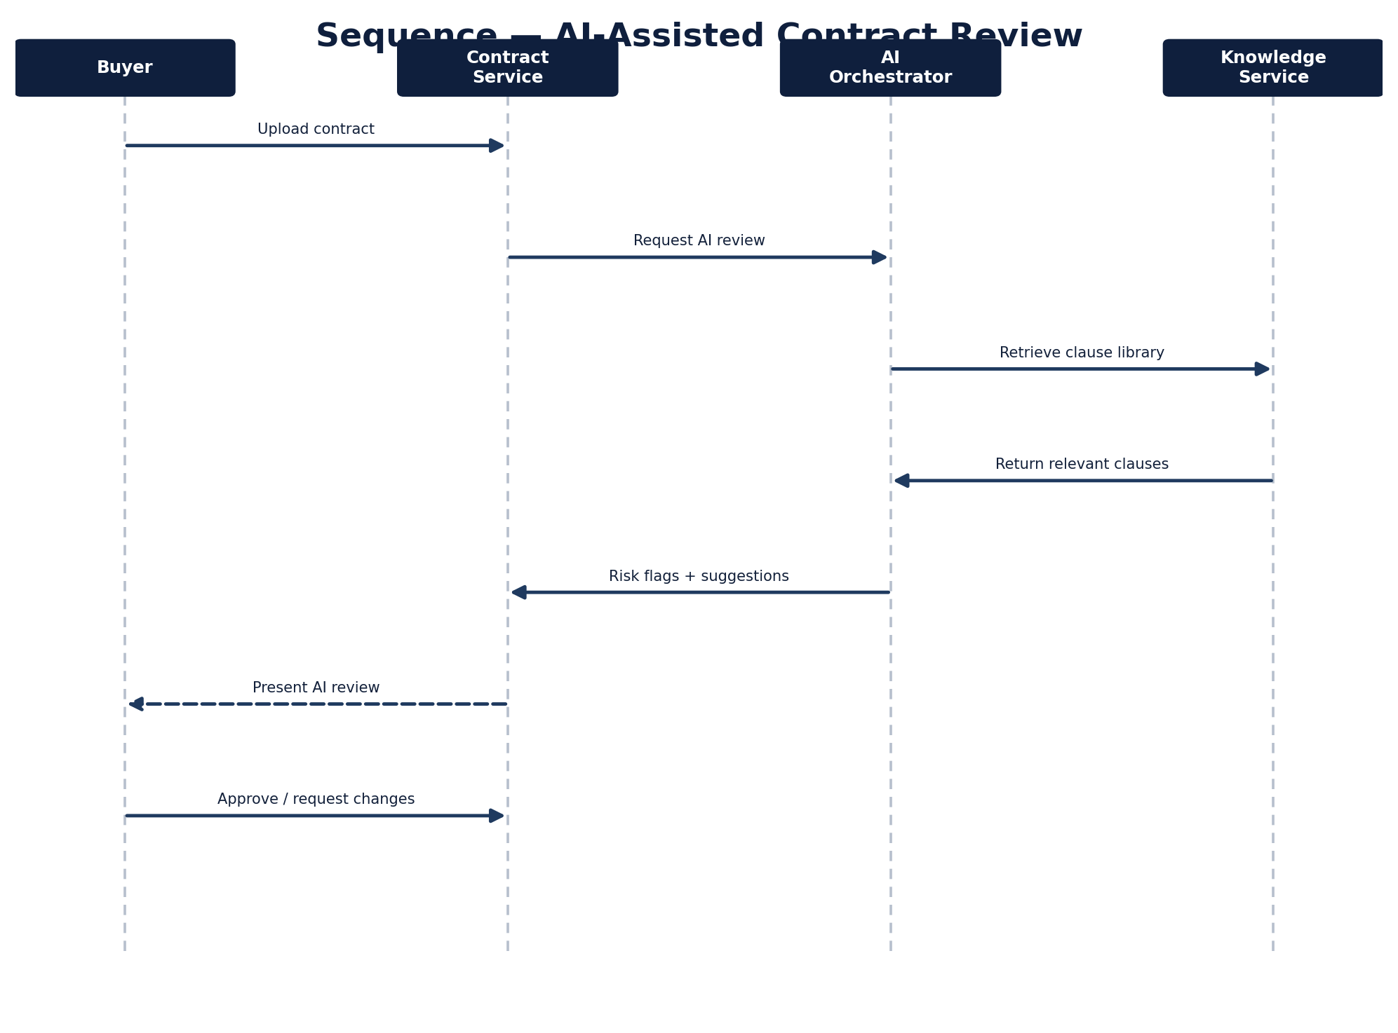
Figure 29.7 — AI-Assisted Contract Review Sequence

29.7 Plugin Execution
A domain service invokes a plugin by capability rather than by name; the Plugin Runtime validates the plugin's manifest before executing it inside a Wasmtime sandbox and recording the execution for audit.
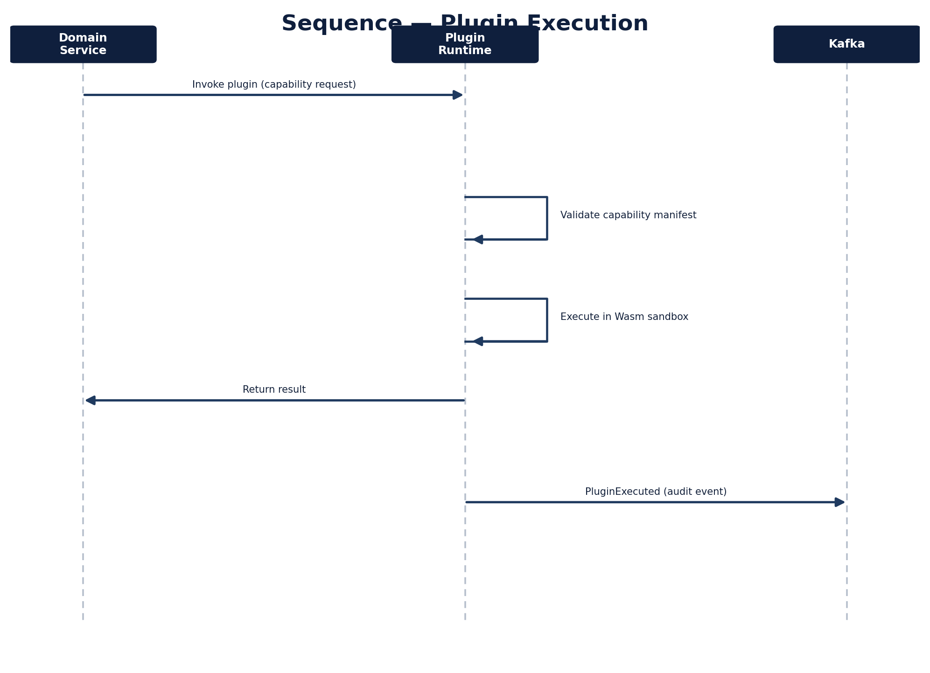
Figure 29.8 — Plugin Execution Sequence

29.8 Connector Invocation
A domain service asks the Connector Runtime to synchronise with an external system; the runtime resolves the correct adapter configuration, makes the external call, maps the response back into OpenS2P's domain shape, and records the invocation for audit.
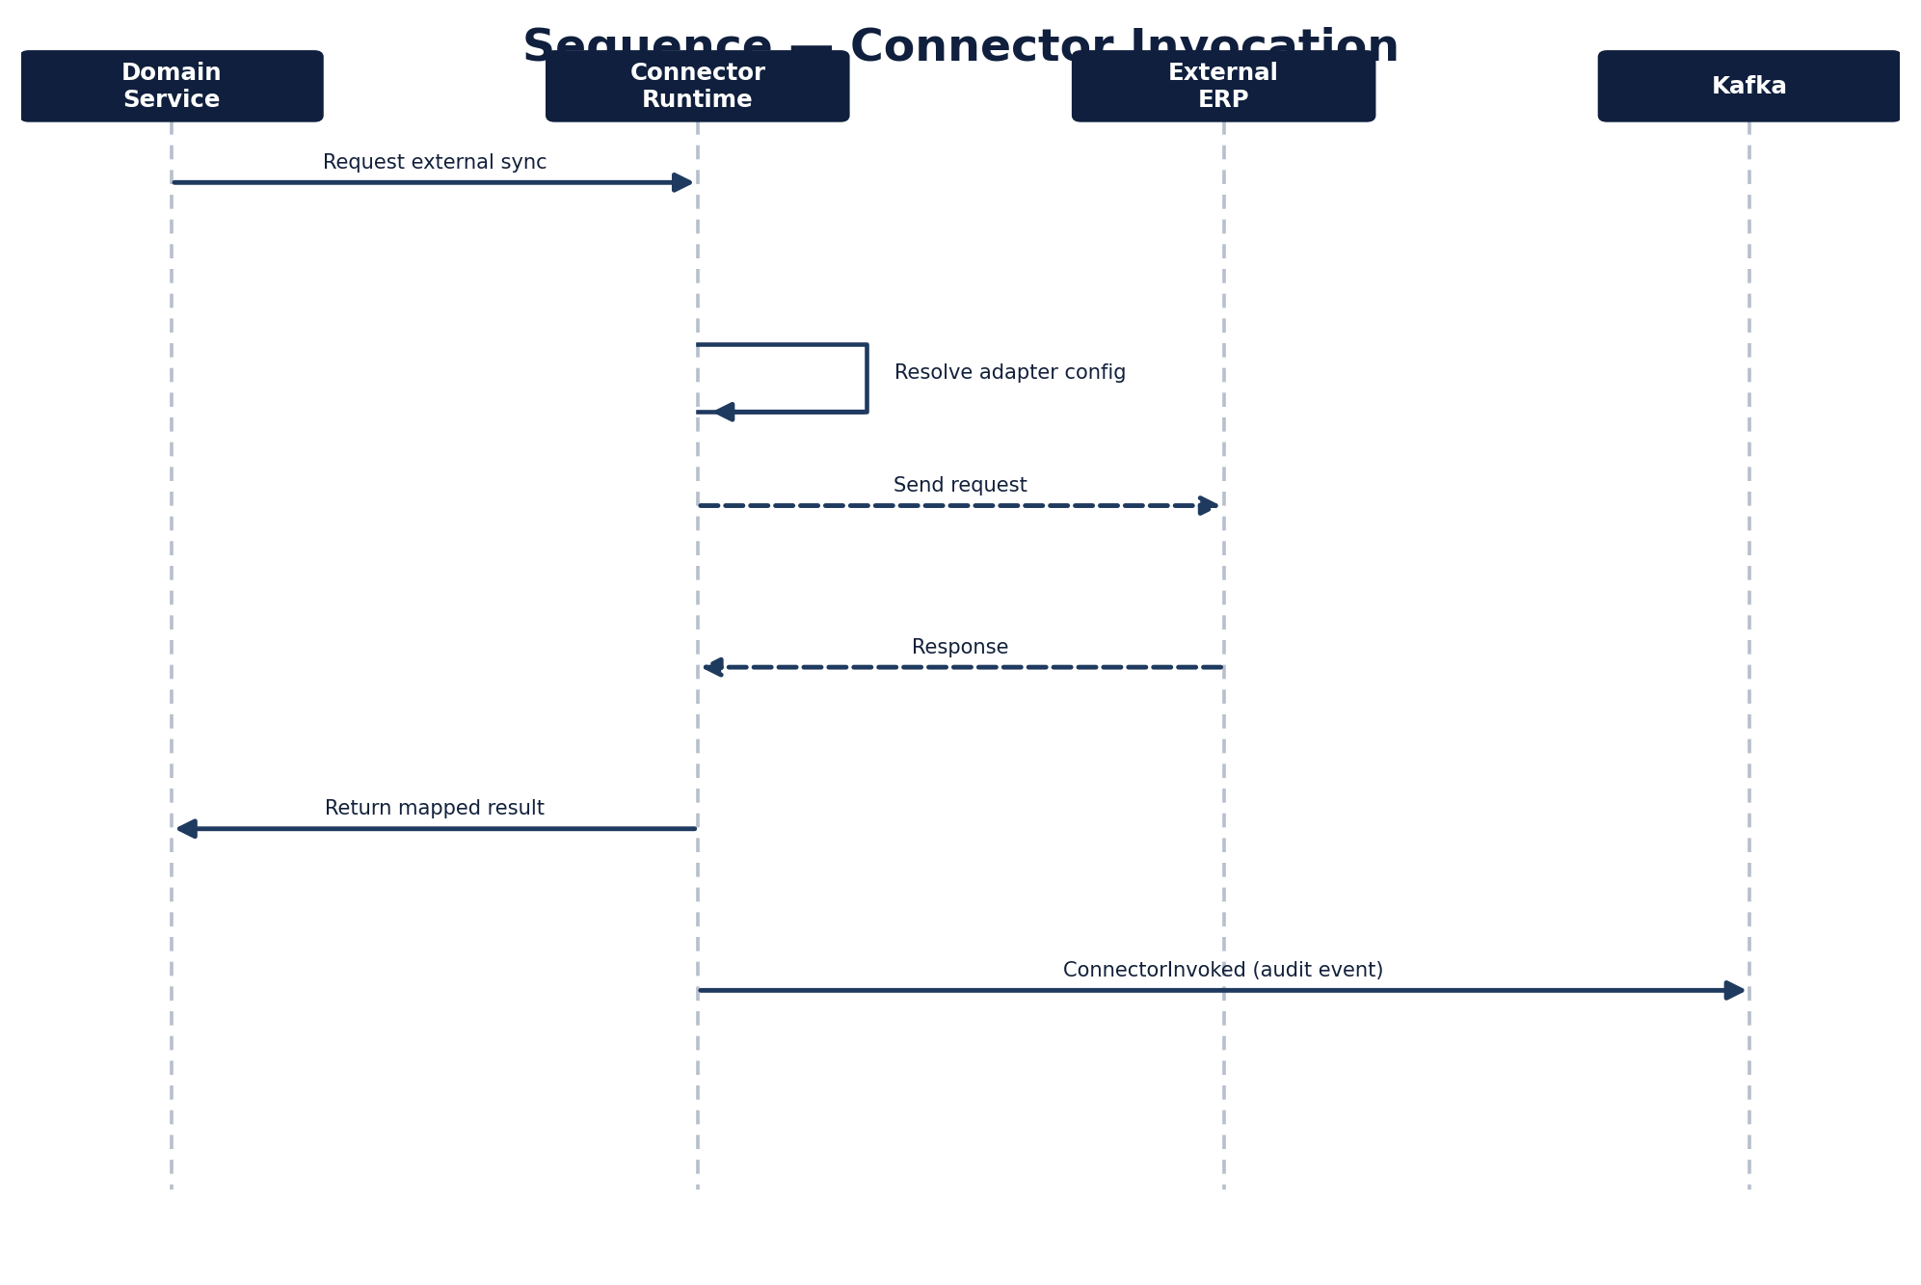
Figure 29.9 — Connector Invocation Sequence

30. Resilience & Failure Handling
Individual resilience mechanisms are implied throughout the service chapters (retry examples in code, the Saga row in the communication-patterns table at 2.3, dead-letter handling in event contracts) but not consolidated. This chapter is that consolidation — the patterns every service is expected to follow, not a new set of decisions.

30.1 Circuit Breakers
Synchronous calls between services (including to the API Gateway's upstream targets) should be wrapped in a circuit breaker that opens after a configurable failure threshold, so a struggling downstream service doesn't cascade load failures upstream. Recommended defaults: 50% failure rate over a 10-request rolling window opens the circuit; a 30-second half-open probe interval.

30.2 Retry Strategy
Retries apply to idempotent operations only (see 30.4). Recommended defaults: exponential backoff starting at 100ms, maximum 3 attempts, full jitter to avoid retry storms across concurrent requests.

30.3 Bulkheads
Each service isolates its outbound connection pools per downstream dependency (e.g. a separate PostgreSQL pool from the Kafka producer pool) so exhaustion in one dependency doesn't starve unrelated request paths.

30.4 Idempotency
State-changing API operations accept an idempotency key (typically the request ID); a service receiving a duplicate key returns the original result rather than re-executing the operation. This is what makes the retry strategy in 30.2 safe.

30.5 Dead-Letter Queues
Kafka consumers route events that fail processing after retry exhaustion to a per-topic dead-letter topic rather than blocking the consumer group or silently dropping the event. Dead-lettered events are visible to operators via the monitoring stack (Section 23) and require manual or automated replay.

30.6 Saga Compensation
Multi-service transactions (e.g. purchase order issuance touching Purchasing, Supplier, and Payment) use the choreographed saga pattern referenced in 2.3: each step publishes a domain event, and a failure at any step publishes a compensating event that prior steps listen for and react to (e.g. releasing a reserved budget). There is no distributed two-phase commit anywhere in the platform.

31. AI Governance
Chapter 10 describes how the AI Orchestrator executes an agent run; this chapter describes how that capability is governed — versioned, evaluated, monitored, and overridden — which is a distinct concern from execution mechanics.

31.1 Prompt & Model Versioning
Prompts are version-controlled artifacts, not inline strings: each prompt template used by the AI Orchestrator carries a version identifier, and an agent run's audit record (31.6) captures which prompt version and which model version produced a given action. This is what makes a past decision reproducible and explainable after the fact.

31.2 Model Registry & Fallback
- Models available to the AI Orchestrator are registered with their capability profile (context window, supported tool-calling format, cost tier) rather than hardcoded per call site.
- A fallback chain is defined per agent task: if the primary model is unavailable or exceeds a latency budget, the orchestrator falls back to a secondary model rather than failing the request outright — the fallback event is itself audited.

31.3 Evaluation & Hallucination Detection
- Agent behaviour is validated against a maintained evaluation dataset of representative procurement scenarios before a new prompt or model version is promoted to production.
- Retrieval-grounded responses (via the Knowledge Service) are checked for citation support — an answer that can't be traced to a retrieved document is treated as lower-confidence input to the Confidence Scorer (10.4), not presented as fact.

31.4 Guardrails
- Tool calls available to an agent are capability-scoped per task (an agent reviewing a contract cannot invoke a payment-issuing tool), independent of the confidence-score gate.
- Output is validated against the expected schema before being handed to a domain service — a malformed or out-of-range proposed action is rejected before it reaches the Confidence Scorer, not after.

31.5 Cost Monitoring
Token usage and inference cost are recorded per agent run and rolled up per tenant, feeding both the quota enforcement described in 27.3 and standard cost dashboards alongside the platform's other OpenTelemetry metrics (Section 23).

31.6 Human Override & AI Audit Log
- Every agent action — approved automatically or by a human — is written to the audit trail shown in Figure 10.2, including the confidence score, the prompt/model version (31.1), and the identity of the approving human where applicable.
- A human reviewer can override an agent's proposed action at the Human Approval gate (Figure 10.3); overrides are themselves audited and are the primary input to the evaluation dataset in 31.3 over time.

Appendices

A. Service Port Allocation
Service | Port | Internal | External
Sourcing | 8080 | ✅ | ✅
Supplier | 8081 | ✅ | ✅
Contract | 8082 | ✅ | ✅
Purchasing | 8083 | ✅ | ✅
Receiving | 8084 | ✅ | ✅
Invoicing | 8085 | ✅ | ✅
Payment | 8086 | ✅ | ✅
Workflow | 8090 | ✅ | ❌
AI Orchestrator | 8091 | ✅ | ❌
Knowledge | 8092 | ✅ | ❌
Plugin Runtime | 8093 | ✅ | ❌
Connector Runtime | 8094 | ✅ | ❌
Marketplace | 8095 | ✅ | ✅
Identity | 8096 | ✅ | ✅
Notification | 8097 | ✅ | ❌
Search | 8098 | ✅ | ✅

B. Service Account Permissions
YAML
serviceAccounts:
purchasing-service:
secrets:
- "purchasing-db-secret"
- "kafka-credentials"
permissions:
- "get pods"
- "list events"

invoice-service:
secrets:
- "invoice-db-secret"
- "kafka-credentials"
permissions:
- "get pods"

workflow-service:
secrets:
- "workflow-db-secret"
- "kafka-credentials"
permissions:
- "get pods"
- "watch pods"

C. Database Connection Pools
TYPESCRIPT
// Connection pool configuration
const dbConfig = {
postgres: {
max: 20,
idleTimeoutMillis: 30000,
connectionTimeoutMillis: 2000,
queue: { limit: 1000 },
healthCheck: true
},
kafka: {
producer: { maxInFlight: 5, acks: 1 },
consumer: { maxConcurrent: 10 }
},
redis: {
max: 50,
idleTimeout: 30000
}
};

D. Health Check Endpoints
TYPESCRIPT
// Standard health check implementation
interface HealthCheck {
status: 'healthy' | 'unhealthy' | 'degraded';
checks: {
database: 'ok' | 'error';
kafka: 'ok' | 'error' | 'warning';
redis: 'ok' | 'error';
version: string;
uptime: number;
};
timestamp: string;
}

// Liveness: simple status
GET /health -> { status: 'healthy', version: '1.0.0' }

// Readiness: full checks
GET /ready -> {
status: 'healthy',
checks: { ... },
timestamp: '2027-01-15T10:30:00Z'
}

End of Software Architecture Document
Document Status: Approved for Publication | Version: 1.1 | Effective Date: OpenS2P Architecture Board after approval
Maintained by: OpenS2P Core Team | License: Apache 2.0

E. Acronyms
Acronym | Meaning
ADR | Architecture Decision Record
API | Application Programming Interface
CLM | Contract Lifecycle Management
DDD | Domain-Driven Design
GRN | Goods Receipt Note
HITL | Human-in-the-Loop
JWT | JSON Web Token
OTEL | OpenTelemetry
PO | Purchase Order
RFx | Request for X (RFI / RFP / RFQ)
S2P | Source-to-Pay
SAD | Software Architecture Document
SLA | Service Level Agreement
SOW | Statement of Work
Wasm | WebAssembly

F. Glossary
Term | Definition
Aggregate | A cluster of domain objects treated as a single unit for data changes, per DDD conventions.
Aggregate Root | The entry-point entity of an aggregate through which all changes to that aggregate must pass.
Bounded Context | An explicit boundary within which a domain model applies consistently.
Confidence Score | A numeric estimate of an AI agent's certainty in a proposed action, used to decide whether human review is required.
Connector | A runtime adapter that integrates OpenS2P with an external system such as an ERP or payment gateway.
Domain Event | An immutable record that something meaningful happened within a service's domain, published for other services to consume.
Plugin | An extension executed in a sandboxed runtime that adds capability without modifying core services.
Schema-per-Tenant | A multi-tenancy pattern in which each tenant's data lives in its own PostgreSQL schema within a shared database.
Three-Way Match | Reconciliation of a purchase order, goods receipt, and invoice before payment is authorised.
Award | The decision to select a winning bid at the close of an RFx, recorded as SourcingEventAwarded.
Goods Receipt | Confirmation that ordered goods physically arrived, recorded by the Receiving Service.
Requisition | An internal request to purchase, which becomes a Purchase Order once approved.
RFx | Umbrella term for RFI (Request for Information), RFP (Request for Proposal), and RFQ (Request for Quotation).

G. Threat Model (Summary)
A STRIDE-style summary of the primary trust boundaries. This is a starting point for a full threat-modelling exercise, not a substitute for one.
Trust Boundary | Primary Threats | Mitigation (baseline / planned)
External client → API Gateway | Spoofing, tampering, DoS | TLS, OIDC token validation, rate limiting (planned)
API Gateway → Domain services | Elevation of privilege | OPA policy evaluation per request
Service → Kafka | Tampering, information disclosure | Broker ACLs and TLS (to be defined in deployment profile)
Service → PostgreSQL | Information disclosure across tenants | Schema-per-tenant isolation, least-privilege DB roles
Plugin Runtime → Host | Elevation of privilege, resource exhaustion | Wasmtime sandbox, capability-scoped manifests (Section 12)

H. Disaster Recovery & Backup Strategy
Recovery objectives and backup approach, to be finalised with the infrastructure team ahead of production launch.
Data Store | Backup Approach | Recovery Objective (proposed)
PostgreSQL | Continuous WAL archiving + daily base backup | RPO ≤ 15 min / RTO ≤ 1 hour
Kafka | Multi-broker replication (replication factor ≥ 3) | No single-broker data loss
PGVector / Neo4j | Daily snapshot | RPO ≤ 24 hours
ClickHouse (audit) | Daily snapshot to object storage | RPO ≤ 24 hours

Availability target: 99.9% platform availability (roughly 8.7 hours of downtime budget per year), consistent with the pod-replacement scenario in 28.1. A 99.95% target is achievable with multi-zone deployment but has not been ratified as a commitment; treat it as a stretch target pending infrastructure sign-off.
Multi-region strategy: not yet defined. The schema-per-tenant model (27.3) is compatible with a future active-passive multi-region design, but no region-failover mechanism exists in this version of the platform — flagged here rather than implied.
Data retention: operational data is retained for the life of the tenant relationship; audit records (ClickHouse) are retained for a minimum of 7 years to support procurement compliance requirements common in enterprise buyers' own audit obligations; exact retention periods per data category should be confirmed against the customer's contractual and regulatory requirements rather than assumed from this default.

I. Version Compatibility Matrix
Minimum supported versions as stated in Section 2.4 (Technology Stack Summary). Upper bounds are not yet pinned platform-wide; treat 'x' as "newest tested minor within that major" until a formal compatibility test matrix is run and this table is updated with confirmed ranges.
Component | Minimum Version | Notes
PostgreSQL | 15.x | PGVector extension requires 15+
Kafka | 3.5.x | KRaft mode assumed (no ZooKeeper dependency)
Kubernetes | 1.28.x | HPA v2 and CSI secret store driver assumed available
Redis | 7.x | —
Neo4j | 5.x | —
ClickHouse | 23.x | —
Wasmtime | 14.x | Plugin Runtime sandbox
OpenTelemetry Collector | 1.20.x | —
Keycloak | 22.x | —

I.1 Compatibility Policy
The matrix above states supported versions; this states the rules for how compatibility is maintained as those versions and the platform's own contracts change.
- API compatibility: governed by the versioning policy in 19.4 — additive changes stay within a major version, breaking changes increment it, with a minimum 6-month deprecation window.
- Event compatibility: consumers must tolerate unknown additional fields in an event payload (forward compatibility); removing or renaming a field is a breaking change requiring a new event name (e.g. PurchaseOrderIssuedV2) rather than mutating PurchaseOrderIssued in place, since Kafka topics may have multiple consumer versions in flight.
- Plugin compatibility: governed by the manifest-based dependency resolution in 14.3 — a plugin declares the minimum platform version it requires, and the Marketplace refuses installation rather than allowing a runtime mismatch.
- Database migration strategy: schema migrations are additive and backward-compatible within a release (new nullable columns, new tables); destructive migrations (column removal, type changes) ship in a separate release after the owning service has stopped reading the old shape, following an expand-contract pattern rather than a single in-place breaking migration.

J. Error Code Catalog
Representative error codes following the OpenS2PError hierarchy defined in Section 21.1. This is illustrative, not exhaustive — the authoritative list for a given service is its OpenAPI specification; keep this appendix in sync as new domain error codes are added.
Code | HTTP Status | Error Class | Meaning
AGGREGATE_NOT_FOUND | 404 | AggregateNotFoundError | Generic not-found for any aggregate root
SOURCING_EVENT_NOT_FOUND | 404 | AggregateNotFoundError | Sourcing event does not exist
SUPPLIER_NOT_QUALIFIED | 409 | BusinessRuleViolationError | Action requires a qualified supplier
SUPPLIER_BLOCKED | 409 | BusinessRuleViolationError | Supplier is inactive or suspended
CONTRACT_NOT_FOUND | 404 | AggregateNotFoundError | Contract does not exist
PURCHASE_ORDER_INVALID_STATE | 422 | BusinessRuleViolationError | Requested transition not valid from current PO state
INVOICE_MATCH_FAILED | 422 | BusinessRuleViolationError | Three-way match failed; see 8.x for detail
AI_CONFIDENCE_LOW | 422 | BusinessRuleViolationError | Agent action requires human approval
UNAUTHORISED | 401 | UnauthorisedError | Missing or expired token
FORBIDDEN | 403 | ForbiddenError | Authenticated but not authorised (OPA denial)
DATABASE_ERROR | 503 | DatabaseError | Underlying data store unavailable
MESSAGING_ERROR | 503 | MessagingError | Kafka unavailable or publish failed
INTERNAL_ERROR | 500 | OpenS2PError (generic) | Unhandled exception

