Struts2 IDE - WTP XML Search Engine

Sommaire
1.Struts2 IDE - WTP XML Search Engine 2
2.Struts2 IDE – Struts.xml 4
2.1.Struts2 icons 4
2.2.Syntax coloring for referenced Nodes 4
2.3.Java completion for @class attribute 6
2.4.Java validation for @class attribute 7
2.5.Java hyperlink for @class attribute : 7
2.6.Java Text Hover 8
2.7.Java method completion for action/@method 8
2.8.Java method validation for action/@method 8
2.9.Java hyperlink for action@method attribute : 9
2.10.interceptor-ref completion 10
2.11.interceptor-ref validation 10
2.12.interceptor-ref hyperlink 10
2.13.interceptor-ref Text hover 11
2.14.interceptor/interceptor-statck with Ctrl+Shift+G 12
2.15.result-type features 13
3.Struts2 IDE – JSP Taglib 14
3.1.JSP Taglib @action 14
3.1.1.Ctrl+Shift+G for action 15
3.1.2.Limitation 15
3.2.JSP Taglib @key 16
4.Struts2 IDE – XML XWork validator 17
5.XML Search engine – UI Dialog 18
5.1.Search Xpath manual 18
5.2.Search Xpath automaticly 19

Struts2 IDE - WTP XML Search Engine
This documentation show you Struts2 IDE which is Eclipse plugins to manage

- XML struts.xml : It provides completion, hyperlink, validation, text hover and Ctrl+Shift+G for Struts2 XML elements (ex : having completion for class attribute with Java class, having completion for interceptor-ref to display the whole of intercator and interceptor-stack...)
- JSP taglib (s:form,...) : It provides completion, hyperlink, validation, text hover and Ctrl+Shift+G for Struts2 XML elements (ex : having completion for action attribute declared in the struts.xml (<s:form action=), for messages key coming from files properties.
- XML XWork validator : It provides completion, hyperlink, validation and Ctrl+Shift+G for XWOrk validators XML elements (ex : having completion for messages key, for field name based on Java class...)

Struts IDE is based on WTP XML Search engine that I wish contribute to Eclipse WTP (see bug https://bugs.eclipse.org/bugs/show_bug.cgi?id=330576 ).

The goal of this XML Search engine is :

- provides a search dialog (like Search/File..., Search/Java...) the capability to search XML files from workspace with Xpath. This dialog is available with the Search/XML... menu.
- using the XML search engine into custom Eclipse plugins to manage completion, hyperlink, validation (and Ctrl+Shift+G to retrieve referenced nodes) with some XML files. The XML Jetty plugin that I'm developping is the sample which use XML Search engine. In short, XML you can declare with Extension Point org.eclipse.wst.xml.search.core.references the references between XML Nodes in your plugins and you benefit automaticly completion, hyperlink, validation (and Ctrl+Shift+G to retrieve referenced nodes). I will explain more that step by step how developping Jetty plugins to manage XML Jetty files.

XML Search egine is splitted into 3 projects (links are SVN projects) :
- org.eclipse.wst.xml.search.core : the XML Search engine Core which provides XMLSearchEngine which can collect Nodes with Xpath. It use DOM SSE to load DOM Document to query with Xpath. This plugisn provides too the Extension Point org.eclipse.wst.xml.search.core.references.
- org.eclipse.wst.xml.search.ui : the XML Search engine UI which provides the Search UI Dialog to query XML files from workspace with Xpath. It provides too the Handler which is enable to manage Ctrl+Shift+G which use information about the Extension Point org.eclipse.wst.xml.search.core.references.
- org.eclipse.wst.xml.search.editor : this plugins is used when you wish write your own plugins which must manage completion, hyperlink, validation (and Ctrl+Shift+G to retrieve referenced nodes) with some XML files. It use org.eclipse.wst.xml.search.core.references to manage thoses features.
- org.eclipse.jst.jsp.search.editor : this plugins is used when you wish write your own plugins which must manage completion, hyperlink, validation (and Ctrl+Shift+G to retrieve referenced nodes) with some Taglib used in JSP files. It use org.eclipse.wst.xml.search.core.references to manage thoses features.
- org.eclipse.wst.xml.search.xpath.processors : this plugin is used to provides XPath Evaluator with WST Xpath2.0 (JFlexCupParser). Please read XPath processor section

If you wish test Struts2 IDE (no distibuable for the moment), you must get the below plugins and :

- org.apache.struts2.ide.core
- org.apache.struts2.ide.ui
- org.apache.struts2.ide.jsp.core

Struts2 IDE – Struts.xml
This section will describe the features of XML Struts2 IDE Plugins based on XML Search Engine.

Struts2 icons
Struts IDE customize the icons of XML Struts file (with S blue) :

Syntax coloring for referenced Nodes
When you have completion, validation, hyperlink, text hover available in the XML file, bold color is used :

You can customize this color with Preferences :

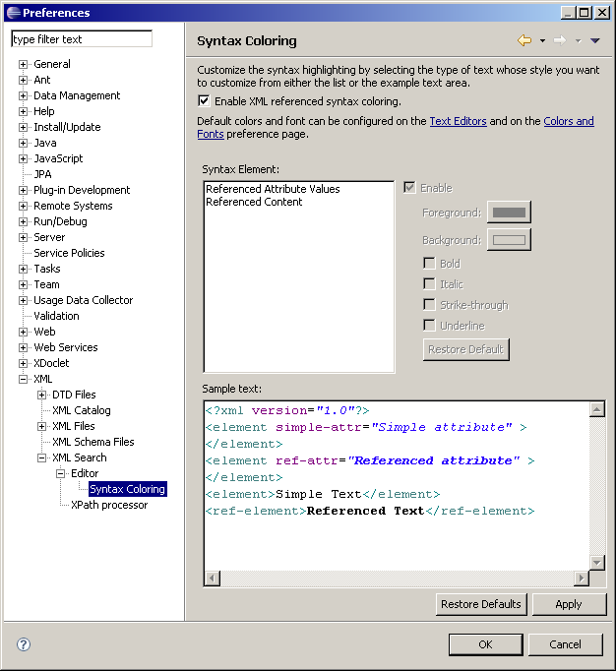

Java completion for @class attribute
The whole @class attribute can manage Java completion :

When Javadoc is available, it is displayed in the second popup :

Java validation for @class attribute
If class doens't exists, it appears with red marker :

Java hyperlink for @class attribute :
You can open the declared Java class.To do that select the class attribute and do Ctrl :

Hyperlink is activated, if you click on mouse, it opens Java class (in this demo, I have not ActionChainResult source):

Java Text Hover

When you hover the mouse to the class attribute, Java doc display :

Java method completion for action/@method
The action/@method attribute can manage Java method completion :

Java method validation for action/@method
If method doens't exists, it appears with red marker :

Java hyperlink for action@method attribute :
You can open the declared Java method .To do that select the method attribute and do Ctrl :

Hyperlink is activated, if you click on mouse, it opens Java class and select the method :

interceptor-ref completion
You can benefit for interceptor-ref completion for @name attribute. It display interceptor and interceptor-stack that you have declared :

interceptor-ref validation
If referenced interceptor doesn't exists, it appears as red marker :

interceptor-ref hyperlink
You can open the referenced interceptor.To do that select the name attribute and do Ctrl :

Hyperlink is activated, if you click on mouse, it select the interceptor declared :

interceptor-ref Text hover
When you hover the mouse to the name attribute of the interceptor-ref, information about referenced interceptor display (here basicStatck):

interceptor/interceptor-statck with Ctrl+Shift+G
You can retrieve the list of interceptor-ref which reference an interceptor or interceptor-stack

To do that, select @name attribute of the interceptor or interceptor-stack, and do Ctrl+Shift+G. XML search is launched and display interceptor-ref which are linked to :

After you can double click on node of Search result to open and select the result node :

result-type features
You have the same features for result-type (compeltion, validation, hyperlink and Ctrl+Shift+G) than interceptor :

Struts2 IDE – JSP Taglib
This section will describe the features of XML Struts2 IDE Plugins based on XML Search Engine.

JSP Taglib @action
Struts2 mailer sample declare thoses actions :

When you write JSP files, you can access to the action declared :

TODO : manage wildcard!!!

Hyperlink is managed to go the XML struts.xml :

Validation is managed :

Ctrl+Shift+G for action
You can do Ctrl+Shift+G for action declared in

Limitation
Welcome.jsp from Struts2 mailer declare s:url like this :

PAY ATTENTION!!! It's not a well XML (s:url element is included in the href attribute), so DTD completion doesn't works and WTP/XML search doesn't works (no completion available, validation....)

JSP Taglib @key

You can having comletion, hyperlink, validation with key of properties files. In Struts2 mailer sample you have this properties files :

For any Struts2 taglib which have « key » attribute, you can use completion :

TODO : manage search of file properties by following logic of Struts2 (name action = file properties name...)!!!

Hyperlink is managed to go the Properties file :

Validation is managed :

Struts2 IDE – XML XWork validator
Coming soon...

XML Search engine – UI Dialog
XML Search engine (see bug https://bugs.eclipse.org/bugs/show_bug.cgi?id=330576 ) give you the capability to search XML nodes in your XML ANY files (here screen are based on XML Jerrty plugins but you can use it with any XML files) with Xpath like Search/File...which is used to search some text in your files. XML Search engine is available with Search/XML... menu :

Search Xpath manual

Imagine you wish find every Nodes result-type which declare httphearder. The Xpath to use is :

/struts/package/result-types/result-type[@name="httpheader"]/@name

You can fill this Xpath in the Xpath field :

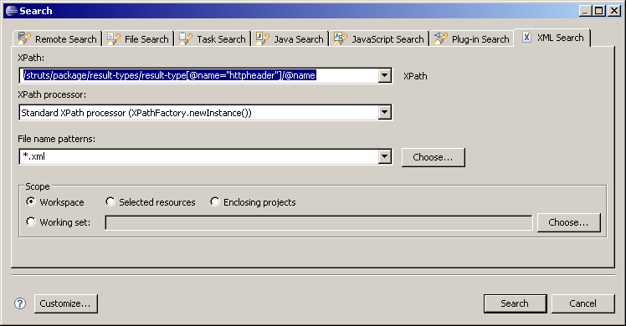
After clicking on Search button, the Search view display the result of the search :

Search Xpath automaticly
Fill the Xpath in the Xpath field can be boring. To do the same search that below, you can select a Node. In this sample we wish search

//struts/package/result-types/result-type[@name="chain"]/@name

to do that open an XML file which follow this Xpath and select the attribute name in the XML editor :

Open the XML Search (Search/XML...), the UI dialog opens and Xpath field is automaticly filled:

