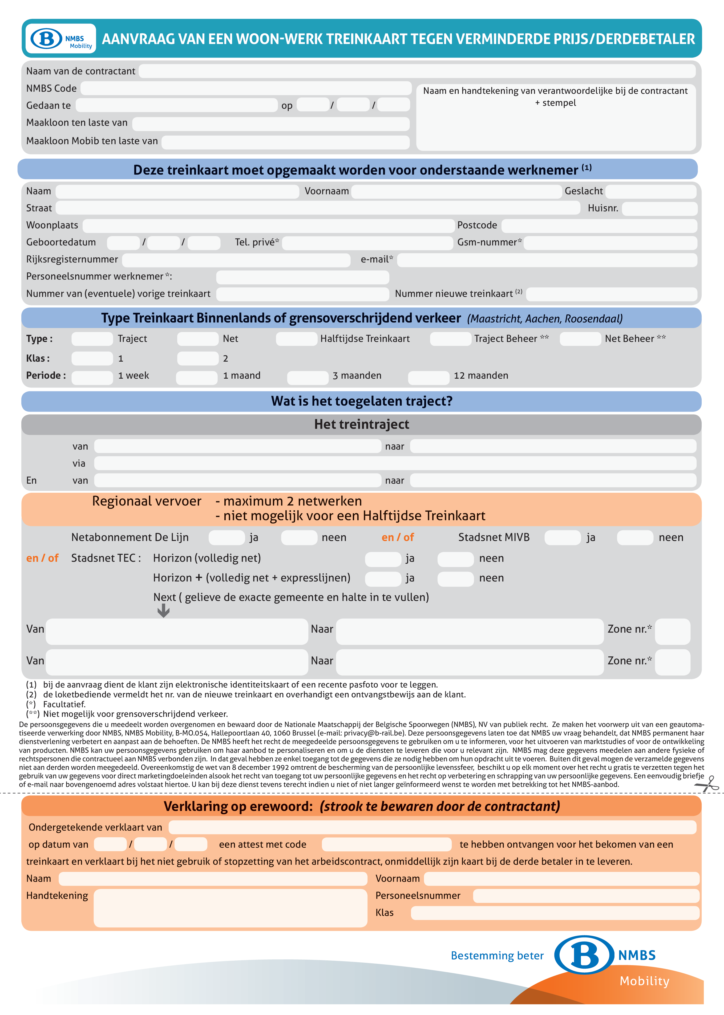

Bruxelles |  |  |  |  |  |  |  |  |  | 2012 |  |  |  | 08 |  | 01
 | reiziger
contractant
Tchize |  |  |  |  |  |  |  |  |  |  |  |  |  |  |  | Tchize |  |  |  |  |  |  |  |  |  |  |  |  |  | M
GPl street |  |  |  |  |  |  |  |  |  |  |  |  |  |  |  |  |  |  |  |  |  |  |  |  |  |  |  |  |  | 26

 |  |  |  |  |  | voyageur
contractant
Tchize |  |  |  |  |  |  |  |  |  |  |  |  |  |  |  |  | Tchize |  |  |  |  |  |  |  |  |  |  |  |  |  | M
GPL Street |  |  |  |  |  |  |  |  |  |  |  |  |  |  |  |  |  |  |  |  |  |  |  |  |  |  |  |  |  |  | 26

