Struts2 IDE - WTP XML Search Engine

Sommaire

1.Struts2 IDE - WTP XML Search Engine 2

2.Struts2 IDE – Struts.xml 4

2.1.Struts2 icons 4

2.2.Syntax coloring for referenced Nodes 4

2.3.Java completion for @class attribute 6

2.4.Java validation for @class attribute 7

2.5.Java hyperlink for @class attribute :  7

2.6.Java Text Hover 8

2.7.Java method completion for action/@method 8

2.8.Java method validation for action/@method 8

2.9.Java hyperlink for action@method attribute :  9

2.10.interceptor-ref completion 10

2.11.interceptor-ref validation 10

2.12.interceptor-ref hyperlink 10

2.13.interceptor-ref Text hover 11

2.14.interceptor/interceptor-statck with Ctrl+Shift+G 12

2.15.result-type features 13

3.Struts2 IDE – JSP Taglib  14

3.1.JSP Taglib @action 14

3.1.1.Ctrl+Shift+G for action 15

3.1.2.Limitation 15

3.2.JSP Taglib @key 16

4.Struts2 IDE – XML XWork validator 17

5.XML Search engine – UI Dialog 18

5.1.Search Xpath manual 18

5.2.Search Xpath automaticly 19

# Struts2 IDE - WTP XML Search Engine

This documentation show you Struts2 IDE which is Eclipse plugins to manage

* **XML struts.xml** : It provides completion, hyperlink, validation, text hover and Ctrl+Shift+G for Struts2 XML elements (ex : having completion for class attribute with Java class, having completion for interceptor-ref to display the whole of intercator and interceptor-stack...)
* **JSP taglib (s:form,...)** : It provides completion, hyperlink, validation, text hover and Ctrl+Shift+G for Struts2 XML elements (ex : having completion for action attribute declared in the struts.xml (<s:form action=), for messages key coming from files properties.
* **XML XWork validator** : It provides completion, hyperlink, validation and Ctrl+Shift+G for XWOrk validators XML elements (ex : having completion for messages key, for field name based on Java class...)

Struts IDE is based on WTP XML Search engine that I wish contribute to Eclipse WTP (see bug <https://bugs.eclipse.org/bugs/show_bug.cgi?id=330576> ).

The goal of this XML Search engine is :

* provides a search dialog (like Search/File..., Search/Java...) the capability to search XML files from workspace with Xpath. This dialog is available with the Search/XML... menu.
* using the XML search engine into custom Eclipse plugins to manage completion, hyperlink, validation (and Ctrl+Shift+G to retrieve referenced nodes) with some XML files. The XML Jetty plugin that I'm developping is the sample which use XML Search engine. In short, XML you can declare with Extension Point org.eclipse.wst.xml.search.core.references the references between XML Nodes in your plugins and you benefit automaticly completion, hyperlink, validation (and Ctrl+Shift+G to retrieve referenced nodes). I will explain more that step by step how developping Jetty plugins to manage XML Jetty files.

XML Search egine is splitted into 3 projects (links are SVN projects) :

* [**org.eclipse.wst.xml.search.core**](https://tk-ui.svn.sourceforge.net/svnroot/tk-ui/cnaf.sidoc.ide/org.eclipse.wst.xml.search.core) : the XML Search engine Core which provides XMLSearchEngine which can collect Nodes with Xpath. It use DOM SSE to load DOM Document to query with Xpath. This plugisn provides too the Extension Point org.eclipse.wst.xml.search.core.references.
* [**org.eclipse.wst.xml.search.ui**](https://tk-ui.svn.sourceforge.net/svnroot/tk-ui/cnaf.sidoc.ide/org.eclipse.wst.xml.search.ui/) : the XML Search engine UI which provides the Search UI Dialog to query XML files from workspace with Xpath. It provides too the Handler which is enable to manage Ctrl+Shift+G which use information about the Extension Point org.eclipse.wst.xml.search.core.references.
* [**org.eclipse.wst.xml.search.editor**](https://tk-ui.svn.sourceforge.net/svnroot/tk-ui/cnaf.sidoc.ide/org.eclipse.wst.xml.search.editor/) : this plugins is used when you wish write your own plugins which must manage completion, hyperlink, validation (and Ctrl+Shift+G to retrieve referenced nodes) with some XML files. It use org.eclipse.wst.xml.search.core.references to manage thoses features.
* [**org.eclipse.jst.jsp.search.editor**](https://tk-ui.svn.sourceforge.net/svnroot/tk-ui/cnaf.sidoc.ide/org.eclipse.jst.jsp.search.editor/) : this plugins is used when you wish write your own plugins which must manage completion, hyperlink, validation (and Ctrl+Shift+G to retrieve referenced nodes) with some Taglib used in JSP files. It use org.eclipse.wst.xml.search.core.references to manage thoses features.
* [**org.eclipse.wst.xml.search.xpath.processors**](https://tk-ui.svn.sourceforge.net/svnroot/tk-ui/cnaf.sidoc.ide/org.eclipse.wst.xml.search.xpath.processors) : this plugin is used to provides XPath Evaluator with WST Xpath2.0 (JFlexCupParser). Please read XPath processor section

If you wish test Struts2 IDE (no distibuable for the moment), you must get the below plugins and :

* [org.apache.struts2.ide.core](https://tk-ui.svn.sourceforge.net/svnroot/tk-ui/org.apache.struts2.ide/org.apache.struts2.ide.core)
* [org.apache.struts2.ide.ui](https://tk-ui.svn.sourceforge.net/svnroot/tk-ui/org.apache.struts2.ide/org.apache.struts2.ide.ui)
* [org.apache.struts2.ide.jsp.core](https://tk-ui.svn.sourceforge.net/svnroot/tk-ui/org.apache.struts2.ide/org.apache.struts2.ide.jsp.core)

# Struts2 IDE – Struts.xml

This section will describe the features of XML Struts2 IDE Plugins based on XML Search Engine.

## Struts2 icons

Struts IDE customize the icons of XML Struts file (with S blue) :

A description...

## Syntax coloring for referenced Nodes

When you have completion, validation, hyperlink, text hover available in the XML file, bold color is used :

A description...

You can customize this color with Preferences :

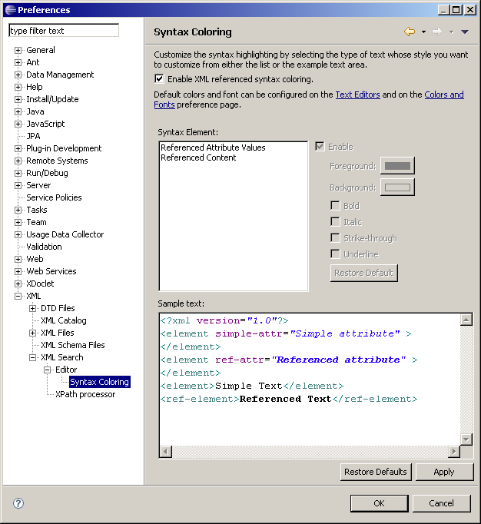

## Java completion for @class attribute

The whole @class attribute can manage Java completion :

A description...

When Javadoc is available, it is displayed in the second popup :

A description...

## Java validation for @class attribute

If class doens't exists, it appears with red marker :

A description...