|  |
| --- |
| http://thistimeimeanit.com/wp-content/uploads/2012/01/the-road-ahead.jpg |
| Dynamic Deployment Spec  ISC Team |
| |  |  |  | | --- | --- | --- | | Pankaj Sitpure | 1/5/13 |  | |

Contents

Introduction: 2

Requirement: 2

Implementation: 3

Definition: 3

UI changes: 4

Security Group Changes: 4

ADD Dynamic Deployment Spec Window: 5

Deployment Spec changes: 5

Database Changes: 6

Business Logic Changes: 6

Security Group based changes: 6

Deployment Spec based changes: 6

User Stories: 6

# Introduction:

The idea is to ask minimum piece of reusable information from user to create deployment specs on the fly when user creates a Security Group. This proposal brings following to ISC:

* Improved user experience
  + By removing the need to creating Deployment Spec we are reusing user’s information and providing security with minimum user interaction.
* Logical and efficient workflow.
* Minimum security Latency

**Current behavior:** User needs to create Deployment Spec to orchestrate a security appliance.

**New Behavior:** ISC will dynamically create deployments and called them “Dynamic Deployment Spec”. User will create this DDS at the time of binding Security Group to a service. User may or may not select these DDS while binding a Security Group.

If user selects/creates a DDS while binding a Security Group this entails user’s intent to provision security dynamically. However, if user does not select a DDS then user will be responsible for creating DS manually.

The lifecycle of DDS is same as existing Deployment Spec the only difference is these dynamic deployment specs created by ISC contains a Boolean flag set to true compared to the ones created by user. User can perform CRUD operations on DDS from DS sub view.

# Requirement:

The following are the requirements for this proposal:

1. Biding Security Group to a service should trigger dynamic creation of Deployment Spec if user creates/selects one.
   * If DDS already exists we should reuse it and accommodate changes into it.
2. Minimize user latency i.e. user does not have to wait until deployment spec is created after creating groups. As soon as user creates groups we should protect those members.
3. Take in consideration to minimize staled information.

# Implementation:

## Definition:

DDS stands for Dynamic Deployment Spec. As the name suggests it is a dynamic version of existing Deployment Spec. Its lifecycle is managed by ISC however, user can perform CRUD on these from DS sub view.

The differences between DDS and existing DS are as follows:

|  |  |  |
| --- | --- | --- |
| Category | Dynamic Deployment Spec | Deployment Spec |
| Creation | ISC | User |
| Dynamic Flag | True | False |
| Type | Host (always) | Host, AZ, HA etc. |
| Security Group in Context | Referenced to the SG(s) | N/A |

A DDS holds the following information.

* Name: String given by the user for this DDS
* Security Tenant: Tenant responsible for provisioning Security for your Data Center
* Region: DDS belongs to
* Protection Scope :
  + Host (Default User cannot select or modify this)
* Floating IP Range: Range of IPS used by all the Deployment Specs instantiated using this DDS.
* Inspection Network: Network which will be used to inspect traffic.
* Management Network: Network used to manage SVAs
* Dynamic flag marked true to discriminate this DDS from user created DS

## UI changes:

This proposal will change the UI workflow as following:

### Security Group Changes:

* While binding Security group to a Service we will add new column which will allow user to provision dynamic deployments using “options” link.
* 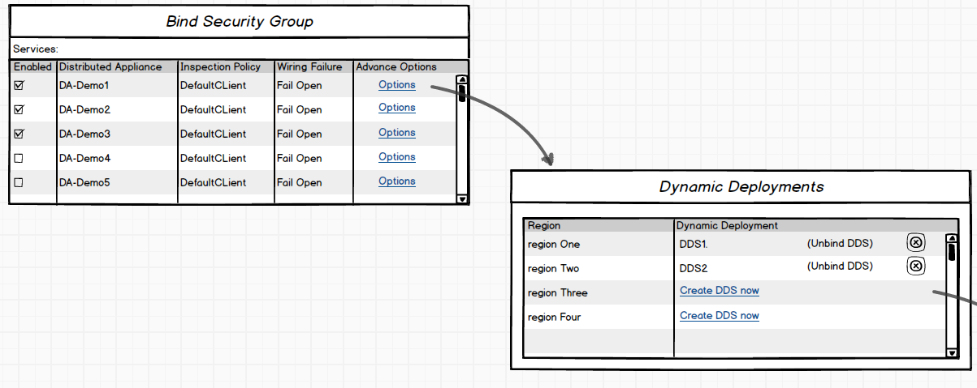We need to update existing Bind windows to accommodate DDS as a part of it. The following mockup displays how our modified Bind workflow will look like the following:

As you can see above user from this updated window will be able create DDS on the fly if he wants to protect these members right away.

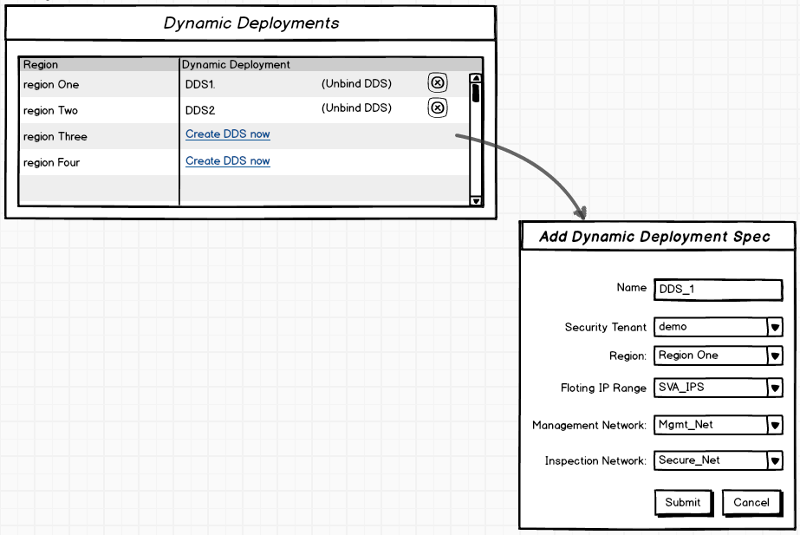

### ADD Dynamic Deployment Spec Window:

* We will add a new window called “Add Dynamic Deployment Spec” this window will only be accessible from *“Bind SG -> Options -> Create DDS Now”* as displayed above.

### Deployment Spec changes:

* Now in the DS view we will have both DS and DDS displayed in the same view. User will be able to manage lifecycle of DDS in very similar way as DS through this view.
* The only difference is when user edits the DDS he will see an extra field which is called “dynamic” (or “auto_create”) as true.
* Once created this can be reused by another Security Group having the same combination of Tenant + Region.
* If used adds a new Security group by reusing the same DDS we will modify this DDS and add required HOST members to protect newly added SG/SGM(s)

## Database Changes:

We will have to make the following changes to our Database in order to accommodate this change:

* Create a *DDS to Region* table
* Add a reference of SGI in this table with proper relationship
* Update DS table to have a Boolean flag (dynamic (or auto_created) = true/false)
* Need to modify respective Entity managers to provide functionalities based on new flag

## Business Logic Changes:

We need to create the following functionalities to support this change:

### Security Group based changes:

* Bind security group service needs to be updated to accommodate this new DDS construct
* SG sync needs to verify all DDS attached with SG and if DDS is deleted then needs to modify it accordingly (i.e. remove reference of that DDS from SG).

### Deployment Spec based changes:

* Needs a add DDS service which will create a dynamic DS with host type members and add it to a DS table.
* List DDS service which will be called by ADD SG filtered based on Tenant+Region in context.

## User Stories:

* Create SG using tenant1 with region1
  + Bind SG1 – DA1
    - Create DDS1 (User intended to have dynamic deployment)
* Create SG using tenant1 with region1
  + Do not create DDS (or unselect DDS is exist)
  + User needs to manually create DS for security appliance deployments

# Testing:

To test this feature you have to keep the following scenarios in mid:

# Positive test cases:

Creating a DDS:

To create a dynamic deployment spec.

* On Virtualization Connector View: Click “*Bind*” button and click “*Manage Dynamic Deployments*” link.
* Click on “*Create Dynamic Deployment Spec*” link

Note:

* + If you already have on DDS for that Virtual System + Region combination you cannot create another until you delete exiting one as you are supposed to reuse DDS.
  + You can delete the existing from the deployment sub-sub view from Distributed Appliance View.

Adding DDS to SGI:

To map a DDS to a Security Group Interface:

* On Virtualization Connector View: Click “*Bind*” button and click “*Manage Dynamic Deployments*” link.
* It will show you available DDS based on region. Click “*OK*” on this window and “*OK*” on Bind Security Group Window. This will map selected DDS with SGI in context.
  + Note: TO map DDS with SGI it is mandatory that SGI is binded. If user unbinds SGI we will remove respective DDS binding from current SGI.

Removing DDS from SGI:

To remove a DDS mapping from current Security Group Interface:

* On Virtualization Connector View: Click “*Bind*” button and click “*Manage Dynamic Deployments*” link.
* It will show you available DDS based on region. Click “*X*” button on each DDS you want to remove from current SGI and click “*OK*” on this window followed by clicking “*OK*” on Bind Security Group Window. This will map selected DDS with SGI in context.

Unbind SGI:

If you unbind SGI all the mappings of this SGI with all DDS will be removed.

Adding SGM to a SG:

When you add a new member inside a Security Group which is using DDS for security provisioning. SG sync will automatically figure out Host based on the member added and will deploy if none exist a new instance of Security Appliance in order to protect this member

* Note: Assuming this SG is bind using a service and also mapped with DDS for every region in VC.

Removing SGM from a SG:

When you remove a member from a given security group which is binded with s service and is mapped with a DDS. SG sync will remove unnecessary DAI which were installed to protect this member.

Summary Positive Test Cases:

|  |  |  |
| --- | --- | --- |
| Entity | Operation | Expected Behavior |
| SGM | Added | SG Sync Job will also sync related DDS before adding inspection Hooks |
| SGM | Deleted | SG Sync Job will also sync related DDS after removing inspection Hooks |
| SGM | Added and Deleted | Combine SGM ADD and SGM Delete both together in one Sync Job |
| SGI | Bind | Bind SG Sync Job will sync related DDS |
| SGI | Unbind | Bind SG Sync Job will remove all DDS mappings |
| SGI | Bind and Unbind | Combine Bind SGI and Unbind SGI together in one Sync Job |
| DDS | Added to SGI | Bind SG Sync Job will sync related DDS before syncing SG |
| DDS | Removed SGI | Bind SG Sync Job will sync related DDS after syncing SG |
| DDS | Added and Removed | Combine Added and removed DDS -> SGI in one sync Job |