Danphe Data Analysis Project

(DEDA)

V 1.1

Contents

Revision 1

Introduction 1

Installation types 1

SSIS , SSAS and SSRS and Power BI. 1

Only Express edition 2

Features 2

## Revision

|  |  |  |
| --- | --- | --- |
| **Version** | **Date of revision** | **Description** |
| Document created (1.0) | 8/1/2024 |  |
| 1.1 | 8/13/ | Updated with projection and different installation types. |
|  |  |  |

## Introduction

## Installation types

### SSIS , SSAS and SSRS and Power BI.

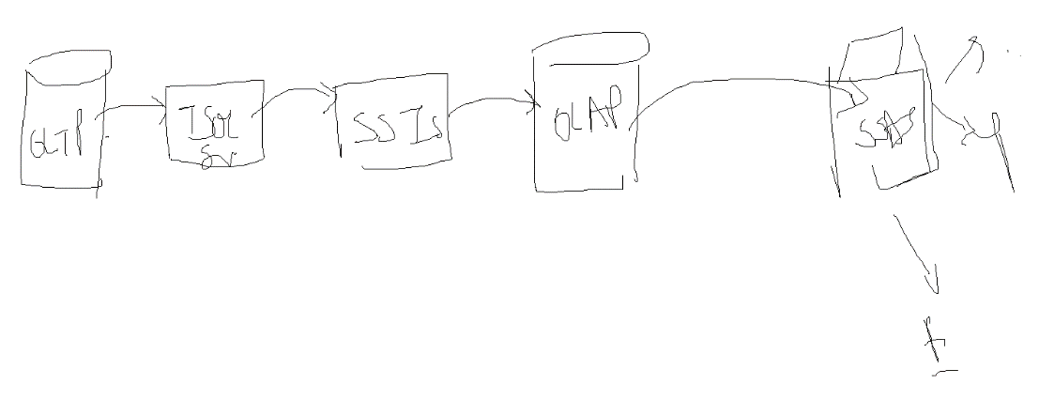

### Only Express edition

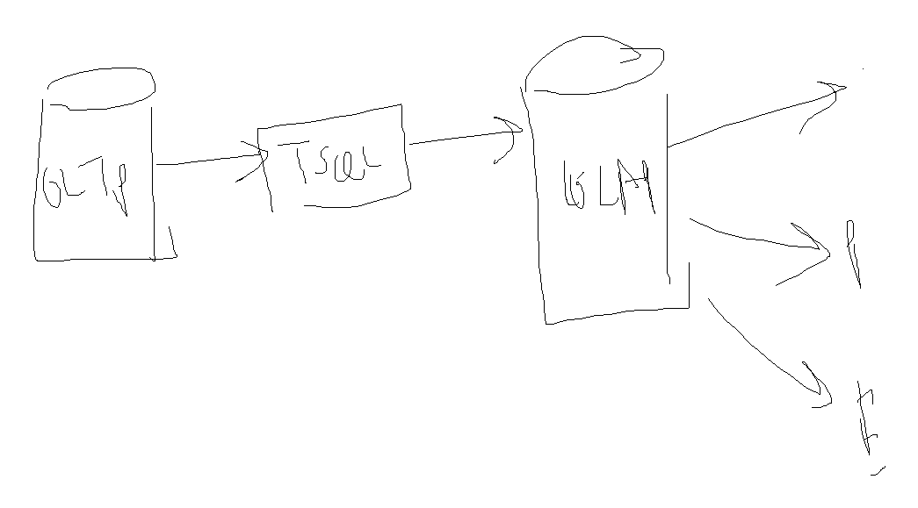

DEDA should be capable to provide analysis using simple SQL Express and TSQL Script.

## Features

* Month wise , year wise and day wise patient count.
* Month wise , year wise and day wise billing amount.
* Patient count and Billing amount service department wise.
* How many patient doctor attended month wise , year wise , day wise
* Billing amount and Patient count projection for coming 3 months.