First Steps
Rivendell-based Radio Automation Machine and Studio Audio Workstation for KVWH-LP

Introduction and Unpacking
This document describes first steps in using your broadcast broadcast automation system. Now that you've unpacked the boxes and torn into the goods, make sure everything is here:
- Radio Automation Machine (RAM) rack-mount enclosure (separate shipping box)
- Studio Audio Workstation (SAW) rack-mount enclosure (separate shipping box)
- Audio card breakout cables (one set in each box)
- Power “bricks” and cables (one set in each box)
Secure the RAM in an appropriate place for your installation. We suggest a 19-inch rack, but put it anywhere safe and out of the way. Make sure you provide for a LAN connection (up to 1Gbps, [10000BaseT]). Secure the SAW in a 19-inch rack in your studio.
You need to supply and route two sets of balanced audio cables (one each for the Left and Right channels for a stereo broadcast): one set for the SAW, and one set for the RAM. The Digigram audio card requires XLR connectors to connect to the SAW and the RAM.
You also need to supply Cat5e (or better) Etherenet cables with RJ-45 connectors for the RAM and the SAW, and a USB cable for connecting the ARC-8 mixing board to the SAW.

SAW and RAM Cabling and Connections
Photo 1 shows the rear of the SAW and highlights the relevant connections. Photo 2 shows the rear of the RAM with relevant connections highlighted.
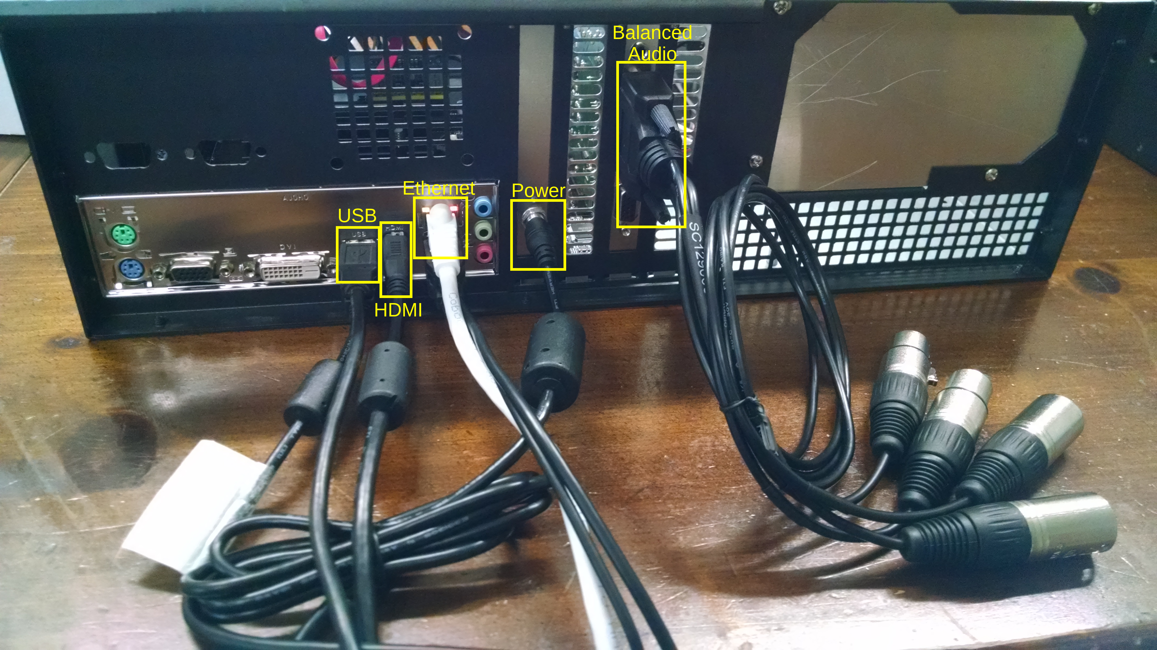Photo 1: SAW Rear Panel with Connctions
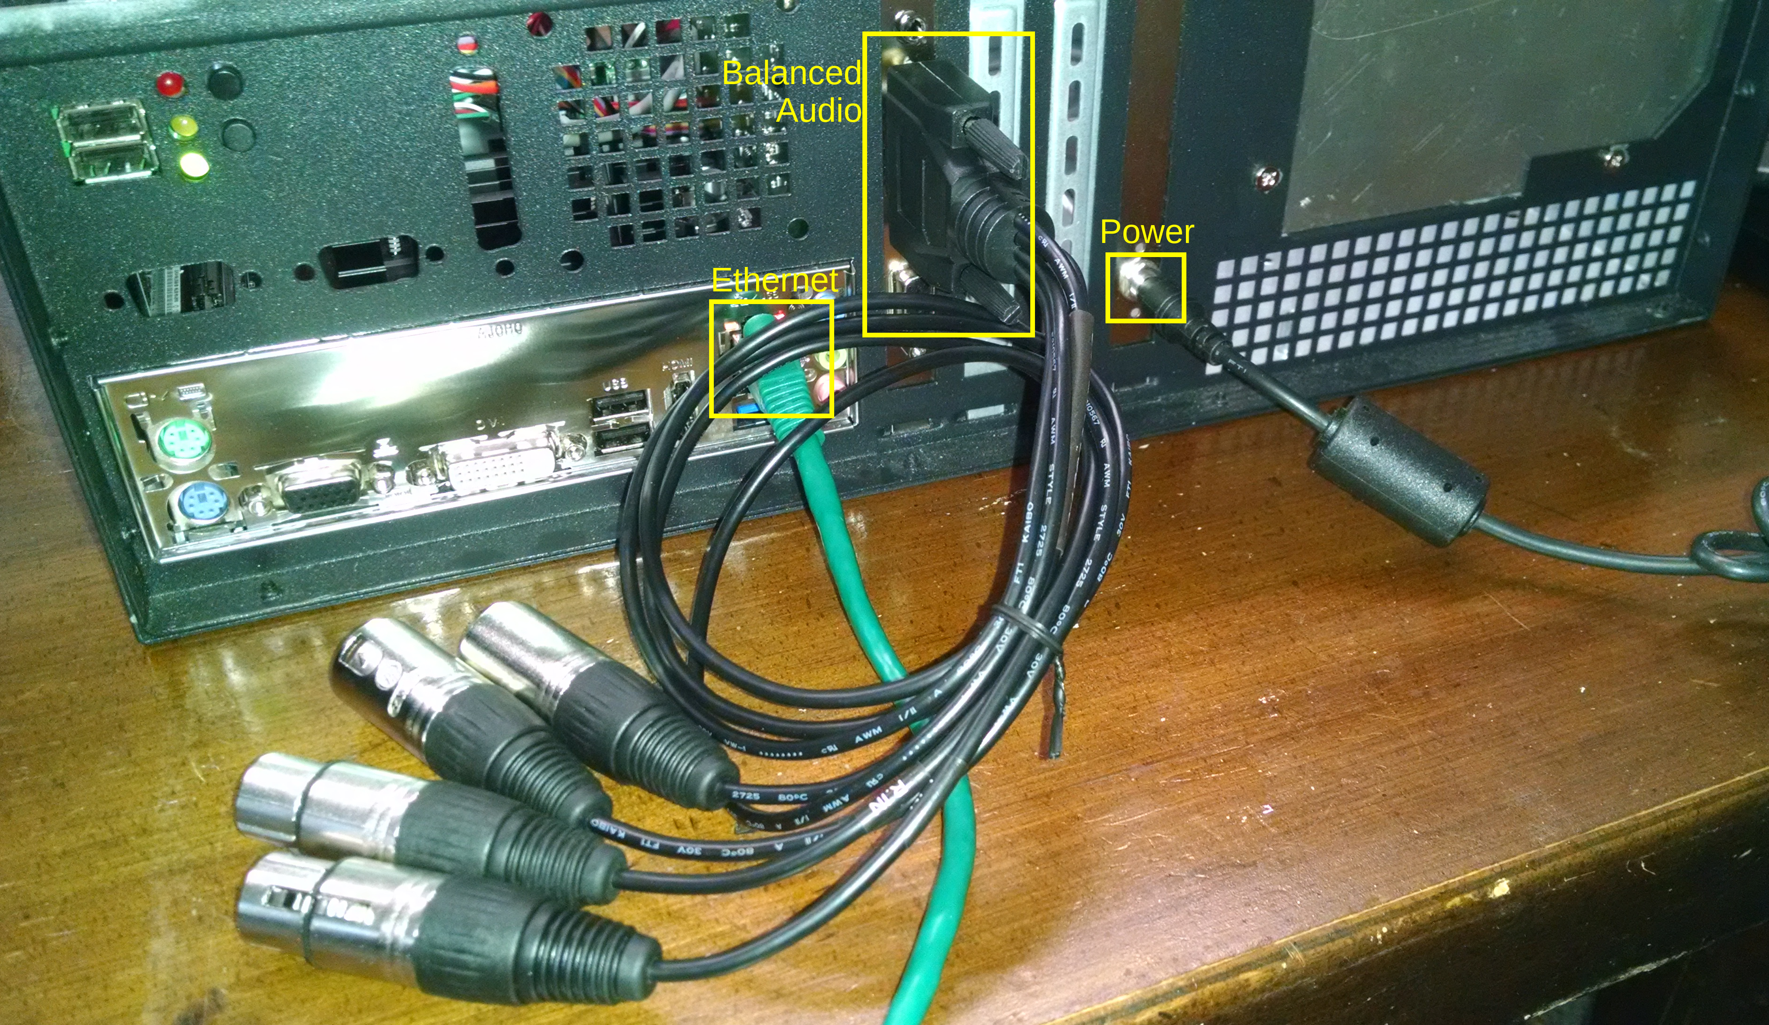Photo 2: RAM Rear Panel with Connections

Saw Connections
- Use Category 5e (or better) Ethernet cables (not included) to connect the SAW to your LAN switch.
- Connect your ARC-8 audio mixing board to the SAW using a USB cable (not included). Use any USB connector other than the blue USB-3 connector for the ARC-8 connection to the SAW (the blue USB-3 connector is reserved for the touchscreen display). Photo 3 shows the SAW rear panel with the USB-3 connector highlighted.
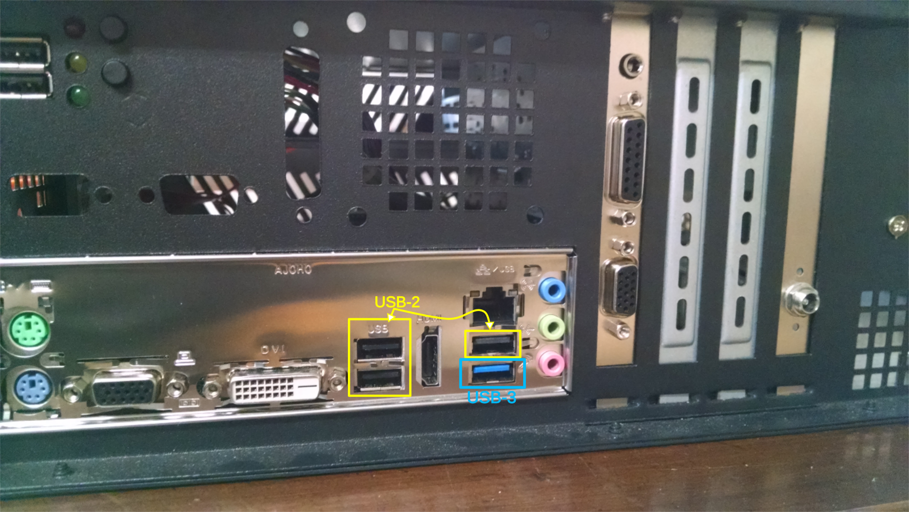
- Connect the HDMI and USB cables included with your touchscreen display to the rear of the SAW (see Photo 1). You may also want to connect a USB (or PS/2) keyboard and a USB (or PS/2) mouse.
- Use the power cable provided to plug in your SAW. It will turn on automatically when power is applied (see Photo 1).

RAM Connections
- Use Category 5e (or better) Ethernet cables (not included) to connect RAM to your LAN switch.
- Connect audio cables from your ARC-8 audio mixing board main output to the Left and Right inputs of the Digigram audio card in the RAM. Photo 2 shows a RAM rear panel with the Digigram audio card and the balanced audio breakout cable.
- Use the power cable provided to plug in your RAM. It will turn on automatically when power is applied (see Photo 1).

Network Configuration
The MAC address for this SAW is: D0:50:99:4B:D5:D2
The MAC address for this RAM is: D0:50:99:49:FA:9C
The MAC address for the service virtual machine is: 52:54:00:A2:12:7F
The MAC address for the fm-automation virtual machine is: 52:54:00:F4:BE:56
The MAC address for the apps virtual machine is: 52:54:00:73:F7:1F
You may be able to start using your RAM and your SAW as soon as you turn them on. They (and the virtual machines contained within the RAM) are configured to obtain Internet Protocol (IP) addresses from your DHCP server. Using the above MAC addresses, you may want to configure your DHCP server to issue statically assigned IP addresses, or “static reservations” to the each of the hosts.
The SAW is configured to start and sign in as the user “ramuser”. This user ID is configured to “own” all the audio devices; ramuser also “owns” all the Rivendell services and JACK digital audio “ports”. Your access to audio and Rivendell services may not work if you log in with a different user ID.
The RAM is meant to run as a “headless” system and therefore no user is configured to log in. You may use the emergency user pmwtech to access the RAM and its virtual machines if necessary. Use a Secure Shell client (e.g., ssh pmwtech@kwvh-ram) to access the RAM. The password for the user pmwtech is phantommachineworks.

Document History
Revision Date | Editor | Change Summary
2016-02-23 | David Klann | Initial revision
2016-02-24 | David Klann | Add SAW photo with USB connectors annotated

