5.7.3 Blackline Master
Matching Descriptions to Graphs  Card 1  The value of a company’s stock doubles approximately every 4 years.  The relationship between the number of years since purchasing the stock and the stock value. | Matching Descriptions to Graphs  Card 5  The value of a company’s stock triples roughly every 8 years.  The relationship between the number of years since purchasing the stock and the stock value.
Matching Descriptions to Graphs  Card 2  A car loses $\frac{1}{4}$ of its value every year after purchase.  The relationship between the number of years since purchasing the car and the value of the car. | Matching Descriptions to Graphs  Card 6  A car loses $\frac{2}{5}$ of its value every year after purchase.  The relationship between the number of years since purchasing the laptop and the value of the laptop.
Matching Descriptions to Graphs  Card 3  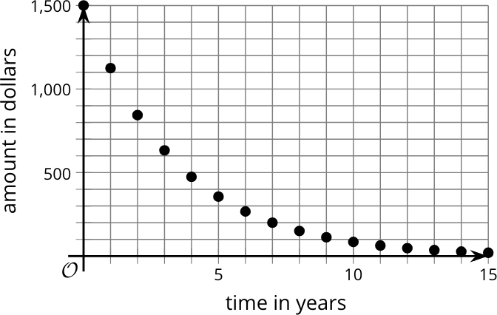 | Matching Descriptions to Graphs  Card 7  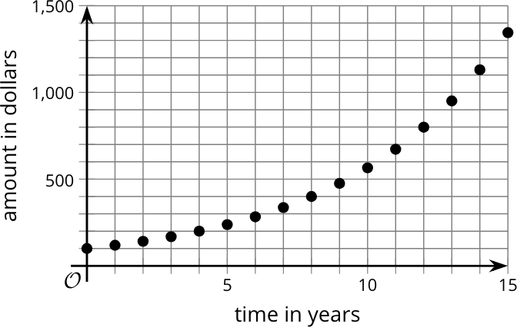
Matching Descriptions to Graphs  Card 4  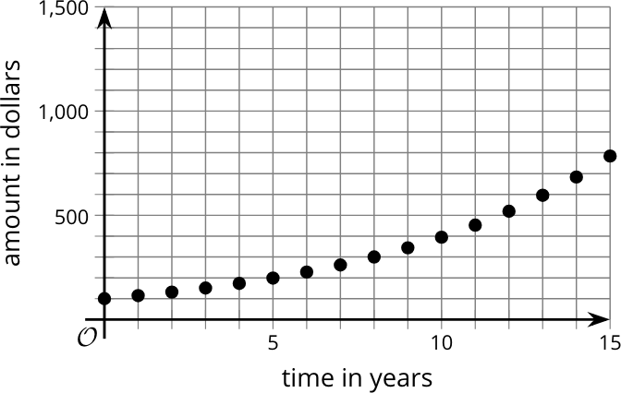 | Matching Descriptions to Graphs  Card 8  