1.11.6 Lesson Synthesis

Graph Images

Graph A
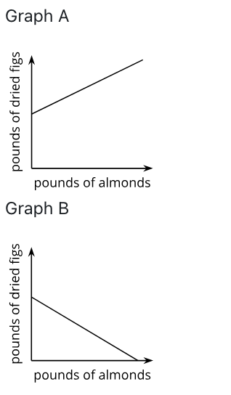

Graph B



