7.12.4 Card Sort
Card Sort: Representations of Quadratic Functions  $$y=x^{2}-1$$ | Card Sort: Representations of Quadratic Functions  $$y=x\left(x-4\right)$$
Card Sort: Representations of Quadratic Functions  $$y=x^{2}-4x+4$$ | Card Sort: Representations of Quadratic Functions  $$y=\left(x+1\right)\left(x-1\right)$$
Card Sort: Representations of Quadratic Functions  $$y=\left(x-1\right)\left(x-4\right)$$ | Card Sort: Representations of Quadratic Functions  $$y=x^{2}-4x$$
Card Sort: Representations of Quadratic Functions  $$y={\left(x-2\right)}^{2}$$ | Card Sort: Representations of Quadratic Functions  $$y=x^{2}-5x+4$$
Card Sort: Representations of Quadratic Functions  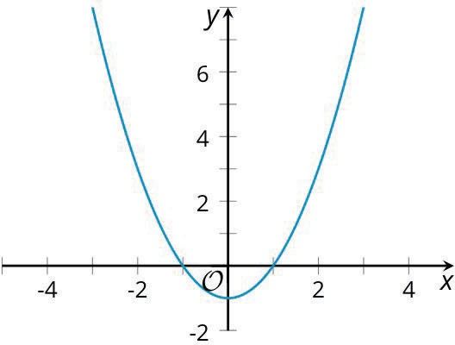 | Card Sort: Representations of Quadratic Functions  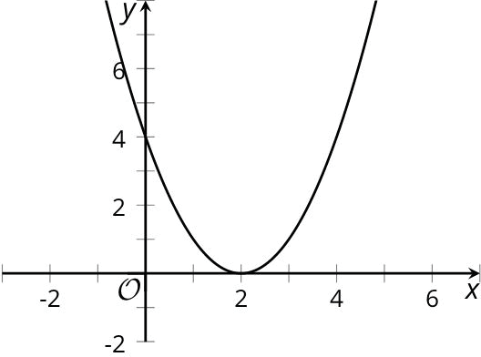
Card Sort: Representations of Quadratic Functions  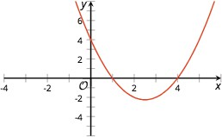 | Card Sort: Representations of Quadratic Functions  