8.1.2 Framing Materials

Picture Dimensions: 7 inches by 4 inches
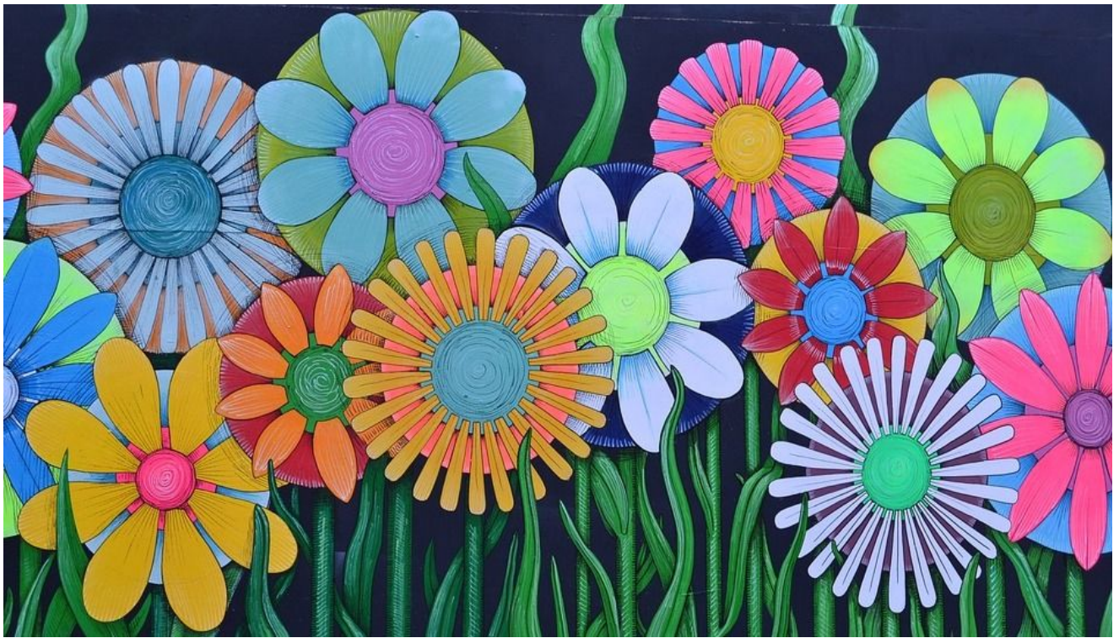

Framing Material Dimensions: 4 inches by 2.5 inches (set of 3)

