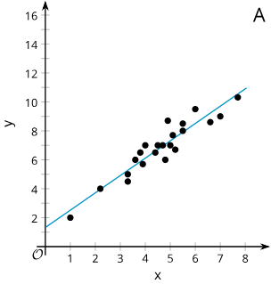
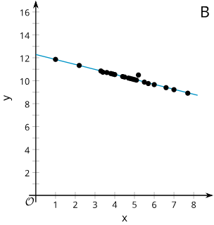
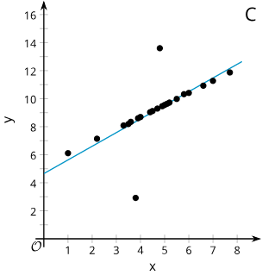
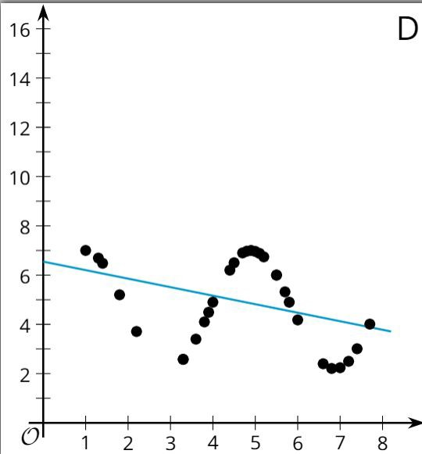
Card Sort: Data Patterns
Card Sort: Data Patterns
Card Sort: Data Patterns
Card Sort: Data Patterns
Openstax CC BY NC SA
Algebra 1, brought to you by Openstax

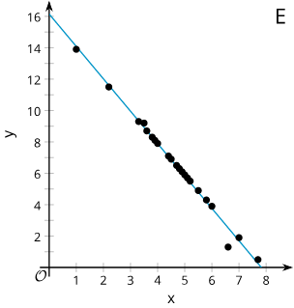
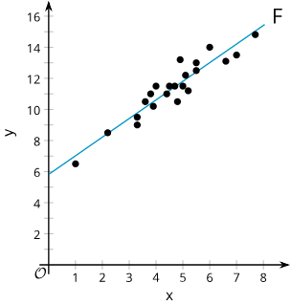
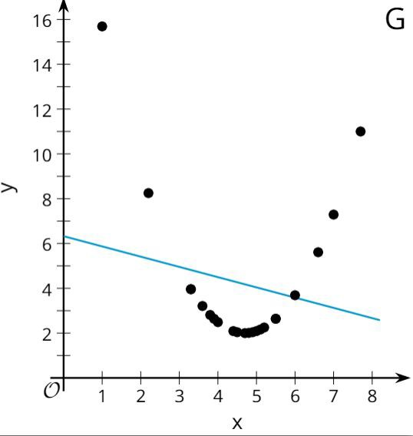
Card Sort: Data Patterns
Card Sort: Data Patterns
Card Sort: Data Patterns
Openstax CC BY NC SA
Algebra 1, brought to you by Openstax

