Card Sort: Scatter Plot Fit

A
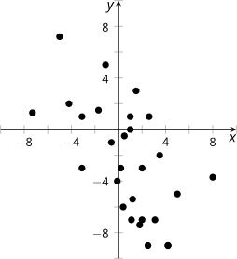
Card Sort: Scatter Plot Fit

B

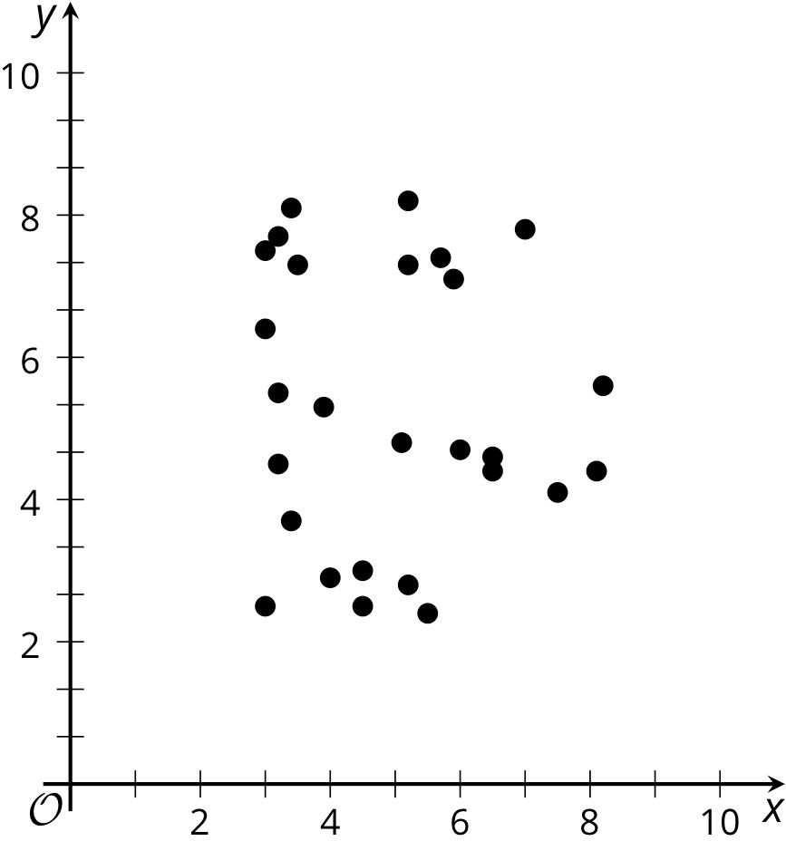

Card Sort: Scatter Plot Fit
Openstax CC BY NC SA
Algebra 1, brought to you by Openstax

C
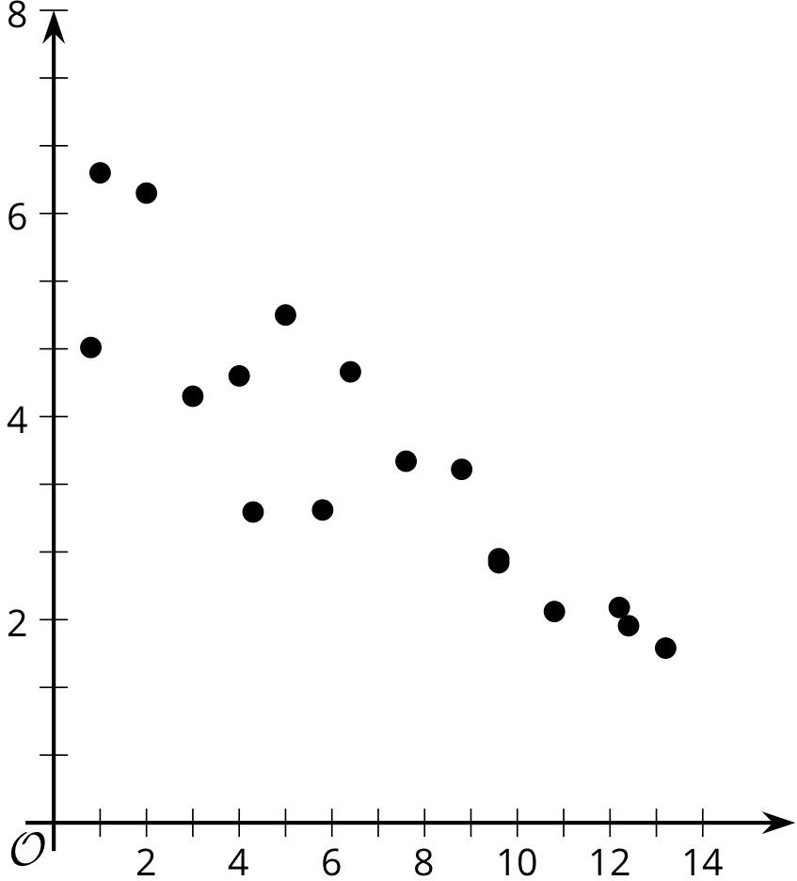
Card Sort: Scatter Plot Fit

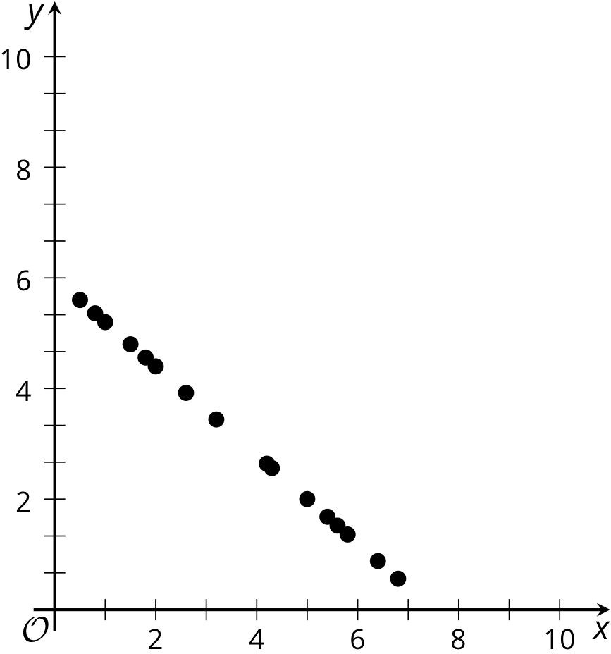
D

Card Sort: Scatter Plot Fit

E
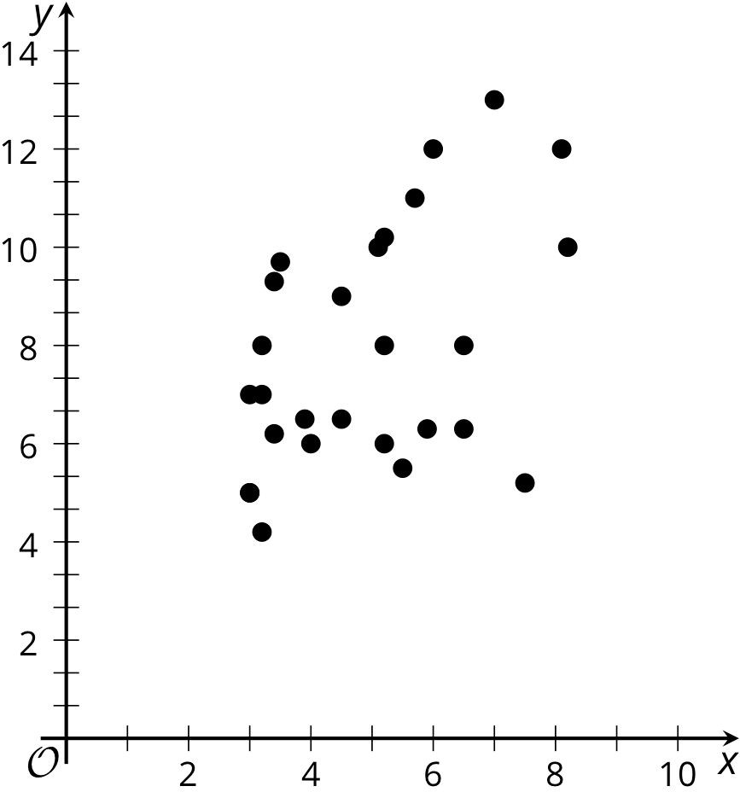
Card Sort: Scatter Plot Fit

F

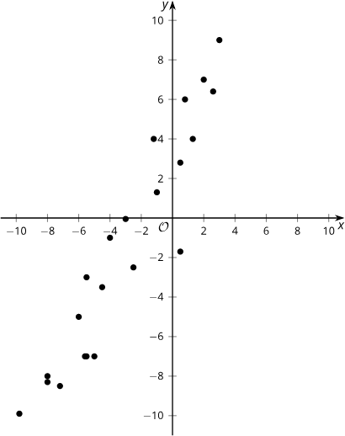

Card Sort: Scatter Plot Fit
Openstax CC BY NC SA
Algebra 1, brought to you by Openstax

G
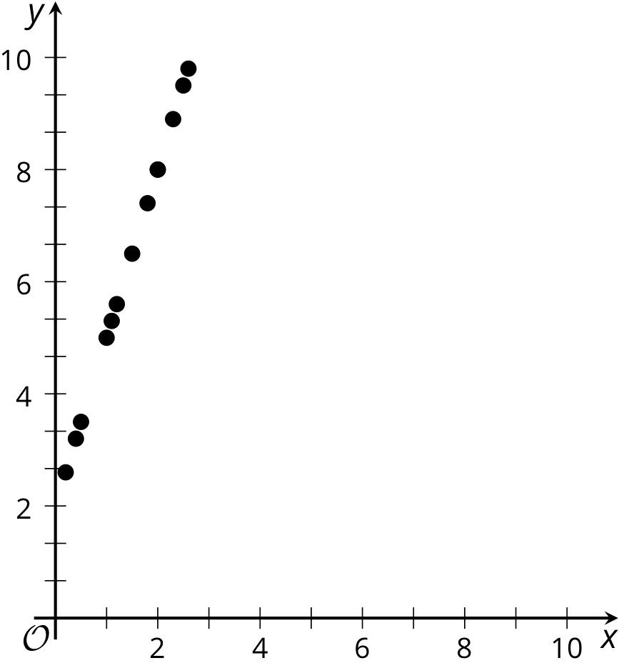
Card Sort: Scatter Plot Fit
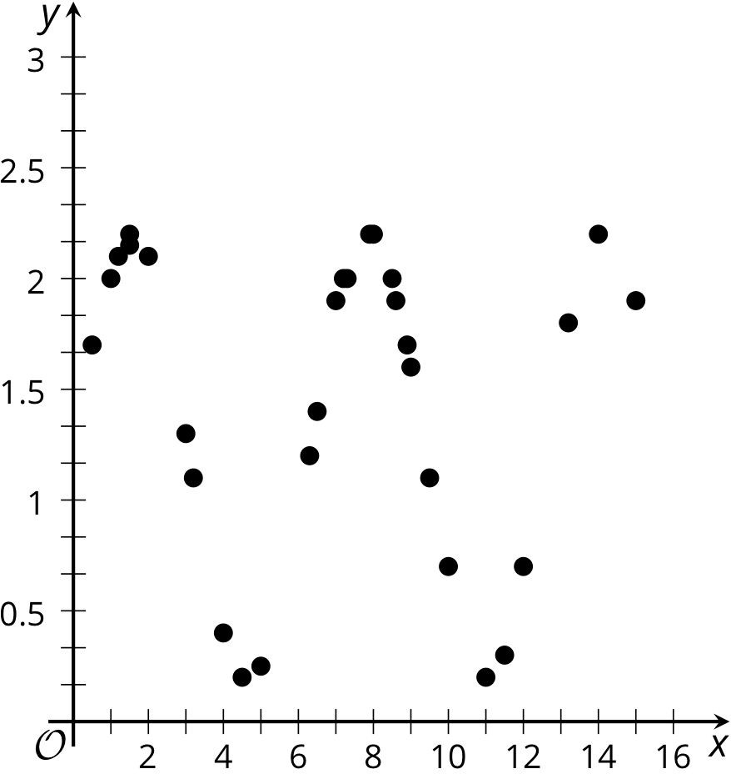
H

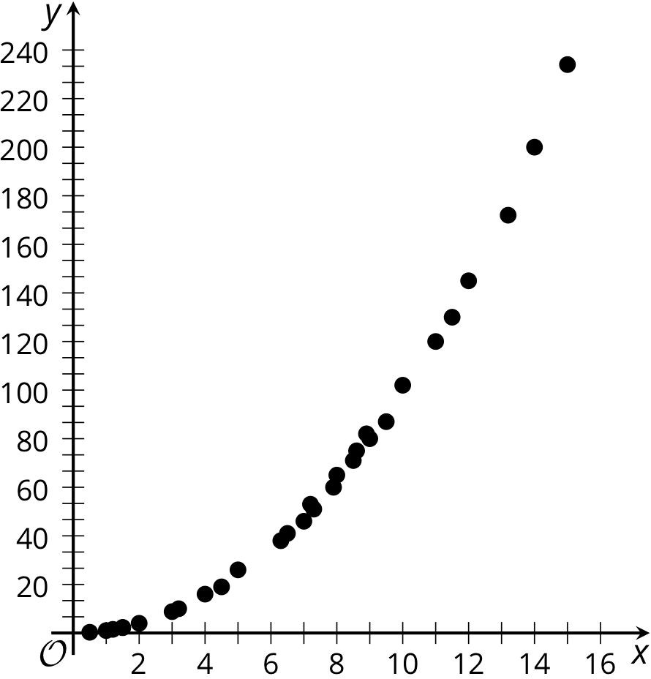
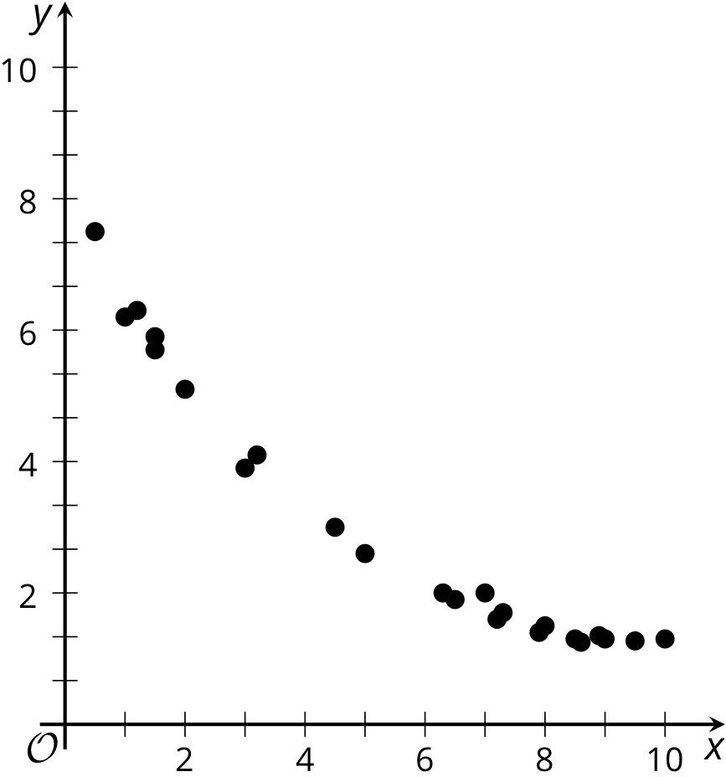
Card Sort: Scatter Plot Fit
I
Card Sort: Scatter Plot Fit
J
Openstax CC BY NC SA
Algebra 1, brought to you by Openstax

