Info Gap: Terms of a Team

Problem Card 1
To participate in a competition, each team must follow the rules about the allowable number of adults and children on a team.
- A team has 6 adults and 8 children. Does the team meet all the membership rules of the competition?
- What is the maximum number of adults allowed on a team?
If helpful, use the coordinate planes in your workbook or graph paper.
Info Gap: Terms of a Team

Problem Card 2
Another competition has diﬀerent membership rules.
- What is the minimum number of members that a team could have? How many adults and children would be on that team?
- What is the maximum number of adults allowed on a team?
If helpful, use the coordinate planes in your workbook or graph paper.

Info Gap: Terms of a Team

Data Card 1
  - A team without adults is allowed.
  - A team with only adults is not allowed.
  - If 3 adults are on a team, there must be at least 6 children.
  - Each team must have no more than 16 members in total.
  - The number of adults must be at most half the number of children on the team.
Info Gap: Terms of a Team

Data Card 2
  - A team with only adults is not allowed.
  - A team with only children is not allowed.
  - The number of children must be at least 3 times that of adults.
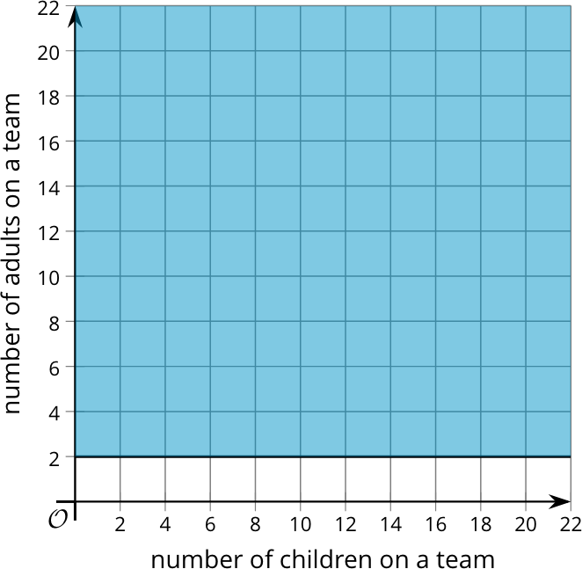
  - The total number of people cannot exceed 20.
  - This graph represents a rule about the number of adults on a team.

