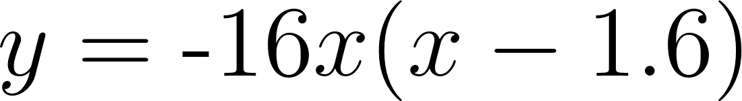


Info Gap: Toy Rocket

Problem Card 1

Kiran was timing the ﬂight of his toy rocket. It launches straight up from the ground.
- How many seconds after launch did the rocket reach the highest point?
- The rocket was 8.8 feet above ground on the way up and again on the way down. How many seconds passed between the two times it was 8.8 feet above ground?
Info Gap: Toy Rocket

Data Card 1

- The stopwatch showed 0 seconds when the toy rocket blasted oﬀ from the ground.
- It landed back on the ground when the stopwatch showed 1.6 seconds.
- The second time the rocket reached 8.8 feet, the stopwatch showed 1.1 seconds.

Info Gap: Toy Rocket

Openstax CC BY NC SA Algebra 1, brought to you by Openstax

Problem Card 2

- How many feet above the ground did the toy rocket go?
- Jada suggested they put Kiran’s rocket on a platform and then launch the rocket from there. Will the rocket reach 20 feet above ground at its highest point?
Info Gap: Toy Rocket

Data Card 2

- The equation modeling the height of Kiran’s toy rocket was

- Represents the height above ground in feet, and represents time in seconds.
- The platform is 4 feet above ground.

