4.1.2 Handout

Graph Images

Day 3: Complete with teacher
Copy the graph from your teacher about the dog’s movement on Day 3. 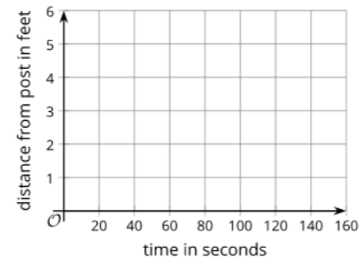

Instructions
Graph the day’s movement you were assigned. Then share with someone else from your group who had the other day. Make sure you have both graphs.

Day 1: The dog walked around the entire time while waiting for its owner. 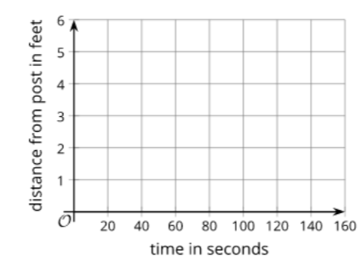

Day 2: The dog walked around for the first minute, and then laid down until its owner returned.



