Card Sort: Representations of Inequalities

situation
- A jar contains only nickels and dimes.
- There is no more than $6 in the jar.
- x represents the number of nickels and y represents the number of dimes in the jar.

Card Sort: Representations of Inequalities

situation
- The length of a rectangle is represented by x and its width is represented by y.
- The perimeter of the rectangle is greater than 240 units

Card Sort: Representations of Inequalities

Inequality

$$y≥100$$

Card Sort: Representations of Inequalities

inequality

$$4x+3y≥240$$

Card Sort: Representations of Inequalities

a solution

$$\left(80,30\right)$$
Card Sort: Representations of Inequalities

a solution

$$(20, 50)$$

Card Sort: Representations of Inequalities
Openstax CC BY NC SA Algebra 1, brought to you by Openstax

graph
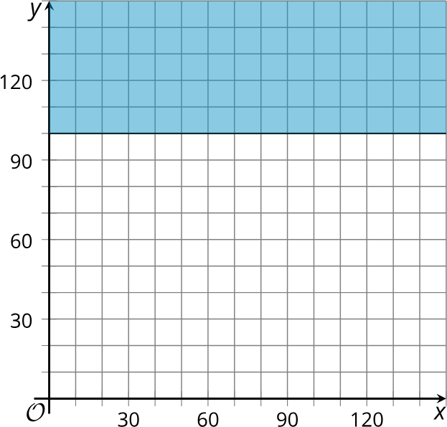
Card Sort: Representations of Inequalities

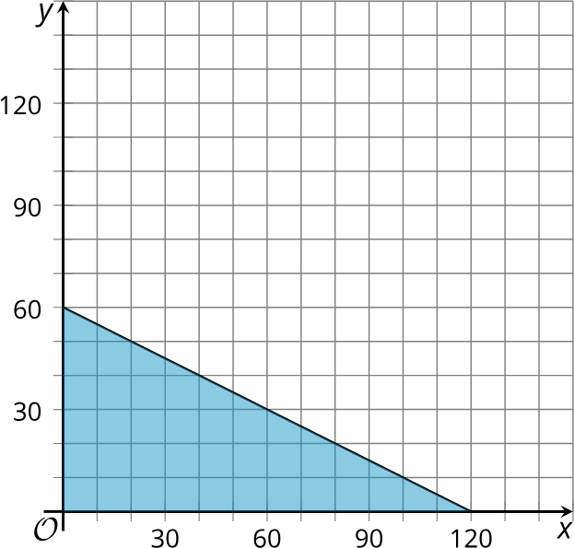
graph

Card Sort: Representations of Inequalities

situation
- A seller at the Saturday market sells honey and jam. He wants to make at least
$240 proﬁt this Saturday.
- He makes $4 proﬁt for each jar of honey he sells and $3 proﬁt for each jar of jam.
- x represents the number of jars of honey he sells and y represents the number of jars of jam.

Card Sort: Representations of Inequalities

situation
- A school is organizing a service trip. Students and teachers can sign up to go.
- x represents the number of teachers who sign up and y represents the number of students.
- The trip will only take place if at least 100 students sign up.

Card Sort: Representations of Inequalities

Inequality

$$0.05x+0.10y≤6.00$$
Card Sort: Representations of Inequalities

inequality

$$2x+2y>240$$

Card Sort: Representations of Inequalities

a solution

$$\left(80,50\right)$$
Card Sort: Representations of Inequalities

a solution

$$(20, 100)$$

Card Sort: Representations of Inequalities
Openstax CC BY NC SA Algebra 1, brought to you by Openstax

graph
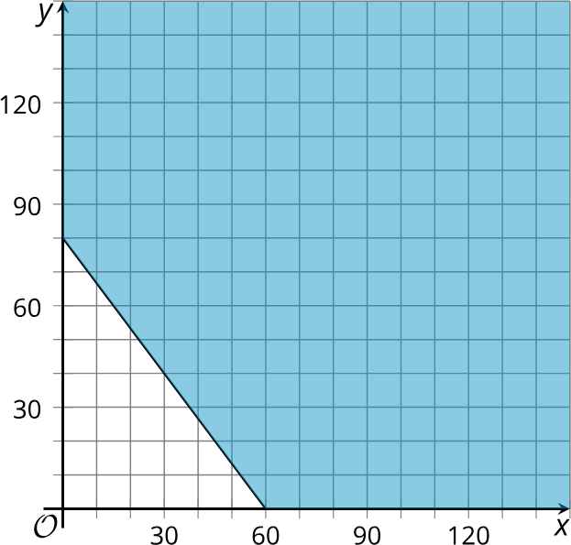
Card Sort: Representations of Inequalities
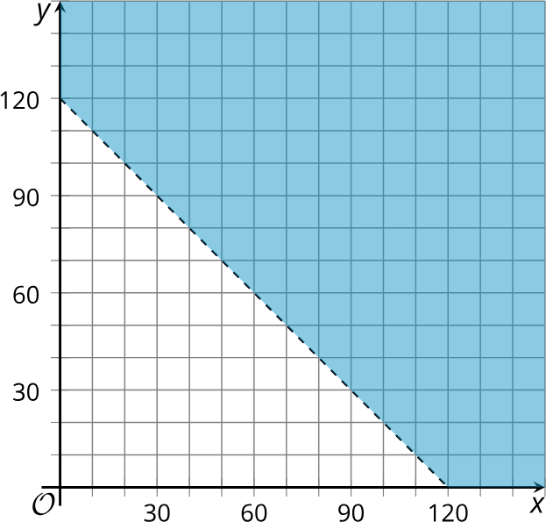
graph

