Project 1 Equations and Graphs

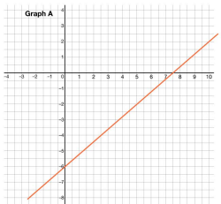
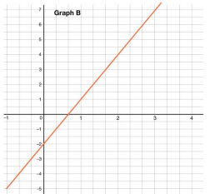
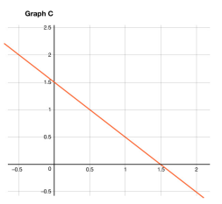
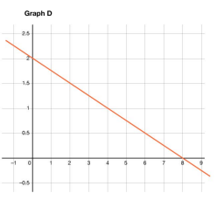

Equation 1: $x + y = 1.5$

Equation 2: $0.8x-y-6$

Equation 3: $y = 3x - 2$

Equation 4: $0.25x + y = 2$

Equation 5: $y = 0.8x - 6$

Equation 6: $25x+100 y=200$

