Lesson 4.6.3 Activity

In a bungee jump, the height of the jumper is a function of time since the jump begins.
Function ℎ defines the height, in meters, of a jumper above a river, 𝑡 seconds since leaving the platform.
Here is a graph of function ℎ, followed by five expressions or equations and five graphical features.
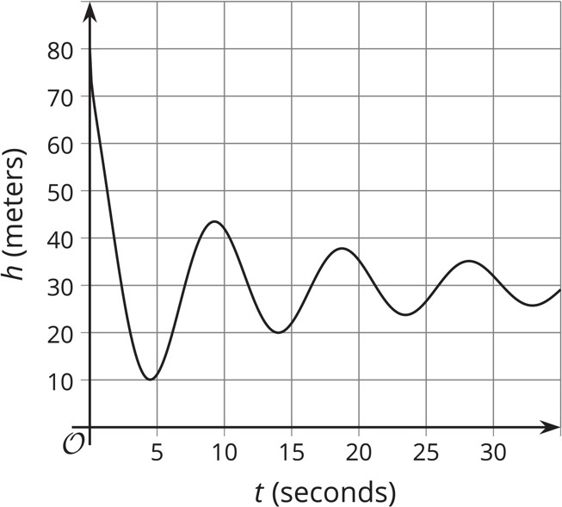

Expressions and Equations | Graphical Features
ℎ(0) | First dip in the graph Vertical intercept
ℎ(𝑡) = 0 ℎ(4) | First peak in the graph Horizontal intercept Maximum
ℎ(𝑡) = 80 | First dip in the graph Vertical intercept
ℎ(𝑡) = 45 | First peak in the graph Horizontal intercept Maximum
ℎ(0) | First dip in the graph Vertical intercept

- Match each description about the jump to a corresponding expression or equation and to a feature on the graph. Record your findings in the provided table.
NOTE: One expression or equation does not have a matching verbal description. Its corresponding graphical feature is also not shown on the graph. Interpret that expression or equation in terms of the jump and in terms of the graph of the function. Record your interpretation in the last row of the table.
Description of jump | Expression/Equation | Feature of graph
a. The greatest height that the jumper is from the river
b. The height from which
the jumper was jumping
c. The time at which the jumper reached the
highest point after the first bounce
d. The lowest point that the jumper reached in the entire jump
e.

Use the graph to estimate the following values.
- If 𝑡 = 0, then ℎ(0) equals what value?
- If 𝑡 = 4, then ℎ(4) equals what value?
- If ℎ(𝑡) = 45, then 𝑡 equals what value?
- If ℎ(𝑡) = 0, then 𝑡 equals what value?

Extending Your Thinking
Based on the information available, how long do you think the bungee cord is? Make an estimate and explain your reasoning.

