**CNX Calculus, Chapter 17**

**Chapter 17: Second-Order Differential Equations**

[Feature Box: Chapter Opening]

[Figure_17_00_01_shock] SAMPLE ONLY <http://www.dreamstime.com/stock-photography-shock-absorber-spring-motorcycle-image35545712>



[Caption]A motorcycle suspension system is an example of a damped spring-mass system. The spring absorbs bumps and keeps the tire in contact with the road. The shock absorber damps the motion so the motorcycle does not continue to bounce after going over each bump.[/Caption]

[/Figure]

[/Feature Box]

[Chapter Outline]

17.1 Second-Order Linear Equations

17.2 Nonhomogeneous Linear Equations

17.3 Applications

17.4 Series Solutions of Differential Equations

[/Chapter Outline]

In Chapter 10, we studied the basics of differential equations, including separable first-order equations. In this chapter, we go a little further and look at second-order equations (equations containing second derivatives of the dependent variable). The solution methods we present are different from those discussed earlier and the solutions themselves tend to involve trigonometric functions as well as exponential functions. We will concentrate primarily on second-order equations with constant coefficients.

Such equations have many practical applications. For example, spring-mass systems like a motorcycle shock absorber can be modeled by a second-order linear differential equation. For motocross riders, the suspension systems on their motorcycles are very important. The off-road courses they ride on often include jumps, and losing control of the motorcycle when they land could cost them the race. In this chapter we will model forced and unforced spring-mass systems with varying amounts of damping (see Example 17.3.5). We will also model certain kinds of electric circuits that can be described by similar differential equations. These kinds of circuits are found in all kinds of modern electronic devices, from computers to smart phones to TVs..

**CNX Calculus, Section 17.1**

[H1]**17.1 Second-Order Linear Equations**

[Learning objectives]

* Recognize homogeneous and nonhomogeneous linear differential equations.
* Determine the characteristic equation of a homogeneous linear equation.
* Use the characteristic equation to determine the roots of a homogeneous linear equation.
* Solve initial-value and boundary-value problems involving linear differential equations.

[/Learning objectives]

Second-order differential equations have several important characteristics that can help us determine which solution method to use. In this section, we examine some of those characteristics and the associated terminology.

[H2]**Homogeneous Linear Equations**

As with first-order equations, it is important to determine whether a second-order equation is linear, so we start by defining the form of a linear second-order equation. Our solution techniques will vary depending on whether a linear equation is homogeneous or nonhomogeneous, so we define those terms here as well.

[Definition]

A second-order differential equation is **linear** if it can be written in the form

,

where , ,  and are real-valued functions. If ––in other words, if for every value of *x*––the equation is said to be **homogeneous.** If  for some value of , the equation is said to be **nonhomogeneous.**

[/Definition]

In linear differential equations, and its derivatives can only be raised to the first power, and they may not be multiplied by one another. Terms involving, say,  or  make the equation nonlinear. Functions ofand its derivatives, such as  or  are similarly prohibited in linear differential equations.

Note that equations may not always be given to you in standard form (the form shown in the definition). You may find it helpful to rewrite them in that form if you are having trouble determining whether they are linear or not, or whether a linear equation is homogeneous.

[Example_17_01_01]

**Classifying Second-Order Equations**

Classify each of the following equations as linear or nonlinear. If the equation is linear, further determine whether it is homogeneous or nonhomogeneous.

1. 
2. 
3. 
4. 
5. 
6. 
7. 
8. 

**Solution**

1. This equation is nonlinear, due to the term.
2. This equation is linear. There is no term involving a power or function of, and the coefficients are all functions of . The equation is already written in standard form, and  is identically 0, so the equation is homogeneous.
3. This equation is nonlinear. The second term involves the product of  and .
4. This equation is linear. , so the equation is nonhomogeneous.
5. This equation is nonlinear, due to the  term.
6. This equation is linear. Rewriting it in standard form gives



With the equation in standard form, you can see that , so the equation is nonhomogeneous.

1. This equation looks like it’s linear, but you should rewrite it in standard form to be sure. You get



This equation is, indeed, linear. With , it is nonhomogeneous.

1. This equation is nonlinear, due to the  term.

[/Example]

[Checkpoint]

Classify each of the following equations as linear or nonlinear. If the equation is linear, further determine whether it is homogeneous or nonhomogeneous.

1. 
2. 

[Hint]

Check for powers or functions ofand its derivatives.

[/Hint]

[Answer]

1. Nonlinear
2. Linear, nonhomogeneous

[/Answer]

[/Checkpoint]

Later in this section, you will see some techniques for solving specific types of differential equations. Before we get to that, however, let’s get a little bit of a feel for how solutions of linear differential equations behave. In a lot of cases, solving differential equations depends on making educated guesses about what the solution might look like. Knowing how various types of solutions behave will be helpful.

[Example_17_01_02]

**Guessing the Solution**

Consider the linear, homogeneous differential equation



Looking at this equation, notice that the coefficient functions are polynomials, with higher powers of  associated with higher-order derivatives of . This might lead you to guess that the solution is a polynomial. Show that  is a solution of this differential equation.

**Solution**

Let . Then  and  Substituting into the differential equation, you see that



[/Example]

[Checkpoint]

Show that  is a solution of the differential equation



[Hint]

Calculate the derivatives and substitute them into the differential equation.

[/Hint]

[/Checkpoint]

An important difference between first-order equations and second-order equations is that with second-order equations we often need to find two different solutions to the equation in order to find the general solution. If we find two solutions, then any linear combination of those solutions is also a solution. We state this fact as the following theorem.

[Theorem_17_01_01]

**Superposition Principle**

If  and  are solutions of a linear homogeneous differential equation, then the function

,

where  and  are constants, is also a solution.

[/Theorem]

The proof of this theorem is left as an exercise.

In order to find the general solution of a second-order differential equation, it is not enough to find any two solutions and then combine them. We must find two linearly independent solutions.

[Definition]

Two functions  and  are **linearly dependent** if there are constants  and , not both zero, such that . Two functions that are not linearly dependent are said to be **linearly independent**.

[/Definition]

From a practical perspective, we see that two functions are linearly dependent if either one of them is identically zero, or if they are constant multiples of each other. If one of the functions is identically zero, say then choose  and , and the condition for linear dependence is satisfied. If, on the other hand, neither  nor  is identically zero, but  for some constant  then choose  and , and again, the condition is satisfied.

For example,  and  are linearly dependent, whereas  and  are linearly independent.

[Theorem_17_01_02]

**General Solution of a Homogeneous Equation**

If  and  are linearly independent solutions of a second-order, linear, homogeneous differential equation, then the general solution is given by

.

[/Theorem]

When we say a function is the general solution of a differential equation, we mean that every solution of the equation can be written in that form. The proof of this theorem is beyond the scope of this text, but can be found in most introductory differential equations textbooks. Note that this theorem goes beyond the Superposition Principle by saying that not only is a linear combination of solutions a general solution of the equation, but that all solutions are of this form––quite a remarkable statement.

[Example_17_01_03]

**Writing the General Solution**

If and  are solutions of  what is the general solution?

**Solution**

Note that  and  are not constant multiples of one another, so they are linearly independent. Then the general solution of the differential equation is 

[/Example]

[Checkpoint]

If and  are solutions of  what is the general solution?

[Hint]

Check for linear independence first.

[/Hint]

[Answer]

.

[/Answer]

[/Checkpoint]

[H2]**Second-Order Equations with Constant Coefficients**

Now that we have a little better feel for linear differential equations, we are going to concentrate on solving second-order equations of the form

 (17.1)

where   and  are constants.

Since all of the coefficients are constants, our solutions are probably going to be functions whose derivatives are constant multiples of themselves. Exponential functions exhibit this kind of behavior, so let’s see what happens when we try a solution of the form  where  is some constant.

If  then  and . Substituting these expressions into Eq. (17.1) we get



Since  is never zero, this expression can only be equal to zero if

.

We call this the characteristic equation of the differential equation.

[Definition]

The **characteristic equation** of the differential equation 

is given by .

[/Definition]

The characteristic equation is very important in finding solutions to differential equations of this form. We can solve the characteristic equation either by factoring, or by using the quadratic formula



This gives three cases. Either the characteristic equation has distinct real roots; a single, repeated real root; or complex conjugate roots. We consider each of these cases separately.

[H3]**Distinct Real Roots**

If the characteristic equation has distinct real roots  and , then  and  are linearly independent solutions of Eq. (17.1), and the general solution is given by

,

where  and  are constants.

[H3]**Repeated Real Root**

Things are a little more complicated if the characteristic equation has a repeated real root, . In that case we know  is a solution of Eq. (17.1), but that is only one solution and we need two linearly independent solutions in order to determine the general solution. Making an educated guess once again, let’s try  as our second solution.

First note that by the quadratic formula,



But is a repeated root, so  and . Then, if , we have

 and 

Substituting these expressions into Eq. (17.1), we see that



So we made a good guess, and we see that  is a solution to Eq. (17.1).

Since  and  are linearly independent, when the characteristic equation has a repeated root , the general solution of Eq. (17.1) is given by



where  and  are constants.

[H3]**Complex Conjugate Roots**

The third case we must consider is when . In this case, when we apply the quadratic formula, we are taking the square root of a negative number. We must use the imaginary number  to find the roots, which take the form  and . The complex number  is called the conjugate of . Thus, we see that when , the roots of our characteristic equation are always complex conjugates.

Now, we have two distinct roots of the characteristic equation, and the functions  and  are linearly independent, so we could write the general solution as



and be done. However, we prefer to work with real-valued functions if possible, so we would like to express the general solution in those terms. Using some smart choices for  and , and a little bit of algebraic manipulation, we can find two linearly independent, real-valued solutions to (17.1) and express our general solution in those terms.

To deal with the complex exponential functions, we also need Euler’s formula:



for all real numbers .

Going back to our general solution, we have



Applying Euler’s formula, we get



Now, if we choose , we get



as a real-valued solution to (17.1). Similarly, if we choose  and  we get



as a second, linearly independent, real-valued solution to (17.1).

Based on this, we see that if the characteristic equation has complex conjugate roots , then the general solution of Eq. (17.1) is given by



where  and  are constants.

[H3]**Summary of Results**

Second-order, linear, homogeneous differential equations with constant coefficients can be solved by finding the roots of the associated characteristic equation. The form of the general solution varies depending on whether the characteristic equation has distinct, real roots; a single, repeated real root; or complex conjugate roots. The three cases are summarized in Table 17_01_01.

[Table_17_01_01]

[Title]Summary of Characteristic Equation Cases[/Title]

|  |  |
| --- | --- |
| Characteristic Equation Roots | General Solution of the Differential Equation |
| Distinct real roots,  and |  |
| A repeated real root, |  |
| Complex conjugate roots |  |

[/table]

[Problem Solving Strategy]

**Using the Characteristic Equation to Solve Second-Order Differential Equations with Constant Coefficients**

1. Write the differential equation in the form .
2. Find the corresponding characteristic equation .
3. Either factor the characteristic equation or use the quadratic formula to find the roots.
4. Determine the form of the general solution based on whether the characteristic equation has distinct, real roots; a single, repeated real root; or complex conjugate roots.

[/Problem Solving Strategy]

[Example_17_01_04]

**Solving Second-Order Equations with Constant Coefficients**

Find the general solution of the following differential equations:

1. 
2. 
3. 
4. 
5. 
6. 

**Solution**

Note that all of these equations are already given in standard form (step 1).

1. The characteristic equation is  (step 2). This factors into , so the roots of the characteristic equation are  and  (step 3). Then the general solution of the differential equation is

 (step 4).

1. The characteristic equation is  (step 2). Applying the quadratic formula, you see that this equation has complex conjugate roots  (step 3). Then the general solution of the differential equation is

 (step 4).

1. The characteristic equation is  (step 2). This factors into , so the characteristic equation has a repeated real root  (step 3). Then the general solution of the differential equation is

 (step 4).

1. The characteristic equation is  (step 2). This factors into , so the roots of the characteristic equation are  and  (step 3). Then the general solution of the differential equation is

(step 4).

1. The characteristic equation is  (step 2). This factors into , so the roots of the characteristic equation are  and  (step 3). Then the general solution of the differential equation is

(step 4).

1. The characteristic equation is  (step 2). This has complex conjugate roots  (step 3). Then the general solution of the differential equation is

(step 4).

[/Example]

[Checkpoint]

Find the general solution of the following differential equations:

1. 
2. 

[Hint]

Find the roots of the characteristic equation.

[/Hint]

[Answer]

1. 
2. 

[/Answer]

[/Checkpoint]

[H2]**Initial-Value Problems and Boundary-Value Problems**

So far, we have been finding general solutions of differential equations. However, differential equations are often used to describe physical systems, and the person studying that physical system usually knows something about the state of that system at one or more points in time. For example, if a constant-coefficient differential equation is representing the displacement of the mass in a spring-mass system, we might know that the mass is not moving at some initial time . This gives rise to the initial condition **.** We might also know the position of the mass at that time is given by , so. With these two initial conditions and the general solution of the differential equation, we can find the *specific* solution to the differential equation that satisfies both initial conditions. This process is called solving an initial-value problem. (Recall that we discussed initial-value problems in Chapter 10.) Note that for second-order equations, we require two initial conditions to find the general solution.

Sometimes we know the condition of the system at two different times. For example, we might know  and . These conditions are called **boundary conditions,** and finding the solution of the differential equation that satisfies the boundary conditions is called solving a **boundary-value problem.**

Mathematicians and scientists are interested in understanding the conditions under which an initial-value problem or a boundary-value problem has a unique solution. Although a complete treatment of this topic is beyond the scope of this text, you should know that within the context of constant-coefficient, second-order equations, initial-value problems are guaranteed to have a unique solution as long as two initial conditions are provided. Boundary-value problems, however, are not as well behaved. Even when two boundary conditions are provided, you may encounter boundary-value problems with unique solutions, many solutions, or no solution at all.

[Example_17_01_05]

**Solving an Initial-Value Problem**

Solve the following initial-value problem: , , .

**Solution**

You already solved this differential equation in Example 17.1.4(a), and found the general solution to be

.

Then

.

When , you have  and . Applying the initial conditions you have



Then . Substituting that expression into the second equation, you see that



So  and the solution to the initial value problem is

.

[/Example]

[Checkpoint]

Solve the following initial-value problem

, , 

[Hint]

Use the initial conditions to determine values for  and .

[/Hint]

[Answer]



[/Answer]

[/Checkpoint]

[Example_17_01_06]

**Solving an Initial-Value Problem and Graphing the Solution**

Solve the following initial-value problem and graph the solution.

, , 

**Solution**

You already solved this differential equation in Example 17.1.4(b), and found the general solution to be



Then

.

When , you have  and . Applying the initial conditions, you obtain



So , , and the solution to the initial value problem is

.

[Figure_17_01_01_example_img] SAMPLE ONLY. Graph of  generated by graph.exe, which is free and available for download at <https://www.padowan.dk/download/>. Note, the graph.exe software itself is available under a GNU General Public license, but it is not clear how the content generated by the software is licensed, so this should be treated as SAMPLE ONLY. Change  to , make axis labels bigger, make axes thicker, add legend .

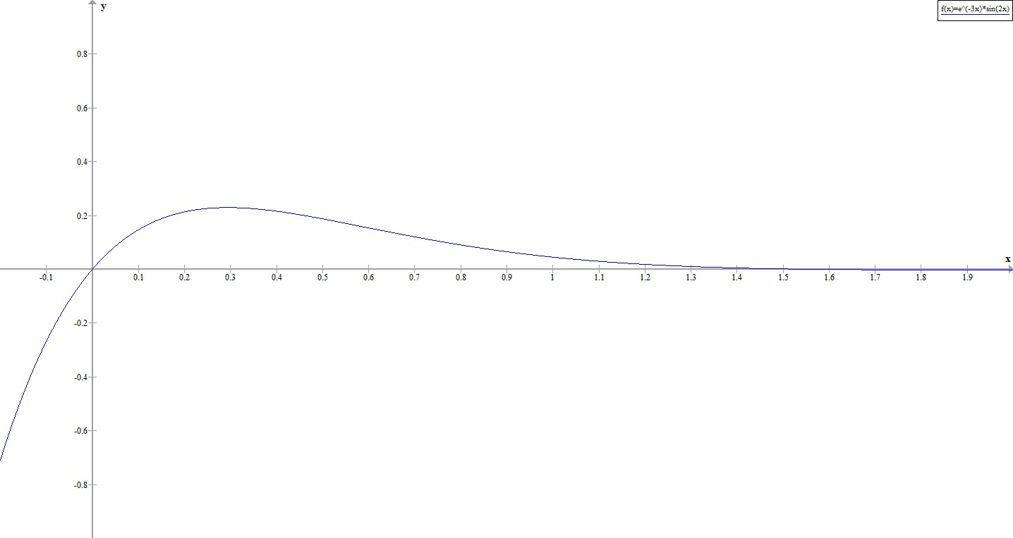

[/Figure]

[Checkpoint]

Solve the following initial-value problem and graph the solution

, , 

[Hint]

Use the initial conditions to determine values for  and .

[/Hint]

[Answer]



[Figure_17_01_02_chkpt_img] SAMPLE ONLY. Graph of  generated by graph.exe. See above for more info about graph.exe. Change  to , make axis labels bigger, make axes thicker, add legend .

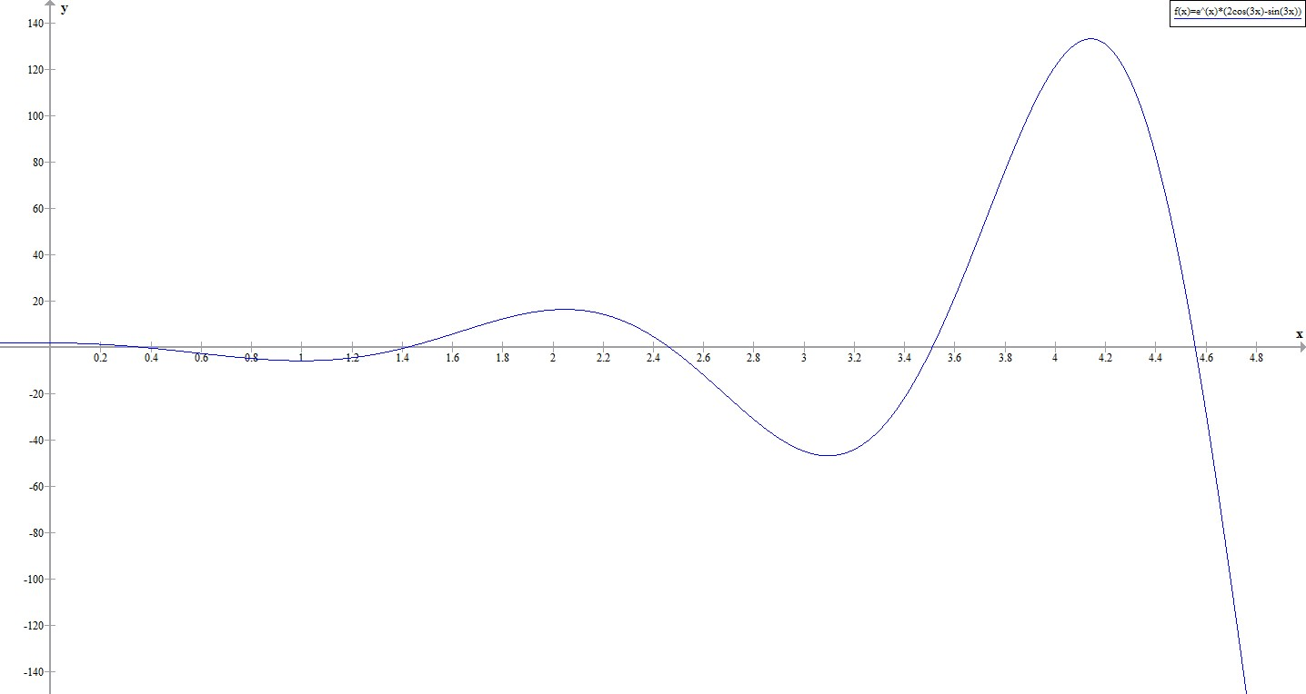

[/Figure]

[/Answer]

[/Checkpoint]

[/Example]

[Example_17_01_07]

**Initial-Value Problem Representing a Spring-Mass System**

Suppose the following initial value problem models the position of a mass in a spring-mass system at any given time.

, , 

Solve the initial value problem and graph the solution. What is the position of the mass at time  seconds?

**Solution**

In Example 17.1.4(c), you found the general solution of this differential equation to be

.

Then

.

When , you have  and . Applying the initial conditions, you get



So , , and the solution to the initial value problem is

.

[Figure_17_01_03_example2_img] SAMPLE ONLY. Graph of  generated by graph.exe. See example 17_01_01 for info on graph.exe. Change  to , make axis labels bigger, make axes thicker, add legend .

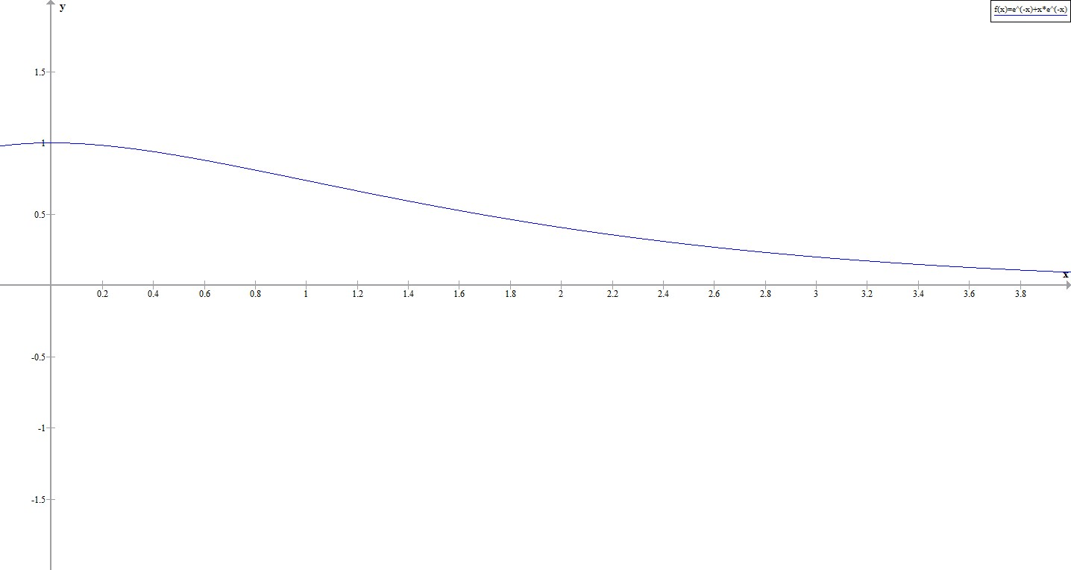

[/Figure]

At time the mass is at position 

[/Example]

[Checkpoint]

Suppose the following initial value problem models the position of a mass in a spring-mass system at any given time. Solve the initial value problem and graph the solution. What is the position of the mass at time  seconds?

, , 

[Hint]

Use the initial conditions to determine values for  and .

[/Hint]

[Answer]



[Figure_17_01_04_chkpt2_img] SAMPLE ONLY. Graph of  generated by graph.exe. See example 17_01_01 for info on graph.exe. Change  to , make axis labels bigger, make axes thicker, add legend .

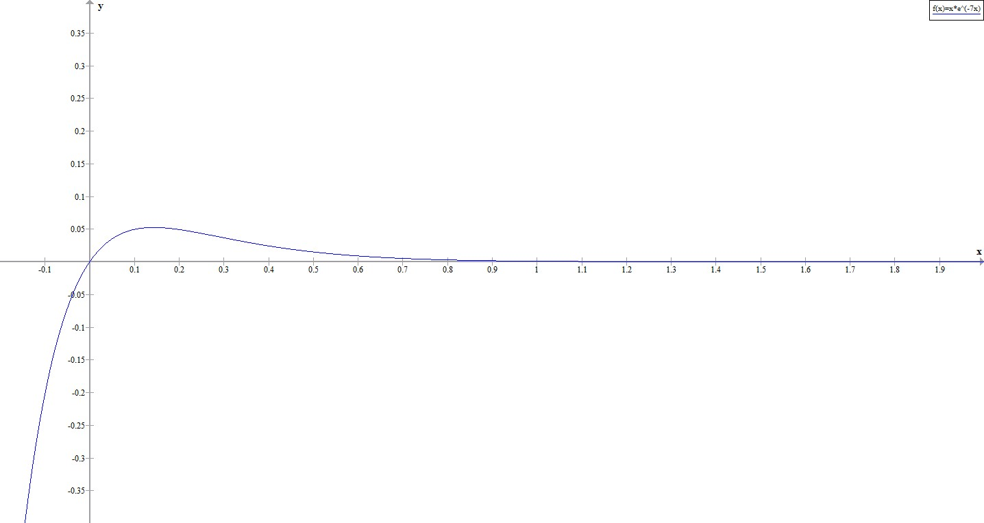

[/Figure]

At time , 

[/Answer]

[/Checkpoint]

[Example_17_01_08]

**Solving a Boundary-Value Problem**

In Example 17.1.4(f) we solved the differential equation  and found the general solution to be . If possible, solve the boundary-value problem if the boundary conditions are:

1. , 
2. , 
3. , 

**Solution**

You have

.

1. Applying the first boundary condition given here, you get . So the solution is of the form . When you apply the second boundary condition, though, you get  for all values of . The boundary conditions are not sufficient to determine a value for , so this boundary-value problem has infinitely many solutions.  is a solution for any value of .
2. Applying the first boundary condition given here, you get . Applying the second boundary condition gives , so . In this case you have a unique solution, .
3. Applying the first boundary condition given here, you get  However, applying the second boundary condition gives , so . You cannot have , so this boundary value problem has no solution.

[/Example]

[Summary]

* Second-order differential equations can be classified as linear or nonlinear, homogeneous or nonhomogeneous
* To find a general solution for a homogeneous second-order differential equation, we must find two linearly independent solutions
* If  and  are linearly independent solutions of a second-order, linear, homogeneous differential equation, then the general solution is given by

.

* To solve a homogeneous second-order differential equations with constant coefficients, find the roots of the characteristic equation.
* The form of the general solution varies depending on whether the characteristic equation has distinct, real roots; a single, repeated real root; or complex conjugate roots.
* Initial conditions or boundary conditions can then be used to find the specific solution of a differential equation that satisfies those conditions.

[KeyTerms]

**Homogeneous linear equation:** A second-order differential equation is called **linear** if it can be written in the form . If for every value of the equation is said to be **homogeneous.**

**Nonhomogeneous linear equation:** A second-order differential equation is called **linear** if it can be written in the form . If for some value of the equation is said to be **nonhomogeneous.**

**Characteristic equation:** The **characteristic equation** of the differential equation is given by .

**Boundary conditions:** Boundary conditions give the state of a system at various points in time. For example, you may know the position of a spring-mass system at one time, and its velocity at another time.

**Boundary-value problem:** A boundary-value problem is a differential equation and associated boundary conditions.

[/keyterms]

**CNX Calculus, Section 17.2**

[H1]**17.2 Nonhomogeneous Linear Equations**

[Learning objectives]

* Write the general solution of a nonhomogeneous differential equation.
* Solve a nonhomogeneous differential equation by the method of undetermined coefficients.
* Use the method of variation of parameters to solve a nonhomogeneous differential equation.

[/Learning objectives]

In this section, we are going to turn our attention to solving nonhomogeneous differential equations. The terminology and methods are different from those we used for homogeneous equations, so let’s start by defining some new terms.

[H2]**General Solution of a Nonhomogeneous Linear Equation**

Consider the nonhomogeneous linear differential equation

.

Then the associated homogeneous equation



is called the **complementary equation.** We will see that the solving the complementary equation is an important step in solving a nonhomogeneous differential equation.

[Definition]

A solution  of a differential equation that contains no arbitrary constants is called a **particular solution** of the equation.

[\Definition]

[Theorem_17_02_01]

**General Solution of a Nonhomogeneous Equation**

Let  be any particular solution of the nonhomogeneous linear differential equation

,

and let  denote the general solution of the complementary equation. Then the general solution of the nonhomogeneous equation is given by

.

[/Theorem]

[Proof]

To prove  is the general solution, we must show, first, that it solves the differential equation, and second, that any solution of the differential equation can be written in that form. Substituting  into the differential equation, we have

So  is a solution.

Now, let  be any solution of . Then



so  is a solution of the complementary equation. But  is the general solution of the complementary equation, so



and we see that .

[\Proof]

[Example_17_02_01]

**Verifying the General Solution**

Given that  is a particular solution of the differential equation , write down the general solution, and verify that it satisfies the equation.

**Solution**

The complementary equation is , which has the general solution . So the general solution to the nonhomogeneous equation is

.

To verify that this is a solution, substitute it into the differential equation. You have

 and .

Then



So  is a solution of .

[/Example]

[Checkpoint]

Given that  is a particular solution of , write down the general solution and verify that it satisfies the equation.

[Hint]

Find the general solution of the complementary equation.

[/Hint]

[Answer]



[/Answer]

[/Checkpoint]

In the previous section, we learned how to solve homogeneous equations with constant coefficients. So, for nonhomogeneous equations of the form , we already know how to solve the complementary equation, and the problem boils down to finding a particular solution for the nonhomogeneous equation. We are going to examine two techniques for this: the method of undetermined coefficients, and the method of variation of parameters.

[H2]**Undetermined Coefficients**

The method of undetermined coefficients involves making educated guesses about the form of the particular solution, based on the form of . When you take derivatives of polynomials, exponential functions, and sines and cosines, you get back polynomials, exponential functions, and sines and cosines. So when  has one of these forms, it makes sense that the solution of the nonhomogeneous differential equation might take that same form. Let’s look at a couple of examples to see how this works.

[Example_17_02_02]

**Undetermined Coefficients When  Is a Polynomial**

Find the general solution of .

**Solution**

The complementary equation is , with general solution . Since , it makes sense that your particular solution might have the form . Then you have  and . In order for  to be a solution of the differential equation, you must find values for  and  such that



Setting coefficients of like terms equal, you have



Then  and  so  and the general solution is



[/Example]

[Example_17_02_03]

**Undetermined Coefficients When  Is an Exponential**

Find the general solution of .

**Solution**

The complementary equation is , with general solution . Since , it makes sense that your particular solution might have the form . Then you have  and . In order for  to be a solution of the differential equation, you must find a values for  such that



So  and .

Then , and your general solution is



[/Example]

[Checkpoint]

Find the general solution of .

[Hint]

Use  as your guess for the particular solution.

[/Hint]

[Answer]

.

[/Answer]

[/Checkpoint]

The method of undetermined coefficients also works with products of polynomials, exponentials, sines and cosines. Some of the key forms of  and the associated guesses for  are summarized in Table 17_02_01.

[Table_17_02_01]

|  |  |
| --- | --- |
|  | Initial guess for |
| (a constant) | (a constant) |
|  | (note, the guess must include both terms even if ) |
|  | (note, the guess must include all three terms even if  or  are 0) |
| Higher-order polynomials | Polynomial of the same order as |
|  |  |
|  |  |
|  |  |
|  |  |
|  |  |
|  |  |

[/Table]

You need to be aware of a key pitfall with this method. Consider the differential equation . Based on the form of , we guess a particular solution of the form . But when we substitute this expression into the differential equation to find a value for , we run into a problem We have  and , so we want



which is not possible.

Looking closely, we see that in this case, the general solution to the complementary equation is . The exponential function in  is actually a solution of the complementary equation, so all the terms on the left side of the equation cancel out. We can still use the method of undetermined coefficients in this case, but have to alter our guess by multiplying it by . Using the new guess, , we have  and . Substitution gives



So  and . This gives us the following general solution:



Note that if  were also a solution of the complementary equation, we would have to multiply by  again, and we would try .

[Problem Solving Strategy]

**Method of Undetermined Coefficients**

1. Solve the complementary equation and write down the general solution.
2. Based on the form of , make an initial guess for .
3. Check if any term of your guess for  is a solution to the complementary equation. If so, multiply your guess by . Repeat this step until there are no terms in  that solve the complementary equation.
4. Substitute  into the differential equation and equate like terms to find values for the unknown coefficients in 
5. Write down the general solution of the nonhomogeneous equation.

[/Problem Solving Strategy]

[Example_17_02_04]

**Solving Nonhomogeneous Equations**

Find the general solution of the following differential equations.

1. 
2. 
3. 
4. 

**Solution**

1. The complementary equation is , which has general solution  [Step 1]. Based on the form of , your initial guess for the particular solution is  [Step 2]. None of the terms in  solve the complementary equation, so this is a valid guess [Step 3].

Now you want to find values for  and , so substitute  into the differential equation. You have

 and ,

so you want to find values of  and such that



Therefore,



This gives  and , so  [step 4].

Putting everything together, you have the general solution



1. The complementary equation is , which has general solution  [Step 1]. Based on the form of , your initial guess for the particular solution is  [Step 2]. However, you see that this guess solves the complementary equation, so you must multiply by . This gives a new guess  [Step 3]. Checking this new guess, you see that it, too, solves the complementary equation, so you must multiply by  again. This gives  [Step 3 again]. Now, checking this guess, you see that none of the terms in  solve the complementary equation, so this is a valid guess [Step 3 yet again].

You now want to find a value for , so you substitute  into the differential equation. You have , so

, and . Substituting into the differential equation, you want to find a value of  so that



This gives , so  [step 4].

Putting everything together, you have the general solution



1. The complementary equation is , which has general solution  [Step 1]. Based on the form of , your initial guess for the particular solution is  [Step 2]. None of the terms in  solve the complementary equation, so this is a valid guess [Step 3].

You now want to find values for , , and , so you substitute  into the differential equation. You have  and , so you want to find values of , , and  such that



Therefore,



This gives ,  and , so  [step 4].

Putting everything together, you have the general solution



1. The complementary equation is , which has general solution  [Step 1]. Based on the form of , your initial guess for the particular solution is  [Step 2]. However, you see that the constant term in this guess solves the complementary equation, so you must multiply by  This gives a new guess  [Step 3]. Checking this new guess, you see that none of the terms in  solve the complementary equation, so this is a valid guess [Step 3 again].

You now want to find values for  and , so you substitute  into the differential equation. You have  and , so you want to find values of  and such that



Therefore



This gives  and , so  [step 4].

Putting everything together, you have the general solution



[/Example]

[Checkpoint]

Find the general solution of the following differential equations.

1. 
2. 

[Hint]

Follow the problem solving strategy.

[/Hint]

[Answer]

1. 
2. 

[/Answer]

[/Checkpoint]

[H2]**Variation of Parameters**

Sometimes,  is not a combination of polynomials, exponentials, or sines and cosines. In this case, the method of undetermined coefficients does not work, and we have to use another approach to find a particular solution to the differential equation. We use an approach called **variation of parameters**.

To simplify our calculations a little, we are going to divide our differential equation through by , so we have a leading coefficient of 1. Then the differential equation has the form

,

where  and  are constants.

If the general solution to the complementary equation is given by , we are going to look for a particular solution of the form . We want to find functions  and  so that  satisfies the differential equation.

We have



Substituting into the differential equation, we obtain

Note that  and  are solutions of the complementary equation, so the first two expressions are 0. Thus, we want



If we require , the first two terms are 0, and this reduces to . This is a system of two equations in two unknowns.



Solving this system gives us  and , which we can integrate to find  and .

Then  is a particular solution of our differential equation. Solving this system of equations is sometimes challenging, so we take this opportunity to review Cramer’s Rule.

[Rule]

[Title]Cramer’s Rule[/Title]

The system of equations



has a unique solution if and only if the determinant of the coefficients is not zero. In this case, the solution is given by

 and 

[/Rule]

[Problem Solving Strategy]

**Method of Variation of Parameters**

1. Solve the complementary equation and write down the general solution .
2. Use Cramer’s Rule or another suitable technique to find functions  and satisfying



1. Integrate  and  to find  and . Then  is a particular solution of the equation.
2. Combine the general solution of the complementary equation and the particular solution found in step 3 to write down the general solution of the nonhomogeneous equation.

[/Problem Solving Strategy]

[Example_17_02_05]

**Variation of Parameters**

Find the general solution of the following differential equations.

1. 
2. 

**Solution**

1. The complementary equation is  with associated general solution . So  and  [Step 1]. Then you want to find functions  and  so that



Applying Cramer’s Rule, you have



and

 [Step 2].

Integrating, you get

 [Step 3]

Then

 [Step 4]

The general solution is

 [Step 5]

1. The complementary equation is  with associated general solution . Therefore  and  [Step 1]. Then you want to find functions  and  so that



Applying Cramer’s Rule, you have



and

 [Step 2].

Integrating, you get

 [Step 3]

Then

 [Step 4]

The  term is a solution of the complementary equation, so you don’t need to carry that term into our general solution explicitly. The general solution is

 [Step 5]

[/Example]

[Checkpoint]

Find the general solution of the following differential equations.

1. 
2. 

[Hint]

Follow the problem solving strategy.

[/Hint]

[Answer]

1. 
2. 

[/Answer]

[/Checkpoint]

[Summary]

* To solve a nonhomogeneous linear second-order differential equation, first find the general solution to the complementary equation, then find a particular solution of the nonhomogeneous equation
* Let  be any particular solution of the nonhomogeneous linear differential equation

,

and let  denote the general solution of the complementary equation. Then the general solution of the nonhomogeneous equation is given by

.

* When  is a combination of polynomials, exponential functions, sines and cosines, use the method of undetermined coefficients to find the particular solution.
* With the method of undetermined coefficients, we assume a solution of the same form as  and then substitute the assumed solution into the differential equation to find values for the coefficients.
* When  is NOT a combination of polynomials, exponential functions, or sines and cosines, use the method of variation of parameters to find the particular solution.
* The method of variation of parameters involves using Cramer’s Rule or another suitable technique to find functions  and satisfying



Then  is a particular solution of the differential equation.

[KeyTerms]

**Complementary equation:** For the nonhomogeneous linear differential equation

.

the associated homogeneous equation, called the complementary equation, is



**Method of undetermined coefficients:** This method involves making a guess about the form of the particular solution, then solving for the coefficients in your guess.

**Method of variation of parameters:** This method involves looking for particular solutions of the form , then solving a system of equations to find  and .

[/key terms]

**CNX Calculus, Section 17.3**

[H1]**17.3 Applications**

[Learning objectives]

* Solve a second-order differential equation representing simple harmonic motion.
* Solve a second-order differential equation representing damped simple harmonic motion.
* Solve a second-order differential equation representing forced simple harmonic motion.
* Solve a second-order differential equation representing charge and current in a RLC series circuit.

[/Learning objectives]

We noted in the chapter introduction that second-order linear differential equations are used to model many situations in physics and engineering. In this section we show how this works for systems of a mass attached to a vertical spring and an electric circuit containing a resistor, an inductor, and a capacitor connected in series. Models like these can be used to approximate other more complicated situations; for example, bonds between atoms or molecules are often modeled as springs that vibrate as described by these same differential equations.

[H2]**Simple Harmonic Motion**

Consider a mass suspended from a spring attached to a rigid support. Gravity is pulling the mass down, and the restoring force of the spring is pulling the mass up. As shown in Figure 17_03_01, when these two forces are equal, the mass is said to be at the equilibrium position. If the mass is displaced from equilibrium, it will oscillate up and down. This behavior can be modeled by a second-order constant coefficient differential equation.

[Figure_17_03_01_spring] SAMPLE ONLY Sample taken from competing text: Zill, Dennis G. *A First Course in Differential Equations with Modeling Applications.* 6th Ed. Figure 5.2 (no text caption), page 171. Change *l* to *L*, change label for (a) to “natural position of spring”, change label for (b) to “equilibrium: ”, change label for (c) to “in motion”. Add broad, double headed vertical arrow to the right of (c) to indicate motion.

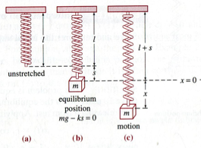

[Caption]A spring (a) in its natural position, (b) at equilibrium with a mass *m* attached, (c) in oscillatory motion. [/Caption]

[/Figure]

Let  denote the displacement of the mass from equilibrium. Note that for spring-mass systems of this type, it is customary to adopt the convention that down is positive. Thus, a positive displacement indicates the mass is *below* the equilibrium point, whereas a negative displacement indicates the mass is *above* equilibrium.

Consider the forces acting on the mass. The force of gravity is given by . According to Hooke’s law, the restoring force of the spring is proportional to the displacement, and acts in the opposite direction from the displacement, so the restoring force is given by . By Newton’s Second Law, we have



But , so our differential equation becomes



It is convenient to rearrange this equation and introduce a new variable, called the angular frequency  Letting , we can write the equation as



This differential equation has general solution . This motion is called **simple harmonic motion.** The **period** of this motion is , and the **frequency** is  (see Figure 17_03_02).

[Figure_17_03_02_SHM] SAMPLE ONLY. Graph of  generated by graph.exe, which is free and available for download at <https://www.padowan.dk/download/>. Note, the graph.exe software itself is available under a GNU General Public license, but it is not clear how the content generated by the software is licensed, so this should be treated as SAMPLE ONLY. Change  to , change  to , make axis labels bigger, make axes thicker, delete legend . Label the period—label the distance from one peak in the curve to the next peak as

.

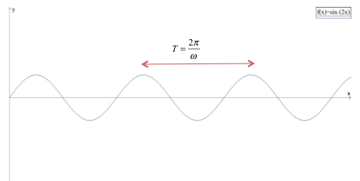

[Caption]A graph of vertical displacement versus time for simple harmonic motion[/Caption]

[/Figure]

[Example_17_03_01]

**Simple Harmonic Motion**

Assume an object weighing 2 pounds stretches a spring 6 inches. Find the equation of motion if the spring is released from the equilibrium position with an upward velocity of 16 ft/s. What is the period of the motion?

**Solution**

You first need to find the spring constant. You have



You also know , so , and you have 

Thus, the differential equation representing this system is . Multiplying through by 16, you get , which has the general solution . The mass was released from the equilibrium position, so , and it had an initial upward velocity of 16 ft/s, so . Applying these initial conditions to solve for  and  gives



The period of this motion is  seconds.

[/Example]

[Checkpoint]

A 200-gram mass stretches a spring 5 cm. Find the equation of motion of the mass if it is released from rest from a position 10 cm below the equilibrium position. What is the frequency of this motion?

[Hint]

First find the spring constant.

[/Hint]

[Answer]

; frequency is  Hz.

[/Answer]

[/Checkpoint]

Under this model, the motion of the mass continues indefinitely. Clearly, this doesn’t happen in the real world. In the real world, there is almost always some friction in the system, which causes the oscillations to slowly die off, an effect we call damping. So now let’s look at how to incorporate that damping force into our differential equation.

[H2]**Damped Vibrations**

Physical spring-mass systems almost always have some damping due to friction, air resistance, or a physical damper, called a dashpot. Because damping is primarily a friction force, we assume it is proportional to the velocity of the mass and acting in the opposite direction. So the damping force is given by . Again applying Newton’s Second Law, our differential equation becomes



Then the associated characteristic equation is



Applying the quadratic formula, we have



Just as in Section 17.1, we consider three cases, based on whether the characteristic equation has distinct real roots, a repeated real root, or complex conjugate roots.

**Case 1: **

In this case, we say the system is **over-damped**. The general solution has the form , where both  and  are less than zero. Over-damped systems do not oscillate (no more than one change of direction), but simply move back toward the equilibrium position. Figure 17_03_03 shows what typical critically damped behavior looks like.

[Figure_17_03_03_overdamped] SAMPLES ONLY. Graphs of  and  generated by graph.exe. See comments on Figure 17_03_02 for URL to download graph software. Change  to , change  to , make axis labels bigger, make axes thicker, delete legends  and . Label left figure as (a), right figure as (b).

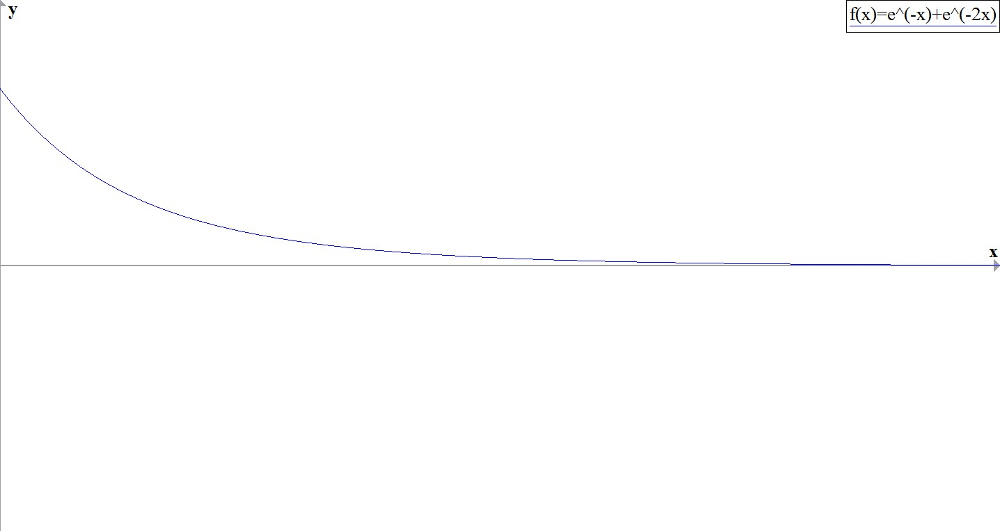 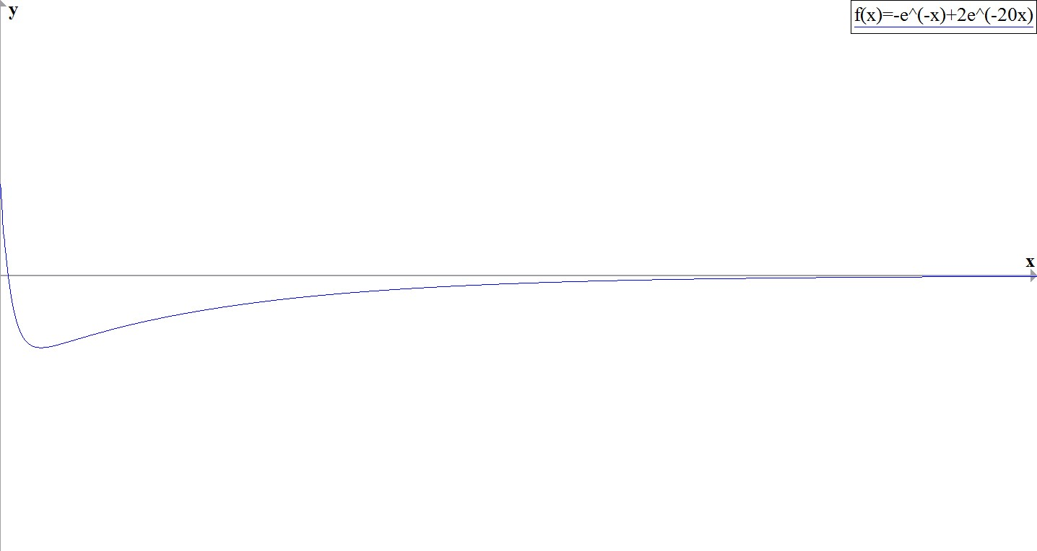

[Caption]Behavior of an over-damped spring-mass system.[/Caption]

[/Figure]

[Example_17_03_02]

**Over-Damped Spring-Mass System**

A 16-pound mass is attached to a 10-foot spring. When the mass comes to rest in the equilibrium position, the spring measures 15 feet 4 inches. The system is immersed in a medium that imparts a damping force equal to 5/2 times the instantaneous velocity of the mass. Find the equation of motion if the mass is released from the equilibrium position with an upward velocity of 5 ft/s.

**Solution**

The mass stretches the spring 5 feet 4 inches, or  feet. Thus , so . You also have , so the differential equation is . Multiplying through by 2 gives , which has general solution . Applying the initial conditions,  and , you get .

[/Example]

[Checkpoint]

A 2-kg mass is attached to a spring with spring constant 24 N/m. The system is then immersed in a medium imparting a damping force equal to 16 times the instantaneous velocity of the mass. Find the equation of motion if it is released from rest at a point 40 cm below equilibrium.

[Hint]

First find the spring constant.

[/Hint]

[Answer]



[/Answer]

[/Checkpoint]

**Case 2: **

In this case, we say the system is **critically damped**. The general solution has the form , where is less than zero. The motion of a critically damped system is very similar to that of an over-damped system––it does not oscillate. However, with a critically damped system, if the damping is reduced even a little, oscillatory behavior results. From a practical perspective, physical systems are almost always either over-damped or under-damped (case 3, which we consider next). It is impossible to fine-tune the characteristics of a physical system so that  and  are exactly equal. Figure 17_03_04 shows what typical critically damped behavior looks like.

[Figure_17_03_04_critdamp] SAMPLES ONLY. Graphs of  and  generated by graph.exe. See comments on Figure 17_03_02 for URL to download graph software. Change  to , change  to , make axis labels bigger, make axes thicker, delete legends  and . Label left figure as (a), right figure as (b).

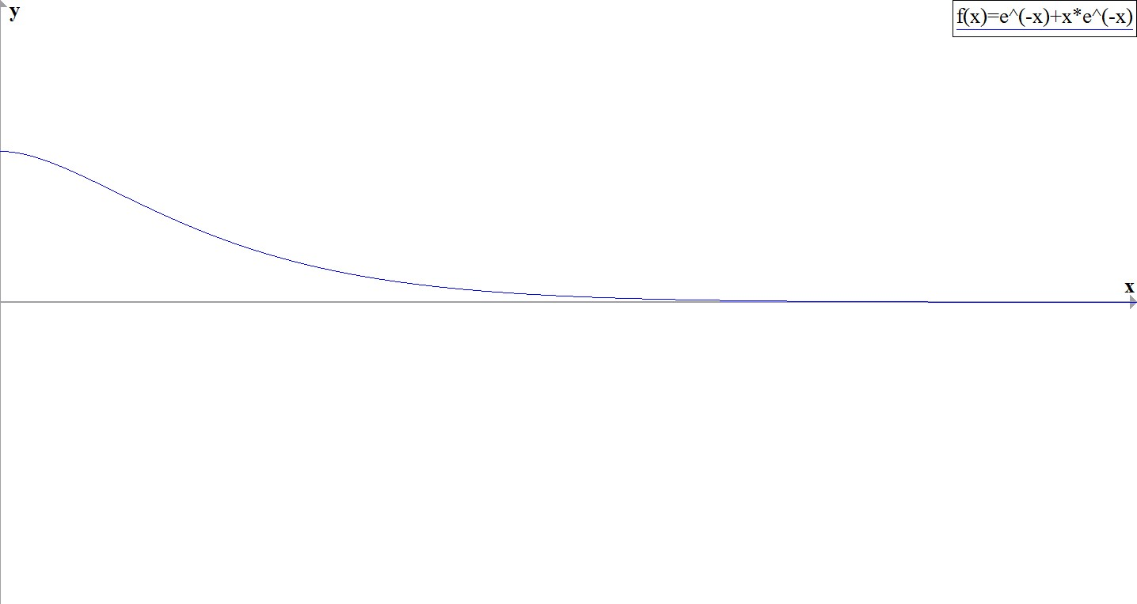 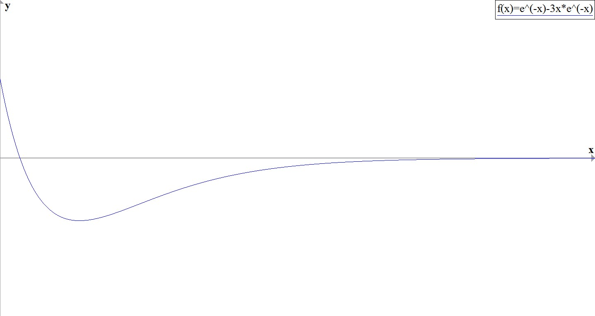

[Caption]Behavior of a critically damped spring-mass system.[/Caption]

[/Figure]

[Example_17_03_03]

**Critically Damped Spring-Mass System**

A 1-kg mass stretches a spring 20 cm. The system is attached to a dashpot that imparts a damping force equal to 14 times the instantaneous velocity of the mass. Find the equation of motion if the mass is released from equilibrium with an upward velocity of 3 m/s.

**Solution**

You have , so . Then the differential equation is , which has general solution . Applying the initial conditions  and  gives .

[/Example]

[Checkpoint]

A 1-pound weight stretches a spring 6 inches, and the system is attached to a dashpot that imparts a damping force equal to half the instantaneous velocity of the mass. Find the equation of motion if the mass is released from rest at a point 6 inches below equilibrium.

[Hint]

First find the spring constant.

[/Hint]

[Answer]



[/Answer]

[/Checkpoint]

**Case 3: **

In this case, we say the system is **under-damped**. The general solution has the form , where is less than zero. Underdamped systems oscillate, with the amplitude of the oscillations decreasing over time. Figure 17_03_05 shows what typical under-damped behavior looks like.

[Figure_17_03_05_underdamp] SAMPLE ONLY. Graph of  and  generated by graph.exe. See comments on Figure 17_03_02 for URL to download graph software. Change  to , change  to , make axis labels bigger, make axes thicker, delete legends  and . Make graphs of dotted lines, rather than solid.

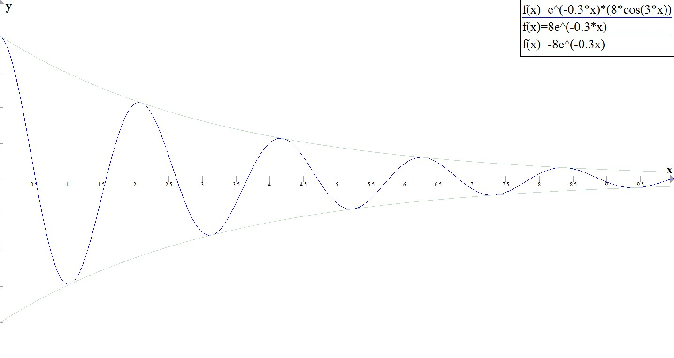

[Caption]Behavior of an under-damped spring-mass system.[/Caption]

[/Figure]

Note that for damped systems, . The system always returns to the equilibrium position over time.

[Example_17_03_04]

**Under-Damped Spring-Mass System**

A 16-pound weight stretches a spring 3.2 feet. Assume the damping force on the system is equal to the instantaneous velocity of the mass. Find the equation of motion if the mass is released from rest at a point 9 inches below equilibrium.

**Solution**

You have  and , so the differential equation is , or . This equation has general solution . Applying the initial conditions,  and , you get .

[/Example]

[Checkpoint]

A 1-kg mass stretches a spring 49 cm. The system is immersed in a medium imparting a damping force equal to 4 times the instantaneous velocity of the mass. Find the equation of motion if the mass is released from rest at a point 24 cm above equilibrium.

[Hint]

First find the spring constant.

[/Hint]

[Answer]



[/Answer]

[/Checkpoint]

[Example_17_03_05]

**Chapter opening: Modeling a Motorcycle Suspension System**



For motocross riders, the suspension systems on their motorcycles are very important. The off-road courses they ride on often include jumps, and losing control of the motorcycle when they land could cost them the race. This suspension system can be modeled as a damped spring-mass system, using the differential equation

.

The system is oriented such that down is positive. A motocross motorcycle weighs 204 pounds, and we assume a rider weight of 180 pounds. When the rider mounts the motorcycle, the suspension compresses 4 inches, then comes to rest at equilibrium. The suspension system provides damping equal to 240 times the instantaneous vertical velocity of the motorcycle (and rider).

1. Set up the differential equation that models the behavior of the motorcycle suspension system.
2. We are interested in what happens when the motorcycle lands after taking a jump. Let time  denote the time when the motorcycle first contacts the ground. If the motorcycle hits the ground with a velocity of 10 ft/s downward, find the equation of motion of the motorcycle following the jump.
3. Graph the equation of motion over the first second after the motorcycle hits the ground.

**Solution**

1. You have



You also have



Therefore, the differential equation that models the behavior of the motorcycle suspension is

.

Dividing through by 12, you get

.

1. The differential equation found in part (a) has general solution , and you have  and . Applying these initial conditions, you get  and , so the equation of motion is

.

1. [Figure_17_03_06_motocross] SAMPLE ONLY. Graphs of  generated by graph.exe. See comments on Figure 17_03_02 for URL to download graph software. Change  to , change  to , make axis labels bigger, make axes thicker, delete legend . Change  axis to start at 0.

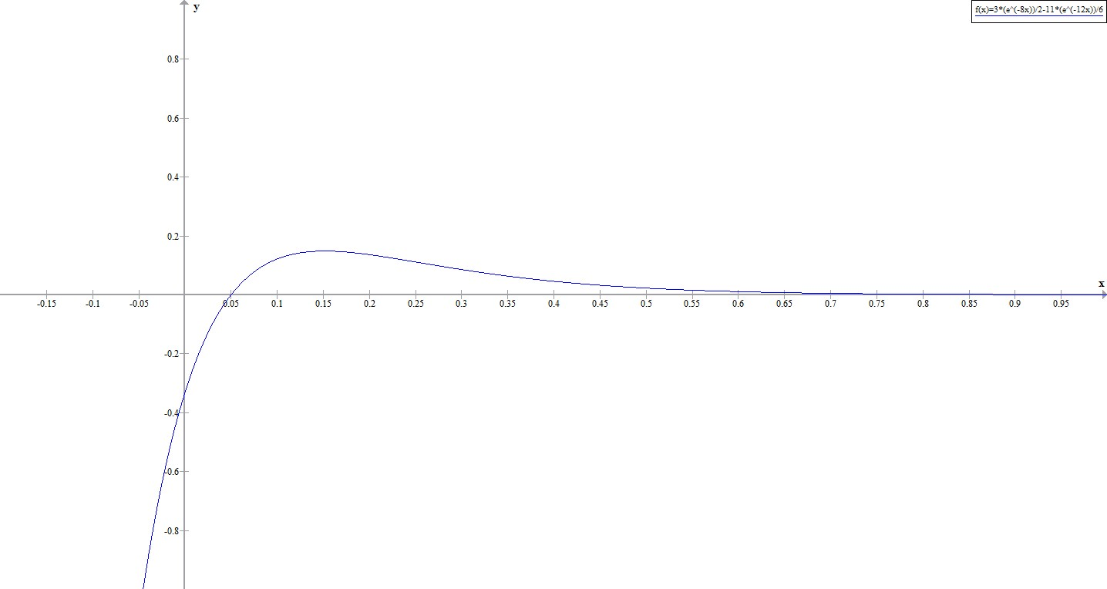

[/Figure]

[Feature Box: Student Project]

**Landing Vehicle**

NASA is planning a mission to Mars. To save money, they have decided to adapt one of the moon landing vehicles for the new mission. However, they are concerned about how the different gravitational forces will affect the suspension system that cushions the craft when it touches down. The acceleration due to gravity on the moon is 1.6 m/s2, whereas on Mars it is 3.7 m/s2.

The suspension system on the craft can be modeled as a damped spring-mass system. In this case, the spring is below the lander, so the spring is slightly compressed at equilibrium, as shown in Figure 17_03_07.

[Figure_17_03_07_lander] SAMPLE ONLY. Lander diagram generated by writer in MS Powerpoint. Photo from Wikimedia.org, to be replaced.

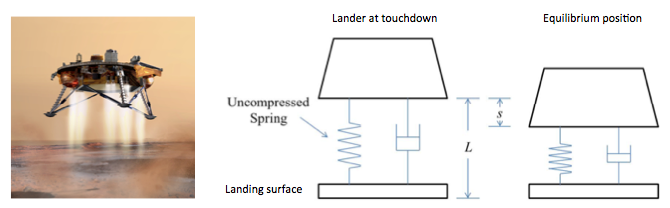

[Caption]The landing craft suspension can be represented as a damped spring-mass system.[/Caption]

[/Figure]

We retain the convention that down is positive. Despite the new orientation, an examination of the forces affecting the lander shows that the same differential equation can be used to model the position of the landing craft relative to equilibrium:



1. The lander has a mass of 15,000 kg and the spring is 2 m long when uncompressed. The lander is designed to compress the spring 0.5 m to reach the equilibrium position under lunar gravity. The dashpot imparts a damping force equal to 48,000 times the instantaneous velocity of the lander. Set up the differential equation that models the motion of the lander when the craft lands on the moon.
2. Let time  denote the instant the lander touches down. The rate of descent of the lander can be controlled by the crew, so that it is descending at a rate of 2 m/s when it touches down. Find the equation of motion of the lander on the moon.
3. If the lander is traveling too fast when it touches down, it could fully compress the spring and “bottom out.” Bottoming out could damage the landing craft and must be avoided at all costs. Graph the equation of motion you found in part 2. If the spring is 0.5m long when fully compressed, will the lander be in danger of bottoming out?
4. Assuming NASA makes no adjustments to the spring or the damper, how far does the lander compress the spring to reach the equilibrium position under Martian gravity?
5. If the lander crew uses the same procedures on Mars as on the moon, and keeps the rate of descent to 2 m/s, will the lander bottom out when it lands on Mars?
6. What adjustments, if any, should NASA make in order to safely use the lander on Mars?

**Solution (appears in solutions manual)**

1. To find the spring constant, we have



Then .

1. The differential equation in part 1 has general solution



Applying the initial conditions  and , we find



1. [Figure_17_03_07_moonlndr_img] SAMPLE ONLY. Graph of  generated by graph.exe. See comments on Figure 17_03_02 for URL to download graph software. Change  to , change  to , make axis labels bigger, make axes thicker, delete legend . Change axis so that it starts at 0.

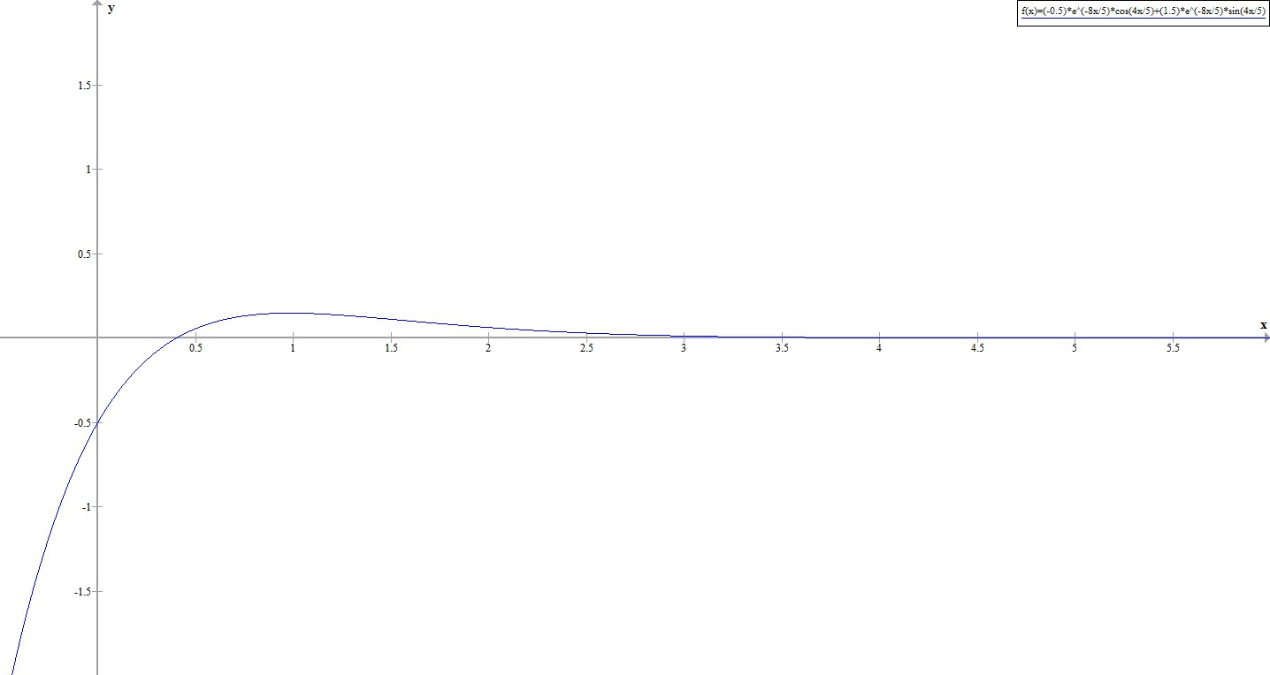

[/Figure]

The spring is 2 m long, and is compressed 0.5 m at equilibrium. When fully compressed, the spring is 0.5 m long. Therefore, if the spring is compressed 1 m beyond equilibrium, the lander will bottom out. The graph shows the spring compresses less than 0.5 m beyond equilibrium, so the lander is in no danger of bottoming out on the moon.

1. Gravity on Mars is 3.7 m/s2. So we have



On mars, the spring is compressed 1.156 m at equilibrium.

1. The spring and damper have not changed, and the lander still has the same mass so the same differential equation used to model lander motion on the moon can be used for Mars. The general solution also remains the same



Our initial conditions are  and , so the equation of motion for the lander on Mars is



Recall the lander will bottom out if the spring is compressed 1.5 m overall. On Mars, the spring is already compressed 1.156 m at equilibrium, so if it is compressed only 0.344 m beyond equilibrium, the lander will bottom out. Graphing the equation of motion we see the spring will compress more than 0.4 m beyond equilibrium, so on Mars, the lander WILL bottom out.

[Figure_17_03_08_marslndr_img] SAMPLE ONLY. Graph of  generated by graph.exe. See comments on Figure 17_03_02 for URL to download graph software. Change  to , change  to , make axis labels bigger, make axes thicker, delete legend . Change axis so that it starts at 0.

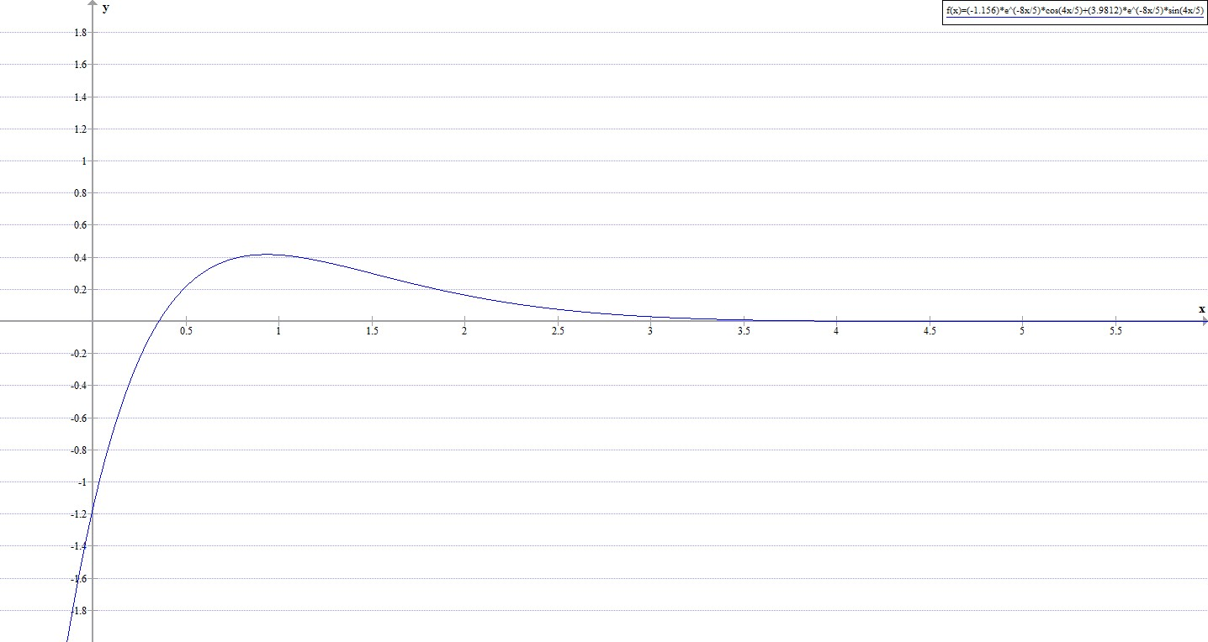

[/Figure]

1. Use a stiffer spring, a more powerful damper, or slow the landing speed of the craft.

[/Feature Box]

[H2]**Forced Vibrations**

The last case we will consider is when an external force acts on the system. We model these forced systems with the non-homogeneous differential equation

.

As we learned in Section 17.2, differential equations like this have solutions of the form , where  is the general solution of the complementary equation and  is a particular solution of the non-homogeneous equation. If the system is damped, . Since these terms do not affect the long-term behavior of the system, we call this part of the solution the **transient solution.** The long-term behavior of the system is determined by , so we call this part of the solution the **steady-state solution.**

[Example_17_03_06]

**Forced Vibrations**

A mass of 1 slug stretches a spring 2 feet and comes to rest at equilibrium. The system is immersed in a medium that imparts a damping force equal to 8 times the instantaneous velocity of the mass. Find the equation of motion if at time  an external force equal to  is applied to the system.

**Solution**

You have , so , and the differential equation is .

The general solution of the complementary equation is . Assuming a particular solution of the form  and using the method of undetermined coefficients, you find , so . At , the mass is at rest in the equilibrium position, so you have . Applying these initial conditions to solve for  and  you get.

[/Example]

[Checkpoint]

A mass of 2 kg is attached to a spring with constant 32 N/m and comes to rest in the equilibrium position. At time  an external force equal to  is applied to the system. Find the equation of motion if there is no damping.

[Hint]

Find the particular solution *before* applying the initial conditions.

[/Hint]

[Answer]



[/Answer]

[/Checkpoint]

[Feature Box: Student Project]

**Resonance**

Consider an undamped system exhibiting simple harmonic motion. The frequency of the resulting motion, given by  is called the natural frequency of the system. If an external force acting on the system has a frequency close to the natural frequency of the system, a phenomenon called **resonance** results. The external force reinforces and amplifies the natural motion of the system.

1. Consider the differential equation . Find the general solution. What is the natural frequency of the system?
2. Now suppose this system is subjected to an external force given by . Solve the initial-value problem , , .
3. Graph the solution. What happens to the behavior of the system over time?
4. In the real world, there is always some damping. However, if the damping force is weak, and the external force is strong enough, real-world systems can still exhibit resonance. One of the most famous examples of resonance is the collapse of the Tacoma Narrows Bridge on November 7, 1940. The bridge had exhibited strange behavior ever since it was built. The roadway had a strange “bounce” to it. On the day it collapsed, a strong windstorm caused the roadway to twist and ripple violently. The bridge was unable to withstand these forces and it ultimately collapsed. Experts believe the windstorm exerted forces on the bridge that were very close to its natural frequency and the resulting resonance ultimately shook the bridge apart.

[Media]

To read more about the collapse of the Tacoma Narrows Bridge, see the Washington State Department of Transportation website at <http://www.wsdot.wa.gov/tnbhistory/connections/connections3.htm>.

[/Media]

[Media]

During the short time the Tacoma Narrows Bridge stood, it became quite a tourist attraction. Several people were on site the day the bridge collapsed, and one of them caught the collapse on film. Watch the video here:

<http://www.youtube.com/watch?v=nFzu6CNtqec>.

[/Media]

1. Another real world example of resonance is a singer shattering a crystal wineglass when she sings just the right note. When you tap a crystal wineglass or wet your finger and run it around the rim, you can hear a tone. That note is created by the wineglass vibrating at its natural frequency. If a singer then sings that same note at a high enough volume, the glass shatters due to resonance.

[Media]

Mythbusters did an episode on this phenomenon, described here: <http://www.discovery.com/tv-shows/mythbusters/mythbusters-database/human-voice-shatter-glass.htm>. Adam Savage also described the experience. <http://www.discovery.com/tv-shows/mythbusters/videos/adam-savage-on-breaking-glass.htm?_ga=1.132033670.806660442.1414861098>.

[/Media]

**Solution (appears in solutions manual)**

1. The general solution is . The natural frequency is .
2. 
3. [Figure_17_03_09_resonance_img] SAMPLE ONLY. Graph of  generated by graph.exe. See comments on Figure 17_03_02 for URL to download graph software. Change  to , change  to , make axis labels bigger, make axes thicker, delete legend .

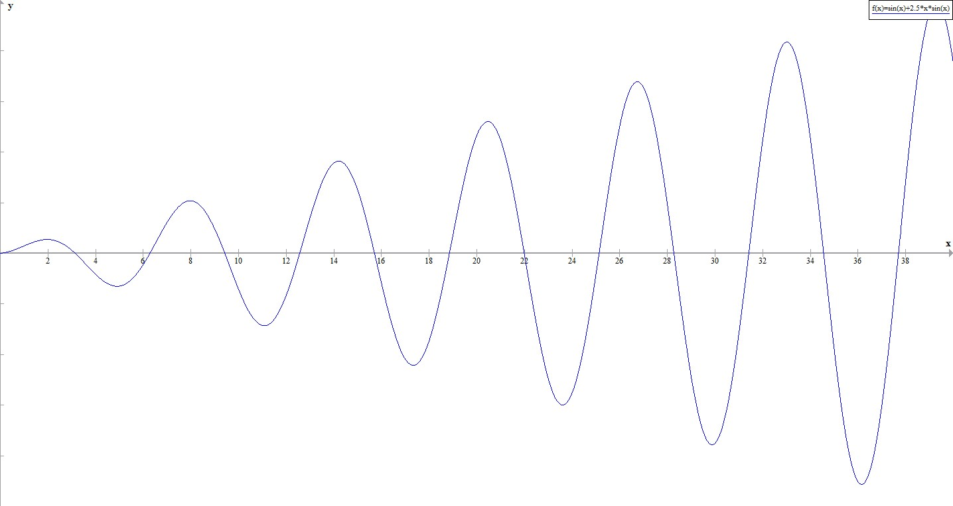

[/Figure]

As time passes, the amplitude of the motion gets bigger and bigger. In a physical system the motion would likely destroy the system.

[/Feature Box]

[H2]**The *RLC* Series Circuit**

If  denotes the current in the *RLC* circuit shown in Figure 17_03_06, and  denotes the charge on the capacitor, then by Kirchhoff’s loop rule,

.

Here *L* is inductance, *R* is resistance, and *C* is capacitance. Noting that , this becomes



Mathematically, this system is analogous to the spring-mass systems we have been examining in this section.

[Figure_17_03_10_circuit] SAMPLE ONLY <http://electronics.stackexchange.com/questions/26268/solving-the-second-order-differential-equation-for-an-rlc-circuit-using-laplace> Change  to *E*. Delete symbols within circle labeled .

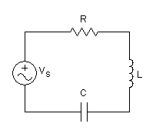

[Caption]*RLC* Series Circuit[/Caption]

[/Figure]

[Example_17_03_07]

**The *RLC* Series Circuit**

Find the charge on the capacitor in an *RLC* series circuit where H, , F, and V. Assume the initial charge on the capacitor is 0 C and the initial current is 9 A.

**Solution**

You have



The general solution of the complementary equation is . Assume a particular solution of the form , where  is a constant. Using the method of undetermined coefficients, you find . So

.

Applying the initial conditions  and , you find  and . So the charge on the capacitor is

.

[/Example]

[Checkpoint]

Find the charge on the capacitor in an *RLC* series circuit where H, , F, and V. Assume the initial charge on the capacitor is 0 C and the initial current is 4 A.

[Hint]

Remember, .

[/Hint]

[Answer]



[/Answer]

[/Checkpoint]

[Summary]

* Second-order constant-coefficient differential equations can be used to model spring-mass systems.
* An examination of the forces on a spring-mass system results in a differential equation of the form

,

where  represents the mass, is the coefficient of the damping force,  is the spring constant, and  represents any net external forces on the system.

* If , there is no damping force acting on the system and simple harmonic motion results.
* If , the behavior of the system depends on whether , , or .
* If  the system is over-damped and does not exhibit oscillatory behavior.
* If  the system is critically damped. It does not exhibit oscillatory behavior, but any slight reduction in the damping would result in oscillatory behavior.
* If  the system is under-damped. It exhibits oscillatory behavior, but the amplitude of the oscillations decreases over time.
* If  the solution to the differential equation consists of a transient solution and a steady-state solution. The steady-state solution governs the long-term behavior of the system.
* The charge on the capacitor in an *RLC* series circuit can also be modeled with a second-order constant-coefficient differential equation of the form



where *L* is the inductance, *R* is the resistance, *C* is the capacitance, and  is the voltage source.

[KeyTerms]

**Simple Harmonic Motion:** An undamped spring-mass system will exhibit **simple harmonic motion**. The mass will continue to oscillate indefinitely.

**Damped Harmonic Motion:** A damped spring-mass system exhibits damped harmonic motion. The mass may or may not oscillate, but will eventually return to the equilibrium position over time.

**Forced Motion:** A spring-mass system subjected to an external force exhibits forced motion. If damping is present in the system, the motion of the system has two components: the transient solution, which dies out over time, and the steady-state solution, related to the forcing function, which characterizes the long-term behavior of the system.

**Steady-State Solution:** The steady-state solution is related to the forcing function and determines the long-term behavior of a forced spring-mass system.

***RLC* series circuit:** A second-order, constant-coefficient differential equation can be used to model the charge on the capacitor in an *RLC* series circuit.

[/key terms]

[KeyEquations]

[/keyequations]

**CNX Calculus, Section 17.4**

[H1]**17.4 Series Solutions of Differential Equations**

[Learning objectives]

* Use power series to solve first-order and second-order differential equations.

[/Learning objectives]

In a previous chapter, we studied how functions can be represented as power series, . We also saw that we can find series representations of the derivatives of such functions by differentiating the power series term by term. This gives

 and . In some cases, these power series representations can be used to find solutions to differential equations.

You should be aware that we give this subject only a very brief treatment in this text. Most introductory differential equations textbooks include an entire chapter on power series solutions. We have only a single section on the topic, so several important issues are not addressed here, particularly issues related to existence of solutions. We have chosen examples and exercises in this section so that power solutions exist. However, that is not always the case. Students interested in a more rigorous treatment of this topic should consult a differential equations textbook.

[Problem Solving Strategy]

**Finding Power Series Solutions of Differential Equations**

1. Assume the differential equation has a solution of the form .
2. Differentiate the power series term by term to get  and .
3. Substitute the power series expressions into the differential equation and equate coefficients of like powers of to determine values for the coefficients  in the power series.
4. Write down the general solution to the differential equation.

[/Problem Solving Strategy]

[Example_17_04_01]

**Series Solutions of Differential Equations**

Find a power series solution for the following differential equations.

1. 
2. 

**Solution**

1. Assume  [Step 1]. Then  and . [Step 2]. You want to find values for the coefficients  so that



This can only happen if the coefficients of each power of  are 0. So you have



Looking only at the equations involving even values of , you see that



Thus, in general, when  is even,  [Step 3]

Turning your attention to the equations involving odd values of , you see that



Therefore, in general, when  is odd,  [Step 3 continued]

Putting this together, you have



Re-indexing the sums to account for the even and odd values of  separately, you obtain

 [Step 4]

This is a perfectly valid power series, and you could simply stop here and be done. However, this is a constant-coefficient differential equation with general solution . You would expect the power series approach to give the same answer, but it is not clear from this representation whether or not that is the case. However, if you choose



then you have  and, and



So you have, in fact, found the same general solution.

1. Assume  [Step 1]. Then  and . [Step 2]. You want to find values for the coefficients  so that



Looking at the coefficients of each power of , you see that the constant term must be equal to , and the coefficients of all other powers of  must be 0. Then, looking first at the constant term,

 [Step 3]

The  term gives you

 [Step 3 continued]

The  term leads to

 [Step 3 continued]

The  term gives you

 [Step 3 continued]

The  term leads to

 [Step 3 continued]

The  term gives you

 [Step 3 continued]

Putting this together, you have



[Step 4]

[/Example]

[Checkpoint]

Find a power series solution for the following differential equations.

1. 
2. 

[Hint]

Write out several terms of the series until you see the pattern.

[/Hint]

[Answer]

1. 
2. 

[/Answer]

[/Checkpoint]

[Summary]

* Power series representations of functions can sometimes be used to find solutions to differential equations.
* Differentiate the power series term by term and substitute into the differential equation to find relationships between the power series coefficients.