Create Plugin (Single Interface)

Introduction

This document explains how to create a single interface plugin for Open Store v4.

You need to have Visual Studio and the VS template for the OpenStore Plugin template (“OS_PluginTemplateSI”).

Place zip file into VS folder: \Documents\Visual Studio 20**\Templates\ProjectTemplates\Visual C#

<https://github.com/openstore-ecommerce/OS_PluginTemplateSI/releases>

# Create Project

Create a new project in VS using the “OS_PluginTemplateSI” VS project template.

**USE case match on next replace operation:**  
Rename ALL instances of “os_plugintemplatesi_” with “new project name_” (IMPORTANT: for this replace make sure you use LOWERCASE) **NOTICE: “_” on the end of this replacement.  
**If you forget the case sensitive replacement, it’s easier to start again.**

Rename ALL instances of “OS_PluginTemplateSI” with “new project name” (Turn off match case).

Ensure the xml ctrl field in the “plugin*.xml” file is the lowercase “new gateway name”.   
<ctrl update="save">lowercase</ctrl> This should match the replacement above (without “_”).

Make sure the ajax provider in “admin.cshtml” is in lowercase.

<input id="ajaxprovider" type="hidden" value="xxxxxxxxxxxxxxxxxxxxxx" />

Rename files and project to match new gateway.

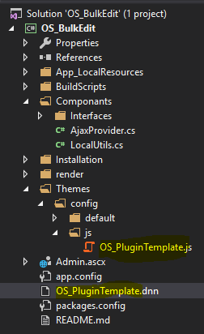

You should be able to compile now. **[NOTE: If using DNN9.3+ you will need to move the Asp.Net framework to v4.7.2+]**

# Add to OpenStore Menu

The plugins are added to the OpenStore admin menu via the plugin interface. The easiest way to add a plugin is to copy the “pluginconfig.xml” of the project into the “\DesktopModules\NBright\NBrightBuy\Plugins” folder, then go into the OpenStore BO>Admin>Plugins and the plugin will be automatically added to the menu. You can also create the plugin manually through the plugin page if you want to.

NOTE: If you create the plugin manually you can use the XML field to get a copy of the XML required to create a pluginconfig.xml file.