WorldPay Payment Gateway

# Introduction

This document describes the setup of the WorldPay gateway for OpenStore v4 on DNN.

# Installation

Install the gateway like any other DNN module. After installation go into the Admin Panel of OpenStore and go into Admin>Plugins. The plugin should be load at this point.

# WorldPay Admin Setup

You need to have a Business Account at WorldPay with a payment installation. We will explain the minimal setup to run WorldPay on OpenStore. OpenStore uses the WorldPay redirect solution.

Go into Setup on the right Menu, Select the settings of the installation you are going to use.

Required:

MD5 Secret Key  
Payment Response URL: <your domain>/desktopmodules/nbright/os_worldpay/notify.ashx  
Signature Fields: “currency:cartId:amount”  
Payment Response Email.

**NOTE:** the Signature Fields must be set to: **currency:cartId:amount**

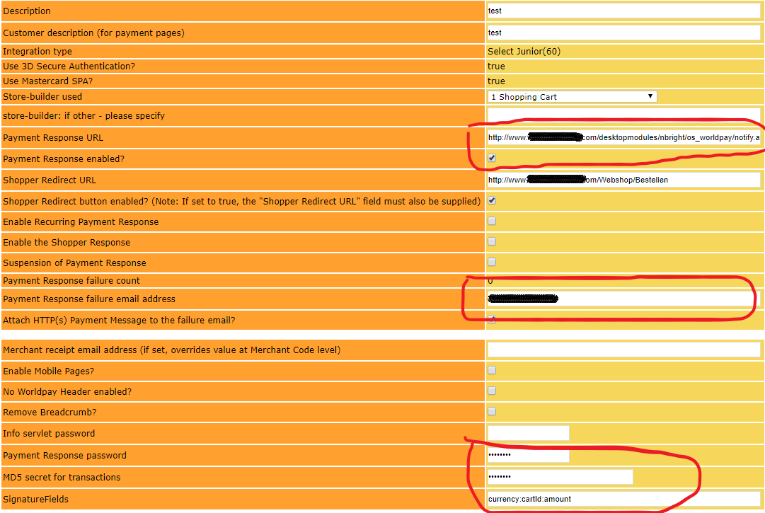

# OpenStore Setup

The configuration parameters of WorldPay can be found in Admin>WorldPay.

