|  |  |
| --- | --- |
| **How to download WIFI FW in ESP32-WROOM module** |  |

To support sensor data need to update ESP32 basic FW with “espruino” machine and then download JavaScript script into it.

Based on this tutorial: <https://techtutorialsx.com/2017/10/15/esp32-javascript-getting-started-with-espruino/>

1. Run flash_download_tool_3.8.5.exe software.
2. Chose -> Developer mode
3. Chose -> ESP32 Download
4. Setup the settings as follow:

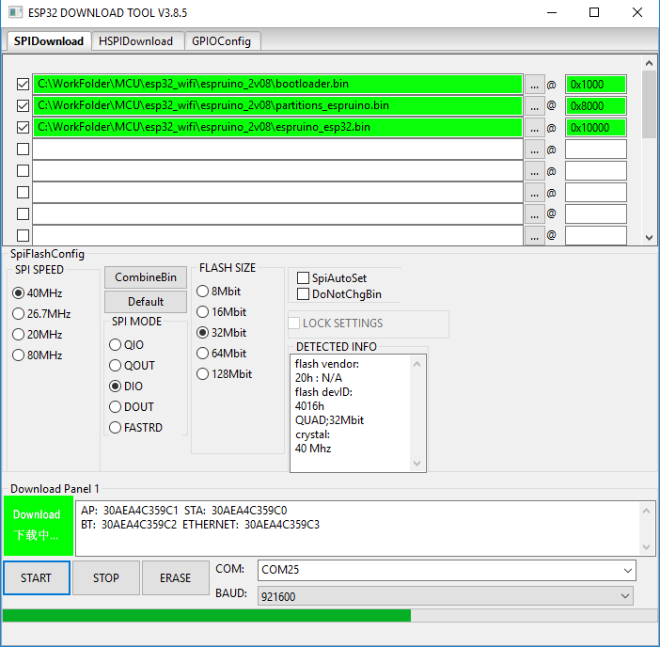

1. Connect the BOOT pin of ESP32 to GND and apply the power;
2. Can skip this step: Push “Erase” and wait until it finish;
3. Can skip this step: Disconnect power*; connect the BOOT pin of ESP32 to GND and apply the power;

* It need to turn off/on the power before flashing.

1. Push “Start” and wait until it finish;
2. Reconnect the power;
3. Run “ESPRUINO WEB IDE”
4. In the ESPRUINO IDE should be setup as follow:

-> Settings -> Communication: Baud rate = 115200

-> Settings -> Communication: Save on Send = “Direct to Flash (execute code at boot)”

-> The script file is open “script_comb.json”

11. Connect the IDE to UART; Check that it is connected:

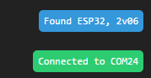

12. Download script to the device; It takes some time; The progress is showing on the right bottom corner.

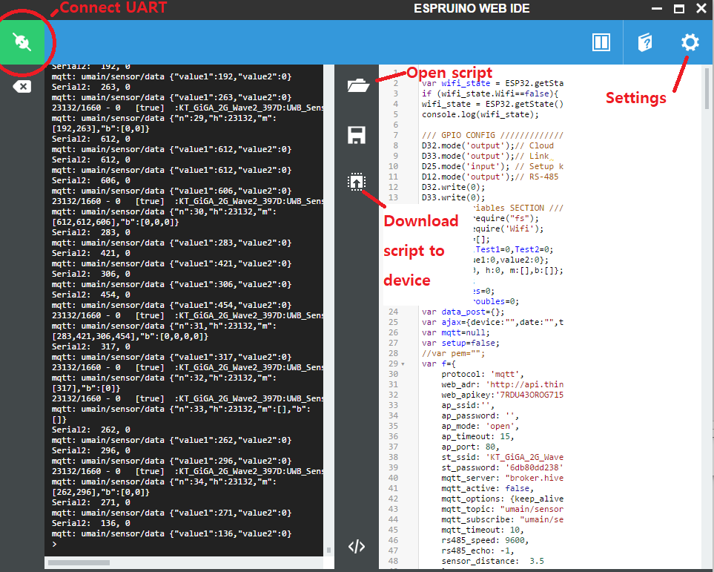

13. When download is finished script prints device’s MAC address:

