


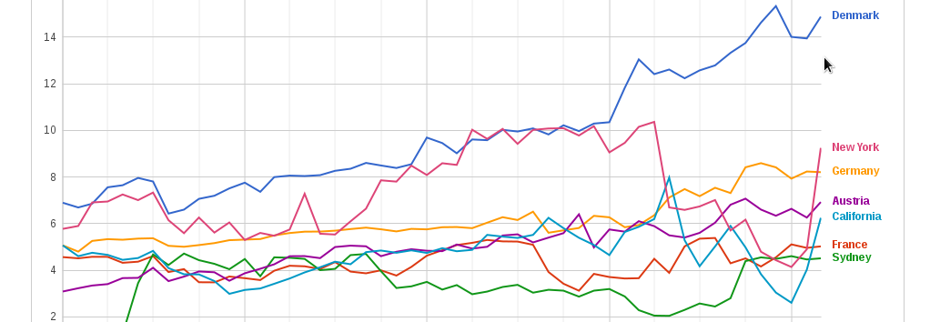
What is Measurement Lab?
measurementlab.net
M-Lab provides the largest collection of open Internet performance data on the planet.
When an Internet application doesn't work as expected, how can you tell whether the problem is caused by your connection, the application or something else? It can be very difficult for professional network administrators, let alone average Internet users, to answer this sort of question today. Transparency has always been an essential component of the Internet's success, and Internet users deserve to be well-informed about the performance of their broadband connections. For that to happen, researchers need resources to develop new analytical tools.
That's where M-Lab comes in.
M-Lab is an open, distributed server platform on which researchers can deploy open source Internet measurement tools. The data collected by those tools is released in the public domain. The goal of M-Lab is to advance network research and empower the public with useful information about their broadband and mobile connections. By enhancing Internet transparency, M-Lab helps sustain a healthy, innovative Internet.

Open Internet Measurement
M-Lab provides the largest collection of open Internet performance data on the planet. As a consortium of research, industry, and public interest partners, M-Lab is dedicated to providing an ecosystem for the open, verifiable measurement of global network performance.
Real science requires verifiable processes, and M-Lab welcomes scientific collaboration and scrutiny. This is why all of the data collected by M-Lab's global measurement platform is made openly available, and all of the measurement tools hosted by M-Lab are open source.
Anyone with the time and skill can review and improve the underlying methodologies and assumptions on which M-Lab's platform, tools, and data rely. Transparency and review are key to good science, and good science is key to good measurement.

measurementlab.net

Ways to Get Involved
M-Lab welcomes the participation of industries, institutions, and researchers who would like to help expand the platform and ensure its growth and success.
- Host an Experiment on the M-Lab Platform
If you are a researcher who is interested in deploying a network measurement experiment on M-Lab, find out how on our Contribute page:
>> http://www.measurementlab.net/contribute
- Contribute to M-Lab Client Implementations
M-Lab “clients” are either standalone network experiments that submit data to M-Lab or are integrations of M-Lab experiments into existing software, like a browser extension. Contact M-Lab to find out more:
>> http://measurementlab.net/contact
- Host an M-Lab Site
M-Lab depends on contributions of servers and connectivity from other industry and institutional partners.
Basic M-Lab System Site Requirements:
  - At least 3 enterprise-grade servers, a dedicated gigabit switch and rackspace
  - 1 Gbps connectivity
  - A dedicated and unified /26 block of IPv4 address space
IPv6 connectivity is a plus
  - Administration: initial setup and physical maintenance of the host.
Complete Guide to Hosting an M-Lab Site:
>> http://goo.gl/6KhIZM

For More Information:
If you would like to contribute servers and connectivity, please contact M-Lab's steering committee:
>> http://measurementlab.net/contact

measurementlab.net

Why measure the Internet?
Have you ever sat down to watch a movie over your broadband Internet connection, only to have the connection re-buffer every 10 seconds? Your ISP may likely be throttling your connection to your content provider to extort extra transit fees. You paid for a connection to the Internet. Why is one kind of content treated differently from another?
Ever wonder whether you're getting the upload and download speeds as advertised by your ISP? You used an “Internet Speed Test” to try to find out, but you're skeptical because the test was created by your ISP.
Why is your broadband connection so much more expensive than a comparable service where you used to live? Why do consumers in the United States pay more money for lower quality Internet service than people in other countries?
These are the kinds of questions that drive M-Lab Researchers.

How is M-Lab Data Used?
M-Lab data is used in a variety of ways by researchers, policy analysts, and others to gain a better understanding of Internet connection data. Test data is submitted by users around the world through a standard platform, and uses measurement tools that are both academically rigorous and methodologically sound to test for everything from network speed and latency to blocking and throttling.
M-Lab tools are divided into three categories:
- Performance:
measures the basic (and not so basic) performance characteristics of your network: speed, latency, jitter and much more.
- Transparency:
provides insight into network management practices such as application-specific blocking, throttling, traffic shaping, and other practices that determine your access to applications and content.
- State:
gives information on the state of the network and the host environments, such as whether IPv6 is enabled, traceroute data, and other information that provides context.

