


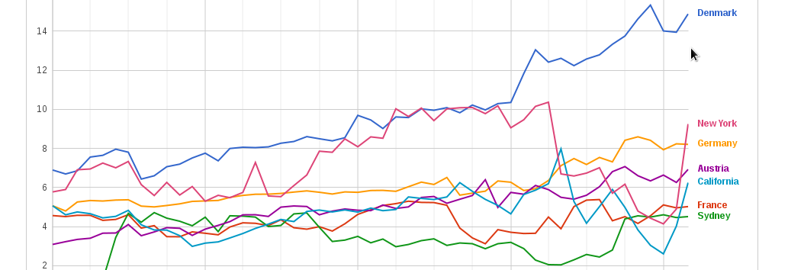

Open Internet Measurement
measurementlab.net
When your Internet connection doesn't work as expected, how can you tell whether the problem is caused by your connection, the application or something else? Answering this question and others like it is surprisingly difficult. That's the purpose of Measurement Lab.
M-Lab is a consortium of research, industry and public-interest partners dedicated to:
- Providing an open, verifiable measurement platform for global network performance
- Hosting the largest open Internet performance dataset on the planet.
- Creating visualizations and tools to help people make sense of Internet performance

Why Measurement Lab?
Real science requires verifiable processes, and M-Lab welcomes scientific collaboration and scrutiny. This is why all of the data collected by M-Lab's global measurement platform is openly available, and all of the measurement tools hosted by M-Lab are open source. Anyone with the time and skill can review and improve the underlying methodologies and assumptions on which M-Lab's platform, tools, and data rely. Transparency and review are key to good science, and good science is key to good measurement.

How is M-Lab Data Used?
M-Lab data is used by researchers, policy analysts, and industries to better understand our connections to the Internet. People from around the world use our tests to see everything from their network speed and latency to potential blocking and throttling of their connections.

measurementlab.net

How can M-Lab Benefit my Organization?
M-Lab welcomes the participation of industries, institutions, and researchers who would like to help expand the platform and ensure its growth and success.
- Measure the Health of Your Networks
You can use M-Lab data to understand the health of your networks from a consumer perspective, and compare aggregate statistics of your network with that of other nearby network providers. Increasing the number of M-Lab servers in the desired measurement region and encouraging more M-Lab tests to be run from within your networks enables more specific queries based on region, metro area, city, and upstream Internet provider.

- Gain Deeper Insight into Network Performance
M-Lab's servers are instrumented at the kernel level with instrumentation to measure network performance across 100 variables collected with each test. By using and contributing to M-Lab data, standard metrics like download and upload throughput, round trip times, and other measures of latency are complemented by many more variables, enabling a very nuanced look into performance at each step in the path between the user initiating a test and the server receiving data.
- Integrate M-Lab Data with Your Own
Because M-Lab data is open and all of our tests are open source, you can integrate our data or

