

**OTC STATUS DASHBOARD** USER GUIDE

T-Systems International GmbH

|  |  |  |
| --- | --- | --- |
| Version |  | 1.0 |
| Last revised: | | 07/07/2021 |
| Status | FINAL | |

T-Systems International GmbH 07/07/2021 public

TABLE OF CONTENTS

|  |  |  |  |  |
| --- | --- | --- | --- | --- |
| 1 | The Dashboard ................................................................................................................... | | | 1 |
|  | 1.1 | Structure of the dashboard ........................................................................................... | | 1 |
|  | 1.2 | States of a service ........................................................................................................ | | 3 |
|  | 1.3 | Main functions of the Status Dashboard ...................................................................... | | 4 |
|  | 1.4 | The RSS feed ............................................................................................................... | | 5 |
| 2 | Grafana pages for detailed analysis .................................................................................... | | | 6 |
|  | 2.1 | Service details .............................................................................................................. | | 6 |
|  | 2.2 | The SLA relevant availability ...................................................................................... | | 7 |
|  | 2.3 | "All-in-one" dashboard ................................................................................................ | | 9 |
|  | 2.4 | Problematic services .................................................................................................... | | 9 |
| 3 | Technical overview .......................................................................................................... | | | 10 |
|  | 3.1 | Main system components .......................................................................................... | | 11 |
|  | 3.1.1 | | The data collector ............................................................................................... | 11 |
|  | 3.1.2 | | Data handling ..................................................................................................... | 11 |
|  | 3.1.3 | | The main dashboard ........................................................................................... | 11 |
|  | 3.1.4 | | The Grafana ........................................................................................................ | 13 |
|  | 3.2 | The customer's viewpoint .......................................................................................... | | 13 |
|  | 3.3 | Redundancy in the data collection ............................................................................. | | 13 |
| 4 | LIST OF ABBREVIATIONS/GLOSSARY .................................................................... | | | 14 |

T-Systems International GmbH 07/07/2021 public

TABLE OF FIGURES

Figure 1: Structure of Status Dashboard of Open Telekom Cloud 1

Figure 2: Global or region-specific messages 2

Figure 3: Maintenance information 2

Figure 4: Using the status filter 5

Figure 5: Detailed view of a service 6

Figure 6: Availability of SLA relevant services 7

Figure 7: Overview of SLA measuring 8

Figure 8: "All-in-one" dashboard 9

TABLE OF TABLEAUS

Tableau 1: Possible color codes and their associated statuses 3

Tableau 2: Color codes of functions 4

T-Systems International GmbH 07/07/2021 public

**1** **THE DASHBOARD**

The main dashboard is the first thing a user will see when accessing the [Status Dashboard](https://status.otc-service.com/) (SD). The main dashboard provides the high-level overview of the status of monitored services of the Open Telekom Cloud (OTC).

**1.1** **Structure of the dashboard**

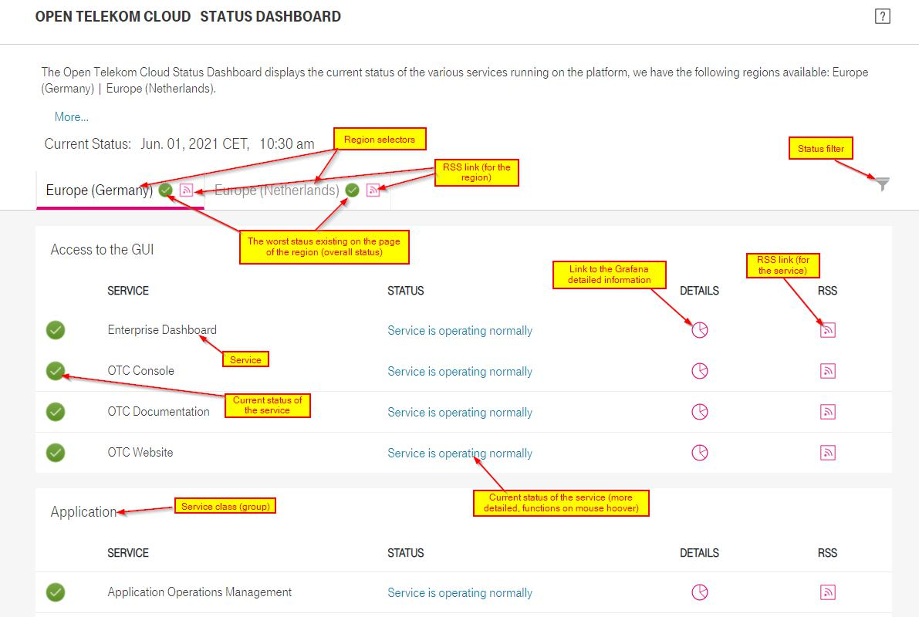

Figure 1: Structure of Status Dashboard of Open Telekom Cloud

T-Systems International GmbH 07/07/2021 public 1

**Messages displayed on the dashboard**

Our Service Team may post messages on the SD. Those messages are for informing customers about issues on the Open Telekom Cloud and measures taken for remediating them, or any other information that can be in interest for our customers. Messages can be posted for the whole Open Telekom Cloud globally or for a specific region only:

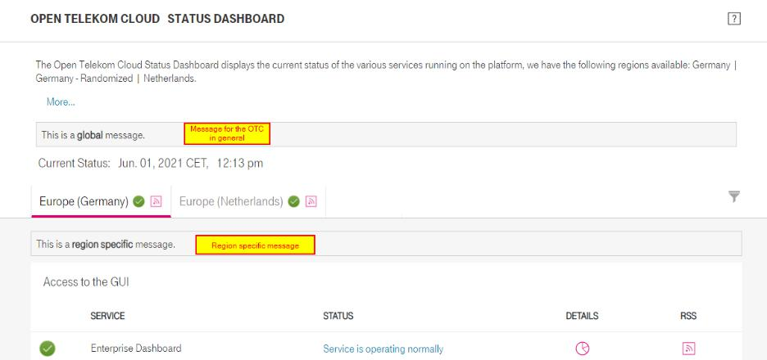

Figure 2: Global or region-specific messages

Messages about upcoming and ongoing maintenances can be displayed on the main dashboard.

Errors detected during ongoing maintenance are treated differently by the SD.

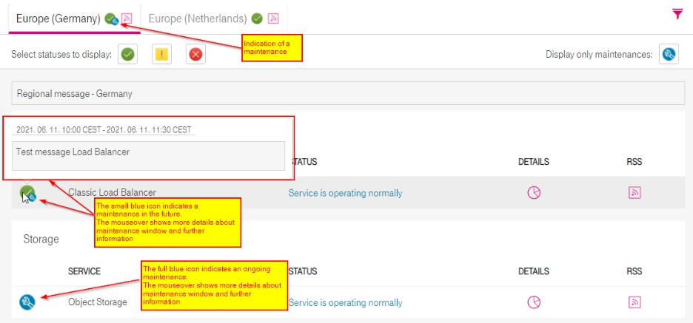

Figure 3: Maintenance information

T-Systems International GmbH 07/07/2021 public 2

**1.2** **States of a service**

Services and functions may be in different states. They may have some issues (slowdown, instability, failure, etc.) or may be fully down. Most likely, our customers will see three different status icons showing the state of the service:

The service operates normally

The service is having some issues (e.g. requests take longer than 3 seconds)

The service is highly unstable or completely down (wrong answer or request takes longer than 10 seconds)

In addition, there are two statuses indicating a planned as well as an ongoing maintenance:

Maintenance is planned for the service

Maintenance is ongoing for the service

The tables below are showing all possible color codes and their associated statuses:

**Services**

|  |  |  |
| --- | --- | --- |
| **Functions (weight)** | **Color** | **Message** |
|  |  |  |
| All good (1) |  | All functions are up and running |
|  |  |  |
| Less than half of the functions are slow (2) |  | Some functions may respond |
|  | slowly |
|  |  |
|  |  |  |
| Greater or equal than half of the functions are slow |  | Most of the functions may |
| (2) |  | respond slowly |
|  |  |  |
| Less than half of the functions are slowed down |  | Some functions are overloaded |
| (3) |  |
|  |  |
|  |  |  |
| Greater than or equal to half of the functions are |  | All functions are slowed down |
| slowed down (3) |  |
|  |  |
|  |  |  |
| Less than half of the functions are unstable (4) |  | Some functions are unstable |
|  |  |  |
| Less than or equal half of the functions are |  | Most of functions are unstable |
| unstable (4) |  |
|  |  |
|  |  |  |
| 1 or less than half of functions down (5) |  | Some functions are down |
|  |  |  |
| Greater than or equal to half of the functions down |  | Service is down |
| (5) |  |
|  |  |
|  |  |  |
| Tableau 1: Possible color codes and their associated statuses |  |  |



T-Systems International GmbH 07/07/2021 public 3

The same for functions of a certain service:

|  |  |  |
| --- | --- | --- |
| **Last 10** | **Color** | **Message** |
|  |  |  |
| All good |  | All responses are up and running |
|  |  |  |
| 3 slow |  | Function may respond slowly |
|  |  |  |
| Last 3 slow |  | Function is slowed down |
|  |  |  |
| 3 response time is zero |  | Instability |
|  |  |  |
| Last 3 response time is zero |  | Function is down |
|  |  |  |



Tableau 2: Color codes of functions

**1.3** **Main functions of the Status Dashboard**

Selecting a certain region will show all services monitored in that region

Clicking on the global RSS link () will download the RSS source (XML). If your browser is equipped with an RSS reader, it will most likely offer subscribing to that feed (depends on the RSS reader installed)

Hoovering the cursor over the "Status" message of the service will lead to a small pop-up window with statuses of all monitored functions of the particular service

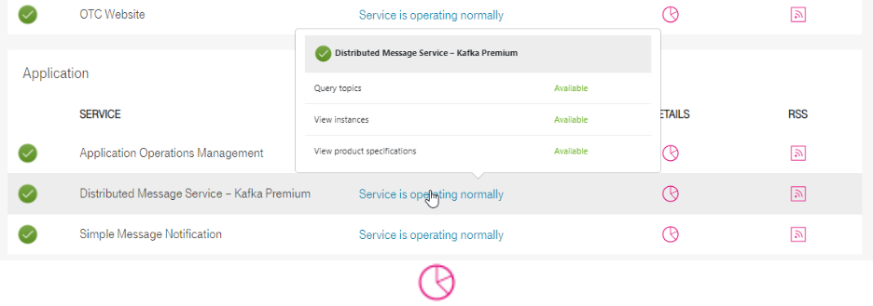

Clicking on the "Details" link ( ) will open a new browser tab with detailed

information about the service on a Grafana page

Clicking on the RSS link () of the service will download the RSS source (XML) for that single service

T-Systems International GmbH 07/07/2021 public 4

**The status filters**

In case of an issue detected for a region, the global status icon will show the worst state that exists in the region. Also, if a planned maintenance is defined in the SD system, the global

status icon will show the upcoming () or ongoing () maintenance. In such cases it can be annoying to scroll through the page to find the service affected. For more convenient listing of services in particular states the status filter is implemented:

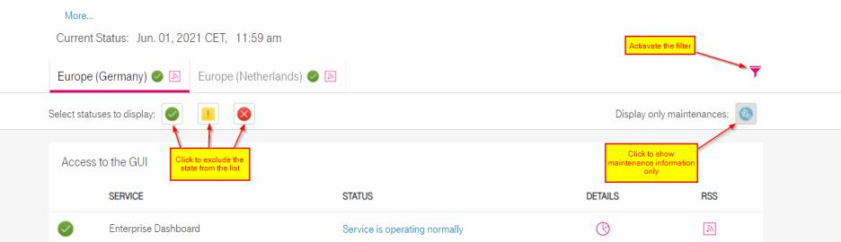

Figure 4: Using the status filter

**1.4** **The RSS feed**

The SD provides RSS feeds for informing customers about status changes in our services. There are two types of RSS feeds:

1. Global RSS feed:

Will contain messages about any service in the region that changes its state (having issue, going down, coming up again).

1. Service specific RSS feed:

Will contain messages only for the particular service for which it was created.

Items (messages) in the feed are sorted by the time of the detection of the state change. The newest message will be always the first (descending order).

You may subscribe to those RSS feeds using any decent RSS reader. Although the SD does not provide push notification functions, using the RSS feed with a short enough refresh period may give almost the same functionality as push notification would do.

The RSS feed may contain the following information:

State change of a service: getting into the error state and the recovery Reminder about messages published for customers on the dashboard

Any message will be kept only for 24 hours in the feed.

T-Systems International GmbH 07/07/2021 public 5

**2** **GRAFANA PAGES FOR DETAILED ANALYSIS**

For showing detailed measurement information about OTC services, a Grafana server hosting several dashboards is implemented in the SD system.

**2.1** **Service details**

Details about a particular service are displayed on a special Grafana page. It can be accessed by clicking on the "Details" icon () on the main dashboard.

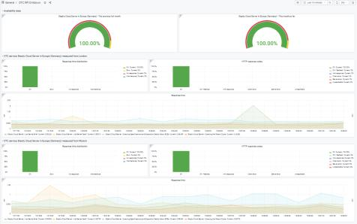

Figure 5: Detailed view of a service

On this dashboard some availability data (for the previous month and for the current month so far) is displayed for any service selected from the main dashboard. Below that, the detailed measurement data is displayed for all data collectors sending test requests to the particular service (in our case, data collectors in London and Munich. More planned...).

In the upper left corner of graphs an information link is available. Hoovering the cursor above the information area the information appears in a pop-up. Some of those are containing links that can be followed.

T-Systems International GmbH 07/07/2021 public 6

**2.2** **The SLA relevant availability**

The availability is calculated for all services. The SLA 1 contains three core services and guarantees certain availability for those. These services are:

1. Elastic Computing Service (ECS)
2. Elastic Volume Service (EVS)
3. Object Storage Service (OBS)

Availability for those services is also calculated. Monthly graphs for the last half year are collected in a separate Grafana page accessible from the information area of the last month availability graph of any service:

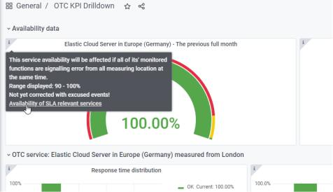

Figure 6: Availability of SLA relevant services

In contrast to the SLA itself, the Grafana page shows availability for four services. The fourth one is the Elastic IP service. It is included into this Grafana page, because SD checks EIP availability by sending HTTP requests to virtual machines (ECS) deployed in different availability zones through their associated public IP addresses. That way this check provides information not only about the status of the EIP service, but also about health of existing virtual machines created by the ECS service.

1. Only in case an Enterprise Agreement 1.0 (EA1.0) or Enterprise Support Agreement 2.0 (ESA2.0) are contractually ordered. More details available [here.](https://open-telekom-cloud.com/resource/blob/data/173450/d4fc9622cfbf9f188d9cdc2a1630b62c/open-telekom-cloud-flyer-enterprise-agreement.pdf)

T-Systems International GmbH 07/07/2021 public 7

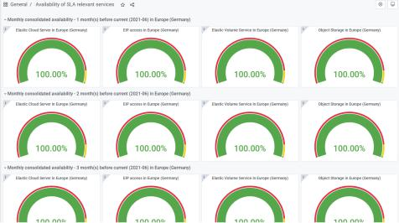

Figure 7: Overview of SLA measuring2

1. EIP is not part of the SLA within Enterprise Agreement 1.0 (EA1.0) or Enterprise Support Agreement 2.0 (ESA2.0)

T-Systems International GmbH 07/07/2021 public 8

**2.3** **"All-in-one" dashboard**

Clicking on the name of the Grafana dashboard ("OTC KPI Drilldown") will take the user to the list of available dashboards. There are two of them that can be used separately: "OTC KPI" and "OTC Problematic services". Others require parameters passed to them when calling from the main dashboard, or from another Grafana dashboard.

The "all-in-one" dashboard is the one called "OTC KPI". It displays graphs for all monitored services for any selected region and time frame:

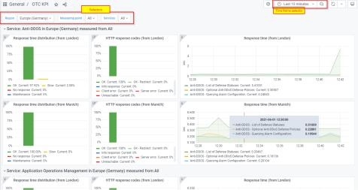

Figure 8: "All-in-one" dashboard

IT professionals may need to see all, or selected services on a single page. Once all graphs on the page are synchronized with each-other and displaying the same period, some correlations between those graphs may give important hints about deeper analysis of the state of the system.

Although it is technically possible to request information on this page about all services in a region for the whole time period of the data retention defined in the system, is still not a good idea to do that. It won't provide much useful information but will put a huge load on the SD system.

**2.4** **Problematic services**

If an issue appears on the OTC, then - depending on the failing system element - several services may be affected. To easily see measurement data for those services on a single page, the dashboard described above has been duplicated and a special filter has been added to it.

As a result, the "OTC Problematic services" dashboard collects all services having any issue during the selected time frame in the Grafana page.

It is important to understand, that on this dashboard all services providing one slow response or error at least from one measuring location will be displayed. It doesn't necessarily mean that those services are really having an issue. It may happen that only one data collector shows an

T-Systems International GmbH 07/07/2021 public 9

increased response time or error which is not correlating with results from the other one. In such a case the OTC service is working well, but a data collector may be affected by some network latency or alike. One should always pay attention to the correlation of graphs on different data collectors for understanding the status of the OTC service monitored.

**3** **TECHNICAL OVERVIEW**

The SD is a simplified monitoring system, capable to show if a service provided by the Open Telekom Cloud is alive, having issues or is down. The user can see current status and historical data for longer than 6 months. The SD is a high-level monitoring system providing information about general availability of services offered by the OTC. The platform is also monitored using other, more detailed, professional grade monitoring systems used by the OTC Operation team. Those monitoring systems are not available publicly. Each customer should acknowledge that monitoring of their own resources used in their own tenants is a responsibility of the given customer3. The OTC provides tools for that (one may set up monitoring of owned resources using services offered by the OTC, like Cloud Eye, Log Tank Service, Cloud Trace Service).

The system is sending queries like API requests to three or more functions of a service. The SD decides about the state of the service by measuring the response time and checking the HTTP response code in replies to API requests.

In a general case, functions of the service itself are tested. In some cases, test requests are sent to real entities created for the testing. Example of that is the Elastic IP (EIP) test, which sends requests to basic HTTP servers on real virtual machines created in different availability zones.

The SD provides information about:

availability of OTC services for all regions and their AZs maintenances

messages from the Service Team towards customer in case of service interruption historical monitoring data

RSS feeds for information about state changes of services availability of SLA relevant services

filtering states and maintenances shown on the dashboard overview of potentially problematic services

1. Please also check chapter 5 of the [service description:](https://open-telekom-cloud.com/service-description) The customer´ duties to cooperate

T-Systems International GmbH 07/07/2021 public 10

**3.1** **Main system components**

SD consists of four main components:

The data collector Data handling

The main dashboard The Grafana

**3.1.1 The data collector**

The data collector is sending out API requests and checks replies to those. Results are exposed using HTTP serving for consuming those by the central database of the SD.

The data collector uses two simple facts for showing error conditions:

1. The response time for an API request cannot ever equal to zero.

Based on this it is possible to use the zero value for showing the error state. If an error or request time-out (10 sec) happens, the data collector forcibly sets the response time to zero. The zero value is used for showing the error in the system and plays essential role in displaying state and availability calculation.

1. The response time for an API request cannot ever equal to any negative value.

In the SD it is possible to define a period of time for services during which period a planned maintenance is conducted. Those maintenances are communicated to customers. Some of them may cause temporary outages in the service maintained. If the data collector detects an error during such time frame, it will set the response time to a small negative value (currently -0.2 sec). Using this trick, the maintenance can be clearly displayed on graphs and it can be excluded from availability calculations.

The SD system can use as many data collectors as needed.

**3.1.2 Data handling**

The SD uses a time series database system for collecting, storing and providing data for dashboards. The DB used in the SD is a Prometheus time series DB.

The Prometheus is capable to fetch data from its data sources. It sends HTTP requests to data collectors in 60 sec period for fetching data measured by them.

The data retention time in the Prometheus DB is a bit more than 200 days. Thanks to this we may provide consolidated availability data for our services for the last half year.

**3.1.3 The main dashboard**

The main dashboard is the first thing a visitor sees when accessing the SD. This is also a proprietary software written by the same team as the data collector. It shows the overall status of OTC regions and statuses of all services monitored in those regions.

T-Systems International GmbH 07/07/2021 public 11

T-Systems International GmbH 07/07/2021 public 12

**3.1.4 The Grafana**

For displaying detailed measurement data for services, a Grafana server is used. Several dashboards are defined in the Grafana system for providing detailed information about our services for any period during the data retention time set up for the Prometheus DB.

**3.2** **The customer's viewpoint**

Main goal of the SD is to provide our customers with monitoring information measured from their viewpoint. To achieve that, the SD system is in a data center fully independent from the OTC platform. Thanks to this, the SD "sees" the OTC just like a customer would see.

**3.3** **Redundancy in the data collection**

The SD can consume data from arbitrary number of data collectors. Using this feature, we installed two data collectors for each OTC regions. This way measurements are done for both regions (Germany and Netherlands) from Munich and from London. This redundancy makes it possible to ignore errors of a single data collector or the network path from a certain data collector to the OTC. The main dashboard will always display the best data available from all collectors. This way issues outside of the OTC are masked (they still can be seen on Grafana dashboards).

T-Systems International GmbH 07/07/2021 public 13

|  |  |  |
| --- | --- | --- |
| **4** | | **LIST OF ABBREVIATIONS/GLOSSARY** |
|  | **Term** | **Description** |
|  |  |  |
|  | API | Application Programming Interface – typically used for automatic control and/or |
|  |  | integration into higher-level orchestration |
|  |  |  |
|  | AZs | Availability Zones |
|  |  |  |
|  | DB | Database |
|  |  |  |
|  | ECS | Elastic Cloud Computing |
|  |  |  |
|  | EIP | Elastic IP |
|  |  |  |
|  | EVS | Elastic Volume Service |
|  |  |  |
|  | HTTP | Hypertext Transfer Protocol |
|  |  |  |
|  | KPI | Key Performance Indicator |
|  |  |  |
|  | OBS | Object Storage Service |
|  |  |  |
|  | OTC | Open Telekom Cloud |
|  |  |  |
|  | RSS | Really Simple Syndication |
|  |  |  |
|  | SD | Status Dashboard |
|  |  |  |
|  | SLA | Service Level Agreement |
|  |  |  |
|  | XML | Extensible Markup Language |
|  |  |  |

|  |  |
| --- | --- |
| Contact |  |
| T-Systems International GmbH | Phone (from Germany): 0800 33 04477 Internet: www.open-telekom-cloud.com |
| Hahnstraße 43d | Phone (from abroad): +800 33 044770 |
| 60528 Frankfurt am Main | Email: service@open-telekom-cloud.com |
|  |  |

T-Systems International GmbH 07/07/2021 public 14