

Enterprise Dashboard

usermanual

T-Systems International GmbH

Version 1.38

Last revised 11/1/2023

Status Released

Publication details

|  |  |  |
| --- | --- | --- |
| Published by | | |
| T-Systems International GmbH Open Telekom Cloud Hahnstraße 43d, 60528 Frankfurt am Main | | |
|  |  |  |
| Filename | Document number | Document name |
| Enterprise Dashboard User Manual | na | Enterprise Dashboard User Manual |
|  |  |  |
| Version | Last revised | Status |
| 1.38 | Dec. 22, 22 | Released |
|  |  |  |
| Dashboard Squad |  |  |

Change history

|  |  |  |
| --- | --- | --- |
| Version | Last revised | Changes/comments |
| 1.0 | Sep. 18, 19 | First official release |
| 1.1 | Sep. 23, 19 | Added limitations and FAQ |
| 1.2 | Oct. 7, 19 | Added new table “ol_otc_product_to_category” in chapter “Database table structure” |
| 1.3 | Oct. 22, 19 | Added new table “dim_ol_reseller_tenants” in chapter “Database table structure”  Added description of each table in chapter Database table structure  Added description for “Value_type” in Business.sap and Business.sap_tag table |
| 1.4 | Nov. 01, 19 | Clarified difference between “out_sap_value” and “src_sap_value” in chapter “database table structure” |
| 1.5 | Nov. 06, 19 | Added new table “dim_ol_sap_tags” in chapter “database table structure” |
| 1.6 | Nov. 14, 19 | Added new FAQ and clarified limitations |
| 1.7 | Nov. 20, 19 | Corrected description of dashboards in chapter “Access Dashboards” |
| 1.8 | Nov. 25, 19 | Reworked chapter 3.3 Setup alerts, more clear and structured description of how to setup alerts. |
| 1.9 | Dec. 04, 19 | The added data field “project_name” in business.sap, business.sap_tag  Added new table in chapter 3.4 “database table structure”  Changed description of the panel in chapter 3.2.1 “tenant-based Dashboard”  Removed limitation of project_id, all project_name’s are available now Changed description of default dashboards in chapter 3.2 “Access Dashboards” |
| 1.10 | Dec. 05, 19 | Fixed spelling mistake in chapter 3.4 for “resource_id” |
| 1.11 | Dec. 17, 19 | Added chapter “API”  Redesign of tagging dashboard and chapter “Tenant based Dashboard with Tags”  Removed limitation for discounts. They are now included in the datafield “out_sap_value” Added new data fields in table “business.sap_tag” |
| 1.12 | Jan. 14, 20 | Reworked Chapter API. New function to create an API key with username + password  Added hint about how to set up alerts |
| 1.13 | Jan. 17, 20 | Fixed minor formatting issues |
| 1.14 | Feb. 10, 20 | General availability. Reworked chapter “General information”, “Access Dashboards” and “Product versions” |
| 1.15 | Feb. 25, 20 | Added limitation and fixed formatting issues |
| 1.16 | Mar. 26, 20 | Reworked Chapter API. |
| 1.17 | Apr. 23, 20 | Added FAQ |
| 1.18 | June, 05, 20 | Added API Health, renaming of consumption response parameters, and removal of redundant fields |
| 1.19 | June, 27, 20 | API endpoints for Grafana organizations added |
| 1.20 | July, 07, 20 | API endpoint for reserved packages added |
| 1.21 | Sept. 15, 20 | Added description of capacity tables, which are accessible as part of Enterprise Dashboard Extra Large  Replaced term “SAP” with “billing in documentation, table names will be changed in a future release  Added limitation about Hybrid Invoicing |
| 1.22 | Sept. 16, 20 | Added new consumption endpoint |
| 1.23 | Oct. 27, 20 | Added new attribute to product_to_category |
| 1.24 | Nov. 05, 20 | Changed FAQ for “Where do I reset my password?”  Added description of Swagger UI in Chapter “API” |
| 1.25 | Nov. 09, 20 | Added table consumption_typ_description and also changed API sample response for consumption API |
| 1.26 | Dec. 15, 20 | Changed tag handling and tag return value for consumption API |
| 1.27 | Jan. 19, 21 | Changed product to the category description |
| 1.28 | Jan. 19, 21 | Changed tag handling and tag return value for consumption API |
| 1.29 | Feb. 1, 21 | Updates for complete user manual to include changes for Grafana 7.3 |
| 1.30 | Feb. 1, 21 | Added user invitation expiration info in Chapter User management |
| 1.31 | Mar. 18, 21 | Update Swagger documentation URL |
| 1.32 | May 19, 21 | Removed “secondsToLive” parameter for creating a Grafana Auth Key in chapter API. Additionally corrected response samples and formating |
| 1.33 | July 15, 21 | Removed column “Edited by” in Change History  Introduced new billing interface and a variety of new tables with it, see chapter Database table structure  The reworked chapter “How to” to reflect the latest changes to dashboards and database  Moved Chapter API from Chapter 3.5 to Chapter 4. Changed input and output parameters to match attribute naming in database tables. |
| 1.34 | Aug. 12, 21 | Deprecated dimensions are removed and other dimensions are extended |
| 1.35 | Oct. 12, 21 | Removed contents of Chapter 4 API. Enterprise Dashboard provides its own API Reference now  Added FAQ “Which version of Enterprise Dashboard do I have?” |
| 1.36 | Nov. 12, 22 | Update Grafana version and UI changes in section 2.2 and section 3 |
| 1.37 | Dec. 22, 22 | Updated screenshots and description for csv export |
|  |  |  |
| 1.38 | Jan 11, 23 | Add capacity EIP table |

Contents

1 Service overview 7

2 General Information 8

2.1 Access Enterprise Dashboard 8

2.2 Product versions 8

2.3 User management 9

2.4 Organization 10

2.5 Current Limitations 10

3 How to 12

3.1 Switch Organizations 12

3.2 Access Dashboards 12

3.2.1 “Getting started”-Dashboard 13

3.2.2 Provided by Open Telekom Cloud 13

3.2.3 Consumption view 13

3.2.4 Consumption view with Tags 14

3.2.5 Global consumption view 15

3.2.6 Global consumption view with Tags 16

3.2.7 Alerts 17

3.3 Database table structure 20

3.3.1 Business.consumption 21

3.3.2 Business.business_partner 23

3.3.3 Business.agp 23

3.3.4 Business.product 23

3.3.5 Business.regulator 24

3.3.6 Business.tag 24

3.3.7 Business.contract 25

3.3.8 Business. dim_ol_project_names 25

3.3.9 Business.consumption_types 26

3.3.10 Business.dim_ol_capacity_ecs_compute 26

3.3.11 Business.dim_ol_capacity_ecs_vm 27

3.3.12 Business. dim_ol_capacity_evs_capacity 28

3.3.13 Business.dim_ol_capacity_obs 29

3.3.14 Business.dim_ol_capacity_eip 30

4 API 32

5 FAQ 33

5.1 Question: How can I change the displayed timespan in a dashboard? 33

5.2 Question: How can I create my own dashboard and widgets? 33

5.3 Question: My widget is very crowded. How can I select a certain service? 33

5.4 Question: Can I use the Dashboard when data is updated? 34

5.5 Question: How can I download data? 34

5.6 Question: Where do I reset my password? 34

5.7 Question: I can’t log in. What’s wrong? 34

5.8 Question: I see users who are not added by me in the Grafana User management. Why? 35

5.9 Question: I see “Average” and “Total” in almost every panel. How is this calculated? 35

5.10 Question: I can see some products with a cost of 0€ and some with 0.00€. What's the difference? 35

5.11 Question: How do you handle S/W time changeover? 35

5.12 Question: Which version of Enterprise Dashboard do I have? 36

6 Abbreviations 37

# Service overview

Enterprise Dashboard is a web-based Dashboard that gives you access to your billing data. It allows you to check your spendings for your used Open Telekom Cloud infrastructure.

Enterprise Dashboard provides you dedicated views for specific tenants and their cost drivers.

It will also allow you to monitor your spendings on a payer level. This means that all costs for each of your tenants assigned to you as a payer are visible within one Dashboard.

Grafana 9.0.4 is currently used. Feel free to check the documentation of Grafana as well, if you’re missing certain functionalities within this user manual. Please check the following link: <https://grafana.com/docs/grafana/v9.0/>

# General Information

## Access Enterprise Dashboard

Enterprise Dashboard can be accessed by visiting the following URL:

* <https://enterprise-dashboard.otc-service.com>

To enter Enterprise Dashboard you need to enter your credentials. Your email and password are required. You will receive an invitation for Enterprise Dashboard, once the order is confirmed and processed. With this invitation, you can set the password of your user account.

Your email and password are case-sensitive. Please check upper and lower cases before clicking Log In.

**\*Note\*** Enterprise Dashboard is offered via­­­­­­­ Direct sales only. Please contact either your contractual partner to set up your access or contact [Request-OpenTelekomCloud@telekom.de](mailto:Request-OpenTelekomCloud@telekom.de)

## Product versions

Enterprise Dashboard is available in 3 versions.

|  |  |  |  |  |
| --- | --- | --- | --- | --- |
| Product versions | API access | Dashboard Self Service | Multi-Tenant | Organizations Management |
| Enterprise Dashboard Small | ✓ | ✓ |  |  |
| Enterprise Dashboard Medium | ✓ | ✓ |  |  |
| Enterprise Dashboard Large | ✓ | ✓ | ✓ |  |

The product feature “**API access**” gives you access to all API calls described in chapter “API”.

The product feature “**Dashboard Self Service**” gives you the option to create “Admin” or “Editor” users, which are allowed to create dashboards, widgets, alerts, or users by themselves. Some examples are described in the Chapter “How to”.

The product feature “**Multi-Tenant**” gives you access to a global dashboard, which aggregates all spendings across several tenants. This allows you to manage your business on a bigger scale.

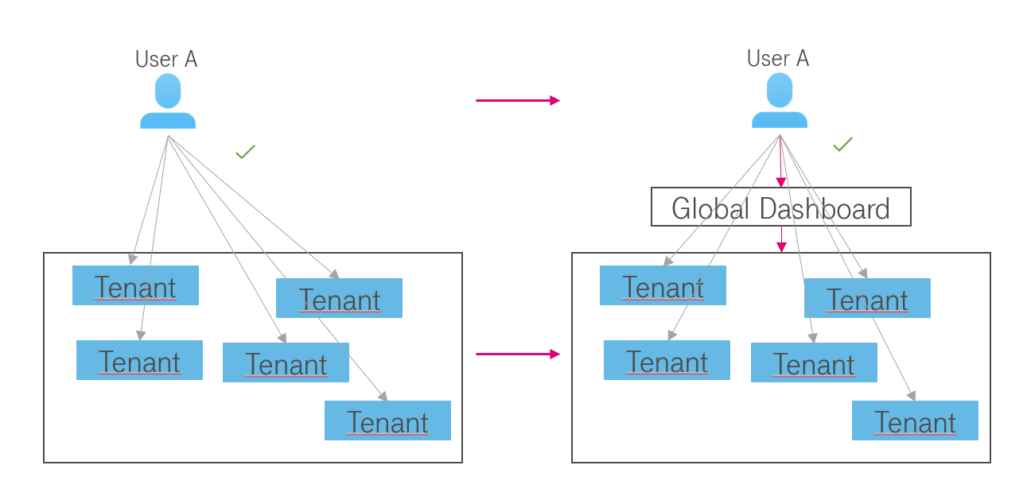

In a scenario like the above, it gets very hard for User A to compare data from multiple tenants. Each of his tenants has only access to the data of the own tenant. To compare data he needs a global dashboard, which allows him to access and compare data of all tenants in one organization. Also from a financial perspective, it’s recommended to consume Enterprise Dashboard Large instead of multiple Enterprise Dashboard Medium.

The product feature “**Organizations Management**” helps you to easily manage access to your dashboards and data. It allows you to split your payer account (see chapter 2.4) into smaller parts with separate global dashboards. This allows you to move certain tenants into a new completely separated organization with new users, user groups, and dashboards.

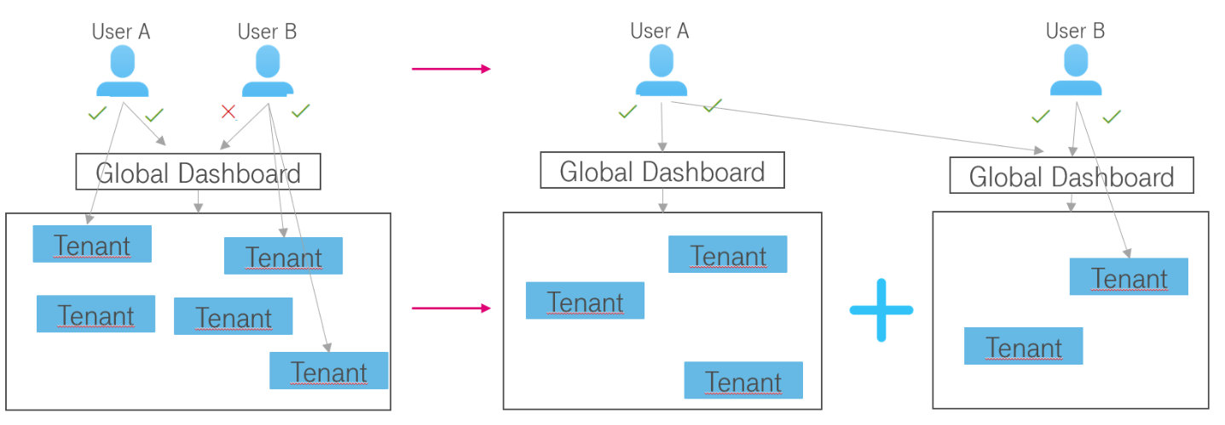

In a scenario like above, where User B is not allowed to access certain tenants, you can separate those tenants and give User B access to that organization and therefore access to the global dashboard.

## User management

After booking Enterprise Dashboard Open Telekom Cloud will provide you an admin account for your organization. An organization contains all contracts owned by your company. With this admin account, you can set up (invite) additional users for either your complete organization, a global view, or certain tenants, a tenant view. Be aware that the invitation will be valid for 30 days before expiring. The initial admin account will be created in each organization that represents your company. You will find more information about the organization and how they are utilized in Enterprise Dashboard in the next chapter.

The following user groups are available in an organization:

|  |  |
| --- | --- |
| Usergroup name | Usergroup permissions |
| Admin | Can do everything scoped to the organization. For example:   * Add & Edit data sources. * Add & Edit organization users & teams. * Create API Keys |
| Editor | * Can create and modify dashboards & alert rules. This can be disabled on specific folders and dashboards. * Cannot create or edit data sources nor invite new users. |
| Viewer | * View any dashboard. This can be disabled on specific folders and dashboards. * Cannot create or edit dashboards nor data sources. |

You can check your permissions within your user preferences. Click on your user icon, select “Preferences” and you will find a list of all organizations you are part of and which permissions you have.

## Organization

Enterprise Dashboard is utilizing Grafana’s built in organization feature, to separate your individual tenants (or in financial terms your contracts) from each other. Open Telekom Cloud will give you depending on your Enterprise Dashboard version access to either a single or multiple/all tenants. Your organization is split into several Grafana organizations, depending on the number of tenants you are currently using.

In the following there are some examples:

* If you have one tenant, you should use the medium version and will have one Grafana organization, representing the billing data of your contract
* If you have at least two contracts, you should use the large version and will have three Grafana organizations. A global organization, including the global dashboard, and one organization for each individual contract
* If you have at least three contracts and want to group them individually on not per default all in one global dashboard, you should use the extra-large version of the dashboard. You will receive some global dashboards, depending on your preferences.

This allows you to set up either dedicated user accounts within Enterprise Dashboard to view just one tenant, or an overall view if you grant them access to your global dashboard.

## Current Limitations

In the following you will see a list of current limitations:

* Billing data is updated once per day around 8 am (GMT +2)
* Billing Data is available up to the day before the current date. On Tuesday you can see data up until Monday
* Alerting for queries using Grafana variables (for example $tenant from Tenant Switcher, used in Payer based Dashboard) is not supported in Grafana
* VAT or other taxes are not included in Enterprise Dashboard
* Enterprise Dashboard cannot be ordered in T-Systems eShop

# How to

## Switch Organizations

You can switch your organizations by navigating to the bottom left of your screen. If you’re allowed to see more than one organization, you will see your currently selected organization at the top. After clicking the “Switch” Button a new pop-up menu will appear, where you can select another organization/tenant.

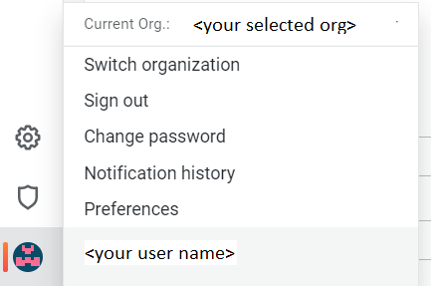

This functionality is available for each user with more than one organization assigned to them.

## Access Dashboards

Make sure that the right organization is selected. You need to select the global dashboard to have an overview of multiple tenants or a tenant-specific dashboard if you want to have the data of one specific tenant.

* The name of a payer organization follows this pattern " 00000XXXX <org name>"
* The name of a tenant organization follows this pattern "10000XXXXX"

You can access the dashboards of your organization by clicking Manage within the “Square”-Symbol in the navigation bar on the left side of the screen.

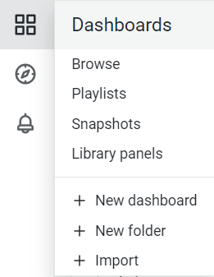

### “Getting started”-Dashboard

Each organization includes a so-called “Getting Started” dashboard, which contains some information relevant to new users of Enterprise Dashboard. For example, all of your dashboards are listed, new releases from Open Telekom Cloud are visible and some basic user permissions are explained.

### Provided by Open Telekom Cloud

There are two default financial dashboards within each organization. Financial dashboards provided by Open Telekom Cloud are located in the folder “Provided by Open Telekom Cloud” and are tagged individually for a quick overview on which aspect a dashboard is focused on.

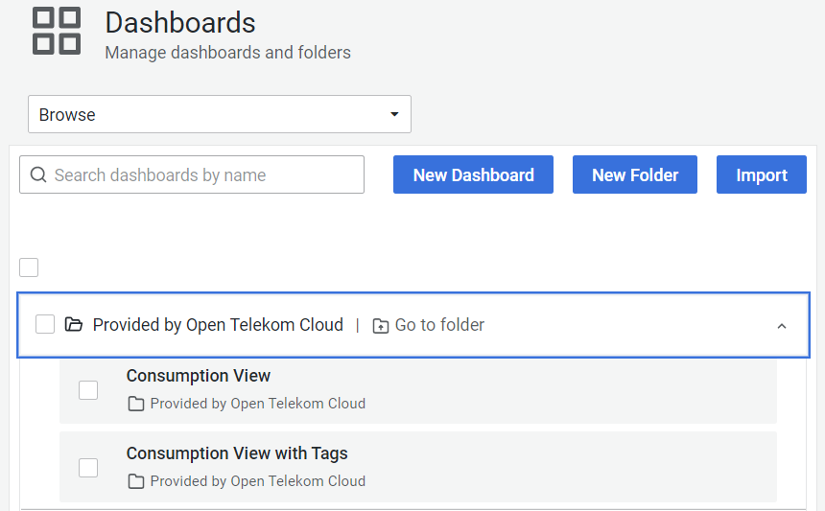

### Consumption view

The Dashboard “Consumption view” aims to display your spendings according to your monthly invoice. It focuses on attributes, which are visible on the pdf file of your invoice, e.g. spendings of individual product categories and products.

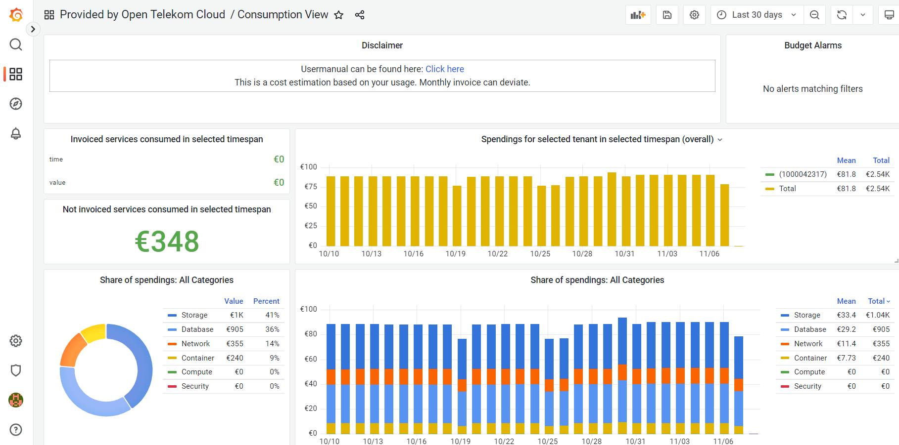

You will see your aggregated costs already in the first panels of the dashboards and will get more detailed views for individual product categories or projects further below.

### Consumption view with Tags

The Dashboard “Tenant consumption view with Tags” displays your invoice data with a focus on those resources, which have been tagged. [Tag Management Service](https://docs.otc.t-systems.com/en-us/tms/index.html) is an Openstack Service that allows the user to add up to 20 additional metadata tags to a virtual machine or data disk (and several other resources). The cost of these machines is visible in the CSV file of your invoice.

You can select either specific Tag Key and Value combinations or display all of them.

For example, you can select the Tag Key “CCE-Dynamic-Provisioning-Node” to see your Container Costs within Open Telekom Cloud. Elastic Cloud Servers spawned within a Cloud Container Engine Node have this Key-Value Pair attached to it.



According to your selection, the dashboard panels will display the costs accordingly.

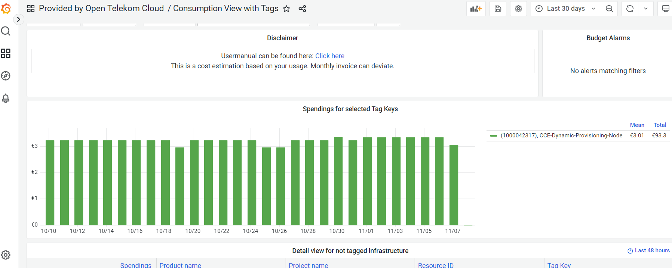

More detailed views for each selected Tag Key-Value combinations can be found further below in the dashboard.

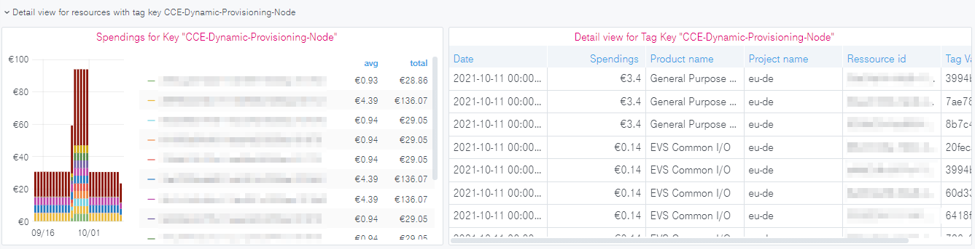

### Global consumption view

Global Dashboards are available for users of Enterprise Dashboard Large.

The dashboard “Global consumption view” is built up in the same way as the dashboard “Tenant consumption view” described in chapter 3.2.3 before. However, there is one exception. You can select either a single, multiple, or all tenants with a selection box in the first row of the dashboard. If you select just one tenant you will have the same view as the tenant organization with its tenant consumption view. If you select more than 1 tenant, each widget will include the costs of the selected Tenants. In the following you will see a screenshot of the mentioned selection box:

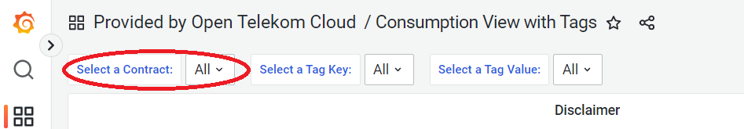

### Global consumption view with Tags

Global Dashboards are available for users of Enterprise Dashboard Large.

The dashboard “Global consumption view with tags” is built up in the same way as the dashboard “Consumption view with tags”. Similar to the other global dashboard before, you can select single, multiple, or all tenants here as well. The spending for the tagged infrastructure of the selected tenants will be shown.

For example, this allows you to observe the spending of Cloud Container Engine, already mentioned in Chapter 3.2.4, but across all your tenants, see screenshot below:

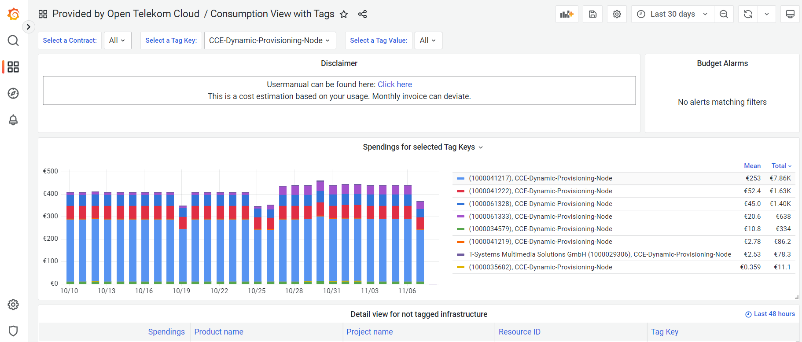

### Alerts

Grafana provides built-in alerting functionalities. Please note that alerts on OTC provided Dashboard are deleted once the dashboard gets an update. We recommend creating copies of the widgets you want to monitor in a new dashboard and/or folder.

In the following, you will find a short introduction, how you can set up an alert on your dashboard. Please note that this functionality is only available for Editor or Admin Users. The complete description can be found here: <https://grafana.com/docs/grafana/v9.0/alerting/alerting-rules/>

New updates in alert can be found on this page : <https://grafana.com/blog/2022/06/14/grafana-alerting-explore-our-latest-updates-in-grafana-9/>

1. Enter the widget editor by clicking “Edit”. Click on the name of a widget to toggle the menu shown in the following screenshot.

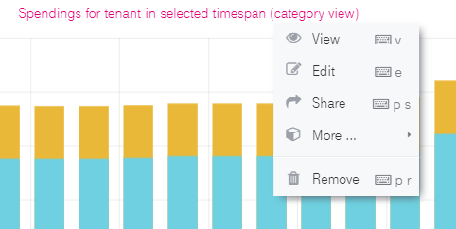

or launch from the side panel

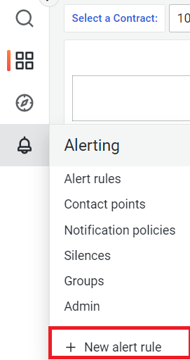

1. You will be forwarded to the alert page. 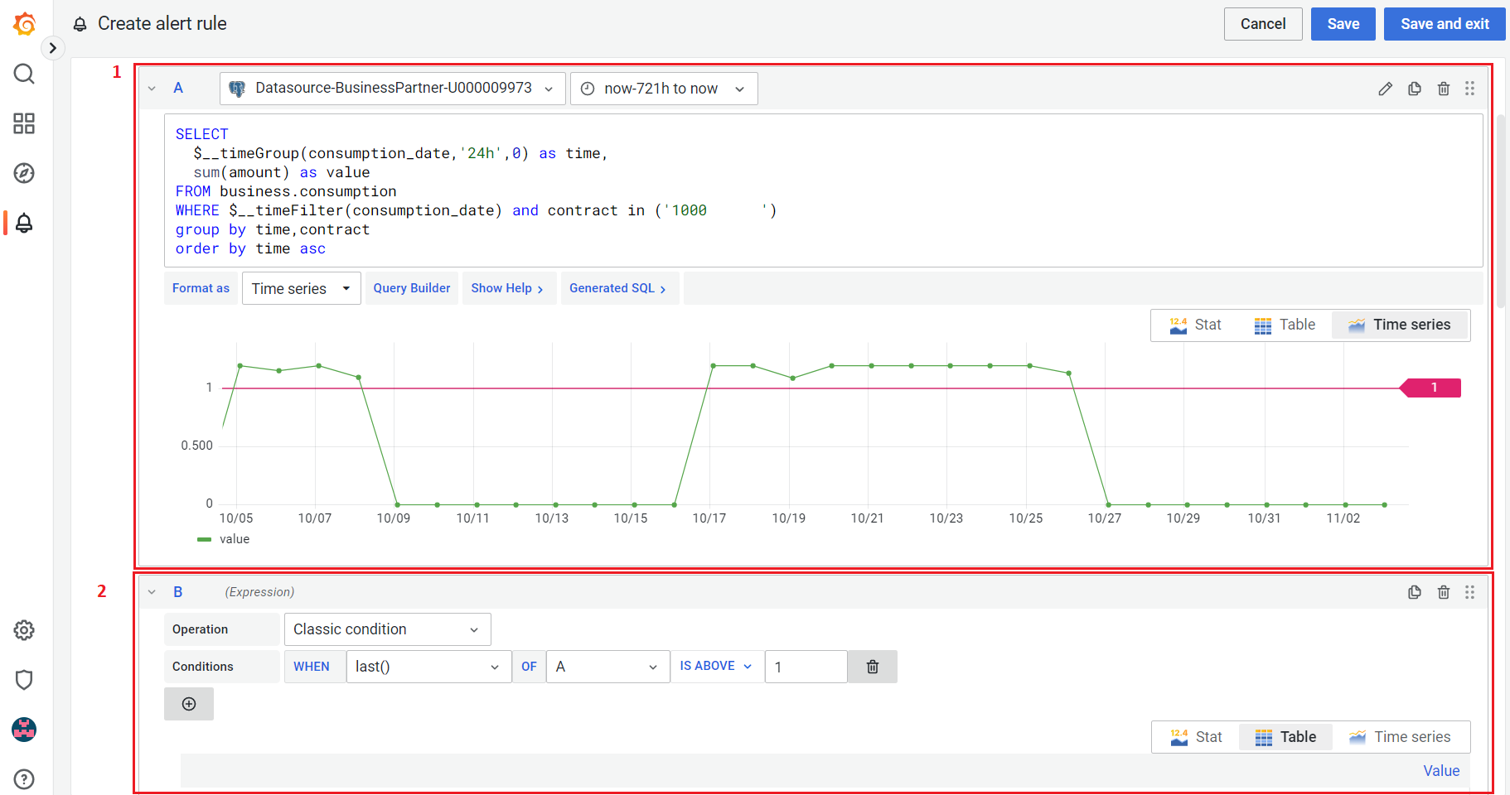
2. Define conditions for your alert. The following variables are important during the creation of an alert:
   1. Section A or 1 in the above screenshot is the criteria for the monitoring. So create a query that will be used for finding the interested parameter.
   2. Define the relative timeframe you want to monitor. Eg. in above screenshot “query(A,721h,now)” means that the results of query A in the last 30 days are monitored. It’s advised to keep the timeframe short as very long time frame might lead to heavy resource usage query.
   3. Section B or 2 in above screenshot is the abnormal or alert trigger worthy condition. It will shown a red horizontal line in Section A like in above screenshot.
3. Set the alert condition like in below screenshot if the alert condition exists for more that 5 min alert actions will be executed. 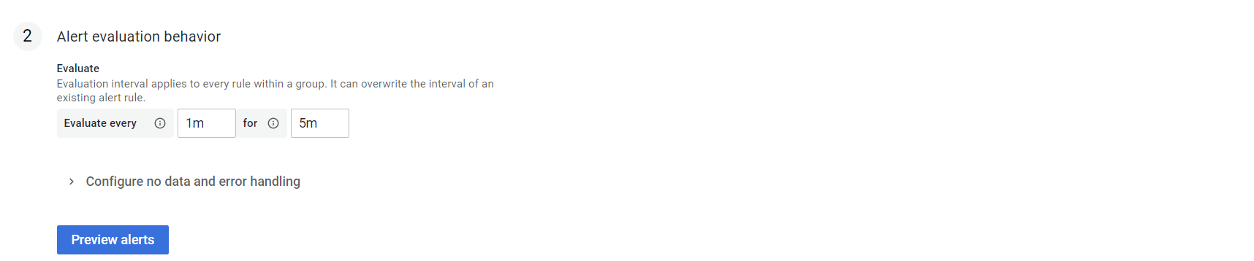
4. Add the alert details like alert name and group it belongs etc.

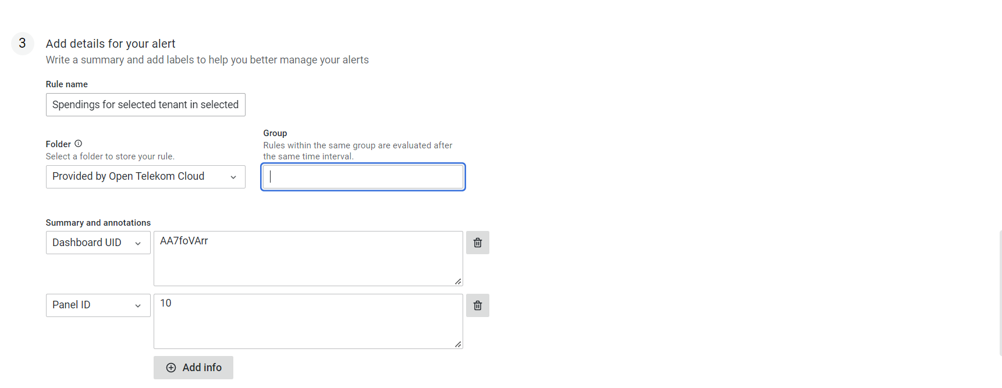

1. Finally set the alert contact or silent conditions to reduce large no alerts. 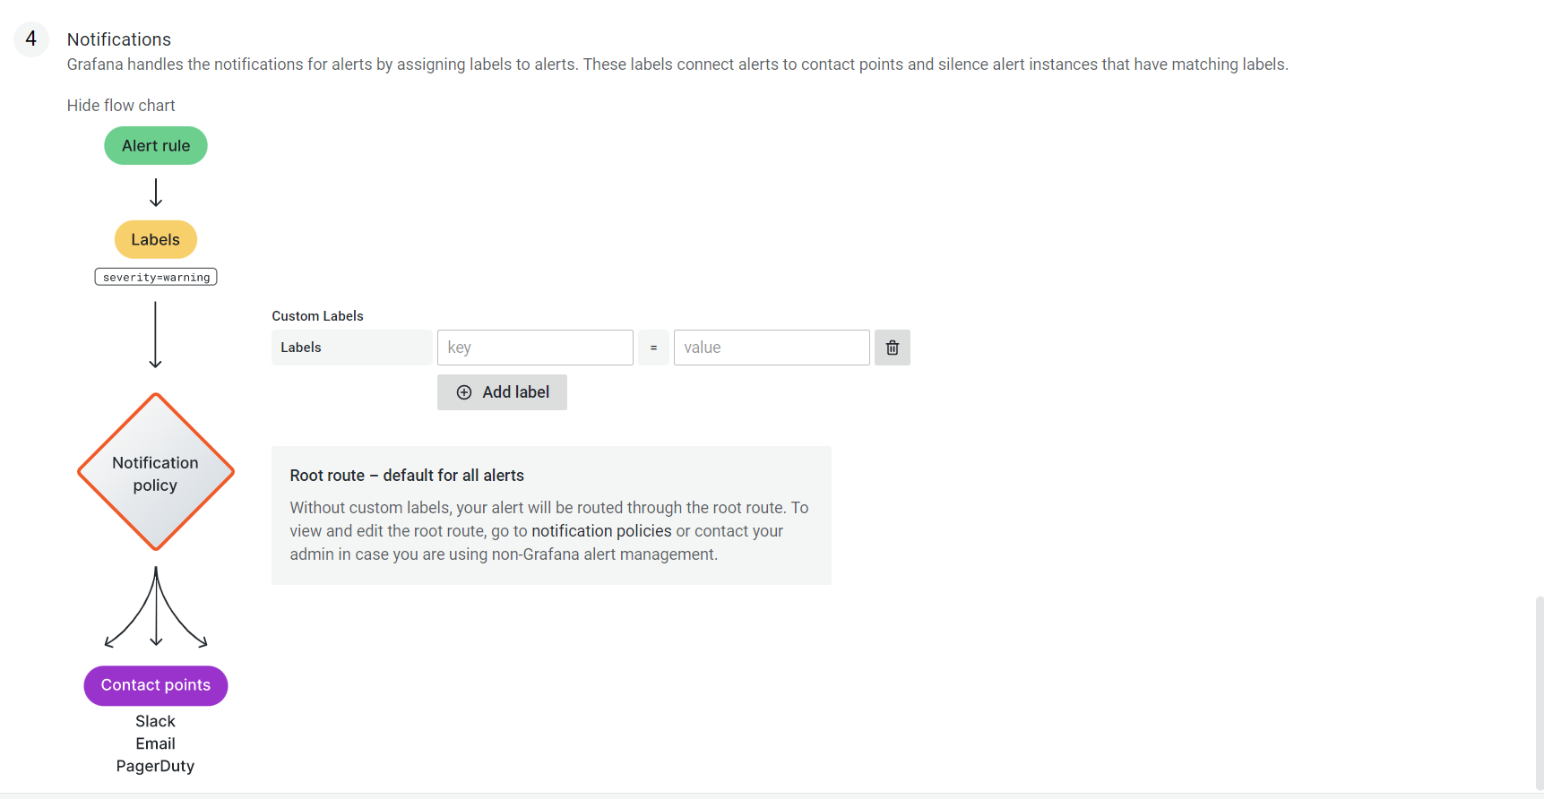

You can create alarms and notification channels as Editor or Admin of an organization. Ask your organization administrator for permission if you want to use this.

## Database table structure

Enterprise Dashboard uses a PostgreSQL 10 Database which has certain tables to use.

The tables are described in the following. Based on those tables you can create your own widgets and queries. The creation of new widgets and dashboards is available for Editor or Admin Users of an organization.

### Business.consumption

This table represents your billing data according to your Open Telekom Cloud invoice (except limitations listed in chapter Current Limitations)

|  |  |  |
| --- | --- | --- |
| Field name | Data type | Description |
| contract | Int8 | This field displays your tenant id, which is the same as your contract id |
| business_partner_id | Int8 | This field displays your business partner id |
| organization_name | varchar | This field displays the name of your company |
| regulator_id | Int8 | This field displays the payer id |
| regulator_name | varchar | This field displays the name of your payer |
| fte_reseller_id | Int4 | This field displays your reseller id. The reseller id is used in certain organization models, you will not need this in most cases |
| agp_id | Int8 | This field displays is your overall business partner id |
| agp_name | varchar | This field displays the name of your overall business partner |
| quantity_unit | varchar | This field displays the unit for the billing items. For example hours for virtual machines or GB for volumes |
| consumption_date | timestamp | This field displays when the billing item was created, therefor when you consumed the service |
| unit_price | Float8 | This field displays the price per quantity |
| quantity | Float8 | This field displays the quantity of the data set. For example, in combination with the unit field, it would be “10 GB” |
| amount | Float8 | This field displays the actual costs in Euro, same as Price*Quantity. **Including** discounts and vouchers |
| amount_excluding_discount | Float8 | This field displays the actual costs in Euro, same as Price*Quantity. **Without** discounts and vouchers |
| product | varchar | This field displays the produt_id used in the T-Systems billing system |
| product_description | varchar | This field displays the name of the product |
| project_id | varchar | This field displays the project id, where the service is consumed |
| project_name | varchar | This field displays the project name, where the service is consumed |
| resource_id | varchar | This field displays the resource id of the service |
| billing_status | Int8 | This field displays if the data set is invoiced or not. 0 means not invoiced, 10 means invoiced |
| consumption_type | varchar | This field displays the type of dataset. This can be:  Cost types:   * K017 & K018 elastic prices * D102 advance payments * D103& D536 monthly payments * D104 allowances * D537 free amount of a monthly payment e.g. of a Reserved Package   Discount types:   * R100 applied discount * R400 enterprise discount |
| contract_name | varchar | This field displays the name of your tenant/company. This name can be additionally configured within FTE. Please get in contact with the dashboard squad for this. |
| hash32 | varchar | Unique identifier for a row |
| region | varchar | Indicates the name of the region to which a resource belongs, e.g. eu-de |
| hash_key | varchar | Key for internal purposes |
| sales_chanel | varchar | original column not existing, we calculate it with FTE data |
| fte_ea_name | varchar | original column not existing, we calculate it with FTE data |
| fte_tenant_contract | varchar | original column not existing, we calculate it with FTE data |

### Business.business_partner

|  |  |  |
| --- | --- | --- |
| Field name | Data type | Description |
| business_partner_id | numeric | This field displays your business partner id |
| business_partner_name | varchar | This field displays your business partner name |
| valid_from | timestamp | This field displays the date from which the data set is valid |
| valid_to | timestamp | This field displays the date to which the data set is valid |

### Business.agp

|  |  |  |
| --- | --- | --- |
| Field name | Data type | Description |
| contract | numeric | This field displays your tenant id, which is the same as your contract id |
| agp_id | varchar | This field displays is your overall business partner id |
| agp_name | varchar | This field displays the name of your overall business partner |
| valid_from | timestamp | This field displays the date from which the data set is valid |
| valid_to | timestamp | This field displays the date to which the data set is valid |

### Business.product

|  |  |  |
| --- | --- | --- |
| Field name | Data type | Description |
| product | varchar | This field displays the produt_id used in the T-Systems billing system |
| product_description | varchar | This field displays the name of your product |
| product_category | String | This field displays the product category of service, used in the T-Systems billing system.    There are the following categories:   * Compute * Storage * Network * Management * SaaS * PaaS   Service |
| producty_family | String | This field displays the product family of a service |
| valid_from | timestamp | This field displays the date from which the data set is valid |
| valid_to | timestamp | This field displays the date to which the data set is valid |

### Business.regulator

|  |  |  |
| --- | --- | --- |
| Field name | Data type | Description |
| regulator_id | numeric | This field displays the payer id |
| regulator_name | varchar | This field displays the name of your payer |
| valid_from | timestamp | This field displays the date from which the data set is valid |
| valid_to | timestamp | This field displays the date to which the data set is valid |

### Business.tag

This table gives you a list of tag keys and tag values, which are pairs. This table is used in Tagging dashboards to access dashboards fast. The initial load is slow depending on the amount of data it needs to query to fill these variables.

|  |  |  |
| --- | --- | --- |
| Field name | Data type | Description |
| contract | numeric | This field displays your tenant id, which is the same as your contract id |
| reseller_id | numeric | This field displays your reseller id. The reseller id is used in certain organization models, you will not need this in most cases |
| hash32 | varchar | Key for internal purposes |
| tag_key | varchar | This field displays the tag keys which are used in your infrastructure |
| tag_value | varchar | This field displays the tag values which are used in your infrastructure |
| valid_from | timestamp | This field displays the date from which the data set is valid |
| valid_to | timestamp | This field displays the date to which the data set is valid |

### Business.contract

This table gives you a list of tenants' ids (contracts) for your payer/reseller account ID. This table is used in Payer/Reseller dashboards to access dashboards fast. The initial load is slow depending on the amount of data it needs to query to fill this variable. Searching for all distinct tenant IDs in business.consumption has the same result as Business.contract, but the query itself will be resolved much quicker due to smaller datasets.

|  |  |  |
| --- | --- | --- |
| Field name | Data type | Description |
| regulator | Int8 | This field displays the payer id |
| reseller_id | Int8 | This field displays your reseller id. The reseller id is in most cases the same as your payer id, presented by the field “regulierer_id” in business.sap tables |
| contract | Int8 | This field displays your tenant id, which is the same as your contract id |
| contract_name | Varchar | This field displays the name of your tenant/company. This name can be additionally configured within FTE. Please get in contact with the dashboard squad for this. |
| charging_type | Int8 |  |
| provisioning_status | Boolean | This field displays the provisioning status of your tenant in Enterprise Dashboard. Should be always true |

### Business. dim_ol_project_names

This table gives you a list of all project_ids and project_names of your organization.

|  |  |  |
| --- | --- | --- |
| Field name | Data type | Description |
| name | varchar | This field displays the name of your project. It’s possible to add or edit projects within IAM. |
| id | varchar | This field displays the project_id and can be used as a link between this table and business.sap |
| description | varchar | This field displays the description of each project. It’s possible to add a description to a project within IAM. |

Object Storage is displayed as “MOS”. Object Storage is a global service and has a unique ID, which can not be found within IAM. This project_id has the project_name “MOS”.

### Business.consumption_types

|  |  |  |
| --- | --- | --- |
| Field name | Data type | Description |
| value_type | varchar | This field displays the type of dataset. This can be:  Cost types:   * K017 & K018 elastic prices * D102 advance payments * D536 monthly payments * D104 allowances   Discount types:   * R100 applied discount   R400 enterprise discount |
| consumption_types_description | varchar | Description of value type.  e.g.  value type = K014  Consumption_type_description = Usage for PLM Cloud with price |

### Business.dim_ol_capacity_ecs_compute

This table is only available if you use Enterprise Dashboard Extra Large. It’s possible to receive Capacity data of your Open Telekom Cloud Hybrid in Enterprise Dashboard. The actual availability of data sets depends on your Hybrid Installation. Data is exported once per day. The “timestamp” attribute shows when the data was collected.

|  |  |  |
| --- | --- | --- |
| Field name | Data type | Description |
| service | varchar | Indicates the service name, which identifies the service to which a resource belongs |
| timestamp | timestamp | Indicates the time stamp in Unix format, e.g. 1598306400000 |
| region | varchar | Indicates the name of the region to which a resource belongs, e.g. eu-de |
| az | varchar | Indicates the name of the AZ to which a resource belongs, e.g. eu-de-01 |
| zone | varchar | Indicates the POD to which a resource belongs |
| cluster | varchar | Indicates the cluster to which a resource belongs. |
| host | varchar | None |
| resource_type | varchar | Indicates the resource type, e.g. s2 |
| type | varchar | Indicates the data type. ECS resource data types are as follows:  vCpu, memory, vGpu, and vmTotal |
| total | float8 | Indicates the total number of resources (vCPU: number; Memory: TB; vGPU: number). |
| used | float8 | Indicates the number of the used resources (vCPU: number; Memory: TB; vGPU: number). |
| free | float8 | Indicates the number of the remaining resources (vCPU: number; Memory: TB; vGPU: number). |
| allocated | float8 | Indicates the number of the allocated resources (vCPU: number; Memory: TB; vGPU: number). |
| spot_allocated | float8 | None |
| containerAllocated | float8 | None |
| available | float8 | Indicates the number of the available resources (vCPU: number; Memory: TB; vGPU: number). |
| used_ratio | float8 | Indicates the resource usage. |
| allocated_ratio | float8 | Indicates the resource allocation rate. |
| over_subscription_ratio | float8 | None |
| additional_info | varchar | None |
| region_id | varchar | Indicates the region ID to which a resource belongs. |
| az_id | varchar | Indicates the ID of the AZ to which a resource belongs |
| zone_type | varchar | Indicates the resource type to which a resource belongs |
| Host_group | varchar | None |
| host_total | int4 | Number of resources in total |
| etl_created | timestamp | Displays when this data set was created |

### Business.dim_ol_capacity_ecs_vm

This table is only available if you use Enterprise Dashboard Extra Large. It’s possible to receive Capacity data of your Open Telekom Cloud Hybrid in Enterprise Dashboard. The actual availability of data sets depends on your Hybrid Installation. Data is exported once per day. The “timestamp” attribute shows when the data was collected.

|  |  |  |
| --- | --- | --- |
| Field name | Data type | Description |
| service | varchar | Indicates the service name, which identifies the service to which a resource belongs |
| timestamp | timestamp | Indicates the time stamp in Unix format, e.g. 1598306400000 |
| region | varchar | Indicates the name of the region to which a resource belongs. |
| az | varchar | Indicates the name of the AZ to which a resource belongs. |
| zone | varchar | Indicates the POD to which a resource belongs. |
| cluster | varchar | Indicates the name of the cluster to which a resource belongs. |
| host | varchar | None |
| resource_type | varchar | Indicates the resource type, e.g. s2.8xlarge.2 |
| type | varchar | None |
| total | float8 | None |
| used | float8 | None |
| free | float8 | None |
| allocated | float8 | Indicates the number of allocated resources. Unit: VM. |
| spot_allocated | float8 | None |
| containerAllocated | float8 | None |
| available | float8 | None |
| used_ratio | float8 | None |
| allocated_ratio | float8 | None |
| over_subscription_ratio | float8 | None |
| additional_info | varchar | None |
| flavor_vCpu | float8 | Indicates the number of vCpu |
| flavor_mem | float8 | Indicates the amount of memory in GB |
| is_public | varchar | None |
| region_id | varchar | Indicates the region ID to which a resource belongs. |
| az_id | varchar | Indicates the ID of the AZ to which a resource belongs |
| zone_type | varchar | None |
| host_total | int4 | None |
| etl_created | timestamp | Displays when this data set was created |

### Business. dim_ol_capacity_evs_capacity

This table is only available if you use Enterprise Dashboard Extra Large. It’s possible to receive Capacity data of your Open Telekom Cloud Hybrid in Enterprise Dashboard. The actual availability of data sets depends on your Hybrid Installation. Data is exported once per day. The “timestamp” attribute shows when the data was collected.

|  |  |  |
| --- | --- | --- |
| Field name | Data type | Description |
| service | varchar | Indicates the service name, which identifies the service to which a resource belongs |
| timestamp | timestamp | Indicates the time stamp in Unix format, e.g. 1598306400000 |
| region | varchar | Indicates the name of the region to which a resource belongs. |
| az | varchar | Indicates the name of the AZ to which a resource belongs. |
| zone | varchar | Indicates the POD to which a resource belongs. |
| cluster | varchar | Indicates the storage pool to which the resource belongs |
| host | varchar | None |
| resource_type | varchar | None |
| type | varchar | Indicates the data type. EVS data types are as follows:  SATA, SAS, and SSD |
| total | float8 | Indicates the total number of resources. Unit: TB. |
| used | float8 | Indicates the number of used resources. Unit: TB. |
| free | float8 | Indicates the remaining number of resources. Unit: TB. |
| allocated | float8 | Indicates the allocated number of resources. Unit: TB. |
| spot_allocated | float8 | None |
| containerAllocated | float8 | None |
| available | float8 | Indicates the number of available resources. Unit: TB. |
| used_ratio | float8 | Indicates the resource usage |
| allocated_ratio | float8 | Indicates the resource allocation rate. |
| over_subscription_ratio | float8 | Indicates the overcommitment ratio. |
| additional_info | varchar |  |
| sata_physical_host | varchar | Indicates the number of SATA PMs. Unit: PCs |
| ssd_physical_host | varchar | Indicates the number of SSD PMs. Unit: PCs |
| sas_physical_host | varchar | Indicates the number of SAS PMs. Unit: PCs |
| pool_model | varchar | None |
| region_id | varchar | Indicates the ID of the AZ to which a resource belongs |
| zone_type | varchar | Indicates the resource type to which a resource belongs |
| etl_created | timestamp | Displays when this data set was created |

### Business.dim_ol_capacity_obs

This table is only available if you use Enterprise Dashboard Extra Large. It’s possible to receive Capacity data of your Open Telekom Cloud Hybrid in Enterprise Dashboard. The actual availability of data sets depends on your Hybrid Installation. Data is exported once per day. The “timestamp” attribute shows when the data was collected.

|  |  |  |
| --- | --- | --- |
| Field name | Data type | Description |
| service | varchar | Indicates the service name, which identifies the service to which a resource belongs |
| timestamp | timestamp | Indicates the time stamp in Unix format, e.g. 1598306400000 |
| region | varchar | Indicates the name of the region to which a resource belongs. |
| az | varchar | None |
| zone | varchar | None |
| cluster | varchar | Indicates the cluster to which a resource belongs. |
| host | varchar | None |
| resource_type | varchar | None |
| type | varchar | None |
| total | float8 | Indicates the total number of resources. Unit: TB. |
| used | float8 | Indicates the remaining number of resources. Unit: TB. |
| free | float8 | Indicates the remaining number of resources. Unit: TB. |
| allocated | float8 | None |
| spot_allocated | float8 | None |
| containerAllocated | float8 | None |
| available | float8 | None |
| used_ratio | float8 | Indicates the resource usage. |
| allocated_ratio | float8 | None |
| over_subscription_ratio | float8 | None |
| additional_info | varchar | None |
| logic_total | varchar | Indicates the total logic capacity. Unit: TB. |
| logic_used | varchar | Indicates the number of used logic. Unit: TB. |
| zone_type | varchar |  |
| host_total | int4 |  |
| etl_created | timestamp | Displays when this data set was created |

### Business.dim_ol_capacity_eip

This table is only available if you use Enterprise Dashboard Extra Large. It’s possible to receive Capacity data of your Open Telekom Cloud Hybrid in Enterprise Dashboard. The actual availability of data sets depends on your Hybrid Installation. Data is exported once per day. The “timestamp” attribute shows when the data was collected.

|  |  |  |
| --- | --- | --- |
| Field name | Data type | Description |
| service | varchar | Indicates the service name, which identifies the service to which a resource belongs |
| timestamp | timestamp | Indicates the time stamp in Unix format, e.g. 1598306400000 |
| region | varchar | Indicates the name of the region to which a resource belongs. |
| az | varchar | None |
| zone | varchar | None |
| cluster | varchar | Indicates the cluster to which a resource belongs. |
| host | varchar | None |
| resource_type | varchar | None |
| type | varchar | None |
| total | float8 | Indicates the total number of resources. Unit: TB. |
| used | float8 | Indicates the remaining number of resources. Unit: TB. |
| free | float8 | Indicates the remaining number of resources. Unit: TB. |
| allocated | float8 | None |
| spot_allocated | float8 | None |
| containerAllocated | float8 | None |
| available | float8 | None |
| used_ratio | float8 | Indicates the resource usage. |
| allocated_ratio | float8 | None |
| over_subscription_ratio | float8 | None |
| additional_info | varchar | None |
| region_id | varchar | Indicates the ID of the AZ to which a resource belongs |
| az_id | varchar | None |
| zone_type | varchar | None |
| status | varchar | None |
| subType | varchar | None |
| etl_created | timestamp | Displays when this data set was created |

# API

Please refer to the [Enterprise Dashboard API Reference](https://enterprise-dashboard.obs.eu-de.otc.t-systems.com/OTC%20Enterprise%20Dashboard%20API%20Reference.pdf)

# FAQ

## Question: How can I change the displayed timespan in a dashboard?

At the top right of each dashboard is a selector where you can configure your displayed timespan. Just click the Clock Icon. See in the screenshot below:

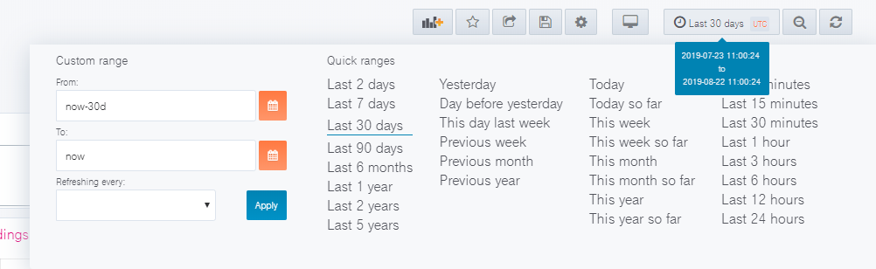

## Question: How can I create my own dashboard and widgets?

We recommend creating a new dashboard if you want to have additional widgets. You can check the following documentation to get more information on how to create new widgets.

Getting started: <https://grafana.com/docs/guides/getting_started/>

New Graphs in dashboards: <https://grafana.com/docs/features/panels/graph/>

New Tables in dashboards: <https://grafana.com/docs/features/panels/table_panel/>

## Question: My widget is very crowded. How can I select a certain service?

Each widget can be limited to show only one of the originally displayed data sets by clicking the names right next to the graph. You can de-select the data set by clicking it again.

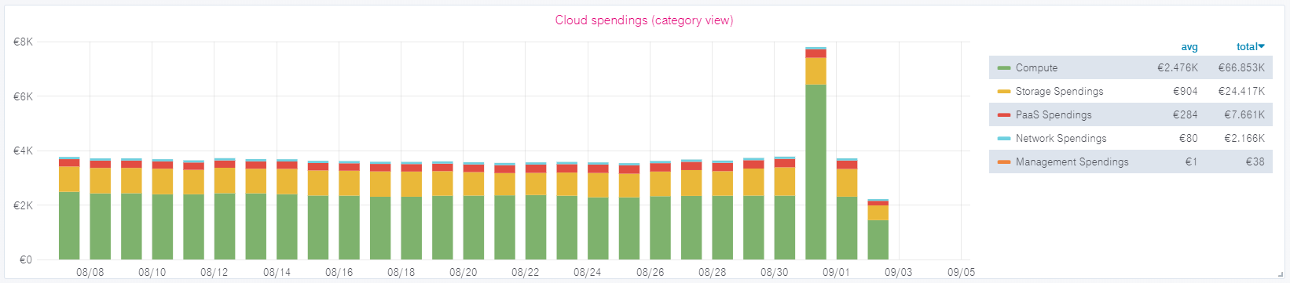

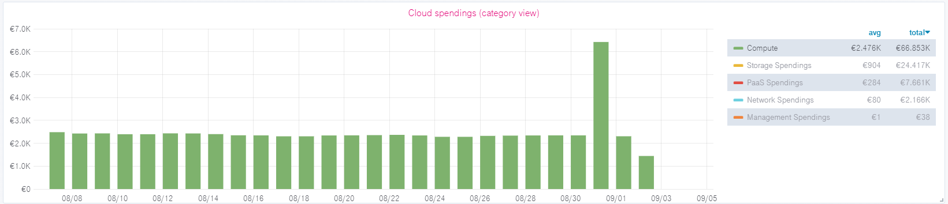

## Question: Can I use the Dashboard when data is updated?

Yes, the dashboard will be accessible and data available.

## Question: How can I download data?

If you are an Editor or Admin User, it’s possible to download data from each widget by clicking on the name of the widget 🡪 Inspect 🡪 Data. You can then download the csv file. Additionally, data can be received via API, please check chapter 4 API

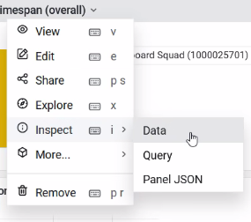

## Question: Where do I reset my password?

Please use this link: <https://enterprise-dashboard.otc-service.com/user/password/send-reset-email>

Additionally, you can reset your password by following the “Forget Password” link on the login page of Enterprise Dashboard.

## Question: I can’t log in. What’s wrong?

You can use both E-Mail and Username to login, but be aware that both the log-in and forget password fields are case-sensitive. This means if your E-Mail address is for example configured as [Test@provider.com](mailto:Test@provider.com), you also need to log in to [Test@provider.com](mailto:Test@provider.com). [test@provider.com](mailto:test@provider.com) will not be recognized. If you forgot your password, please use the link in chapter 5.6. You can also change your E-Mail address to all minor case within the preferences.

## Question: I see users who are not added by me in the Grafana User management. Why?

There are 4 default users which are used by operations or dashboard squad itself to establish hotfixes or to help with customer issues.

* Admin
* Provisioning
* Account for Payer Dashboard
* Account for Tenant Dashboard

## Question: I see “Average” and “Total” in almost every panel. How is this calculated?

The average and total are calculated on the exact amount of datasets in the selected timespan. More information here: <https://grafana.com/docs/features/panels/graph/>

## Question: I can see some products with a cost of 0€ and some with 0.00€. What's the difference?

Products that have been used but are still in the free budget will be displayed as 0€. 0.00€ will be displayed if there are costs smaller than 1 cent. Technically those are still costs that will be invoiced, therefore they are displayed in Enterprise Dashboard. You can hide these products by ticking “hide series” options in the legend options of each panel. Please note that editing a dashboard or panel is only available for Editor or Admin Users.

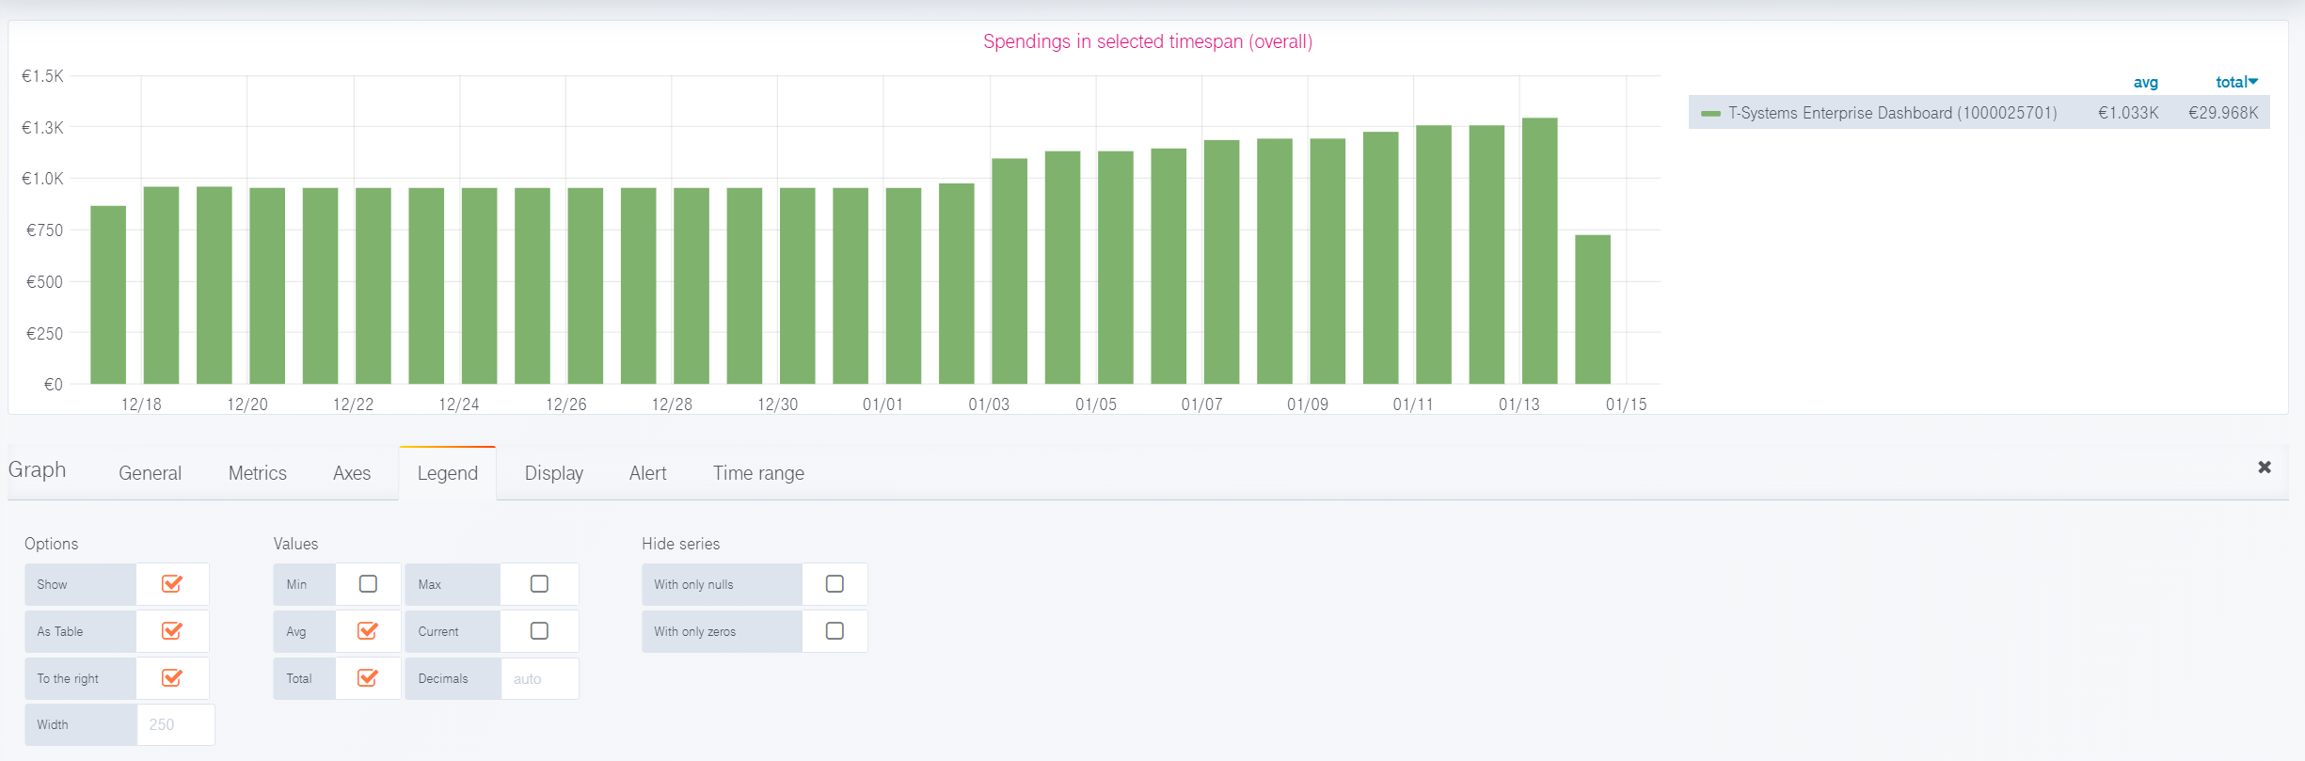

## Question: How do you handle S/W time changeover?

Within Enterprise Dashboard a changeover between summer and winter time is visible on the specific dates by observing the quantity field. For example, a machine that is never stopped will have a runtime of 23 hours on the 28th of March 2021 and 25 hours on the 27th of October 2019.

Below you will find the runtime of a unique machine, which was running 24/7. You can clearly see the drop on a S/W time changeover.

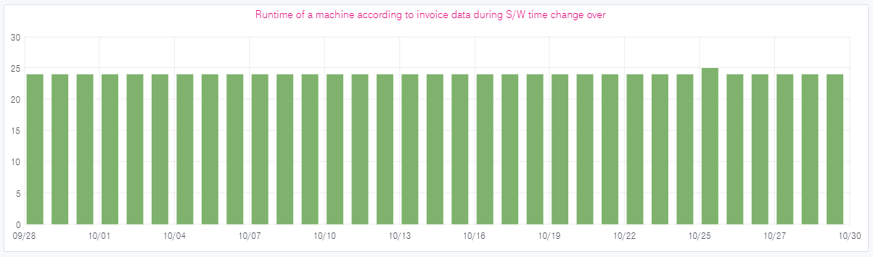

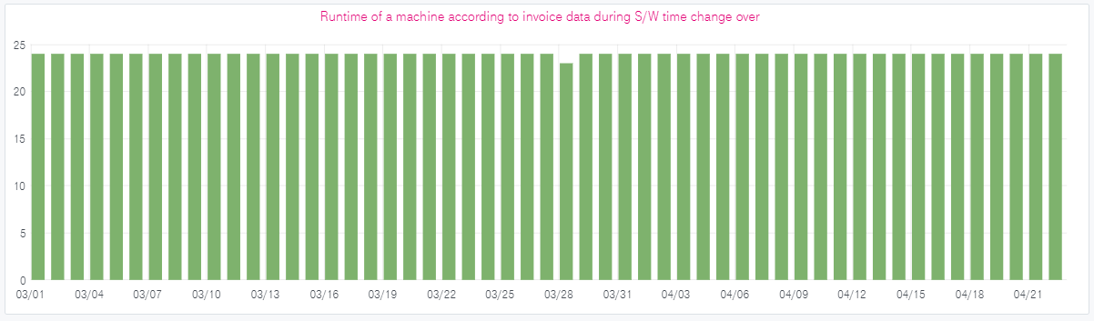

## Question: Which version of Enterprise Dashboard do I have?

Enterprise Dashboard will be listed within your invoice, therefore you can see Enterprise Dashboard within your consumption data. Enterprise Dashboard is billed on the first day of a month.

# Abbreviations

No special abbreviations are used in this document. If you want to have a look at generally used abbreviations in Open Telekom Cloud, please check the Help Center: <https://docs.otc.t-systems.com/en-us/glossary/index.html>

|  |  |  |
| --- | --- | --- |
| Contact T-Systems International GmbH  Hahnstraße 43d  60528 Frankfurt am Main | Email: cloudhandlingsupport@telekom.de | Internet: www.open-telekom-cloud.com |