Lab_2: Add and Shift Multiplier

Introduction
In this experiment, you will need to implement a $m×n$ multiplier from scratch. Note that "starting from scratch" means that you cannot directly use the methods already available in the standard library. As the name implies, you can only “add” and “shift” data.
This is not a course on digital circuits, so we will detail the calculation method, which you will just need to implement in a hardware description language.
You can also compare the predefined multiplex implementations with your implementation at the end of the experiment, which will help you understand the importance of "Don't reinvent the wheel"

Algorithm

How to hand computation binary multiplication

Algorithm block diagram (Moore model)

Example: $6×5=110×101$

Declare of top level
To facilitate automatic scoring, the declaration of the top-level function must be exactly the same as the following.

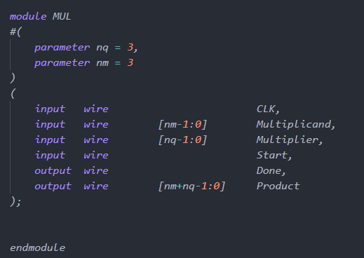
Please add input wire rst by yourself.

Behavior of test-bench
In order to facilitate automatic scoring, the behavior of testbench must be exactly the same as the following.
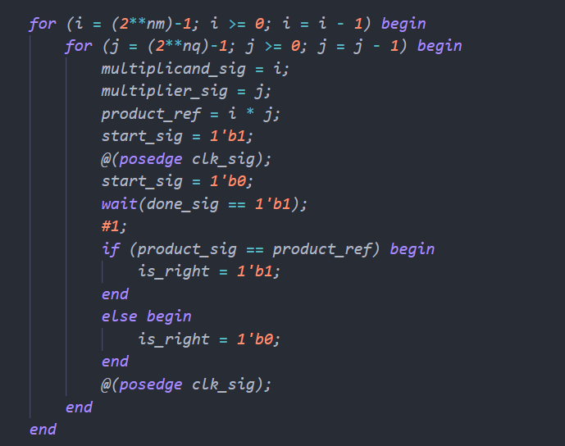
测试用例：
nm | 3 | 3 | 4 | 4 | 3 | 5
nq | 3 | 4 | 3 | 4 | 5 | 3

Requirements
- The algorithm can be divided into Two parts: operator and controller. This experiment requires you to use more than two different modules to implement this algorithm. No data processing is allowed in the controller.
- You need to use finite state machines (FSM) to implement controller. For finite state machines, you can find examples in Professor Ha's courseware.
- The experiments in this course forces you to separates the timing logic from the combinatorial logic. It is not acceptable to use clocks in the combinatorial logic.
- Note that this lab we should write a multiplier for $m×n$ bits, so the use of parameter is necessary. To conserve resources, No more than $2m+n+1$ registers may be used in operator part, and no more than $m+1$ adders may be used in operator part.
- Draw state transition diagram and system block diagram (such as Figure 1 in Lab_1.pdf) before you start writing code.
- There is a reference of state transition diagram as follows:
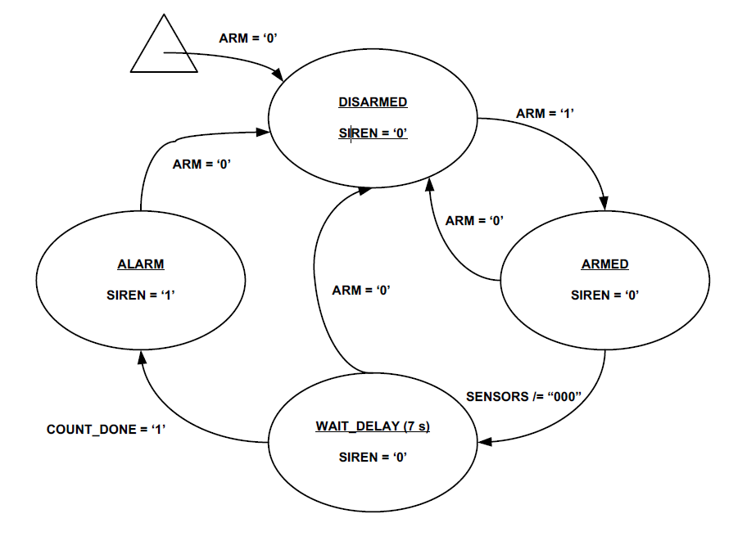
- The state transition diagram should contain the following key points and distinguish them in different formats:
  - Name of state
  - Conditions for transitioning from one state to another
  - Value of control signal in each state (or during the transition from one state to another)
- There is a reference of the system block diagram as fellow:
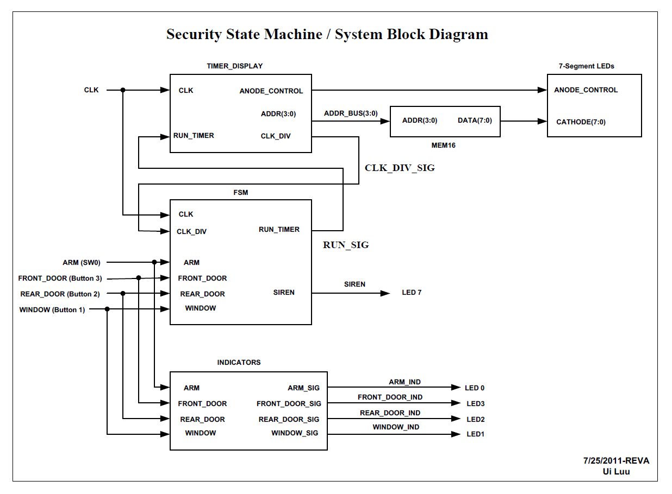
- The system block diagram should contain the following key points:
  - Components and name of each component
  - Signals and name of each signal
  - Ports and name of each port
  - All of the registers.

Code format
- Keywords (except data type) are all lowercase.
- Naming must be meaningful (except for the prescribed name). There are no restrictions on naming. You can reasonably use uppercase letters and underscores to make your name easier to read and understand.
- Use four Spaces or a Tab to indent your code. Reasonable indentation makes your code easier to read and understand.

First Submit
- Compress the diagrams and name the compressed package as follow the format:
Lab2_[YourNameInEnglish]_[YourStudentNumber].zip
- You should submit:
  - State transition diagram
    - Draw it by computer rather than your hand
  - System block diagram/schematic
    - Draw it by computer rather than your hand
- File Organization Schema in Package:
Lab2_[YourName]_[YourStudentNumber].zip
├─State_Transition_Diagram.pdf
└─System_Block_Diagram.pdf
- Upload the .zip file to related lab folder : \\10.19.129.139\EE116_Lab\Lab2\Lab2_first_submit
- The reference State Transition Sketch and System Block Sketch will be given after submission deadline.

First Submit Deadline: 2021-10-18 17:30

Second Submit
- Compress the HDL codes and name the compressed package as follow the format:
Lab2_[YourNameInEnglish]_[YourStudentNumber].zip
- You should submit:
  - Source codes
    - All of the source codes
  - Test bench codes
    - All of the test bench codes
- File Organization Schema in Package:
Lab2_[YourName]_[YourStudentNumber].zip
├─[ The name of the module where you implemented the addition function].v
├─[ The name of the module where you implemented the control function].v
├─[ The name of the module where you implemented the shift function].v
├─[ The name of top-level].v
└─testbench.v
- Upload the .zip file to related lab folder : \\10.19.129.139\EE116_Lab\Lab2\Lab2_second_submit

Second Deadline: 2020-10-25 17:30
- Submit on time, get all scores.
- Submission time does not exceed 24 hours of the deadline, get half of the score.
- Submitted more than 24 hours from the deadline, get no score.

Any Question?
Any questions on course or labs can be proposed in the Discussing Forum on BB.
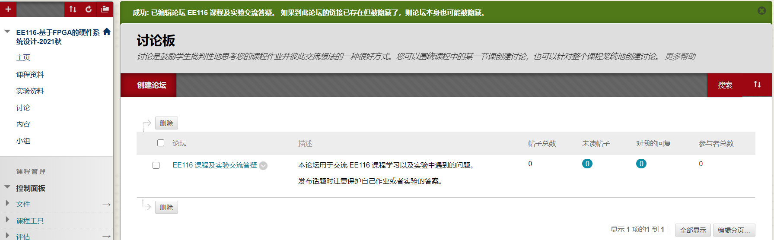
We recommend you subscribe the forum to receive the newest topics on time.

