Lab_2: Add and Shift Multiplier

Tip 1: state transition diagram

A simple idea

Question: Is this a good idea for our needs? Why?

An improved idea
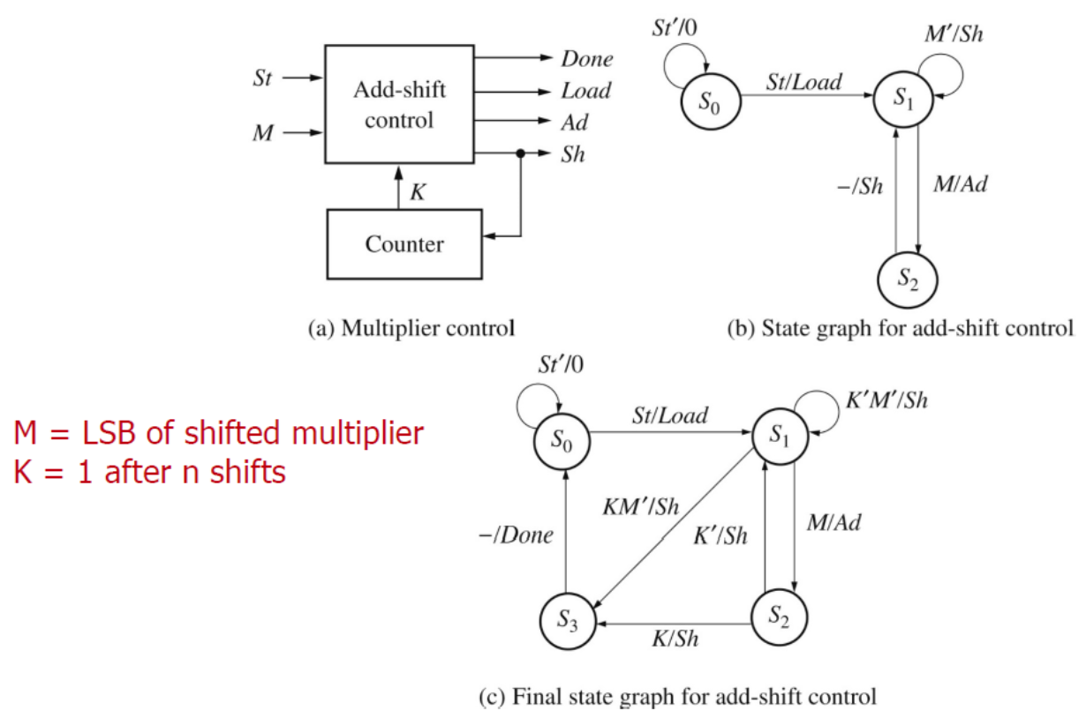

Question: Is this state transition diagram simplified by the previous state transition diagram? Why? If not, how did we get this picture from the previous one?

An example

