Lab_2: Add and Shift Multiplier

Tip 3: a method to control an operation

How to add a number to itself?
That is the C++ code:
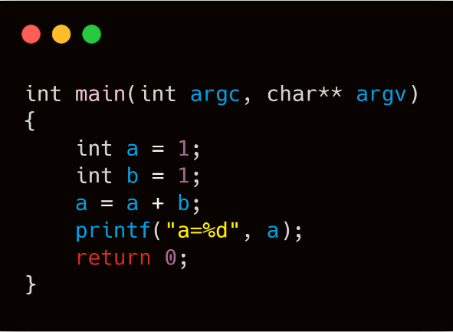
Then let us think the specific operational details:
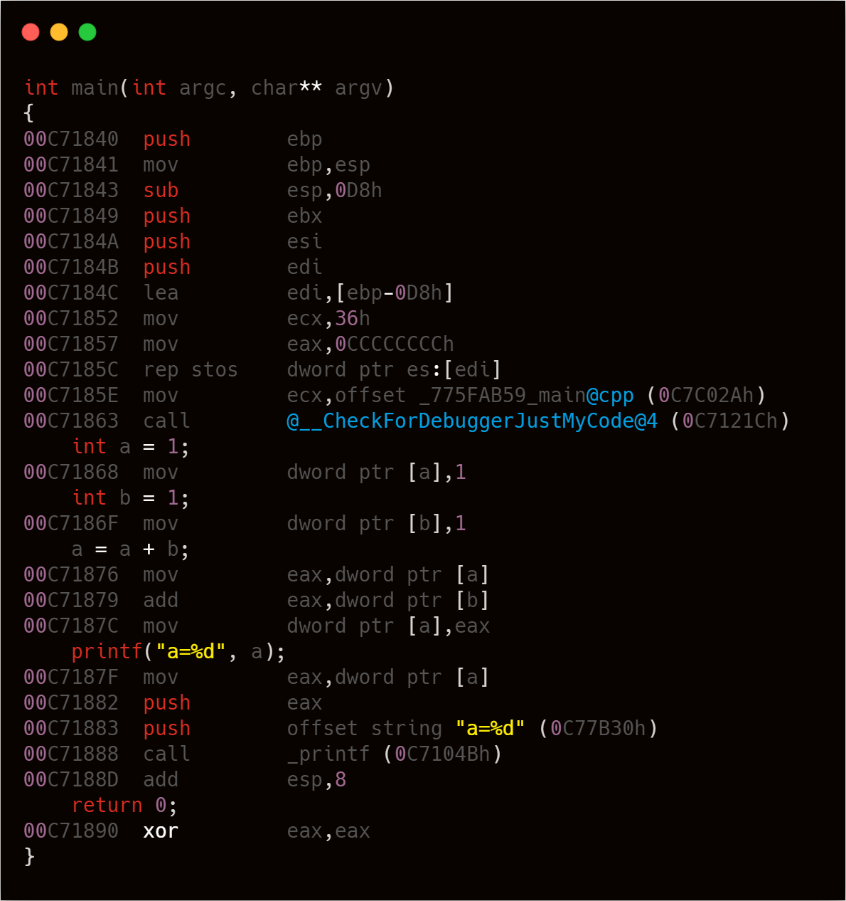
Please focus on the add operation

There are three steps to calculate $a=a+b$: read $a$, add $b$ to $a$, and then write the result back. In software, we should execute these operations step by step.
Note that in hardware, all components work at the same time. If we want to control this calculation, choosing one step to control and let others run all time is feasible. Let’s find a basic module for each step and draw the system block diagram.
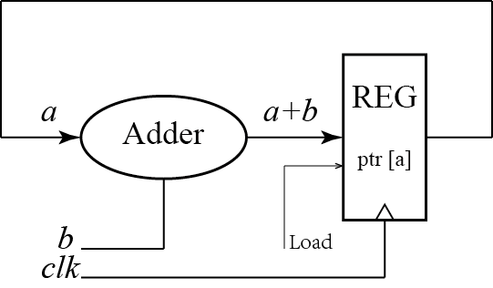
We could use similar system block diagram to deal with similar operations.

