ShanghaiTech University
EXAMINATION FOR
(Semester II : 2019/2020)

EE216 – RECONFIGURABLE COMPUTING
June 2020 – Time Allowed: 2 Hours

Instructions to Candidates
1. This paper contains TEN (10) questions and comprises FOUR (2) printed pages.
- All questions are compulsory. Answer ALL questions.

- Total marks of all questions are EIGHTY (80).

- This is an OPEN BOOK examination.

- Programmable calculators are not allowed.

Please answer the following questions based on the attached research paper.
Hints:
The front-end-of-line (FEOL) is the first portion of IC fabrication where the individual devices (transistors, capacitors, resistors, etc.) are patterned in the semiconductor. The back end of line (BEOL) is the second portion of IC fabrication where the individual devices (transistors, capacitors, resistors, etc.) get interconnected with wiring on the wafer, the metalization layer.
In electrical engineering, a shmoo plot is a graphical display of the response of a component or system varying over a range of conditions or inputs.

- Write a title for this paper.
(8 marks)

- Write a conclusion for this paper.
(8 marks)

- Compared with traditional SRAM-FPGA, what are the advantages of VS-FPGA? (At least four points)
(8 marks)

- How does the via-switch work? You can refer to Figure 33.3.2 and Figure 33.3.S1.
(15 marks)

- From Figure 33.3.5, the VS-FPGA may fail. List some reasons.
(6 marks)

- What is the difference between VS-FPGA and AS-FPGA?
(6 marks)

- The following figure gives a simple illustration of systolic array. From the description of paragraph 7 and Figure 33.3.6, write names for gray block, white block and descriptions for green line (between white blocks) and blue line (between gray blocks and white blocks).
(8 marks)

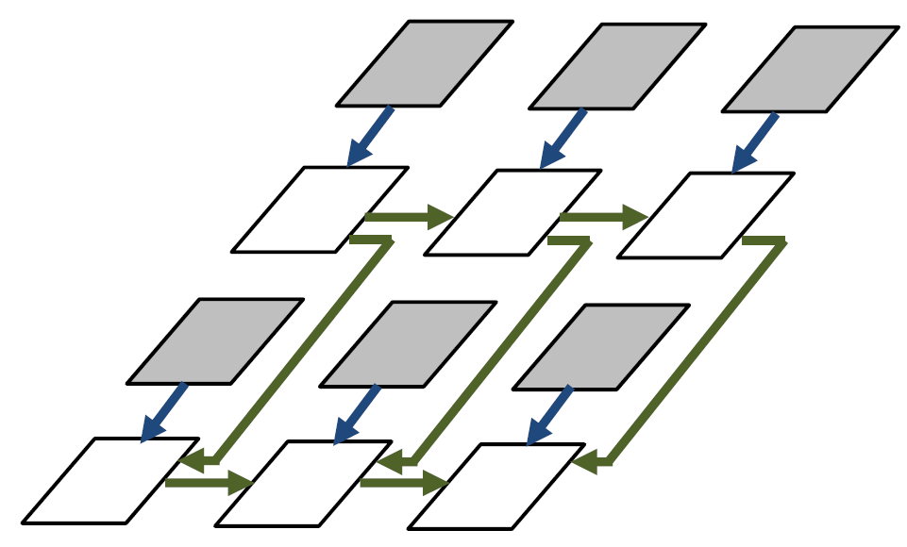

- List the strategies the authors used to exploit the VS-FPGA architecture for AI applications.
(8 marks)

- This is an amplified figure of 5in-LUT x2 in Figure 33.3.6. Draw the critical path of the circuit.
(5 marks)

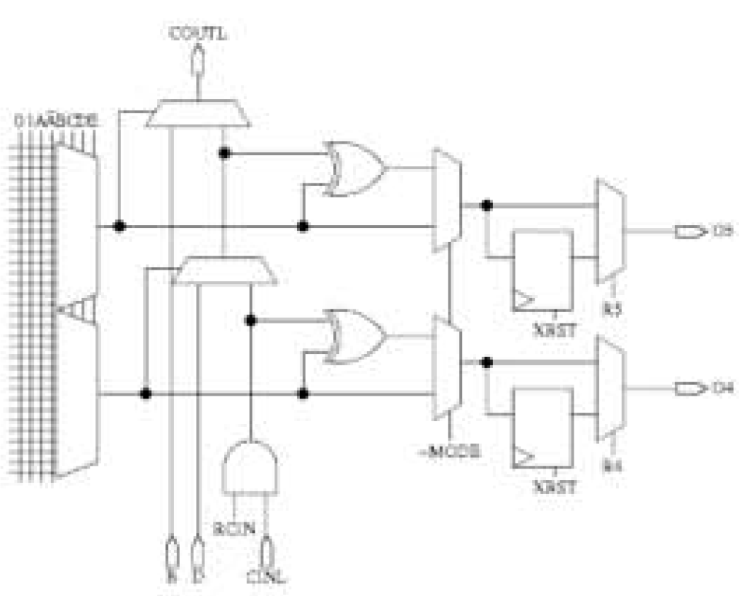

- Although non-volatie FPGAs show some advantages over SRAM FPGAs, currently Xilinx and Intel still use SRAM FPGAs. Please give a few possible reasons in combination with the content of the class and this paper.
(8 marks)

The research paper is attached from the next page.

END OF PAPER

