Student Name Chinese: _____________________
Student Name Pinyin: _____________________
Student Email: _____________________
Student Id: _____________________
School: _____________________
Year of Entrance: _____________________
ShanghaiTech University Final Examination Cover Sheet
Jan 14 2024

Academic Year: 2023 - 2024
Term: Fall
Course-offering School: School of Information Science and Technology
Instructor: Yajun Ha
Course Name: Reconfigurable Computing
Course Number: EE216

Exam Instructions for Students:
1. All examination rules must be strictly observed throughout the entire test, and any form of cheating is prohibited.

2. Other than allowable materials, students taking closed-book tests must place their books, notes, tablets and any other electronic devices in places designated by the examiners.

3. Students taking open-book tests may use allowable materials authorized by the examiners. They must complete the exam independently without discussion with each other or exchange of materials.

For Marker’s Use:
Section | Q.1 | Q.2 | Q.3 | Q.4 | Q.5 | Total
Max | 25 | 20 | 13 | 12 | 30 | 100
Marks
Recheck

Q.1
(a)Which of the following statements about initial and always is incorrect? _________. (4 marks)
A. initial can only execute once.
B. The difference between initial and always is that the former cannot be synthesized, while the latter can be synthesized.
C. always executes continuously in a loop.
D. initial and always cannot execute simultaneously.

(b)Assume [wire [7:0] data = 8'b11010010;] then data[3:0] = _________. (4 marks)
(c)Assume that the width of the input signal X is 10, the width of the input signal A is 5, and the width of the input signal B 14. In order to achieve the function of Y = X * A + B without losing accuracy, what is the minimum width of the output signal Y? Assuming all signals are signed _________. (4 marks)
(d) Given the below code, draw the waveform of all the signals. (5 marks)
  - module testbench();
  - reg clk, rst, q0, q1, q2, q3;
  - always@(posedge clk) begin
  - if (rst) begin
  - q0 <= 0;
  - q1 <= 0;
  - q2 <= 0;
  - q3 <= 0;
  - end
  - else begin
  - q1 <= q0;
  - q2 = ~q1;
  - q3 <= q2 + 1;
  - end
  - end
  - always#5 begin
  - clk <= ~clk;
  - end
  - initial begin
  - rst <= 1;
  - clk <= 0;
  - #10;
  - rst <= 0;
  - q0 <= 1;
  - #40;
  - $finish;
  - end
  - endmodule

(e) Draw the block diagram of below two modules using logic gates and registers. (8 marks)
- module M1(
- input A, B, C, D,
- output E
- );
- assign E = !((A|^B)&(~C&D));
- endmodule

- module M2(
- input clk, A, B, C, D,
- output E
- );
- reg F, G;
- always@(posedge clk) begin
- F <= A | B;
- G <= B & C;
- E = ~A ^ (F | G)
- end
- endmodule

Q.2
- Design an automatic beverage vending machine. The beverage costs 10 cents. The machine accepts two types of coins: 5 cents and 10 cents. Consider change dispensing. Draw the FSM (Finite State Machine) and implement the state machine with Verilog including an asynchronous reset that can reset the FSM to state A. (10 marks)

- module top_module(
- input clk,
- input in,
- input areset,
- output out); //

- // State transition logic

- // State flip-flops with asynchronous reset

- // Output logic

- endmodule

- LUT, or Lookup Table, is a fundamental building block in digital design and is commonly used in FPGAs. A LUT is a small, configurable memory unit that stores data and is used to implement combinational logic functions.
- How many different 3 input functions can a 3 input LUT implement? Why? (5 marks)
- Using nothing other than 3-LUTs, demonstrate how you would construct a 6-LUT. Label your inputs x0, x1...., x5, and output as y.(5 marks)

Q.3
Given the following Verilog code:
- Draw the schematic of the hardware that will be synthesized from the Verilog code below. (8 marks)
- How many timing paths are in the schematic generated from the code? What are they? (5 marks)

- module Top(
- input CLK,
- input RST,
- input in,
- output out
- );

- wire A;
- reg B;
- reg C;
- wire D;
- wire E;
- reg F;

- assign A = in;

- always @(posedge CLK or posedge RST)
- begin
- if(RST == 1'b1)
- B <= 1'b0;
- else
- B <= A ;
- end

- assign D = ~ B & C;
- assign F = D | E;

- always @ (*)
- begin
- E = B ^ C;
- end

- always @(posedge CLK or posedge RST)
- begin
- if(RST == 1'b1)
- C <= 1'b0;
- else
- C <= F ;
- end

- assign out = C;
- endmodule

Q.4
In the following circuit, the registers have a clk-to-q delay of 5ns and a setup time of 3ns. NOT gates have a delay of 2ns, AND and OR gates have a delay of 6ns, the maximum delay and the minimum delay of the “Black Box” logic component is 9ns and 7ns.
- Calculate the allowable range of the hold time of the registers. (6 marks)
- Calculate the acceptable range of the clock period for this circuit. (6 marks)
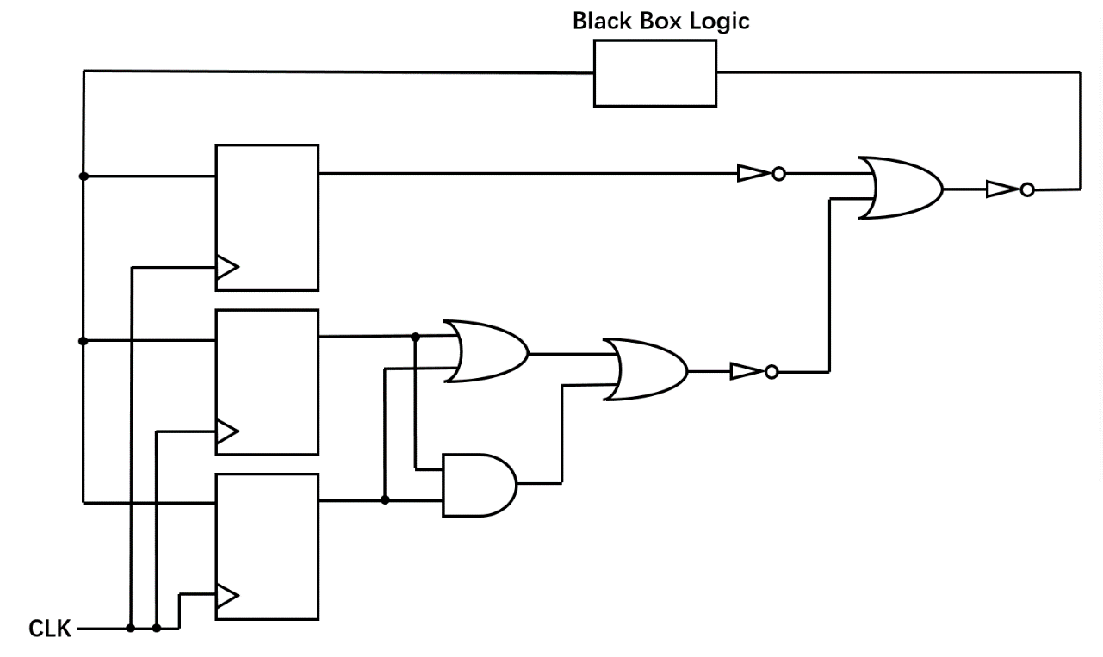

Q.5

- There are three AXI interfaces in Vitis HLS, list their names and explain their differences. (6 marks)
- Given the below code
- void foo(int A[32], int B[32], int C[32]) {
- #pragma HLS interface m_axi port=A bundle=D1
- #pragma HLS interface m_axi port=B bundle=D1
- #pragma HLS interface m_axi port=C bundle=D2
- for (int i=1; i<32; i++) {
- B[i] = A[i] + A[i-1] + C[i] + C[i-1];
- }
- }
- Use PIPELINE pragma to optimize this function, where should you insert it? (2 marks)
- What is the minimum Initial Interval (II) it can achieve after applying PIPELINE? Explain why. (4 marks)
- In order to achieve II=1, how you can modify the code? Describe in words or code. (8 marks)
- Given the below code, using array partition pragmas to meet the target II. (6 marks) You can write down the pragmas directly or describe in words. Assume all the arrays are implemented by single port BRAMs, what is the minimum number of BRAM required? (4 marks)
- int A[32][32];
- int B[32][32];
- int C[32];
- for (int i = 0; i < 32; i++) {
- for (int k = 0; k < 32; k++) {
- #pragma HLS PIPELINE II=1
- int result = 0;
- for (int j = 0; j < 32; j++) {
- result += A[i][k] * B[k][j] + A[31-i][k];
- }
- C[k] = result;
- }
- }

END OF PAPER

