- Student Name Chinese: _____________________
Student Name Pinyin: _____________________
Student Email: _____________________
Student Id: _____________________
School: _____________________
Year of Entrance: _____________________
ShanghaiTech University Final Examination Cover Sheet
Jan 4 2026

Academic Year: 2025 - 2026
Term: Fall
Course-offering School: School of Information Science and Technology
Instructor: Yajun Ha
Course Name: Reconfigurable Computing
Course Number: EE216

Exam Instructions for Students:
1. All examination rules must be strictly observed throughout the entire test, and any form of cheating is prohibited.

2. Other than allowable materials, students taking closed-book tests must place their books, notes, tablets and any other electronic devices in places designated by the examiners.

3. Students taking open-book tests may use allowable materials authorized by the examiners. They must complete the exam independently without discussion with each other or exchange of materials.

For Marker’s Use:
Section | Q.1 | Q.2 | Q.3 | Q.4 | Q.5 | Total
Max | 25 | 20 | 13 | 12 | 30 | 100
Marks
Recheck

Q.1
(a)Which of the following statements about initial and always is incorrect? ____D_____. (4 marks)
A. initial can only execute once.
B. The difference between initial and always is that the former cannot be synthesized, while the latter can be synthesized.
C. always executes continuously in a loop.
D. initial and always cannot execute simultaneously.

(b)Assume [wire [7:0] data = 8'b11010010;] then data[3:0] = ____4‘b0010_____. (4 marks)
(c)Assume that the width of the input signal X is 10, the width of the input signal A is 5, and the width of the input signal B 14. In order to achieve the function of Y = X * A + B without losing accuracy, what is the minimum width of the output signal Y? Assuming all signals are signed. ____16_____. (4 marks)
(d) Given the below code, draw the waveform of all the signals. (5 marks)
  - module testbench();
  - reg clk, rst, q0, q1, q2, q3;
  - always@(posedge clk) begin
  - if (rst) begin
  - q0 <= 0;
  - q1 <= 0;
  - q2 <= 0;
  - q3 <= 0;
  - end
  - else begin
  - q1 <= q0;
  - q2 = ~q1;
  - q3 <= q2 + 1;
  - end
  - end
  - always#5 begin
  - clk <= ~clk;
  - end
  - initial begin
  - rst = 1;
  - clk = 0;
  - #10;
  - rst = 0;
  - q0 = 1;
  - #50;
  - $finish;
  - end
  - endmodule
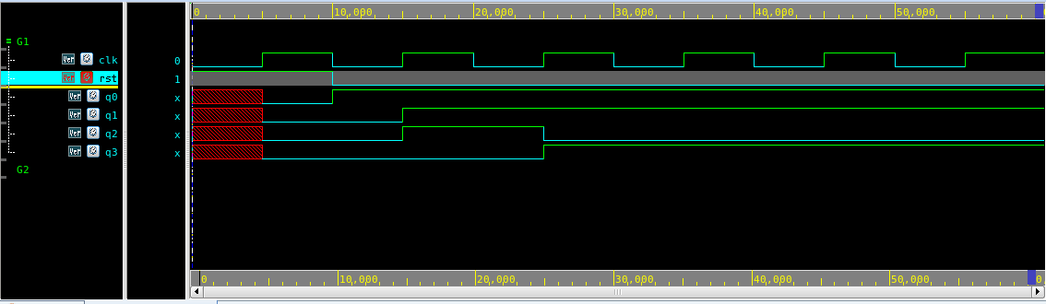
信号初始状态正确 1’
信号完整 1’
信号波形正确 3’

(e) Draw the block diagram of below two modules using logic gates and registers. (8 marks)
- module M1(
- input A, B, C, D,
- output E
- );
- assign E = !((A^B)&(~C&D));
- endmodule

- module M2(
- input clk, A, B, C, D,
- output reg E
- );
- reg F, G;
- always@(posedge clk) begin
- F <= A | B;
- G <= B & C;
- E = ~A ^ (F | G)
- end
- endmodule

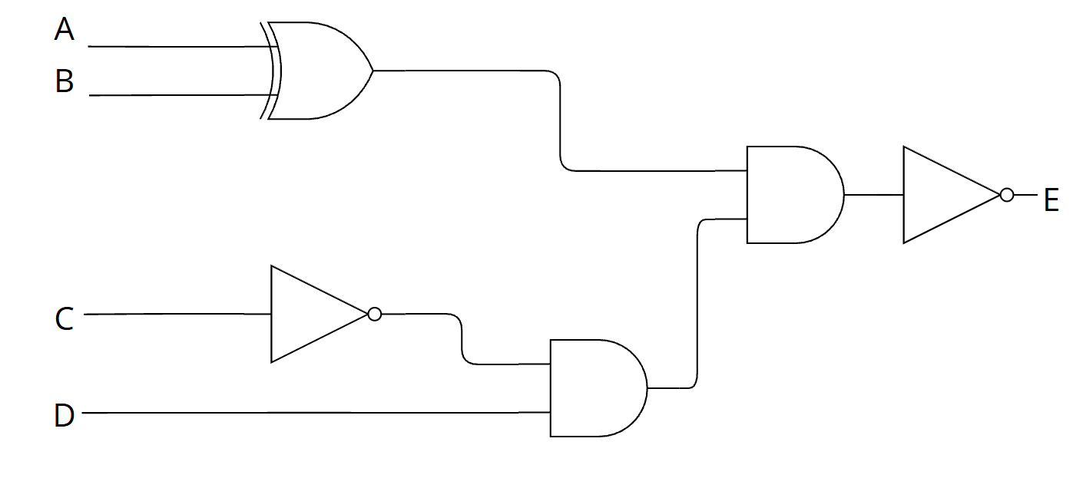

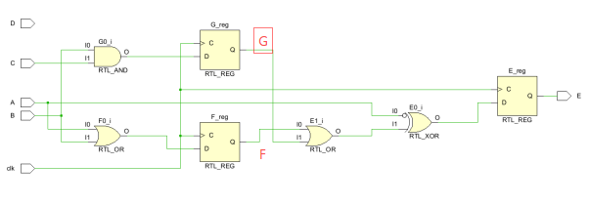
M1 框图正确（2 marks）
M2 框图正确（5 marks）

Q.2

- Design an automatic beverage vending machine that sells drinks for 10 cents. The machine accepts two coin types: 5 cents (in = 1) and 10 cents (in = 2). When the total inserted amount reaches or exceeds 10 cents, the output signal out should assert immediately to dispense the beverage. The machine must also handle change: whenever change is required, the corresponding change output should assert immediately. Draw the corresponding finite state machine (FSM), and implement it in Verilog with an asynchronous reset that returns the FSM to its initial state. (10 marks)
- module top_module(
- input clk,
- input [1:0] in,
- input areset,
- output out,
- output change); //

- // State transition logic

- // State flip-flops with asynchronous reset

- endmodule

- LUT, or Lookup Table, is a fundamental building block in digital design and is commonly used in FPGAs. A LUT is a small, configurable memory unit that stores data and is used to implement combinational logic functions.
- How many different 3 input functions can a 3 input LUT implement? Why? (5 marks)
- Using nothing other than 3-LUTs, demonstrate how you would construct a 6-LUT. Label your inputs x0, x1...., x5, and output as y.(5 marks)

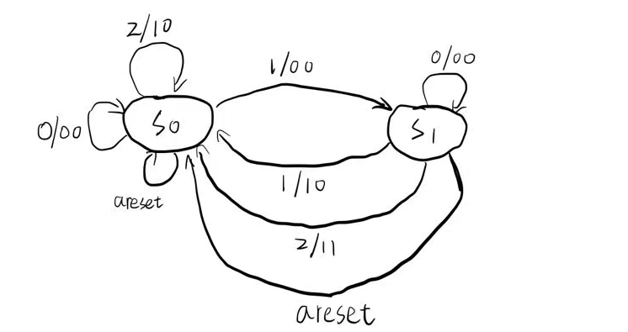
- module top_module(
- input clk,
- input [1:0] in,
- input areset,
- output reg out,
- output reg change
- );

- parameter S0 = 2'b00;
- parameter S1 = 2'b01;

- reg [1:0] state, next_state;

- always @(posedge clk or posedge areset) begin
- if (areset)
- state <= S0;
- else
- state <= next_state;
- end

- always @(*) begin
- case (state)
- S0: begin
- if (in == 2'd1)
- next_state = S1;
- else
- next_state = S0;
- end

- S1: begin
- if (in == 2'd0)
- next_state = S1;
- else
- next_state = S0;
- end

- default: next_state = S0;
- endcase
- end

- always @(*) begin
- out = 0;
- change = 0;

- case (state)
- S0: begin
- if (in == 2'd2) begin
- out = 1;
- change = 0;
- end
- end

- S1: begin
- if (in == 2'd1) begin
- out = 1;
- change = 0;
- end
- else if (in == 2'd2) begin
- out = 1;
- change = 1;
- end
- end
- endcase
- end
- endmodule
(b)2^(2^3), since 3 LUT can implement logic truth table with 2^3 rows, and by assigning each row with different output value, we can implement 2^(2^3) different logic functions.
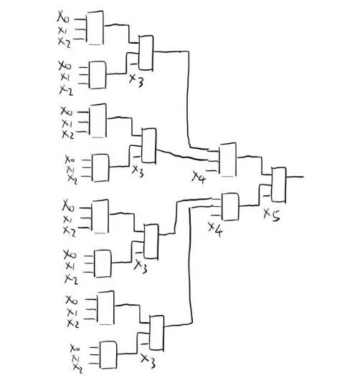

(a)状态机正确 4’
Verilog代码语法正确 1’
Verilog代码功能正确 5’
(b)(1)结果正确 3’, 解释正确 2’
(2)结构图正确 5’

Q.3

Given the following Verilog code:
- Draw the schematic of the hardware that will be synthesized from the Verilog code below. (8 marks)
- How many timing paths are in the schematic generated from the code? What are they? (5 marks)

- module Top(
- input CLK,
- input RST,
- input in,
- output out
- );

- wire A;
- reg B;
- reg C;
- wire D;
- reg E;
- wire F;

- assign A = in;

- always @(posedge CLK or posedge RST)
- begin
- if(RST == 1'b1)
- B <= 1'b0;
- else
- B <= A ;
- end

- assign D = ~ B & C;
- assign F = D | E;

- always @ (*)
- begin
- E = B ^ C;
- end

- always @(posedge CLK or posedge RST)
- begin
- if(RST == 1'b1)
- C <= 1'b0;
- else
- C <= F ;
- end

- assign out = C;
- endmodule
(a)
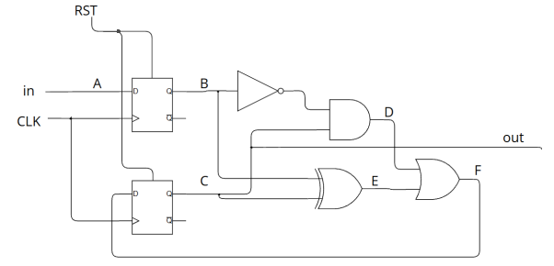

(b)in -> A -> reg
Reg -> B -> D -> F -> reg
Reg -> B -> E -> F -> reg
Reg -> C -> D -> F -> reg
Reg -> C -> E -> F -> reg
Reg -> C -> out

信号标注完整 1’
绘图规范 1’
结构图正确 6’

Q.4

(a) In a generic 3x3 Image Filter design, we use a LineBuffer and a window array to process the stream. We need to implement a "Sliding Window" operation inside the column loop.
Context:
- LineBuffer[3][WIDTH] stores the necessary image rows. Assume row 0, 1, 2 of the LineBuffer correspond to the top, middle, and bottom rows of the filter window respectively.
- window[3][3] is the local register array.
- j is the current column index.
Complete the code to:
- Shift the data within the window to the left (prepare for new data).
- Load the new column data from the LineBuffer into the rightmost column of the window.
(6 marks)
前五个都写对六分，每错一个扣1分，全错0分。
- PIC_COLS: for(int j = 0; j < cols; j++) {
- window[0][0] = window[0][1];
- ___________________________;
- ___________________________;

- ___________________________;
- ___________________________;
- ___________________________;

- ___________________________;
- ___________________________;
- ___________________________;
- // Execute the Kernel (e.g., Average, Sobel, Gaussian)
- PIXEL result = apply_filter(window);
- dst[j] = result;
- }

window[0][0] = window[0][1]; // (题目已给)
window[1][0] = window[1][1];
window[2][0] = window[2][1];

window[0][1] = window[0][2];
window[1][1] = window[1][2];
window[2][1] = window[2][2];

window[0][2] = LineBuffer[0][j];
window[1][2] = LineBuffer[1][j];
window[2][2] = LineBuffer[2][j];

(b) To achieve II=1, we apply #pragma HLS ARRAY_PARTITION variable=window complete.
- Explain why this is necessary for the window array. (3 marks)
说出类似并发，同时读取等合理即可，不合理0-1分。
- If we remove this pragma, what hardware resource (RAM or Registers) will the tool likely use for window, and how will it affect the performance? (3 marks)
RAM（1分）；解释多次读写无法进行合理即可（2分）

• 为什么必须使用该指令 (Why necessary):
为了实现 II=1，我们需要在同一个时钟周期内并行访问 window 数组的所有元素（包括移位时的读取/写入，以及 apply_filter 计算时的读取）。如果不进行 Partition，数组通常默认为存储器块，无法支持如此多的并发访问。
• 移除指令后的硬件资源 (Resource without pragma):
工具很可能会将 window 数组实现为 BRAM (Block RAM) 或 LUTRAM (Distributed RAM)。
• 对性能的影响 (Performance Impact):
BRAM 通常只有两个读写端口（Dual-port）。由于我们在一个周期内需要对窗口进行 9 次写入和多次读取，两个端口远远不够。
这将导致工具无法在一个周期内完成调度，从而导致 II (Initiation Interval) 显著增加（例如 II 会变成 5 或更大），大大降低系统的吞吐量和性能。
(注：使用了 complete partition 后，数组会被综合为寄存器 (Registers/Flip-Flops)，从而支持无限的并发访问。)
(合理即可)

Q.5

- There are three AXI interfaces in Vitis HLS, list their names and explain their differences. (6 marks)
- Given the below code
- void foo(int A[32], int B[32], int C[32]) {
- #pragma HLS interface m_axi port=A bundle=D1
- #pragma HLS interface m_axi port=B bundle=D1
- #pragma HLS interface m_axi port=C bundle=D2
- for (int i=1; i<32; i++) {
- B[i] = A[i] + A[i-1] + C[i] + C[i-1];
- }
- }
- Use PIPELINE pragma to optimize this function, where should you insert it? (2 marks)
- What is the minimum Initial Interval (II) it can achieve after applying PIPELINE? Explain why. (4 marks)
- In order to achieve II=1, how you can modify the code? Describe in words or code. (8 marks)
- Given the below code, using array partition pragmas to meet the target II. (6 marks) You can write down the pragmas directly or describe in words. Assume all the arrays are implemented by single port BRAMs, what is the minimum number of BRAM required? (4 marks)
- int A[32][32];
- int B[32][32];
- int C[32];
- for (int i = 0; i < 32; i++) {
- for (int k = 0; k < 32; k++) {
- #pragma HLS PIPELINE II=1
- int result = 0;
- for (int j = 0; j < 32; j++) {
- result += A[i][k] * B[k][j] + A[31-i][k];
- }
- C[k] = result;
- }
- }

(a)
Question: There are three AXI interfaces in Vitis HLS, list their names and explain their differences. (6 marks)
一个接口2分；lite：强调轻量级；stream：强调顺序流动；master：强调内存映射
English Answer:
The three AXI interfaces are:
- AXI4-Lite (s_axilite):
  - Description: A light-weight, low-throughput memory-mapped interface.
  - Usage: Typically used for control signals, status registers, and passing small scalar arguments (configuration data) to the IP core. It is simple and consumes fewer resources.
- AXI4-Stream (axis):
  - Description: A high-speed, point-to-point streaming interface without address channels.
  - Usage: Used for high-performance data streaming where data flows sequentially (e.g., video processing, signal processing pipelines). It does not allow random memory access.
- AXI4 Master (m_axi):
  - Description: A high-performance, memory-mapped interface that supports burst transactions.
  - Usage: Used for reading/writing large amounts of data from/to global memory (like DDR). It allows the HLS IP to initiate data transfers (DMA-like behavior).
中文答案:
Vitis HLS 中有三种 AXI 接口：
- AXI4-Lite (s_axilite):
  - 描述: 一种轻量级、低吞吐量的内存映射接口。
  - 用途: 通常用于控制信号、状态寄存器以及向 IP 核传递小的标量参数（配置数据）。它结构简单，占用资源较少。
- AXI4-Stream (axis):
  - 描述: 一种高速的点对点流式接口，没有地址通道。
  - 用途: 用于高性能数据流传输，数据按顺序流动（例如视频处理、信号处理流水线）。它不支持随机内存访问。
- AXI4 Master (m_axi):
  - 描述: 一种支持突发传输（Burst）的高性能内存映射接口。
  - 用途: 用于从/向全局内存（如 DDR）读写大量数据。它允许 HLS IP 主动发起数据传输（类似 DMA 行为）。

(b)
Question: Given the code...
- Use PIPELINE pragma to optimize this function, where should you insert it?
- What is the minimum Initial Interval (II) it can achieve after applying PIPELINE? Explain why.
- In order to achieve II=1, how you can modify the code?
English Answer:
1) Location of Pragma:
You should insert #pragma HLS PIPELINE inside the for loop (at the beginning of the loop body) or immediately before the loop.
c
for (int i=1; i<32; i++) {
#pragma HLS PIPELINE II=1
B[i] = A[i] + A[i-1] + C[i] + C[i-1];
}
2) Minimum II and Reason:
- Minimum II: 2 (Likely).
- Reason: The calculation requires A[i] and A[i-1]. Without manual optimization, the HLS tool typically issues two separate read requests to the m_axi interface for array A (and similarly two for C) in each iteration. Since an m_axi port (or the specific bundle D1) typically processes one read request per cycle, reading two values takes 2 cycles. This creates a resource contention on the memory port, limiting the Initiation Interval (II) to 2.
3) Modification for II=1:
To achieve II=1, we must remove the redundant memory reads. We can use a local variable (register) to store the value read in the previous iteration (A[i-1] and C[i-1]) so that we only need to perform one new read for A[i] and C[i] per cycle.
Code Modification:
c
void foo(int A[32], int B[32], int C[32]) {
#pragma HLS interface m_axi port=A bundle=D1
#pragma HLS interface m_axi port=B bundle=D1
#pragma HLS interface m_axi port=C bundle=D2

int A_prev = A[0]; // Pre-read the first element
int C_prev = C[0];

for (int i=1; i<32; i++) {
#pragma HLS PIPELINE II=1
int A_curr = A[i]; // Only 1 read per cycle
int C_curr = C[i]; // Only 1 read per cycle

B[i] = A_curr + A_prev + C_curr + C_prev;

// Shift values for next iteration
A_prev = A_curr;
C_prev = C_curr;
}
}
中文答案:中文作答一道大题扣2分
1) Pragma 插入位置:
写for内部或者22/21-22都2分，其他不得分
应该将 #pragma HLS PIPELINE 插入在 for 循环内部（循环体的开头）或者紧挨着循环之前。
2) 最小 II 及其原因:
II=2两分，原因写出读写2分；
- 最小 II: 2 (通常情况)。
- 原因: 计算需要 A[i] 和 A[i-1]。如果不进行手动优化，HLS 工具通常会在每次迭代中向 m_axi 接口发起两次独立的读请求（数组 C 同理）。由于一个 m_axi 端口（或特定的 bundle D1）通常在一个周期内只能处理一个读请求，读取两个值需要 2 个周期。这导致了内存端口的资源冲突，从而将启动间隔 (II) 限制为 2。
3) 如何修改代码以实现 II=1:
直接对接口进行array_partition不得分，用额外的变量存得8分，语法有错误每有一个扣两分
为了实现 II=1，必须消除冗余的内存读取。我们可以使用局部变量（寄存器）来存储上一次迭代读取的值（即 A[i-1] 和 C[i-1]），这样我们在每个周期只需要对 A[i] 和 C[i] 进行一次新的读取。
代码修改:
（见上方英文部分的 Code Modification）

(c)
Question: Given the below code, using array partition pragmas to meet the target II. Assume all the arrays are implemented by single port BRAMs, what is the minimum number of BRAM required?
English Answer:
Pragmas:
To achieve II=1 in the k loop, the inner j loop must be fully unrolled, and we must handle the simultaneous accesses.
- Array B: The inner loop j is unrolled (implied by pipelining the outer k loop). We need to access all 32 elements of row B[k] (i.e., B[k][0] to B[k][31]) in parallel.
  - #pragma HLS ARRAY_PARTITION variable=B dim=2 complete
- Array A: In each cycle, we read A[i][k] and A[31-i][k]. These are two different rows accessed simultaneously. With single-port BRAMs, we need to partition the rows. Since i and 31-i always have different parity (one is even, one is odd), a cyclic partition factor of 2 is sufficient.
  - #pragma HLS ARRAY_PARTITION variable=A dim=1 cyclic factor=2
  - (Note: complete partition on dim 1 is also a valid answer, but cyclic factor=2 is the minimum required).
Minimum Number of BRAMs:
- Array B: Partitioned completely on dimension 2 (size 32). This requires 32 single-port BRAMs (one for each column).
- Array A: Partitioned cyclically by 2 on dimension 1. This requires 2 single-port BRAMs (one for even rows, one for odd rows).
- Array C: Only one write per cycle (C[k]). Requires 1 single-port BRAM.
- Total: 32 + 2 + 1 = 35 BRAMs.
中文答案:
A，B写对partition各2分（C只要AB有一个对就给2分，不用写C），有语法错误一个扣两分你；数量35和解释都对4分。
Pragmas (编译指令):
为了在 k 循环中实现 II=1，内部的 j 循环必须完全展开，我们需要处理并行访问。
- 数组 B: 内部循环 j 被展开。我们需要并行访问 B[k] 这一行的所有 32 个元素（即 B[k][0] 到 B[k][31]）。
  - #pragma HLS ARRAY_PARTITION variable=B dim=2 complete
- 数组 A: 在每个周期中，我们需要读取 A[i][k] 和 A[31-i][k]。这是同时访问两行不同的数据。由于使用单端口 BRAM，我们需要对行进行划分。因为 i 和 31-i 的奇偶性总是相反的（一个是偶数，一个是奇数），所以在维度 1 上进行因子为 2 的循环划分（cyclic partition）就足够了。
  - #pragma HLS ARRAY_PARTITION variable=A dim=1 cyclic factor=2
  - (注：在维度 1 上进行 complete 全划分也是正确答案，但 cyclic factor=2 是满足要求的最小代价)。
最少 BRAM 数量:
- 数组 B: 在维度 2 上完全划分（大小 32）。这需要 32 个单端口 BRAM（每一列一个）。
- 数组 A: 在维度 1 上进行因子为 2 的循环划分。这需要 2 个单端口 BRAM（偶数行一个，奇数行一个）。
- 数组 C: 每个周期只有一次写入 (C[k])。需要 1 个单端口 BRAM。
- 总计: 32 + 2 + 1 = 35 个 BRAM。

END OF PAPER

