Docker on synology documentation

Install docker


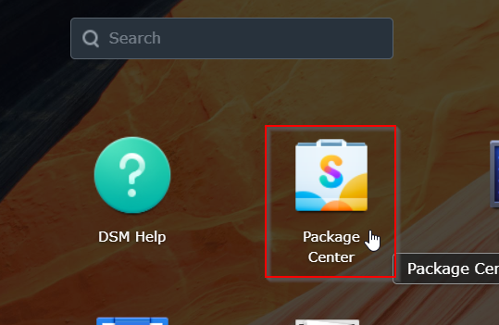

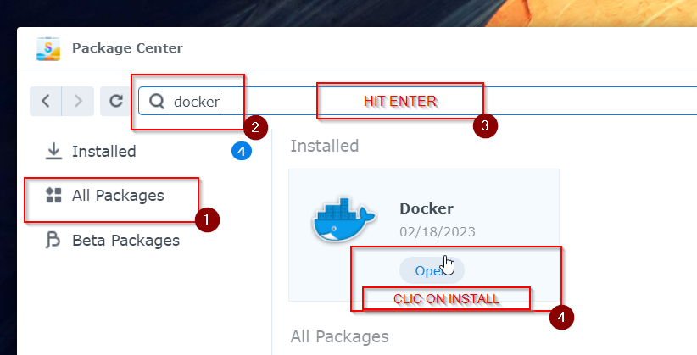
Auto generated folder In “File Station”
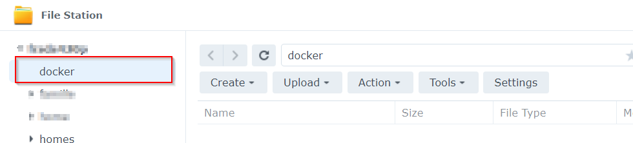

Creating a container

Open docker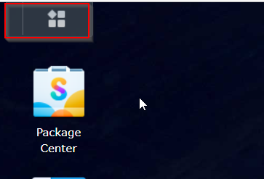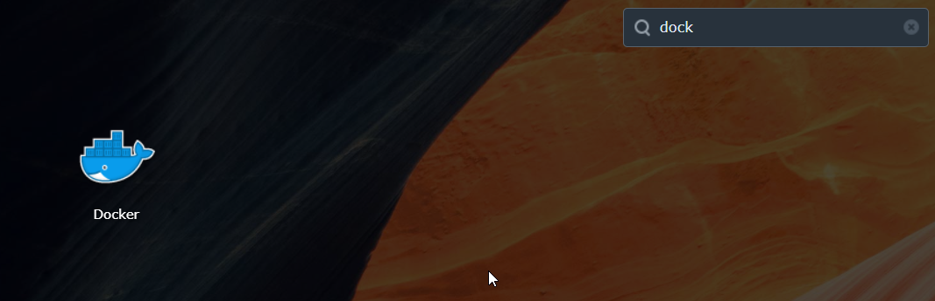
Download container
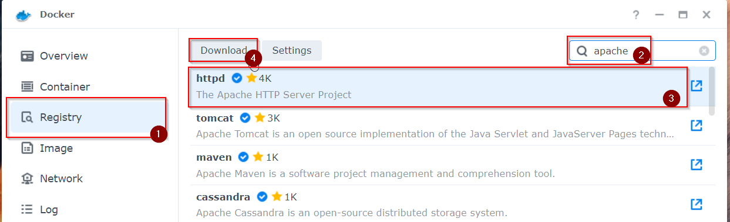

Chose tag, prefer fixed version then latest for a better version control

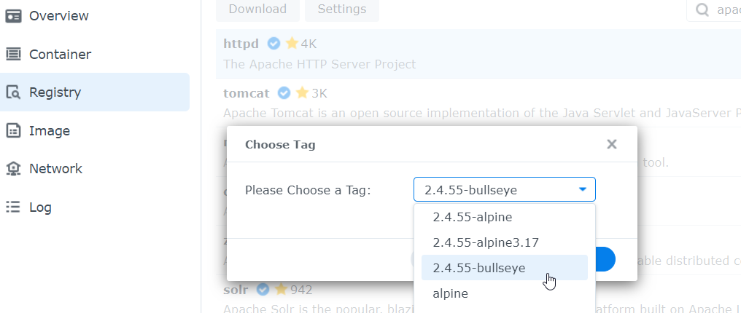

The image is downloaded
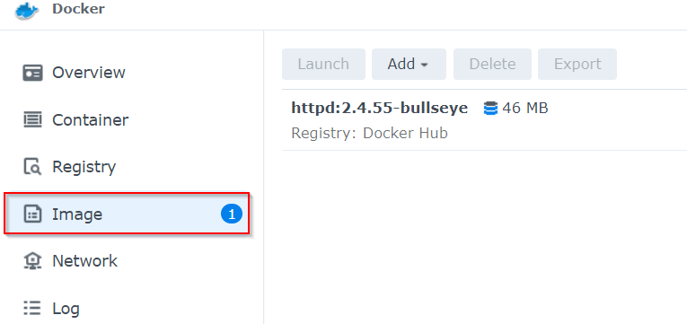

Double clic on image to start installation
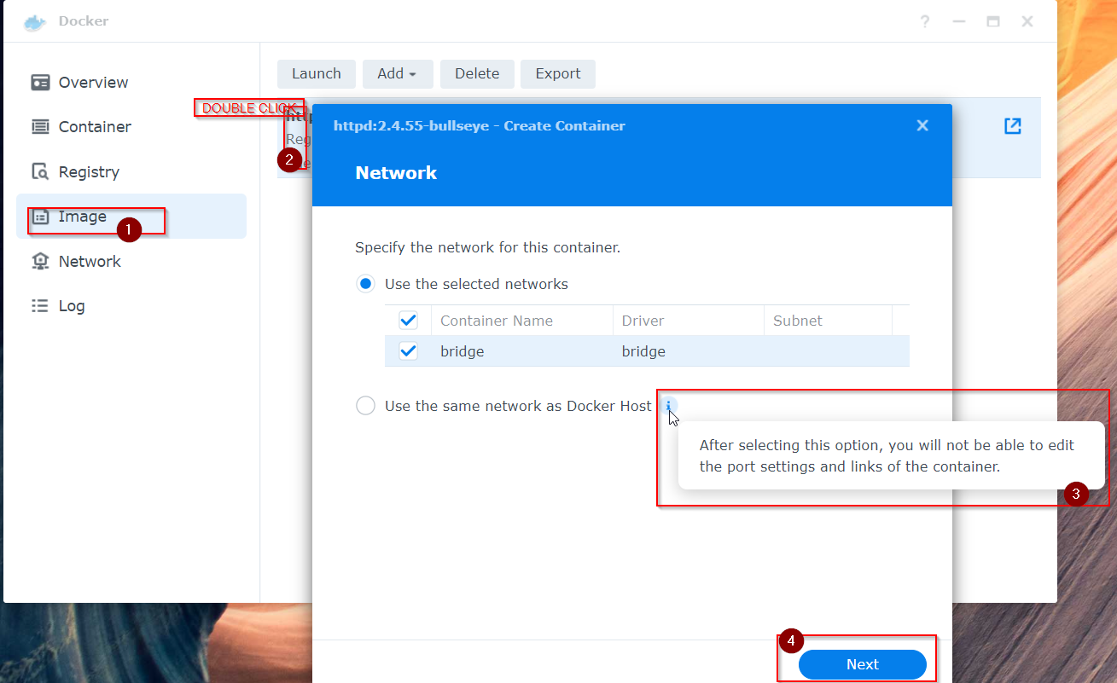

Setting that you may leave to default or modify them if you want
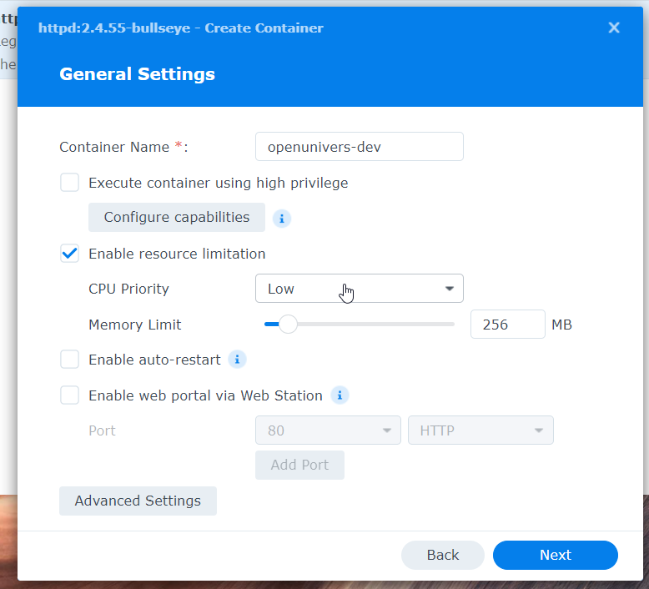

Interrupted

Wordpress
(link to youtube video : How to HOST WORDPRESS SITE at home on SYNOLOGY (The right way in DSM7) - YouTube)

Configure ddns on you sinology
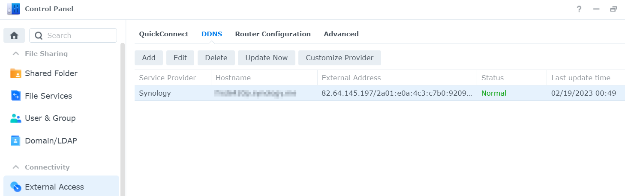

configure zone in you demaine name provider interface
add CNAME zone

port forwding on you router
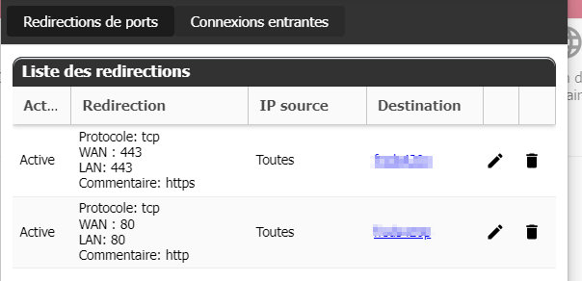

Donwload some packages on synology
Webstation
Apache 2.4
mariaDB10
etner a password it would be root password, click done
php 7.3
phpMyAdmin 7.4 for easy database management

wordpress
download wordpress from the brouser, extract it, paste in wev/customfolderforwordpress
notice that web folder si automatically created when installing sinology “web station”

connect to php admin

username : root
password = password used when creating mariadb

in php admin
new -> “persolizeddbname” create
user account -> new (add user account)
host : local instead of anyhost
care insecure password may generate wird erro message, if there an error try to change password combination
user account (choise the ast selected one )-> edit privileges -> click on database ->double clic select a right database
- Double click on dtabase name to select then go
- Check all (Database-specifi privileges)

Delete index.html in web folder. No doing so will cause issues
In sylogy “web station”
Crete a virtual host
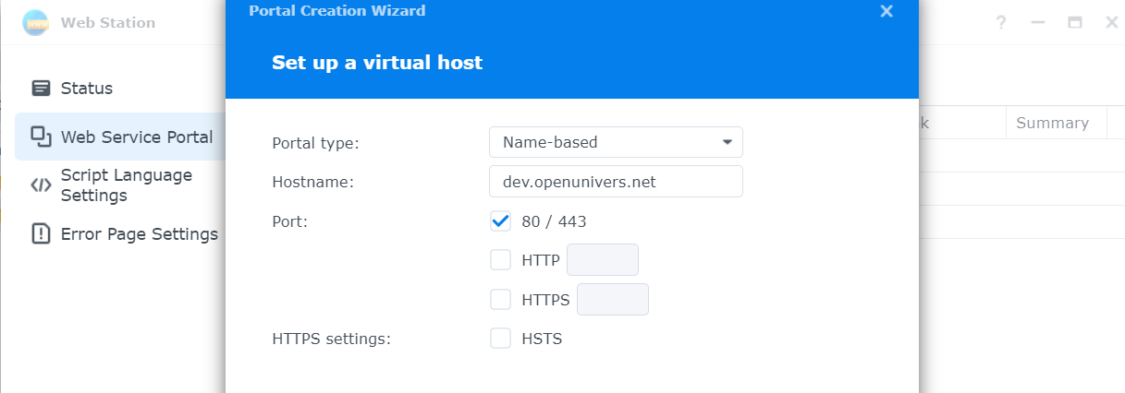

When people type dev…. Sinology will, tourgh web station, redirect to this website we are creating
Select the wordpressfolder as rootfolder
Backend server Apache installed version
Script language settings
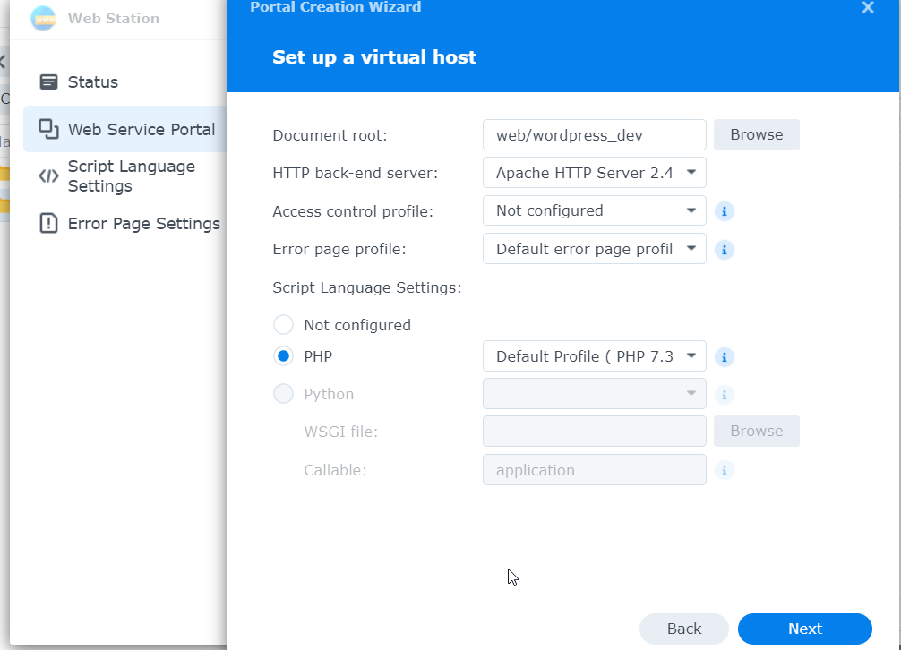

Next then create
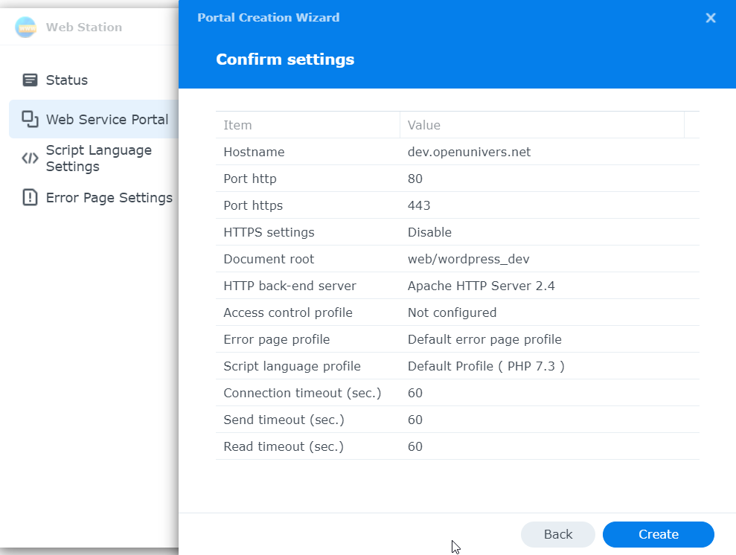

If asked, allow read permission on current and above folder for the group http
In web station/script language setting
Create a profile and tacle all extension possible among those nidded cf Server Environment – Make WordPress Hosting 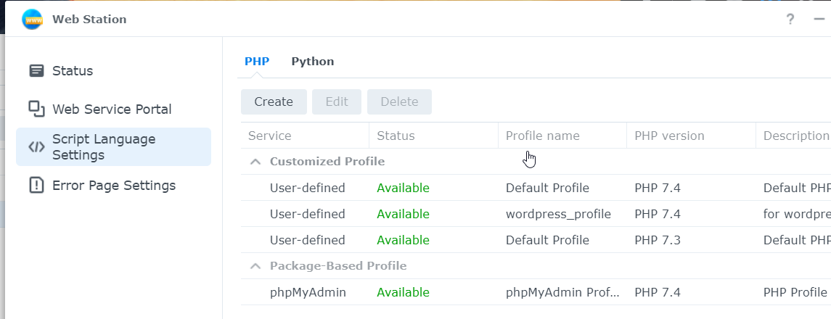
Now that we have created our profile, lets update our web service portal conf
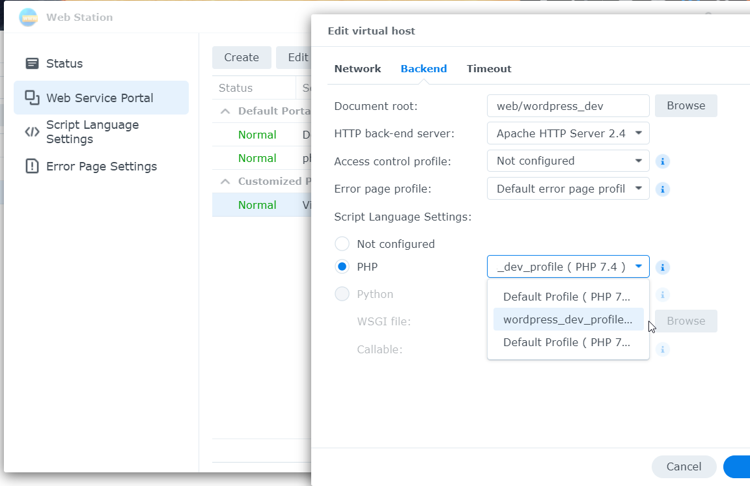

Make sure http local groupe has read and writte privileges to wordpress folder
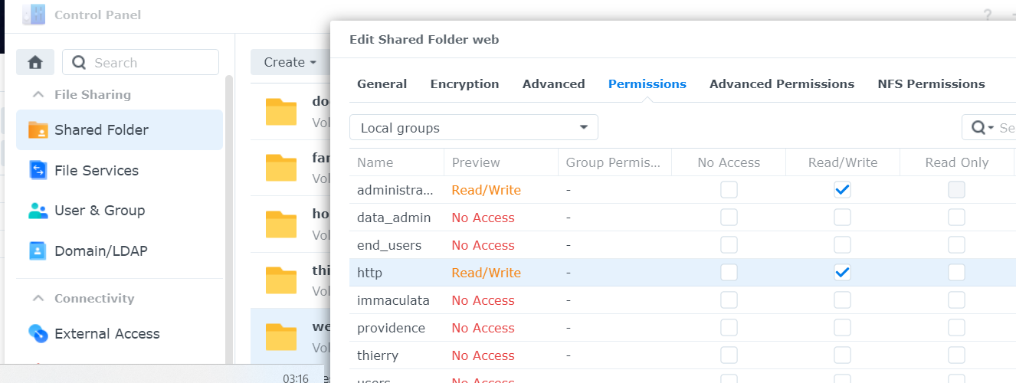

Now access your worpress ia your web link, it is the one we redirected above thour our domaine name provider interface

Fill with a new username, password, andeamil and leave other info as defamut and go/istall
It will took a while wait until a new page appear
Then refresh the age it should say that the install is finshd orask to login
Login with the precedent email and your good to go

