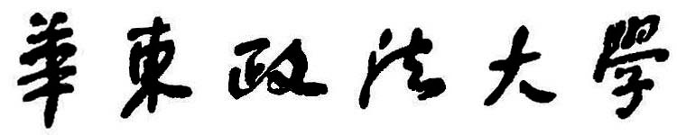

本科生毕业论文(设计)

|  |  |
| --- | --- |
| 题 目： | [#maxlen 24]${thesis_title1} |
|  | [#maxlen 24]${thesis_title2} |
| 院 (系)： | ${department_name} |
| 专 业： | ${major_name} |
| 班 级： | ${squad_name} |
| 学 号： | ${std_code} |
| 姓 名： | ${std_name} |
| 指导教师： | ${advisor_name} |