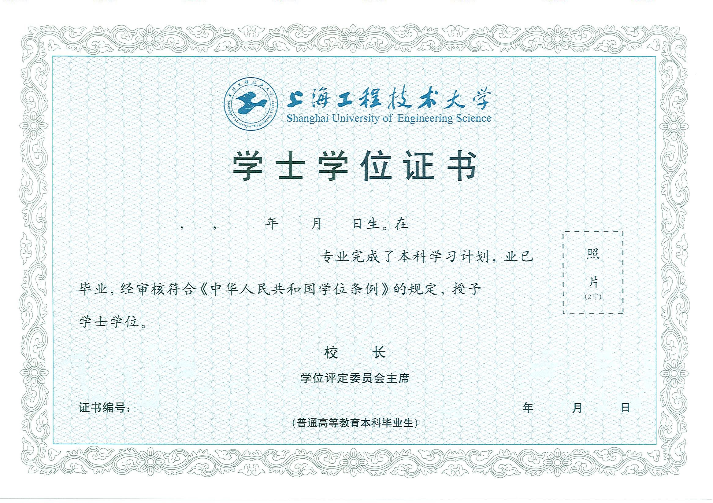

${name} ${x} ${bY} ${bM} ${bD} ${ss}

${minor}
(在${school}主修${major} )
${degree}
（辅修专业）

${diplomaNo} ${y} ${M} ${d}

