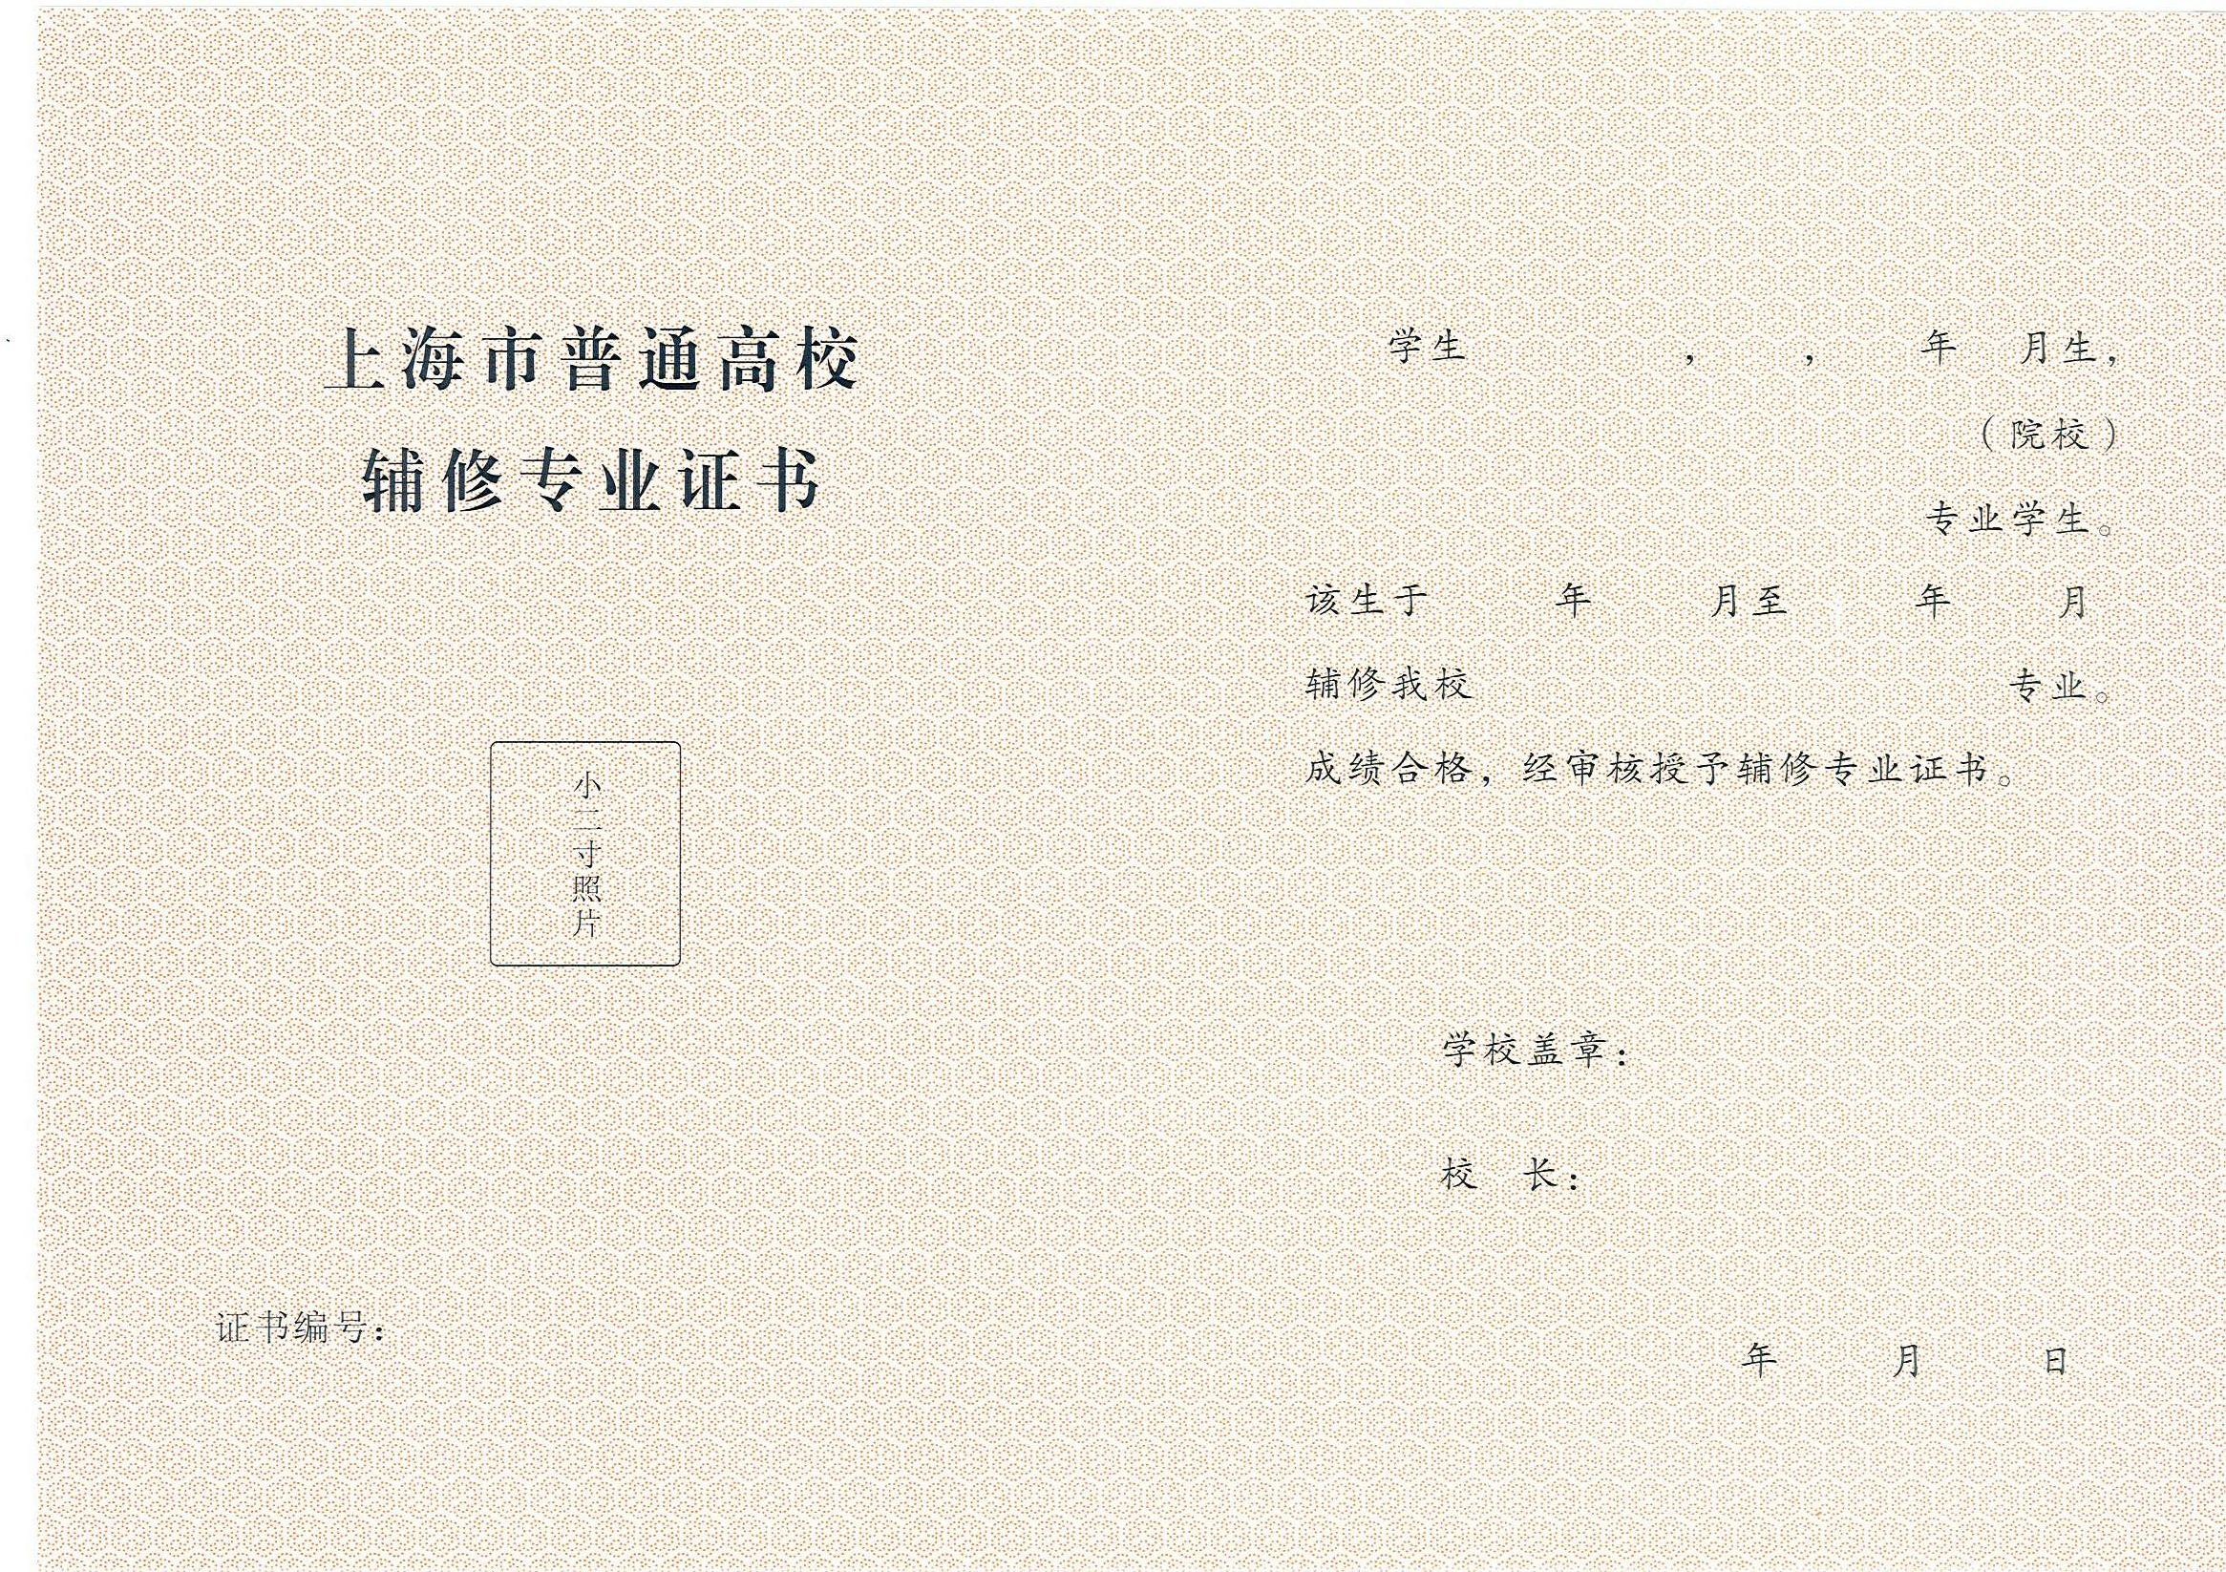
${name} ${x} ${bY} ${bM}
${ss}
${major}
${sY} ${sM} ${eY} ${eM}
${minor}

${code}
${y} ${M} ${d}

