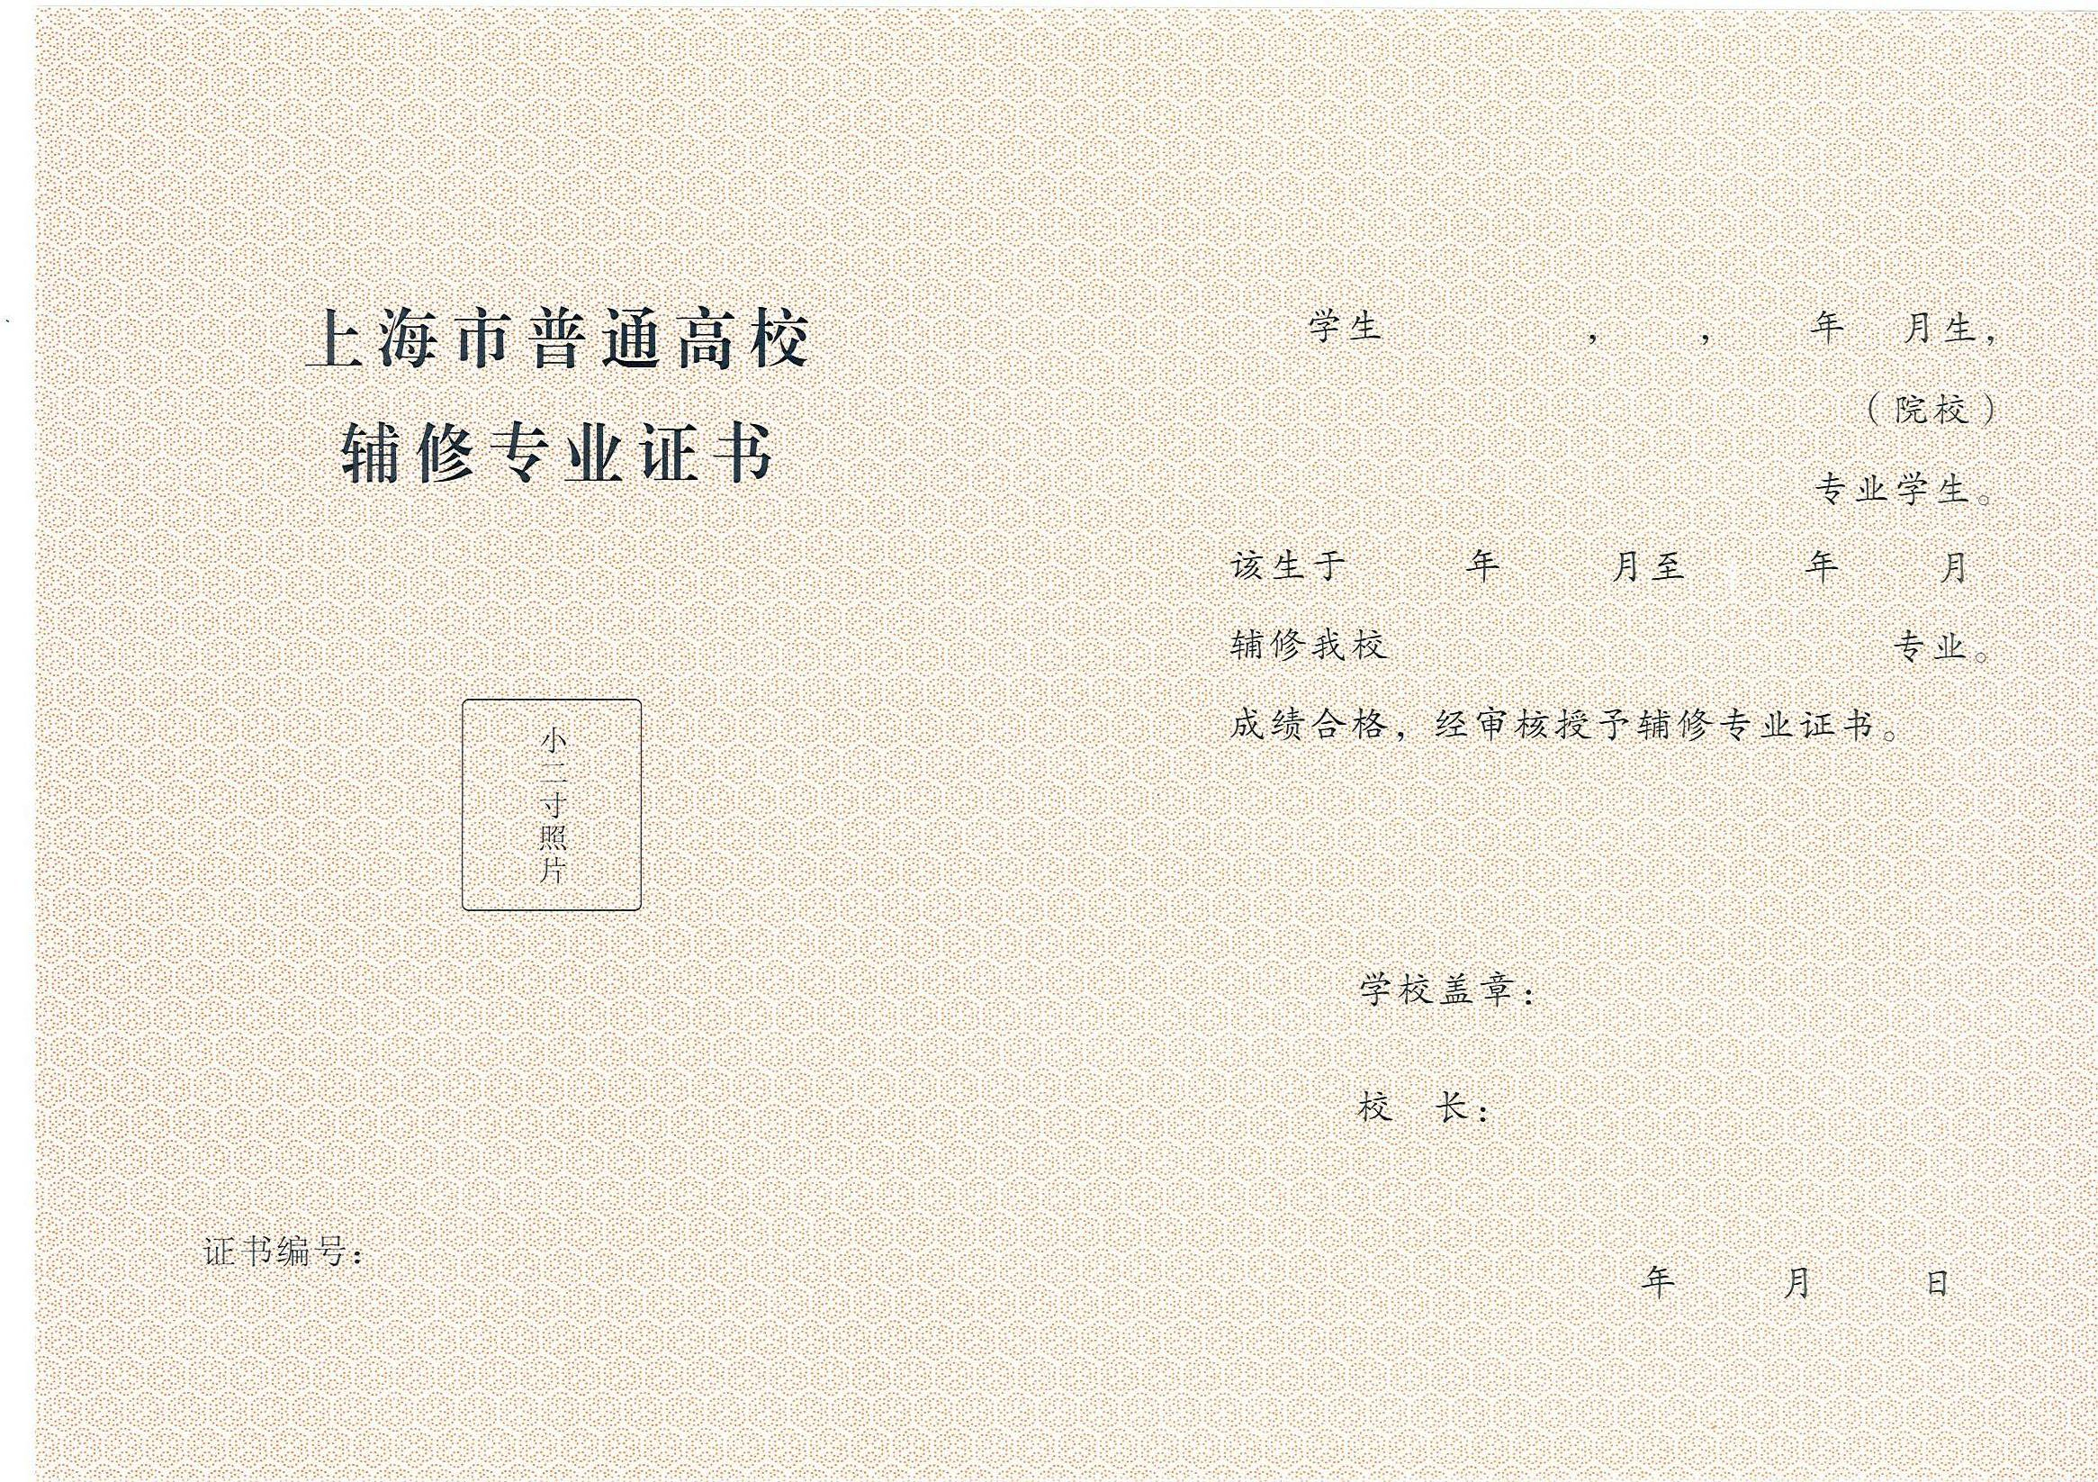

**${name} ${x} ${bY} ${bM}**

**${ss}**

**${major}**

**${sY} ${sM} ${eY} ${eM}**

**${minor}**

**${code}**

**${y} ${M} ${d}**