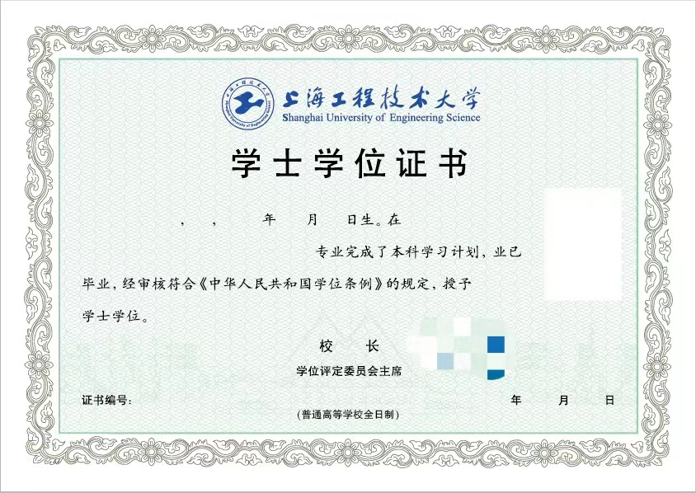

**${name} ${x} ${bY} ${bM} ${bD} ${ss}**

**${minor}**

**(在${school}主修${major} )**

**${degree}**

**（辅修专业）**

**${diplomaNo} ${y} ${M} ${d}**