OVMS
Open Vehicle Monitoring System



www.openvehicles.com

Kia Soul EV v0.4.4
OVMS Hardware Module v2
User Guide v1.0 (2016/03/01)

History

v0.9 2016/01/20 Initial version (RT0.4.4) by Jörg Lesniak
v1.0 2016/03/01 Included corrections from Tom an Ann

Recent changes

- Table of contents
1.Welcome! 4
2.Understanding components to be used 5
3.Parts needed 6
4.SIM card 6
5.Firmware update / SIM installation 7
6.Configuration 9
7.Register your cell phone with the OVMS Module 9
8.Change the OVMS Module Password 9
9.Set the OVMS Module in Kia Soul mode 10
10.Configure the GPRS Data Connection (Needed for smartphone App usage) 11
11.Car installation of the OVMS Module and antennas 13
12.Thanks to... 19
13.Contact / Feature requests / Firmware downloads 19

Welcome!
The OVMS (Open Vehicle Monitoring System) team is a group of enthusiasts who are developing a means to remotely communicate with our cars, and are having fun while doing it.

The OVMS module is a low-cost hardware device that you install in your car simply by installing a SIM card, connecting the module to your car’s diagnostic port connector, and positioning a cellular antenna. Once connected, the OVMS module enables remote control and monitoring of your car.

There are two ways for you to communicate with the OVMS module:

- Send text messages from a cell phone to the OVMS module’s phone number. The module will respond back via text messaging. If you want, the OVMS module can also send text messages to you when the car reaches certain states, such as if charging is interrupted.
- Use a smartphone App. Both the OVMS module and the App communicate with an OVMS server via UDP/IP or TCP/IP over the Internet. The smartphone Apps provide a richer experience and more functionality, but they do require a data plan on the SIM card you purchase and install in the OVMS module.

This Guide will help you setup and configure your OVMS module. Initial configuration of the OVMS module is done via SMS. Once configured, you can use either SMS and/or the cellphone Apps to communicate with the OVMS module.


Warning!
OVMS is a hobbyist project, not a commercial product. It was designed by enthusiasts for enthusiasts. Installation and use of this module requires some technical knowledge, and if you don't have that we recommend you contact other users in your area to ask for assistance.

Legal disclaimer: by using the OVMS you agree to do so completely at your own risk. Being a hobbyist project, the OVMS has neither CE approval nor undergone any official EMC tests. It has no ECE approval, so depending on your country may not be legal on public roads.

Warning!
The OVMS module currently consumes about 2.7 Ah per day from the 12V battery, which has 60 Ah capacity on the Soul. If you do not charge or drive for several days, you must charge the Soul or unplug the OVMS to avoid deep discharge of the 12V battery! Failure to do this can result in unrecoverable failure of the 12V battery. If the car does not power up, that can be due to low voltage on the 12V battery: try charging! The OVMS will send an alert if it detects the voltage dropping below 11.5V reminding you to charge in time.

Understanding components to be used
For setting up OVMS, it's fine to have an overview of the components in use and preparation steps to do before configuring all the devices:
OVMS Server: The server deals as communication partner to the OVMS module, storing all the information you're interested in (SOC, charging/not charging etc.)
OVMS Module: This is the part installed in your Kia Soul, communicating with the car using CAN bus and dealing with the needed information from the car. The module sends information to the OVMS server, to be accessible for your smartphone.
Smartphone: The smartfone has two roles in this game: For setting up the OVMS-module by sending SMS commands to the module, and for displaying the actual information of your car(s). The first role will for most users just to setup the module.The last role is definitely the most important in daily use.
In general the usage of an OVMS Server is not a must. You may communicate with the OVMS Module just by ending text messages (SMS), but most users will prefer a nice application on their smart phone to see what's going on with the car.
To prepare setup and having the needed hardware in your hands, the following steps will be necessary (necessary only if you want to use an OVMS Server based solution):
- Choose an OVMS Server you'll like to use. This may be the server of the OVMS project or dexter's server. You need an account for this server, so register yourself and log in.
- Register the chosen OVMS server and note the following information:
DNS-name of the OVMS server and the GCM sender ID (you'll see that on the servers website)
login data for the OVMS-server
The OVMS-password you'll use to access the OVMS-module (do not choose easy passwords!)
A vehicle name to identify your car and a password for it
- Note the cell-phone number of the SIM
With this information you're ready to start the setup of the components.

Parts needed
You can buy all parts at the OVMS hardware partner Fasttech:
http://www.fasttech.com/link/ovms
Note: Fasttech is shipping from China, import customs and tax will apply for EU.
For each Soul EV you'll need:
- Universal GPS Antenna (SMA Connector)
GPS Antenna: SMA: $4.89
- OpenVehicles OVMS GSM Antenna
GSM Antenna: $2.50
- ODB-II to DB9 Data Cable for OVMS (left)
ODB-II OVMS Cable: $9.50
- OVMS Car Module v2
OVMS Module: $99.00

If you want to avoid having two antennas: There are combi antennas integrating GSM & GPS available (e.g. "shark fin antenna"). If you test one of these, please report your results :-). Both antenna connectors are SMA, an active GPS antenna needs to run on 3 V.

To update the OVMS firmware, you'll also need one of these:
- PICKIT 2 Compatible Programmer/Debugger
PICKIT 2 Compatible Programmer: $16.99
- PICKIT 3 Compatible Programmer/Debugger
PICKIT 3 Compatible Programmer: $26.28
If you want to do OVMS development and/or debugging, a serial interface or serial to the USB adapter will be needed. Both programmers may be used, but you'll need different applications to load the firmware to the Car Module 2! See http://dexters-web.de/faq#flash for more details.

SIM card
You'll need a standard size SIM card with a data plan. The Soul module will normally need about 1-10 MB of data per month, depending on your driving and GPS logging. Data though will be sent in small and infrequent packets, so be aware of providers rounding up prepaid data transfers (like Congstar.de) or book some minimal flat rate. Also, mobile GPRS coverage and stability depends on the network; for Germany, D1 (T-Mobile) offers good coverage and stability, followed by D2 (Vodafone). E-Plus is usable in urban areas, O2 is not recommended.
Some providers for Germany (conditions may have changed!):
- T-Mobile "Xtra Call" + "Xtra Flat Daten": D1, best coverage, flat rate required, limit 50 MB (should be sufficient in most cases)
- Congstar "Prepaid Starter" + "Surf Flat Option 200": D1, best coverage, flat rate required, limit 200 MB
- Allmobil: D2, good coverage, fair rates, no flat rate required
- Blau "9 cent Tarif": E-Plus, usable urban coverage, fair rates, no flat rate required

Follow your provider's guidelines on activating the SIM card (full activation can take up to 24 hours). The card needs to be unlocked to start without PIN entry. Use a smart phone to unlock the SIM. This can easily be done using your mobile phones SIM card management App. Using your mobile phone you can also test the card activation status and GPRS access. It's a good idea to check with your smartphone that you may connect to your provider without beeing asked for a pin. If this works like that, you're be able to continue.

Firmware update / SIM installation
See "Firmware Easy-Install" on the OVMS home page. Firmware installation is nearly the same for all vehicles. Please see the details on the OVMS homepage. The general steps are:
- Open OVMS module (only one side to open!)
- Connect programmer
- Connect programmer and your PC using the USB cable (delivered with the programmer)
- Cownload the firmware for the module
- Download and install the program in order to load the firmware to the module (which one to take depends on the programmer you're using (PICKIT 2 or 3.5)
- Follow the instructions on the OVMS homepage to load the firmware to the module
- Detach programmer and cables
Before closing the OVMS module, insert the SIM card and make sure the switch beside the LEDs is set inwards (outwards deactivates GPRS). Now connect GPS and GSM antenna and the ODB-II data cable.
Before installing the antennas and the OVMS Module to your Soul EV, I suggest to just plugin all connectors and do the configuration before. So you can easily check everthing that it's working and do corrections if necessary (firmware updates etc.).
If you finished setup and configuration of the OVMS module, you may physically install everything on place.
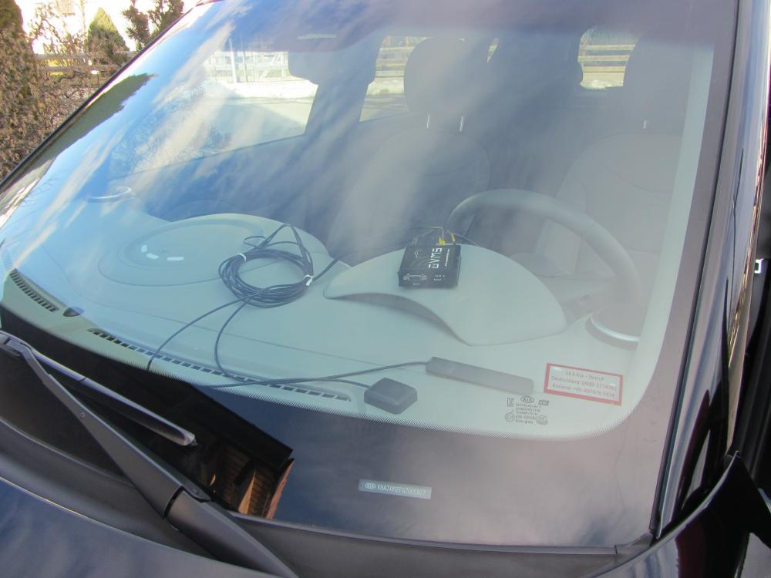Picture 1: First "installation" in your Soul EV
For the first setup, just connect all cables and lay down the module and the antennas on your Soul EV car dashboard like shown in the picture. Then connect the ODB-II data cable with the car.

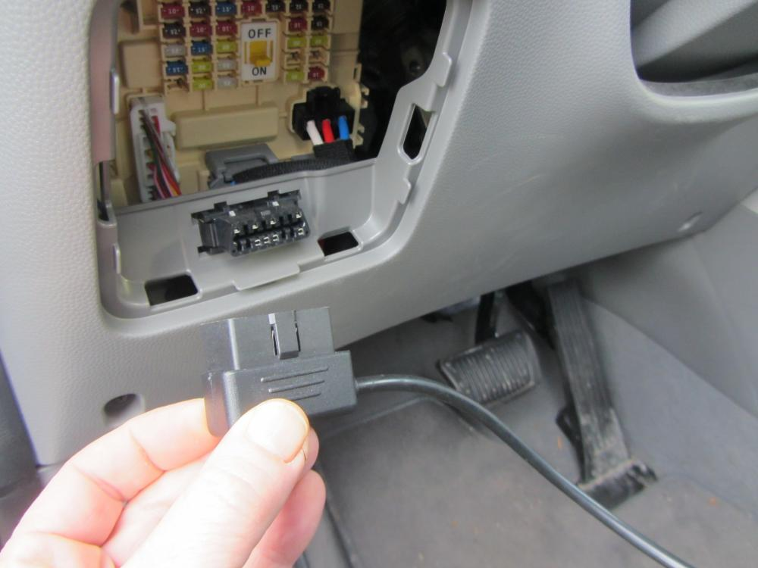Picture 2: Connect ODB-II data cable
The cable can't be connected wrong, just check the connetor form, before plugging in. The module will start immediately and need 1-2 minutes to be active, so wait a little. There are 2 things to know:
- Soul EV only delivers actual data when charging, or while driving
- The module must have it's basic configuration, before being able to send you information from the car.

Configuration
Registration and configuration of the Soul OVMS is basically the same as for the Tesla Roadster or Twizzy, except the vehicle type needs to be "KS" (for "Kia Soul“). To make it easier for you, here are the first steps taken from the Tesla Roadster configuration guide.

Register your cell phone with the OVMS Module
By registering a cell phone with OVMS, that phone can then send commands to the OVMS module without needing to supply the OVMS Module Password. For security purposes, to send commands from other cell phones (or any SMS send-capable device/website), you’ll need to supply the OVMS Module Password.
For your convenience, we recommend creating an Address Book entry in your cell phone for your car using the phone number of the SIM card you installed. Give it a descriptive name. To register your cell phone with OVMS, send the following text message to the car, exactly as follows:
REGISTER OVMS

Note that “OVMS” is the default OVMS Module Password, and that the “REGISTER”
command must be all uppercase. If all is well, within a few seconds OVMS will send you a text message back with:
Your phone has been registered as the owner.
At this point, the telephone number of your phone has been registered and stored
by the OVMS module. You don't need the OVMS module password to talk to the car from
this cell phone, as the car will use CallerID to recognize it.

Change the OVMS Module Password
You should now change the default OVMS Module Password to one of your own choosing. Choose a password between 4 and 22 characters in length, with no spaces. The OVMS Module Password is case-sensitive. To set it, send a Text Message to the car from the registered cell phone, as follows:
PASS MYNEWPASSWORD

(obviously replace MYNEWPASSWORD with the secret password of your choice). If all is well, within a few seconds the car will reply back with:
Module password has been changed.
At this point, you have text message monitoring of the car! One useful query you can send to the car is:
STAT ?

This will result in OVMS sending you a text message back with Charge Mode, Charge Status and SOC (Battery State of Charge), for instance:
Not charging
SOC: 96%

Another query you can send is:
GPS ?

This will result in OVMS sending you back a text message containing a Google Maps link that will show you the location of the car. Note that queries end with a question mark – that is your assurance that the SMS will not change any settings in the OVMS Module. If you want to send queries (and some commands) from a different cell phone than the registered phone, simply add the OVMS Module Password as the last parameter, for instance:
STAT? MYNEWPASSWORD
GPS? MYNEWPASSWORD

If you forget your OVMS Module Password and have lost this document, you can query it
from the registered cell phone by sending the following query:
PASS ?

After a few seconds, you should get a response back telling you the Module password. See Appendix A of the Tesla Roadster configuration guide for a complete list of SMS commands.

Set the OVMS Module in Kia Soul mode
After "REGISTER" and "PASS", you should then send the "MODULE" command (just 1 blank between the several parameters!) , for example:
This will activate the Soul specific vehicle data processing and command extensions. "your-car-id" is for how you want to name your car. K is for metric distances (km) and SMSIP activates SMS and GPS communication. KS stands for KIA Soul. After some seconds OVMS will reply with somethings similar to this:
MODULE <your-car-id> K SMSIP KS
Module
VehicleID: YOUR-CAR-ID
Units:K
Notifications:SMSIP
VehicleType:KS

The module should now respond to the "VERSION" command like this:
OVMS Firmware version:2.8.1/KS0.44/V2
This is the framework version, the vehicle type + version and the hardware version. If you haven't done already, switch the Soul on, so the module can read the diagnostic data from the CAN bus.
Now, send a "STAT?" SMS to the module. It should reply with the Soul specific status message looking like this:
Not charging
SOC: 100%
Ideal Range: 116km
Est. Range: 116km
ODO: 5,029.5km

If you do not want to use the smartphone app, this is all you have to do up to this point. Have a look at the SMS commands to query information from your vehicle. If you want to use smartphone app, you have to configure GPRS and SERVER to be able to transmit information from the module to the server and your app.

Configure the GPRS Data Connection (Needed for smartphone App usage)
If you don’t want to use a smartphone App to control the car, you can skip these steps , and proceed to configure Car Control.
GPRS configuration has to be done before defining SERVER configuration.
Warning!
You should only enable GPRS data mode after you have registered your vehicle on an OVMS server (see Pre-Installation Step D). Once enabled, you should ensure that the module correctly connects to the server. Do not leave GPRS enabled without a correct server registration, or high data charges may result from the module's repeated failed attempts to connect to the server.
The best way to prevent high data charges is to set the GPRS-switch of the OVMS module to OFF (towards the outside).Then configure GPRS and SERVER and move it into the GPRS ON position (to the inner of the module board). Yes, you have to open and close the module two times…..
Configuring of the GPRS Data Connection is done via the GPRS Text Message command. This can be sent only from the registered cellphone. There are 3 parameters to be set, all of them you should have gotten from your cellular provider. Asking Google like „APN PROVIDER_NAME“ will give you most of the information needed.

Cellular Network APN
For 1und1 in Germany (D-Netz) the APN is web.vodafone.de.
Cellular Network Username
For 1und1 in Germany you can leave this field blank, which is done via a dash “-“.
Cellular Network Password
For 1und1 in Germany you can leave this field blank, which is done via a dash “-“.

An example of a proper GPRS command (this one is specifically for 1und1 in Germany) is:
If all is well, within a few seconds the car (better: the module) will reply you back with:
GPRS web.vodafone.de - -
GPRS:
web.vodafone.de
User:
Password:
DNS:
GSM: no name
GPRS: DISABLED

If you want to confirm what your GPRS settings are, send the following query:
It should show you a reply similar to the response after setting up.
GPRS?
Now the command SERVER has to be sent to the module by SMS. This can be sent only from the registered cellphone. There are 3 parameters to be set, as follows:
OVMS Server IP address
This is the IP address of the OVMS server you want to use. Please obtain the IP-Adress from the website of the OVMS server you've choosen. For example dexter's server IP is 188.138.75.229.
If you wish you can use another server, in which case you’ll need to contact info@openvehicles.com for information on how to configure your own server. Note that you will need to tell your smartphone App to use the same server you specify here.
OVMS Server Password
Paranoid mode:
a. “P” will enable this mode
b. “-“ will disable this mode
When enabled, the server is unable to decode the messages being relayed between the OVMS Module and your smart phone App. An example of a proper SERVER command is:
If all is well, within a few seconds the OVMS Module will reply with:
SERVER 188.138.75.229 MyOVMSServerPassword -
Server:
IP:188.138.75.229
Password:MyOVMSServerPassword
Paranoid:-
You may display or check the same information by sending the following SMS to the module:
SERVER ?
After these two setup-steps unplug the module from your Soul, open it and set the GPRS-Switch to the ON position (to the inner of the board). Then close the module, reconnect the antennas and the connection to your Soul EV and wait some minutes for the module to get ready.
Important: the Kia Soul EV delivers data to the module only, when in charging mode, or driving. So for the first test, start your Soul EV to enable the module to gathering data.
If everything worked fine, only the green LED should blink once a second on the OVMS module. On the OVMS server you're using you should now see the first data coming in, position of the car etc.

Car installation of the OVMS Module and antennas
The OBD-II port (diagnostic port) is located at the bottom of the left front, as already shown. Antenna position should be best at the left and right top front screen of the Soul EV. Cables can be put under the plastic body cover left without opening a lot of screws. You may want to leave some space between the GSM and GPS antenna (left and right off the rear mirror), as the GSM antenna can emit short high power bursts.
First remove the driver's door seal. Then remove the left cover of the a-pillar. Additionally, remove the cover left of the steering wheel, by using a screw-driver:

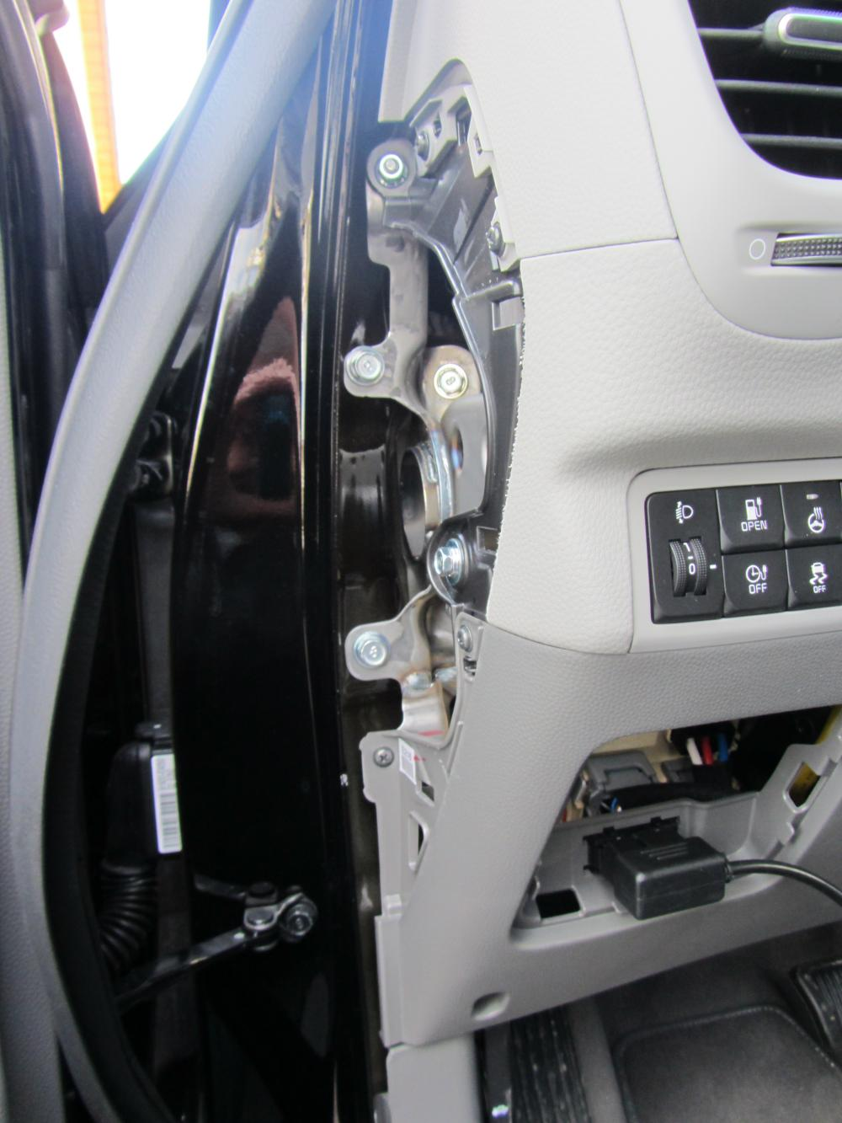Picture 4: Open left cover
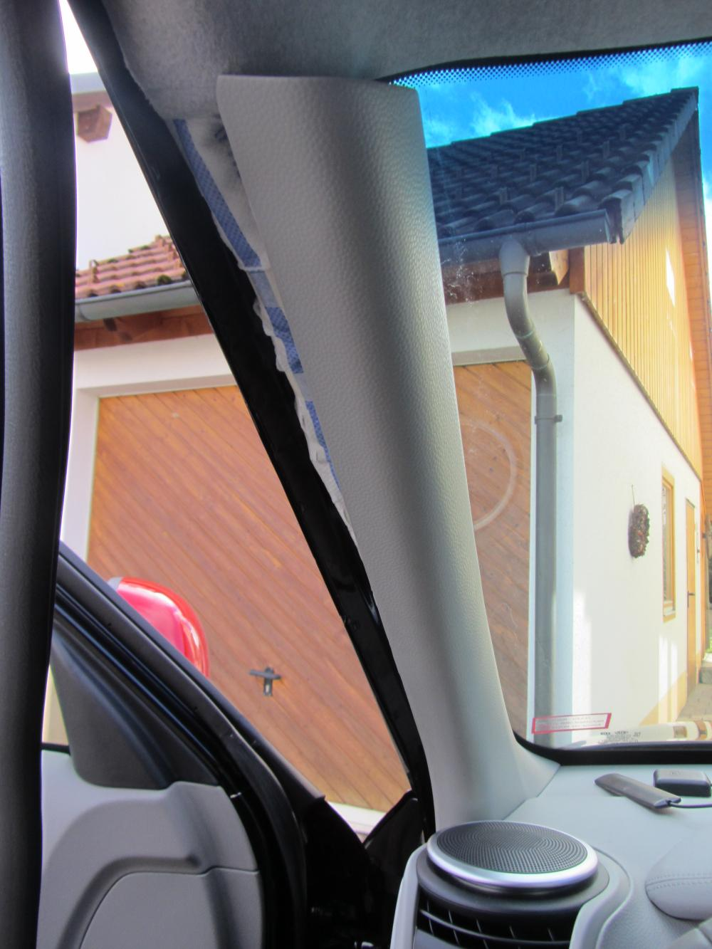Picture 3: left cover of the a-pillar

Now open the cover beneath the steering wheel, by removing the two screws (one left, one right).

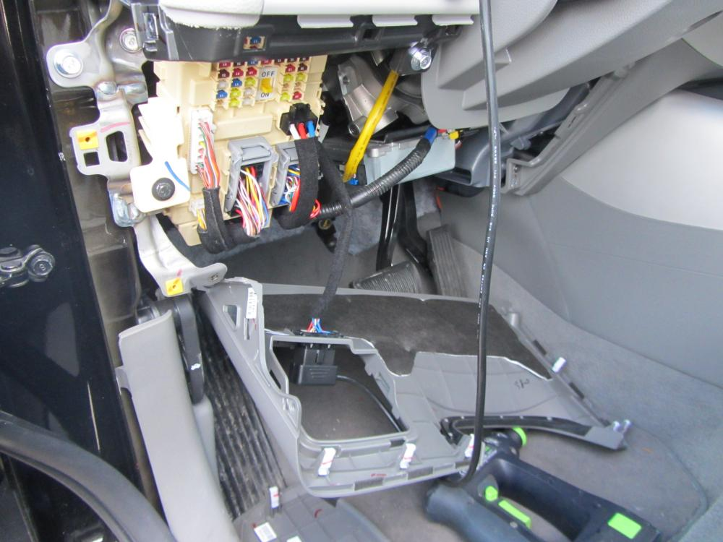Picture 5: All covers open

The ODB-II connector of the Soul EV is just clicked into the cover. Click it out, be therewill be not enough space when the ODB-II connector of the module is plugged into the service- ODB-II connector.

Now it's time to install the antennas. The headliner of the Soul EV can be easily pulled down a little, to put the cables under it. If you put the GSM antenna on the right and the GPS antenna on the left of the front screen, there will be not enough space between them to prevent interferences.
Before placing the cables under the roof, don't forget to mark the cables at the end with the plugs! The plugs look nearly the same, so don't mix them up! A bit rubber tape at the end will be enough to identify the antenna cables.

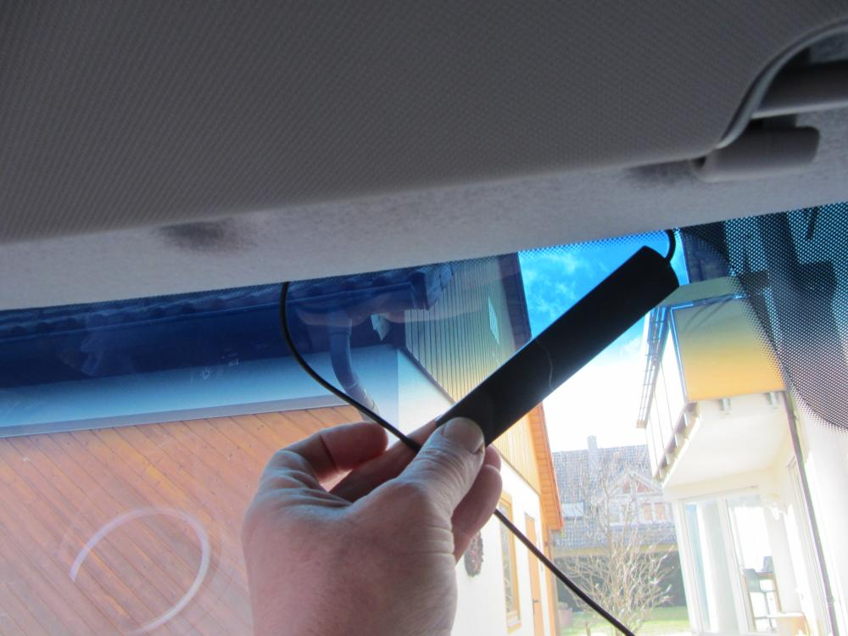Picture 6: Place the antenna cable under the headliner

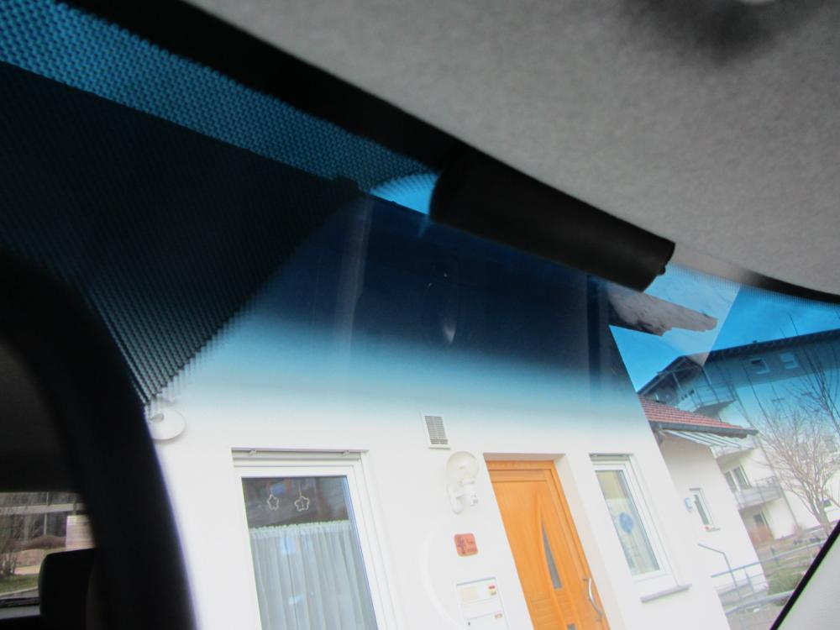Picture 7: GSM antenna

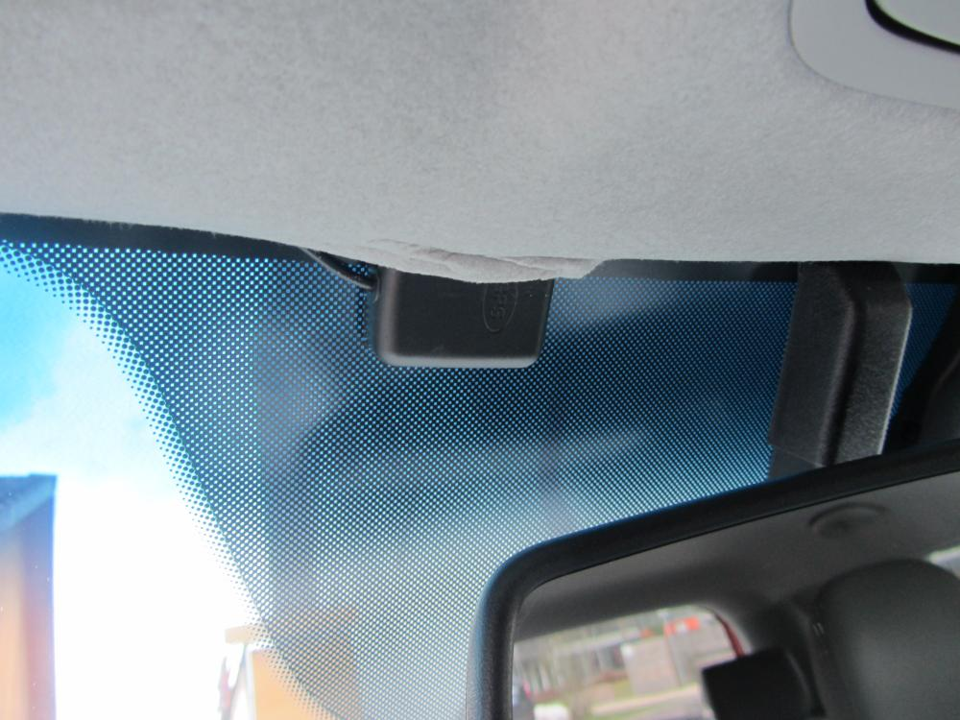Picture 8: GPS antenna to the left of the rear view mirror

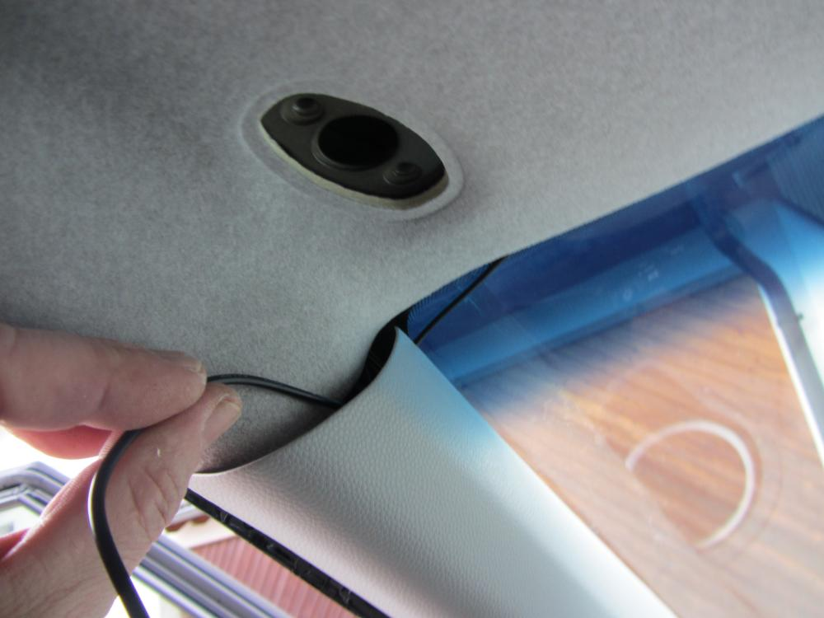Picture 9: cable wiring
Now hide the cables under the headliner and the left cover of the a-pillar.
A credit-card is useful to push the cables under the headliner.
When finished the cables are invisible.
As you close the cover lay, the cables to the left side of the a-pillar.

The steel plate with the two holes is a good place to fix the module. Connect first the two antennas, and navigate the module through the hole over the steel plate.
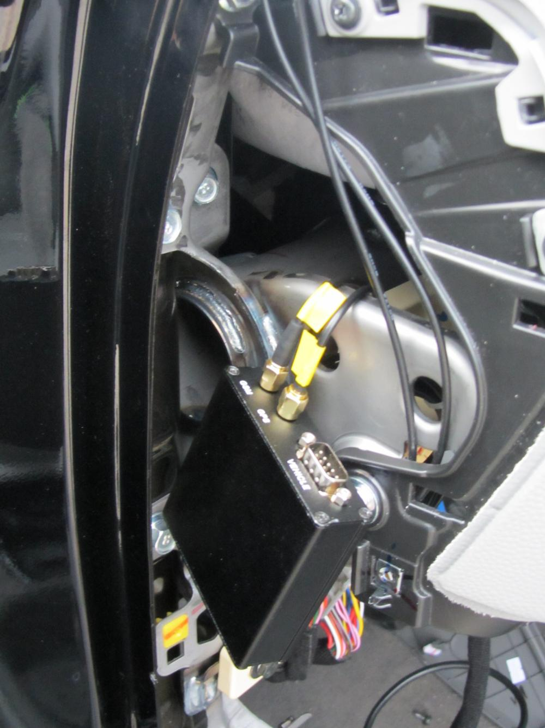Picture 10: connect antennas with the OVMS module
The OBD cable should be connected, when the module is in the inside position.
After having connected the last cable, a zip tie is an easy way to fix the module in that position.

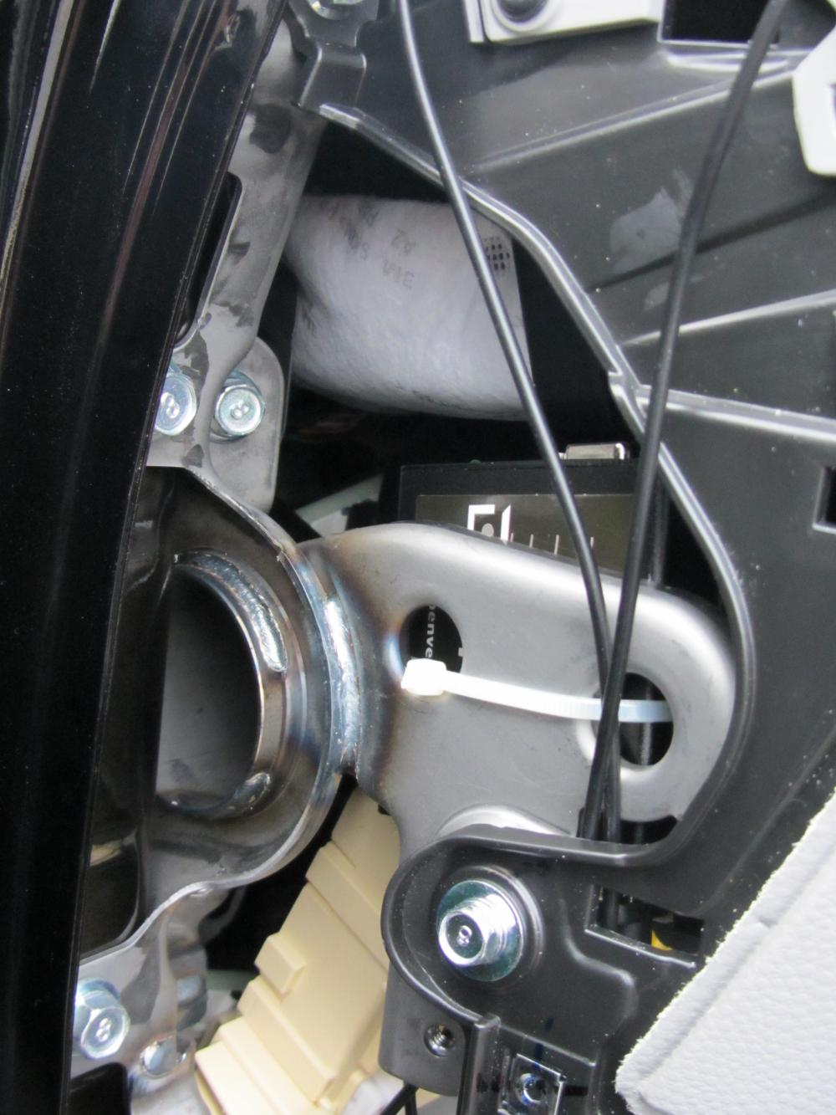Picture 11: the fixed module

The antenna and the OBD socket should be facing in the direction of the floor.
Now connect the OBD cable to the unclipped OBD-II port of the Soul EV.
Now close all covers. The OBD-II port and the plug should lay outside the servicecove. An additional zip-tie could be used to fix the datacables in a stable position.

Before closing the last cover (service cover), move the ODB connectionb to a save position and check that no pins of the ODB-II socket are open or uninsolated.
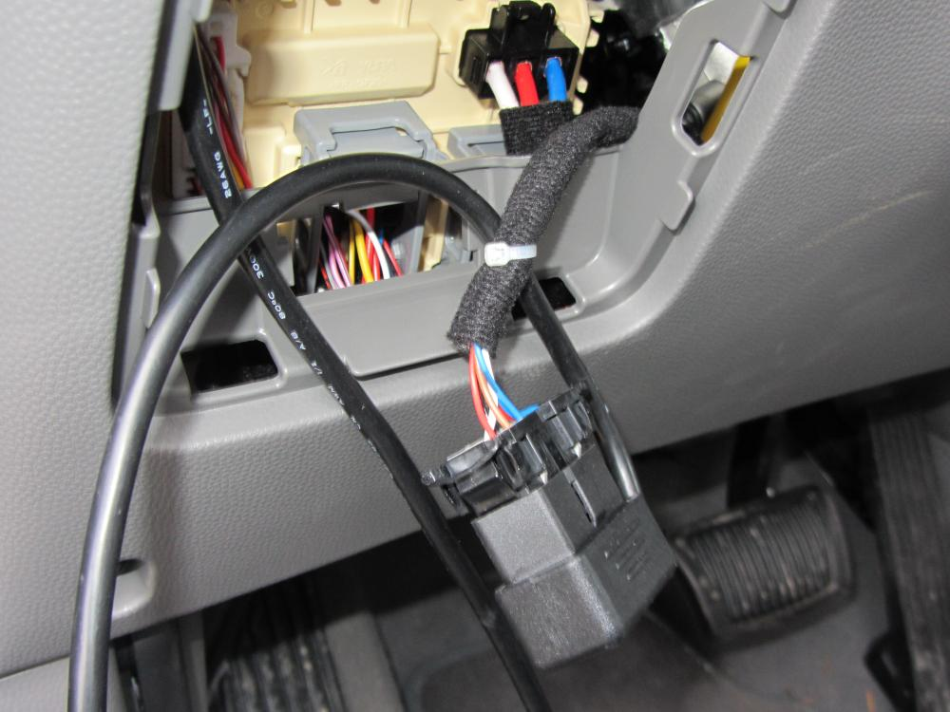Picture 12: Last steps

Thanks to...
- the whole OVMS team for developing the OVMS platform
- goev_no05 from Mandal, Vest-Agder, Norway for developing the module-software
- Michael Balzer from http://www.dexters-web.de/ for his support and OVMS server
- everyone at the german going-electric forum http://www.goingelectric.de/ who participated in decoding the CAN messages and shared feature ideas
- Ann S. and Tom Z. for checking the english version of this document

Contact / Feature requests / Firmware downloads
If you need help, want to give some feedback, find bugs, have an idea on improving or miss some feature, you can contact me (Jörg Lesniak) on the http://www.goingelectric.de/ forum. Just look for member Nukem36.
If you want to take part in the development in any way, please subscribe to the OVMS developers mailing list:
http://lists.teslaclub.hk/mailman/listinfo/ovmsdev

Remember, this is a community project, any help is appreciated :-)
Thank you!

