OVMS
Open Vehicle Monitoring System



www.openvehicles.com

Tesla Roadster
Guide v1.0 (10th January 2012)

Welcome

The OVMS team is a group of enthusiasts who want an interface to be able to talk to our cars remotely, perhaps add on-car displays (such as heads-up speed), and we want to have fun doing it.

The Open Vehicle Monitoring System is three things:

- A low-cost module that fits in the car. It is powered by the car, talks to the car on the CAN bus, and uses the GSM cellular network to talk to its user.

- A server. The car module can be configured to either talk to the server (via UDP/IP or TCP/IP over the Internet) or the user directly (via SMS).

- A cellphone App. This talks to the server (via TCP/IP HTTP protocol) to retrieve messages from the car and issue instructions.

Part [1] is all that is required. You can use a cellphone and SMS messages to talk to the App. It requires a SMS messaging plan on the SIM card in the GSM modem in the car.

Parts [2] and [3] provide a much more seamless and powerful experience, but are optional. They requires a small data plan on the SIM card in the GSM modem in the car.

Even if you choose [2]+[3], you can still use [1] as well (for initial setup as well as ongoing on-demand).

The Car Module

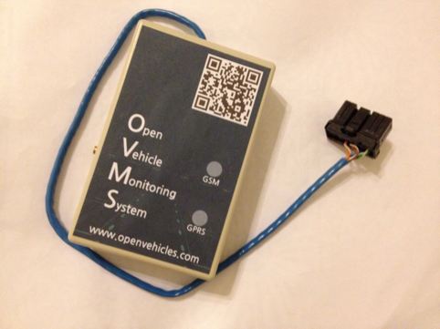

The car module contains a low-power micro-controller control board and a GSM cellular modem. It plugs into the car's diagnostics port (from where it receives power and listens to the car's internal communications), and provides monitoring and control functions via either SMS messages or smartphone apps (over the Internet).

Cellular Service and the SIM

Prior to installation in the car, you will need to install a pre-activated SIM in the OVMS module, so that the module can use the GSM cellular network. You need a full-sized SIM, and can use whichever is most suitable for your location and services required.

If you only wish to use SMS message control, then you only need an SMS messaging plan. If you wish to use smartphone Apps to control the car, then you will need a GPRS data plan as well as a small SMS messaging plan (for initial setup). We estimate that you will only need around 2MB a month for data usage (but maybe more if you enable the optional location streaming feature if use the smartphone apps more than normal).

You will need to pre-activate the SIM (usually by placing it in a normal cellular telephone and going through whatever steps your cellular provider requires to activate the service).

You will need to write-down the telephone number that the cellular provider has allocated to the SIM, and if you are using GPRS data you will also need the provider's APN, username and password for GPRS service.

Once active, you need to open the OVMS module box using the four screws on the underside. Once open, the box will look something like the following:

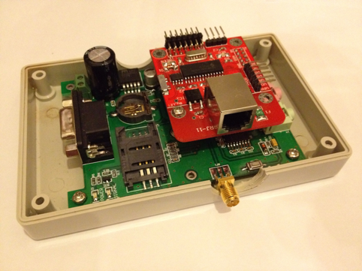

You can see the SIM card slot. in the lower right corner of the modem (bottom) board. Slide the plastic cover to open, put your SIM card in the phone, then slide back to secure it in place.

You can then close the OVMS box and securely tighten the four screws. Please take care not to over-tighten these screws, as can be easy to break the plastic of the box. We recommend that you loosen/tighten these screws manually, and don't use an electric screwdriver for this.

Installation

Now that the OVMS module has the SIM card in place, it is ready to install in the car. This step should take you less than fifteen minutes, and you will need a set of screwdrivers.

The module is going to be placed in the passenger footwell of the car, against the front wall, secured in place with the adhesive velcro tape provided. Find a place close to the DIAG port connector shown in the picture below.

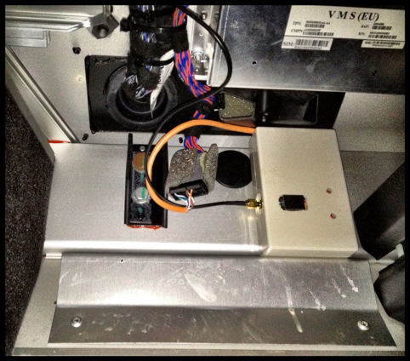

Placement is simple:

- Ensure both velcro strips are fixed together.
- Remove the adhesive backing from one side, and securely fasten it to the back of the OVMS module.
- Using a clean dry cloth, clean the area of the car passenger footwell that you are going to attach it to.
- Remove the adhesive backing from the side of the velcro strip facing the car, and then firmly push the OVMS module into place - holding it still for a few seconds to allow the adhesive to work.
- You can then remove the OVMS module, as you require, as the velcro will allow it to be easily added/removed.

Before plugging it in for the first time, you need to install the antenna.

The OVMS module comes with an adhesive-backed GSM antenna designed to provide excellent cellular service. You should find the performance of this antenna fantastic - and much better than even your cellphone, but proper placement is essential.

Areas your could place it include the bottom of the windscreen on the passenger side, the top of the windscreen on the passenger side (hidden by the sun visor), behind the passenger on the side pillar, or under the dashboard (for the brave and experienced at dismantling Tesla Roadster dashboards). You can place this wherever you want, but please ensure it is high-up on the car and away from any metal objects that might interfere with the signal.

For this example, we're going to choose the bottom of the windscreen on the passenger side, in a Right-Hand-Drive car (passenger on the left), as follows:

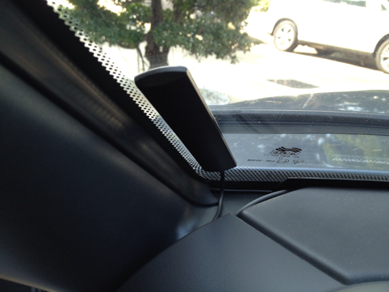

To route the antenna cable, you will need to remove the fuse-box cover (one screw that needs to be turned 90degrees - marked with the top red arrow in the picture below), then two screws from the box below the fuse box (these screws should be completely removed in order to be able to remove the box and access the compartment beneath). You do not need to adjust anything in the fuse box - you only need the cover removed to make it easier to route the cable.

Start with the cable at the windscreen and route it down the side of the passenger door front pillar. The plastic corner marked with the green arrow in the picture below can be pulled back slightly, and you can push the cable through into the open bottom compartment. Pull the cable through there so that the antenna is where you want it and there is no loose cable outside the box. The antenna itself can be mounted to the windscreen by first cleaning the area with a clean dry cloth, removing the adhesive backing tape, then firmly pushing the antenna against the glass and waiting a few seconds for the adhesive to stick.

Now for the tricky bit. You need to get the cable through to the passenger footwell, but it is tight. It is much easier to get a guide wire up into the fuse box compartment than to get the antenna cable down into the passenger footwell. So, we recommend you use a small (12inches / 30cm or so) piece of stiff wire to use as a guide and push it up from the area marked by the green arrow on the bottom right of the picture below. Once the guide wire is in the fuse box, push it down into the lower compartment you opened and wrap it around the antenna cable. You can then pull the guide wire back down into the passenger footwell, bringing the antenna cable with it.

The antenna cable can then be screwed in to the OVMS module. You can then tidy up any loose cable, and screw-back the lower compartment box (two screws) and fuse box cover (one screw 90degrees to lock).

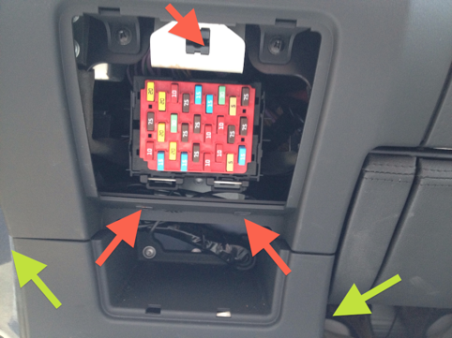

Plugging in to the car

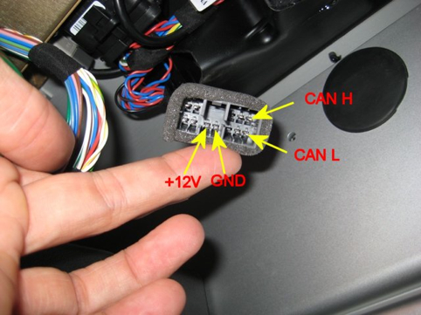

Ensure the car is turned off, then plug the short OVMS module cable into the car DIAG port. You should immediately see the RED light on the OVMS module turn on.

At this point, check the car. Tap on the VDS in the centre console and make sure it turns on. Turn on the car and make sure everything works as expected.

If you see any problems at all with the car, disconnect the OVMS module and contact openvehicles.com for assistance. The module has been designed to have no impact on the vehicle, and you should not operate the vehicle if you see any problems or notice any interference at all.

The module is powered by the car 24x7, but uses very little power (especially compared to the Tesla Roadster's 53KWh battery pack).

Lights

The OVMS module has two lights: one RED and one GREEN.

The following are the light combinations you may see:

- GREEN light off, RED light slow blinking alternately on and off roughly once a second:

The system is trying to reset the GSM connection. It has previously lost GSM connectivity, so is now waiting for the modem to stabilise before trying to establish a connection to the network carrier again. This combination should persist for 30 seconds.

- GREEN light and RED light slow alternatively blinking roughly once a second:

The system is trying to establish a GSM connection with the carrier. This combination should persist for at most 240 seconds (and usually much less unless there is a GSM connectivity issue).

- RED light fully on, and GREEN light off:

The system is having problems communicating with the modem and is performing a hard reset. This combination should persist for at most 10 seconds.

- RED light completely off (never on) and GREEN light off:

The system has lost GSM connectivity and is waiting for it to come back. This combination should persist for at most 120 seconds.

- RED light completely off (never on) and GREEN light on:

The GSM network is up. The GPRS link has not been (or is being) established. This is the ideal state if you have not configured GPRS but want just GSM (SMS) control.

- RED light short rapid blinks, and GREEN light solid on:

Both the GSM and GPRS networks are up and connected ok. This is the ideal state if you have configured GPRS.

You may see it take up to a minute or two to reach the steady state, when you first connect the module to the car.

For a new installation, you would not expect GPRS to be established, so should wait for a RED light completely off (never on) and GREEN light on. This indicates that the GSM network is up and SMS control is possible.

Register Your Phone

Using your main cellular telephone, create an address book entry for your car OVMS module. Then, send an SMS to the car, as follows:

REGISTER OVMS

(note that OVMS is the default car password)

If all is well, within a few seconds the car will SMS you back with:

Your phone has been registered as the owner.

At this point, the telephone number of your phone has been registered and remembered by the car module. You don't need the password to SMS the car any more, as the car will use callerid to recognise you.

Change the Default Password

Using the cellular telephone that you registered to the car in the last step, you should now change the default OVMS password in the car. This password is known as the "user password".

Send an SMS to the car, as follows:

PASS MYNEWPASSWORD

(obviously replacing MYNEWPASSWORD with the secret password of your choice)

We recommend you keep it between 4 and 22 characters, and upper-case only.

If all is well, within a few seconds the car will SMS you back with:

Your password has been changed.

At this point, you have SMS control of the car. You only need to proceed with GPRS network setup if you want to use a cellphone App to control the car.

Optional: Define the OVMS Network Connection

Usin the cellular telephone that you registered to the car in the previous steps, you need to set the GPRS and OVMS parameters in the car. You do this by sending an SMS to the car:

PARAMS K SMS,IP 64.111.70.40 imobile.three.com.hk - - DEMO NETPASS -

If all is well, within a few seconds the car will SMS you back with:

System parameters have been set.

The parameters are listed one-by-one, seperated by spaces, after the PARAMS command. Let's go through them:

- "K". This is used to specify "K" for Kilometers or "M" for miles, and is used to tell the car what you prefer to work in.

- "SMS,IP". This is a comma-seperated list of notification mechanisms you want the car to use. "SMS" would be just SMS to registed phone, "IP" would be just PUSH notifications to your cellular App via the OVMS server, and "SMS,IP" would be both.

- "64.111.70.40". This is the IP address of the OVMS server you have chosen to use. This example is the public tmc.openvehicles.com server, and you can use this or any other you choose.

- "imobile.three.com.hk","-","-". This is the APN, username and password for the cellular network. Use "-" if any field is empty. You will need to check with your cellular provider to find the correct values for this, and please double-check. Problems here are the single biggest cause of issues.

- "DEMO". This is the unique vehicleid that identifies your vehicle to the OVMS server.

- "NETPASS". This is the network password for your vehicle. It should be different than the user password, and we recommend you use between 4 and 22 characters.

- "-". The last parameter controls paranoid mode. In this mode, the messages between the apps and the cars and further encrypted using the shared user password (which the server is not privy to). Setting this to "PARANOID" will enable this mode and will mean that the server will merely relay the messages and will be unable to decode and of the messages (such as battery status, location, etc).

You will also need to ensure that your car vehicleid and network password are pre-registered on the OVMS server you have chosen. For openvehicles.com, the procedure is:

- With a web browser, go to www.openvehicles.com and register for a user account on the site. You can use any username and password you want (it doesn't have to be the same as the vehicleid and network password).

- Contact the www.openvehicles.com adminstrators (info@openvehicles.com) letting them know: (i) the username you chose, (ii) your vehicleid, and (iii) your network password. The administrators will then authorise your account and create the appropriate permissions for your vehicle to use the OVMS server.

The Smartphone Apps

Smartphone Apps are available for both the iOS and Android mobile phone systems. You can find the apps in the Apple iTunes and Android Marketplace stores.

Thanks

So many people to thank. W.Petefish for sourcing the car connector, Fuzzylogic for the original hardware and software design and demonstration of it working, Scott451 for figuring out many of the Roadster CAN bus messages, and many others for showing that this kind of thing can work in the real world.

The Open Vehicles Team

