Currently APIs
We have 3 namespace for APIs

- /influxdb: route the traffic to influxdb instance
  - /influxdb/query
- /ml: route the traffic to ml instance
  - /ml?appname=acme-air
- /api: route traffic to api engine instance
  - /api/autoshift-config/
  - /api/docker-compose/count?appname=acme-air
  - /api/docker-compose/up
  - /api/docker-compose/rm
  - /api/jmeter-load

APIs needed for Demo 3
Proposed Basic API Structure

Version Number for API
Get Autoshift Status (Best Recommendation)

API Format:

{"status":200,"message":"message from server","response":{}}

Status = HTTP status code
http://www.restapitutorial.com/httpstatuscodes.html

Login

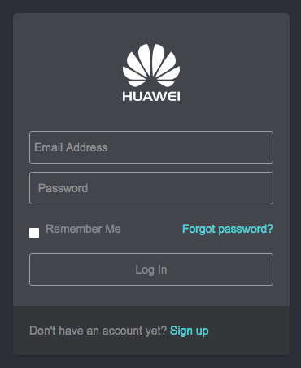 | GET /api/login/  RETURN  Not Login  {"status":401,"message":"Not Login","response":{}}

Home / Applications

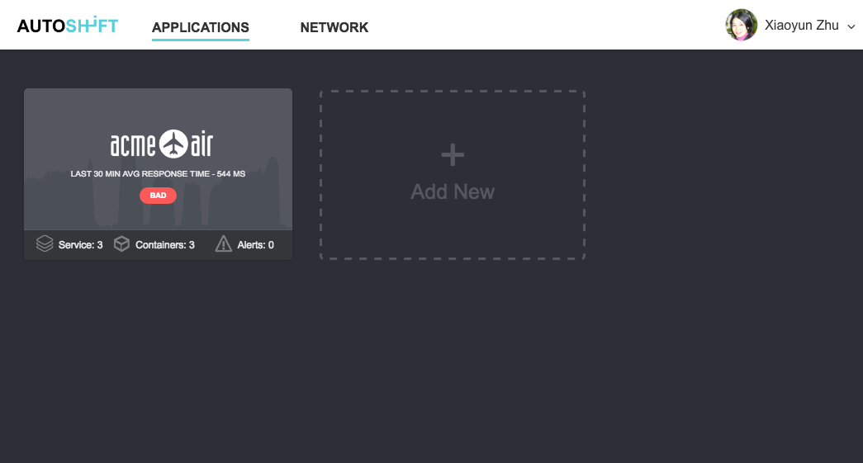 | GET /api/login/  RETURN (response portion)  Logged In - Render the list of application right away  {  "id": 42,  "first_name": "Daniel",  "last_name": "Chen",  "email": "daniel.chen@huawei.com",  "applications": [  {  "id": 3,  "name": "acme-air",  "status_id": 3,  "service_count": 3,  "container_count": 6,  "alert_count" 0,  "logo": "themes/autoshift/images/logos/acme-air.png"  }  ]  }

Delete Application

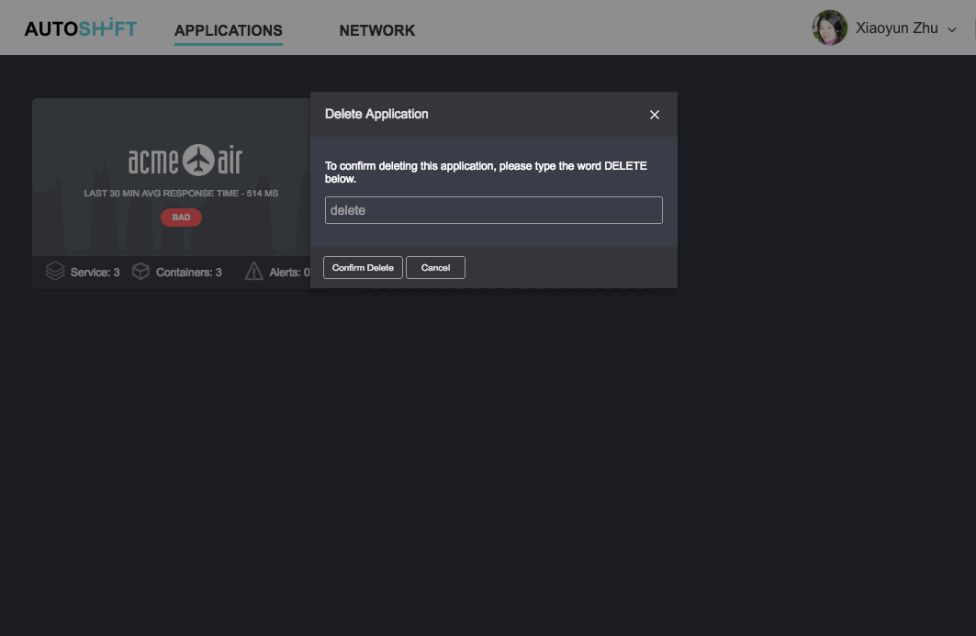 | DELETE /api/app/  PAYLOAD  {“id”: 3}  RETURN  {"status":200,"message":"","response":{}}

Upload Temp File

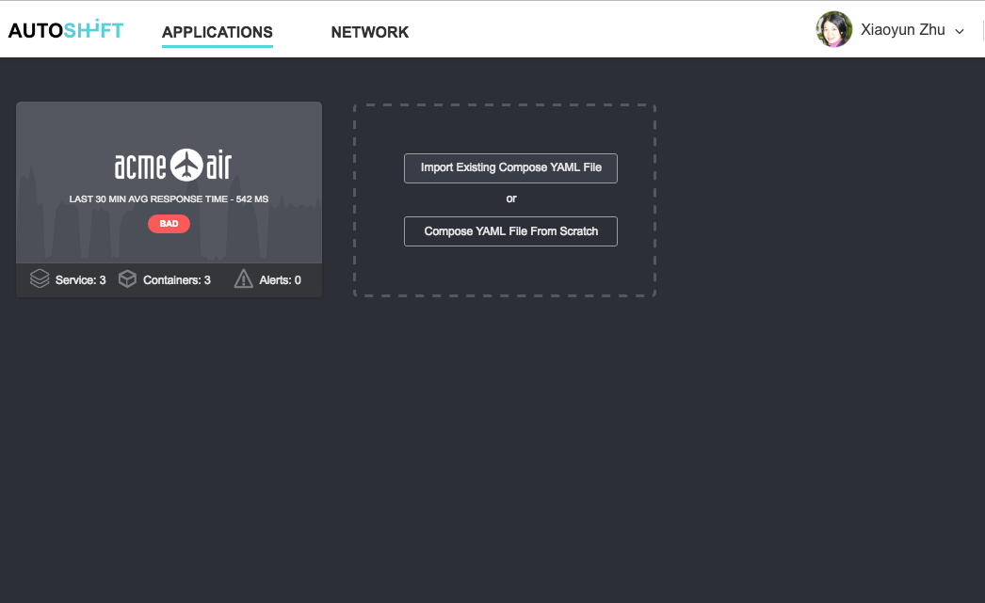 | POST /api/upload/  *Standard file upload  RETURN  {"status":200,"message":"","response":{“uri”:”/tmp/file/path”}}

Create Application Using Uploaded Compose File

POST /api/app/

PAYLOAD

{“name”: “Acme Air”, “compose-file”: “/tmp/file/path”}

RETURN

{"status":200,"message":"","response":{“id”:43}}

Application Detail

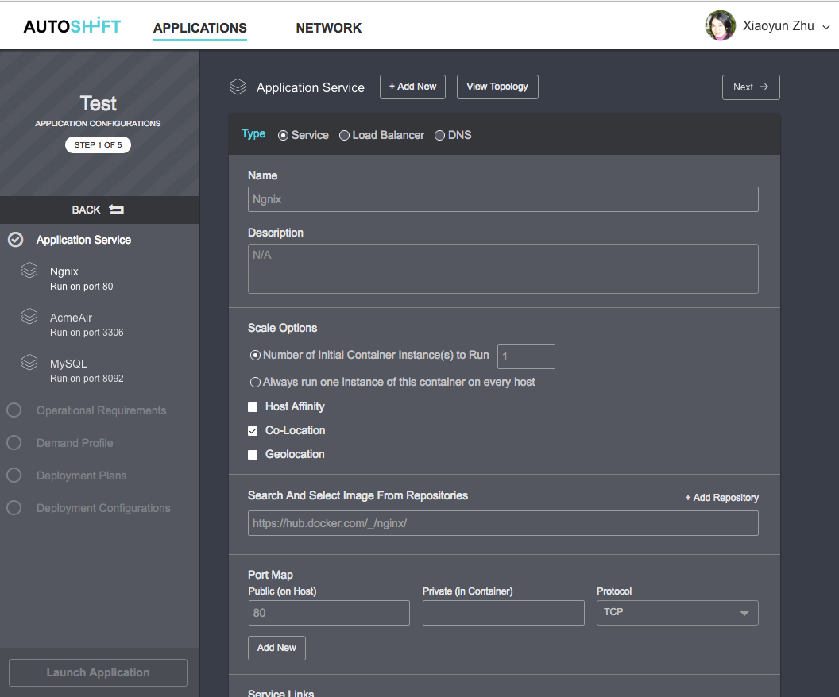 | GET /api/app/43  RETURN (response portion)  {  "id": 43,  "name": "Acme Air",  "status_id": 1,  "compose_file": {  "web": {  "build": "web",  "command": "python app.py",  "ports": [  "5000:5000"  ],  "volumes": [  "web:/code"  ],  "links": [  "redis"  ]  },  "redis": {  "image": "redis"  },  "datadog": {  "build": "datadog",  "links": [  "redis"  ],  "environment": [  "API_KEY=__your_datadog_api_key_here__"  ],  "volumes": [  "/var/run/docker.sock:/var/run/docker.sock",  "/proc/mounts:/host/proc/mounts:ro",  "/sys/fs/cgroup:/host/sys/fs/cgroup:ro"  ]  }  },  "sla_params": {},  "jmeter": []  }

Application Deployment - List of Demand Profiles

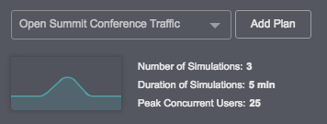 | GET /api/app/43/jmeters  RETURN (response portion)  [  {  "id": 36,  "type": 3,  "name": "Summer Conference",  "load_duration": 3600,  "start_users": 10,  "peak_users": 2000  }  ]

Application Deployment Plans

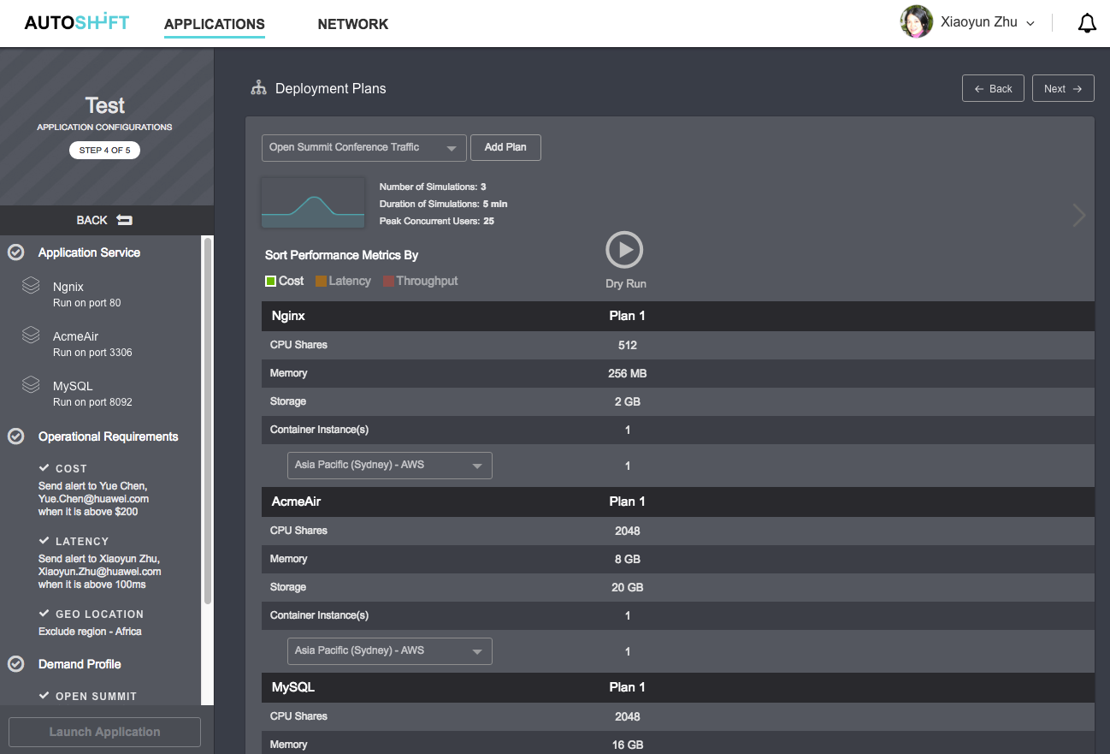 | GET /api/app/43/plan?jmeter=36  RETURN (response portion)  [  {  "id": 264,  "name": "Plan 1",  "dry_run_id": 543,  "status_id": 1,  "autoplanning": false,  "created": 1470861608,  "services": [  {  "name": "Ngnix",  "cpu_shares": 2048,  "memory": 512,  "storage": "1T",  "instances": [  {  "location": "path/to/target",  "scale": 2  }  ]  },  {  "name": "MySQL",  "cpu_shares": 2048,  "memory": 512,  "storage": "1T",  "instances": [  {  "location": "path/to/target",  "scale": 1  }  ]  }  ],  "results": {  "latency": 24,  "cost": 7800,  "throughput": 178,  "error_rate": 0.2,  }  }  ]

Application Deployment Plans - Add Plan (autoplanning always = false when clone)

POST /api/app/43/plan

PAYLOAD

{"jmeter": 36, “clone_plan”: 264, “name”: “Plan 2”}

RETURN (response portion)

[
{
"id": 265,
"name": "Plan 2",
"dry_run_id": null,
"status_id": 1,
"autoplanning": false,
"created": 1470861608,
"services": [
{
"id": 23,
"name": "Ngnix",
"cpu_shares": 2048,
"memory": 512,
"storage": "1T",
"instances": [
{
"location": "path/to/target",
"scale": 2
}
]
},
{
"id": 26,
"name": "MySQL",
"cpu_shares": 2048,
"memory": 512,
"storage": "1T",
"instances": [
{
"location": "path/to/target",
"scale": 1
}
]
}
],
"results": {}
}
]

Application Deployment Plans - Delete Plan

DELETE /api/app/43/plan/264

RETURN

{"status":200,"message":"","response":{}}

Application Deployment Plans - Edit Plan (One attribute at a time)

PUT /api/app/43/plan/264/service/35

PAYLOAD

{"cpu_shares": 1024}

RETURN

{"status":200,"message":"","response":{}}

Application Dry Run - Run (autoplanning attribute in plan = autoshift)

POST /api/app/43/dryrun

PAYLOAD

{"jmeter": 36, “plan”: 264}

RETURN

{"status":200,"message":"","response":{“id”:436}}

Application Dry Run - Stop

DELETE /api/app/43/dryrun/264

RETURN

{"status":200,"message":"","response":{}}

Launch Application
 | POST /api/app/43/  PAYLOAD  {"plan_id": 65}  RETURN  {"status":200,"message":"","response":{“id”:43}}

Application Dashboard (type: user, system, anomaly, relevancy)

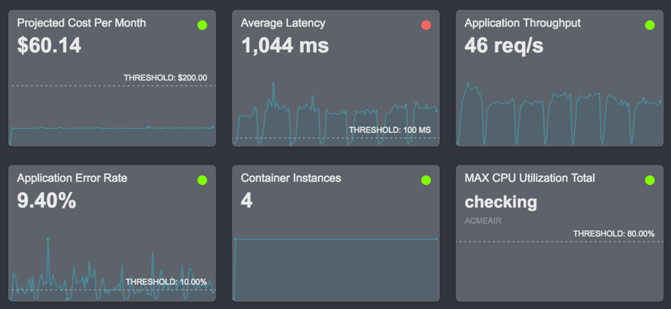 | GET /api/app/43/metrics?type=system  RETURN (response portion)  [  {  "value_type": "cost",  "threshold_value": 200,  "select": "value",  "from": "PriceFiltered",  "where": "application=test",  "label": "Projected Cost Per Month",  "scale_factor": 1,  "subtitle": "",  "id": "value_PriceFiltered_test",  "db": "api"  },  {  "value_type": "ms",  "threshold_value": 100,  "select": "value",  "from": "NginxLatencyFiltered",  "where": "application=test",  "label": "Average Latency",  "scale_factor": 1,  "subtitle": "",  "id": "value_NginxLatencyFiltered_test",  "db": "api"  },  {  "value_type": "rps",  "threshold_value": null,  "select": "value",  "from": "NginxReqPerSecFiltered",  "where": "application=test",  "label": "Application Throughput",  "scale_factor": 1,  "subtitle": "",  "id": "value_NginxReqPerSecFiltered_test",  "db": "api"  }  ]

Application Dashboard - Relevant Metric

GET /api/app/43/metrics?type=relevancy&metric_id=value_NginxReqPerSecFiltered_test

RETURN (response portion)

[
{
"value_type": "cost",
"threshold_value": 200,
"select": "value",
"from": "PriceFiltered",
"where": "application=test",
"label": "Projected Cost Per Month",
"scale_factor": 1,
"subtitle": "",
"id": "value_PriceFiltered_test",
"db": "api"
},
{
"value_type": "ms",
"threshold_value": 100,
"select": "value",
"from": "NginxLatencyFiltered",
"where": "application=test",
"label": "Average Latency",
"scale_factor": 1,
"subtitle": "",
"id": "value_NginxLatencyFiltered_test",
"db": "api"
},
{
"value_type": "rps",
"threshold_value": null,
"select": "value",
"from": "NginxReqPerSecFiltered",
"where": "application=test",
"label": "Application Throughput",
"scale_factor": 1,
"subtitle": "",
"id": "value_NginxReqPerSecFiltered_test",
"db": "api"
}
]

