OpenVINO Tokenizers

RegexSplit Merge Correction

STATUS  Proposed |  | OWNER  Unassigned |  | LAST UPDATED  Nov 04, 2026

Authors | Not specified
Reviewers | Project maintainers
Related docs | Issue 810 and the cited research note
Scope | Unlimited RegexSplit merge modes and adjacent delimiters

1. Abstract
Correct RegexSplit merge modes so adjacent matches preserve all text and produce Hugging Face compatible pre-tokenization pieces.
The design covers unlimited splits, both merge directions and inversion. Zero-width matching and finite split limits remain separate issues.

2. Goals and Non-Goals
Goals | Non-goals
HF parity for adjacent delimiters | Change finite split limits
Preserve ordered input bytes | Change zero-width matching
Support inverted matching | Change tokenizer public APIs
Retain skipped-token flags | Guarantee parity for every tokenizer

3. Background and Problem Statement
Adjacent delimiter matches overwrite pending state or reuse a stale start offset. Consequently converted tokenizers can lose spaces or duplicate text.
Regex matching yields byte spans. A pending span pairs a delimiter with its neighboring non-delimiter in the requested direction. Every input byte appears once in output order.

4. Proposed Architecture

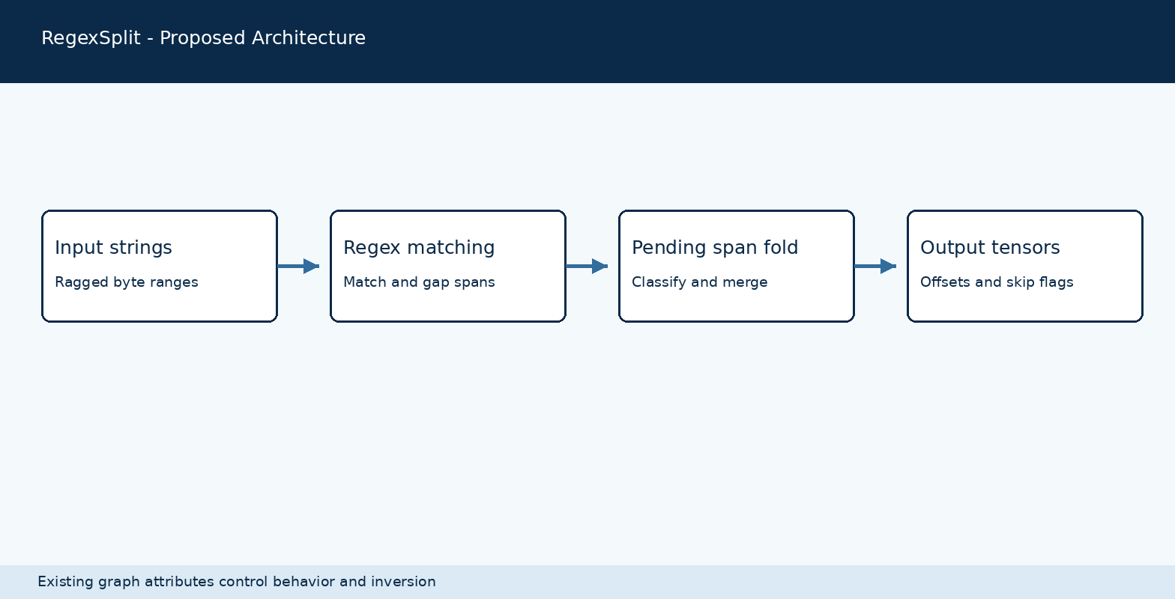
Figure 1. RegexSplit processing flow.

Core components

Component | Responsibility | Primary storage | Failure behavior
HF parser | Builds tokenizer graph | Tokenizer configuration | Existing conversion errors
Regex matcher | Produces byte spans | Compiled PCRE2 pattern | Existing match behavior
Span fold | Merges adjacent spans | Per-piece pending state | No new fallback
Ragged output | Emits offsets and skips | Output tensors | Existing allocation behavior
Tokenizer | Maps pieces to IDs | Model vocabulary | Existing tokenizer behavior

5. Request Lifecycle
- The converted graph supplies ragged string tensors and a regex pattern.
- RegexSplit validates inputs and compiles the pattern using existing behavior.
- The existing behavior and inversion attributes select span classification.
- The operator folds adjacent spans and emits byte ranges and skip flags.
- Pending state is local to each input piece; there is no durable write.
- The output ranges pass to subsequent tokenizer graph stages.
- The graph returns tokens to the caller. No telemetry is added.

6. API and Data Contracts

Primary data contract

Field | Type | Required | Description
input | ragged strings | Yes | Text encoded in input byte buffer
pattern | string | Yes | Existing PCRE2 pattern
behaviour | string | Yes | Existing split mode attribute
invert | boolean | Yes | Flips span classification
max_splits | integer | Yes | Unlimited value is -1
ranges | integer arrays | Yes | Output byte begin and end offsets
skips | boolean array | Optional | Preserve protected-token markers

Contract guarantees

- With unlimited splits and nonempty matches, emitted spans partition the input.
- Span order follows input byte order and preserves ragged row boundaries.
- The operator attributes and model format remain unchanged.
- Token IDs depend on later vocabulary and merge stages.
The existing operator interface is defined in src/regex_split.hpp.
Issue: github.com/openvinotoolkit/openvino_tokenizers/issues/810

7. Consistency, Idempotency, and Replay

Each input piece has independent temporary state. Repeated inference with the same input and model should produce the same spans. Distributed replay and durable writes do not apply.
Scenario | Expected behavior | Reasoning
Repeated input | Same output for same model | Fold state is local
Adjacent delimiters | Retain each delimiter span | Only opposing span classes merge
Inverted matches | Classify spans after inversion | Matches HF split behavior
Multiple ragged rows | Each piece starts with empty state | No cross-row span merge

8. Security and Privacy Considerations

- Authentication and tenant policies are outside this in-process operator.
- The change adds no logging or persistent storage of input text.
- Credentials and key management do not apply.
- Use synthetic strings in reproducible tests.
- Retention and deletion are controlled by the calling application.

9. Operational Readiness
Signal | SLO or alert | Owner | Launch gate
Regression suite | Compare baseline and fixed | Maintainers | Required
HF parity | Compare pieces and token IDs | Maintainers | Required
Model coverage | Record tested models | Maintainers | Recommended
Performance | No benchmark claimed | Maintainers | Follow-up
Platforms | Run project CI | Maintainers | Required
Rollout constraint: Follow normal project review and release process.

10. Alternatives Considered

Alternative | Why considered | Why not selected
Reset only | Small patch | Does not handle inverted adjacent text spans
Rewrite regex | Simple for one marker | Does not cover arbitrary patterns
Expand split limits | Addresses nearby bug | Separate compatibility question
Zero-width repair | Improves parity | Requires separate iterator semantics

11. Open Questions
- Finite max_splits behavior requires a separate design.
- Zero-width match iteration requires a separate design.
- Cross-platform and performance coverage depend on project CI.
- Maintainer review determines release timing.

12. Decision and Next Steps
Use the pending-span fold for unlimited merge modes. Validate against the baseline, HF and representative tokenizers before review and normal release.
Milestone | Deliverable | Exit criteria
M1 | Pending span implementation | Adjacent spans retained
M2 | Baseline and HF tests | No unexplained regression
M3 | Maintainer review and CI | Project checks complete
M4 | Normal project release | Release decision by maintainers

Delimiter classification follows the existing invert attribute.

