Brief description of system

Cxx integration

PalmTestSuite class derived from CxxTests::TestSuite is the main class, from where everything begins. Every method of this class is one single test, which is executed by the CxxTests framework.

A test is considered as failed by the CxxTests framework, if one of the TS_ASSERT()-s‘ expression will evaluate to false during the execution of the test. (Or any other CxxTests specific assert macro, in this code mainly TS_ASSERT() is used)

To add a new test, a new method in PalmTestSuite should be added. For CxxTest framework to be aware of the new test, runner.cpp should be regenerated via the following command:

python cxxtestgen.py --error-printer -o runner.cpp PalmTestSuite.h

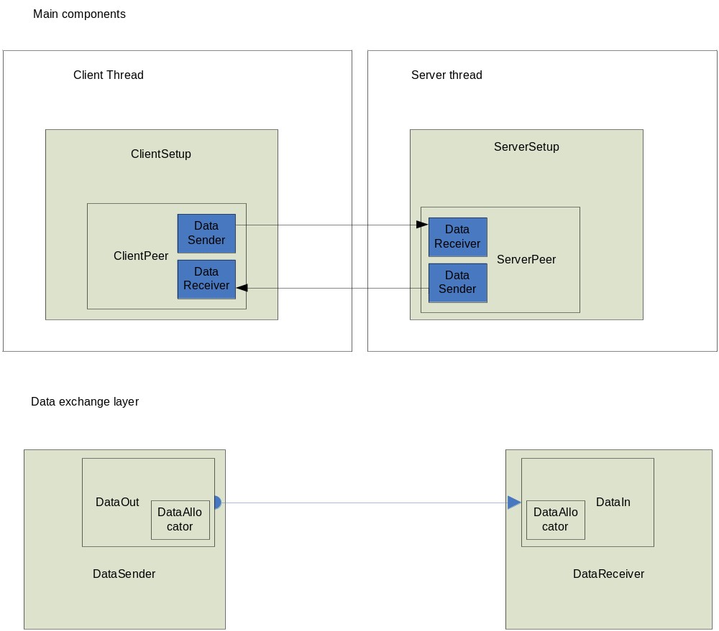

Main components inheritance relationship
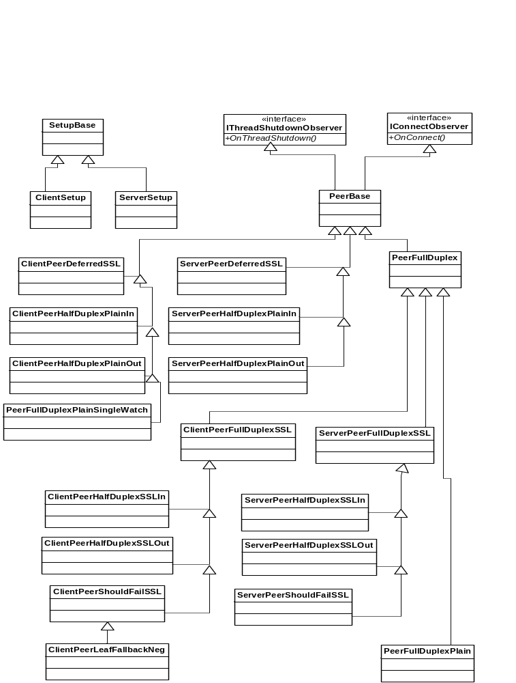
Main components description

Each test is set up as follows: (with the exception of BasicCertnameHostnameMatch test)
ServerSetUp class is instantiated in main thread, it starts to run in a new thread.
- ServerSetUp sets up the necessary resources for a server peer to be able to communicate with a client peer
- ServerSetUp waits for incoming connections
- when a client is connected, ServerSetUp instantiates the appropriate server peer for the specific test, which in turn will communicate with the client peer
- server and client peer exchange some data according to tests' specifications
- server peer frees up resources
- ServerSetUp frees up resources
- the server thread is joined from application main thread

ClientSetUp class is instantiated in main thread, it starts to run in a new thread.
- ClientSetUp sets up the necessary resources for a client peer to be able to communicate with a server peer
- ClientSetUp instantiates the appropriate client peer for the specific test
- client peer tries to connect to a predefined address, and port, and with a certain protocol according to the test's specifications
- in case connection was successfully set up, client peer will exchange data with server peer, in a manner according to the specifications
- client peer frees up resources
- ClientSetUp frees up resources
- the client thread is joined from application main thread.

Program flow ends in main thread.

Data exchange layer

Data between client and server (with a few exceptions) is exchanged using DataSender and DataReceiver instances as follows:

Sender side (can be client peer or server peer):
- allocates an instance of DataSender
- DataSender will send certain amount of data in chunks, as follows:
  - allocates a chunk of data represented by DataOut
  - on G_IO_OUT event, calls DataOut::Send until whole chunk is sent
  - starts with a new chunk
- deallocates resources related to DataSender

Receiver side (can be client peer or server peer):
- allocates an instance of DataReceiver
- DataReceiver will receive certain amount of data in chunks, as follows
  - allocates a DataIn instance
  - on a G_IO_IN event calls DataIn::Receive
  - this happens until a chunk of data is wholly received
  - CRC check is performed on received chunk
  - receive process restarted by allocating a new DataIn instance
- deallocates resources related to DataReceiver

Error handling

When a fatal error arises, current test’s further evaluation must be stopped, without stopping the whole program execution. This means, both threads have to be stopped gracefully. This is accomplished in the following way:

PeerBase, from which all the peers are derived, implements IThreadShutdownObserver. ServerSetup also implements IThreadShutdownObserver.

When a fatal error arises, all the instances of classes implementing IThreadShutdownObserver will be notified in OnThreadShutdown(), independent of the thread in which they are currently running. These class instances will take the necessary steps to gracefully shut down the thread, and so current test evaluation will be stopped.

How the thread shutdown notification is exactly carried out?
PipeFd class creates a pipe, on this pipe’s output side a GIOChannel is created. Every instance of IThreadShtudownObserver must subscribe to a GSource watch, which will be triggered on the above GIOChannel’s G_IO_IN event.
When PipeFd::SendShutDownSignal() is called, this will write 1 byte into the pipe, triggering the above GSource, which in turn calls IThreadShutdownObserver::OnThreadShutdown() for every instance subscribed to this event.

Description of responsibilities, description of relationships and data flows between main components

Interfaces:

IThreadShutdownObserver:
Used to catch thread shutdown events. An instance implementing this interface can be subscribed to thread shutdown events. On such events OnThreadShutdown() will be called.

IConnectObserver:
Used to catch channel connect events. An instance implementing this interface can be subscribed to channel connect events, e.g.: on a PmSockConnectCrypto, PmSockAcceptCrypto, PmSockConnectPlain call using the following construction:

PmSockSetUserData(pPmSockIOChannel_, this);
PslError pslError = PmSockConnectPlain(pPmSockIOChannel_, Callback<IConnectObserver>)

Where object this must implement IConnectObserver interface.

Main components:

ServerSetUp
Sets up resources, than instantiates a server peer. These resources will be used during communication between client peer and server peer:
- creates GMainContext, GMainLoop for client thread
- opens and configures a listening socket (plain socket)
- creates a watch on this listening socket
- when an incoming connection triggers this watch:
  - calls accept on socket
  - creates a palmsocket thread context
  - creates a palmsocket channel (PmSockIOChannel)
  - associates the connected socket with the palmsocket channel
  - manufactures the appropriate server peer
  - program execution is taken over by server peer
- waits until server peer is finished

ClientSetUp:
Sets up resources before a client peer is instantiated.
- creates GMainContext, GMainLoop for client thread
- creates a palmsocket thread context (PmSockThreadContext)
- creates a palmsocket channel (PmSockIOChannel)
- sets in created channel hostname/ip address of server, to where a client peer will connect
- manufactures the appropriate client peer
- program execution is taken over by client peer
- client setup waits, until client peer is finished

PeerBase:
Abstract base class for all client and server peers. Implements reusable base functionalities of peers.
Methods to be overridden:
ChannelWatchOn_G_IO_IN() – called on a G_IO_IN event occurring when on PmSockIOChannel is incoming data (the channel through which client and server peers exchange data)
ChannelWatchOn_G_IO_OUT() – called on a G_IO_OUT event occurring when on PmSockIOChannel is ready for accepting outgoing data (the channel through which client and server peers exchange data)
Run() – called after a peer is instantiated, either from ClientSetUp or ServerSetUp

PeerBase implements the following interfaces:
IThreadShutdownObserver:
Overridden method: OnThreadShutdown.: Implements the error handling mechanism, as described in ‘Error handling’ section. When this method is called, it will quit GMainLoop.

IConnectObserver:
OnConnect has no implementation in PeerBase.

A typical scenario for a client peer derived from PeerBase:
Overridden method: Run()
- kicks of connection with server peer, using PmSockConnectPlain or PmSockConnectCrypto, These functions also subscribe (IConnectObserver *)this instance to channel connect events.
Overridden method: IConnectObserver::OnConnect()
- client peer will typically create a watch for G_IO_IN or G_IO_OUT events on communication channel. Full duplex clients will create for both events. Watches will trigger ChannelWatchOn_G_IO_IN() respectively ChannelWatchOn_G_IO_OUT().
Overridden method: ChannelWatchOn_G_IO_IN()
- a DataReceiver instance will read certain amount of data from channel.
Overridden method: ChannelWatchOn_G_IO_OUT().
- a DataSender instance will write certain amount of data to channel

A typical scenario for a server peer derived from PeerBase:
Overridden method: Run():
- kicks off connection with client peer, using PmSockConnectPlain or PmSockAcceptCrypto. This functions also subscribes (IConnectObserver *)this instance to channel connect events.
Overridden method: IConnectObserver::OnConnect()
- Server peer will typically create a watch for G_IO_IN or G_IO_OUT events on communication channel. Full duplex clients will create for both events. Watches will trigger ChannelWatchOn_G_IO_IN() respectively ChannelWatchOn_G_IO_OUT().
Overridden method: ChannelWatchOn_G_IO_IN()
- a DataReceiver instance will read certain amount of data from channel.
Overridden method: ChannelWatchOn_G_IO_OUT().
- a DataSender instance will write certain amount of data to channel

PeerBase derived classes:
As a rule of thumb:
- a class containing “Out” in its name, takes part in a half duplex communication and it is the sender
- a class containing “In” in its name, takes part in a half duplex communication and it is the receiver
- SSL in the class name means, class communicates on a crypted channel

Exceptions constitute the following classes. They implement a bit of a different mechanism from the rest of the peer classes. Executable tasks are put in a queue in class constructor, one of these tasks is executed on every G_IO_IN/G_IO_OUT event, until no more executable tasks are found in queue, than bidirectional shutdown is initiated.

ClientPeerDeferredSSL
Executes the following tasks in the following order, on every G_IO_IN event:
- Receive 10000 bytes from server peer
- Receive 1 last byte from server peer, receive ‘close notify’ event (confirm bidirectional shutdown)

ServerPeerDeferredSSL
Executes the following tasks in the following order, on every G_IO_OUT event:
- Send 10000 bytes to client peer
- Sleep for 5 seconds
- Send 1 last byte to client peer, send ‘close notify’ event (initiate bidirectional shutdown)

Task classes:
All derived from the base class Task. Their main purpose is to carrie out one single (or multiple) operations at the call of Execute(). These classes are used just from the deferred test.

ConfigFile class:
All the config file related operations are implemented here. Operations like:
- Reading configuration options for each and every test, from the configfile
- Apply default values to configuration options, in case configuration file does not specify an explicit value for that option, for a certain test

Data classes:
These classes take care of data exchange between peers.

DataAllocator:
Fast data allocator. Used when the same amount of bytes have to be allocated over and over. This class does not allocate each and every time, only once, and gives out the same memory portion, on an allocation request. The portion is marked as used. On a dispose request the portion is marked as unused, and it can be given out again.

DataIn:
Reads a ‘chunk’ of data from a channel into an internal buffer. Ability to do a CRC validation of the data chunk by cutting terminating 4 bytes and using it as CRC value for the rest of the data.

DataReceiver:
Reads a certain amount of data from a channel in multiple iterations. Uses DataIn class for this.

DataOut:
Allocates a chunk of data using DataAllocator. Writes this chunk of data to a channel. Ability to send in multiple iterations.

DataSender:
Sends a certain amount of data to a channel in multiple iterations. Uses DataOut class for this.

Description of automated certificate generation scripts

These scripts are located in <svn_root>/certificate directory.

Script generateCertificates:
This script has to be executed first. It does the following:
- Generates a private key: server.key
- Generates a self signed certificates with various settings, using multiple config files from ./configfiles subdir
- For every self signed certificate generated, generates a .pem file which consist of the concatenation of private key and self signed certificate
Output directory: ./generated
CA certificates with the following settings are generated:
- CN=localhost
- CN=libpalmsocket.libpalmsocket.com
- CN=127.0.0.1
- CN=127.10.10.10
- Subjalt_name/DNS=libpalmsocket.libpalmsocket.com
- Subjalt_name/IP=127.0.0.1
- Subjalt_name/IP=127.10.10.10

Script generateCA2000Certificate:
As this script uses some of the outputs from previous script, it can be executed just after that one.
Generates a certificate with validity in the past (2000.jan – 2001.jan).
For this the following steps are necessary:
- Generate a certificate signing request .csr with openssl req
- Sign the certificate signing request with openssl ca, result will be a .crt

Conditionally compiled switches, macros

#define VERBOSE
This symbol has to be defined at the beginning of every .cpp file (before CommonUtils.h is included), where logging takes place. If you want to disable logging for that particular .cpp, undefine this symbol.

The following macros need VERBOSE as defined symbol:

UTIL_PRINT_NEWLINE_WITH_FILENAME_AND_FUNCTIONNAME
UTIL_PRINT_NEWLINE
UTIL_PRINT

Independent of the VERBOSE macro:

LOGVAR(varname) – logs variable name, as well as variable value. Following types are accepted:
int, long, unsigned int, const std::string&, bool.

Config file parameters

Configuration file has to be named: “palmTestsConfig”, and is organized as follows:

Each test has its own configuration section, where all the settings can be altered for that specific test. E.g.: [HalfDuplexPlainServer].

[Default] section:
Default values for each test. When a value in one of the test sections is not present, default value will be applied.

Parameters applicable for each test:

ServerListenPort=30999
The port on which ServerSetUp will listen for incoming connections.

NumberOfBytesToSend=10240000
This amount of bytes will be exchanged between client-server peers.

ChunkSize=1024
With chunk size this big will the test run.

Enabled=1
1 means test is enabled, and will be run. 0 means test disabled

Address=localhost
specifies the address to where client peer will try to connect. IP or hostname.

PrivateKeyPath=/tmp/cxx/privatekey_localhost.pem
Specifies the path to the .pem file to be used for the actual test

Parameters applicable just for the [Default] section. In any other section they will be ignored:

LogToFile=1
1 means logging will be outputted to a file, 0 means to stdout.

LogFilePath=logfile.txt
Specifies the name of the logfile, in case LogToFile is enabled.

