《宏观经济学》2009年6月考试的参考答案
- NX=NCO=1.1;
S_{public}= T-G, S_{public} =0.5, T=2.5, so,G=2；
S= S_{public} + S_{private}=0.5+1.5=2;
S=NCO+I, so I=S-NCO=2-1.1=0.9;
Y=C+I+G+NX, so C=Y-I-G-NX=10-0.9-2-1.1=6.

- (1) M=30,000/(10%)=30,000*10=300,000;
(2) C=D and D=10*(30,000-C); So M=C+D=54545.45
(3) M=30,000/(10%+10%)=30,000*5=150,000.
(4) k=1/(r_{d}+t×r_{t}+c+e), M=k×B, the center bank can influence the money supply by changing B and the reserve requirements of demand deposit and time deposit. The commercial bank can influence the money supply by changing excess reserves. The public can influence the money supply by changing currency hold.

- (1) Nominal GDP = P x Y = $12,000 and Y = real GDP = $6,000, so P = (P x Y)/Y = $12,000/$6,000= 2.
Since M x V = P x Y, then V = (P x Y)/M = $12,000/$500 = 24.
(2) If M and V are unchanged and Y rises by 5 percent, then since M x V = P x Y, P must fall by 5 percent. As a result, nominal GDP is unchanged.
(3) If the Fed wants inflation to be 3 percent, it will need to increase the money supply 8 percent. Thus M x V will rise 8 percent, causing P x Y to rise 8 percent, with a 3 percent increase in prices and a 5 percent rise in real GDP.
(4) The Fed can choose: purchase the U.S. government bonds in open market; decrease reserve requirements; decrease the discount rate.
(5) The government prints too much money that result in inflation.
(6)

- (1) The interest rate will fall.
(2) Since the interest rate has decreased, investment and national saving increases and private saving decreases.
(3) The more elastic is the supply of loanable funds, the flatter the supply curve would be, so the interest rate would decline by less and thus national saving would rise by less.

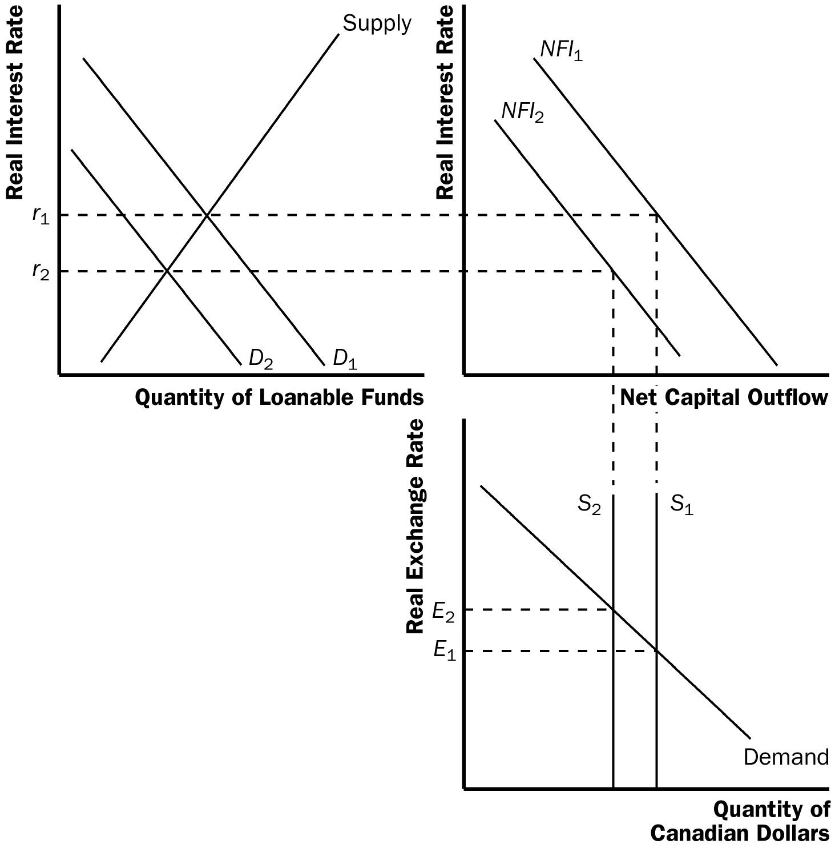
(1) When U.S. mutual funds become more interested in investing in China, China’s net capital outflow declines as the U.S. mutual funds make portfolio investments in China’s stocks and bonds. The demand for loanable funds shifts to the left and the net capital outflow curve shifts to the left, as shown in Figure. As the figure shows, the real interest rate declines, thus reducing China’s private saving, but increasing China’s domestic investment. In equilibrium, China’s net capital outflow declines.
(2) Since China's domestic investment increases, in the long run, China's capital stock will increase. It will help the economic growth.
(3) The real exchange will rise.
(4) The export will decrease. The import will increase. So the net export will decrease. But the foreign direct investment will increase. The reasons are for the real exchange’s appreciated.

- (1) AD curve shifts to the left, the output falls, and unemployment rate rises, the price level falls.
(2) AS curve shifts to the left, the output falls, and unemployment rate rises, the price level rises.

- (1) The initial effect of the tax reduction of $30 billion is to increase aggregate demand by $30 billion x 2/5 (the MPC) = $12 billion.
(2) Additional effects follow this initial effect as the added incomes get spent. The total effect depends on the multiplier. With an MPC of 2/5, the multiplier is 1/(1 – 2/5) = 5/3. So the total effect is $12 billion x 5/3 = $20 billion.
(3) Government purchases have an initial effect of the full $30 billion, since they increase aggregate demand directly by that amount. The total effect of an increase in government purchases is thus $30 billion x 5/3 = $50 billion. So government purchases lead to a bigger effect on output than a tax cut does. The difference arises because government purchases affect aggregate demand by the full amount, but a tax cut is partly saved by consumers, and therefore does not lead to as much of an increase in aggregate demand.

8. (1) the short-run aggregate-supply curve shifts to the right, reducing the price level and increasing the quantity of output. The short-run Phillips curve shifts to the left. In both diagrams, the economy moves from point A to point B. In equilibrium, both the inflation rate and the unemployment rate decline.
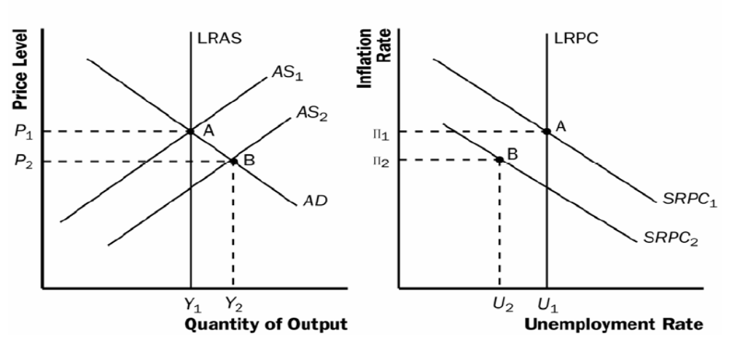

(2) The effects of this event do not mean there is no short-run tradeoff between inflation and unemployment, as shifts in aggregate demand still move the economy along the short-run Phillips curve.
(3) Contractionary monetary policy to reduce inflation will make the economy move along a short-run Philips curve from A to B in the short-run and reach C in the long-run with the fall of expected inflation. The short-run costs of disinflation, which arises because the unemployment rate is temporarily above its natural rate, could be reduced if the Fed's action was credible, so that expectations would adjust more rapidly.
