武汉大学2010-2011学年第二学期期末考试
经济与管理学院 2010级 2011年6月29日

《宏观经济学》试题参考答案（A卷）

- (10 points)
- △GDP= $400
- △NNP=△GDP-△depreciation=$400-$50=$350
- △NI= △NNP - △sales taxes = $350 - $30 = $320
- △PI= △NI -△ retained earnings = $320 - $100 = $220
- △PDI= △PI-△personal income tax = $220 - $70 =$150

- (10 points) To a macroeconomist, saving occurs when a person’s income exceeds his consumption, while investment occurs when a person or firm purchases new capital, such as a house or business equipment..
- When your family takes out a mortgage and buys a new house, it is investment.
- When you use your $200 paycheck to buy stock in AT&T, it is saving since your income of $200 is not being spent on consumption goods; but it is not investment because it does not form new capacity directly. The trade just means a change of ownership.
- When your roommate earns $100 and deposits it in her account at a bank, it is saving, because the money is not spent on consumption goods.
- When you borrow $1,000 from a bank to buy a car to use in your pizza-delivery business, it is investment since the car is a capital good.

- (10 points) All factors, that affect AD at a given price level, can be categorized to four groups according to which component of spending is most directly affect: (1)C, such as a tax cut/hike, a stock market boom/decline; (2) I, such as optimism/pessimism about the future, a fall/rise in interest rates due to an increase/decrease in money supply; (3)G, such as greater/smaller spending on defense or highway construction, (4)NX, such as a boom/recession overseas, an exchange-rate depreciation/appreciation.
According to the production factors, the long-run AS may change arising from the following four sources which affect the natural rate of output: (1)K (physical capital or human capital ), such as the increase of the number of machines or that of college degrees;(2)L, such as an increase in immigration from abroad, the change of the natural rate of unemployment due to increasing minimum wage or the unemployment insurance system; (3)N (natural resources), such as a discovery of a new mineral deposit, good weather, a change in the availability of imported resources; (4)A, such as the advance of internet technology, other events that act like changes in technology.
All these variables——K, L, N, A, shift the short-run AS curve too. Another important new variable that affect the short-run AS is the change of expected price level. A decrease in the expected price raises the AS in the short-run.
In the short-run, the continuing increase in money can raise GDP for that there is unexpected price level. However, in the long run, the AS curve is vertical, as people adjust their expected price levels to the actual price level. so the increase of money which raise AD and price level but can not have the economy to grow continuously only by use of expansionary monetary policy.

- (15 points)

- If Chinese government decided it no longer wanted to buy U.S. assets, U.S. net capital outflow would increase, increasing the demand for loanable funds, as shown in the following figure. The result is a rise in U.S. interest rates, an increase in the quantity of U.S. saving (because of the higher interest rate), and lower U.S. domestic investment.
- In the market for foreign exchange, the real exchange rate declines and the balance of trade increases
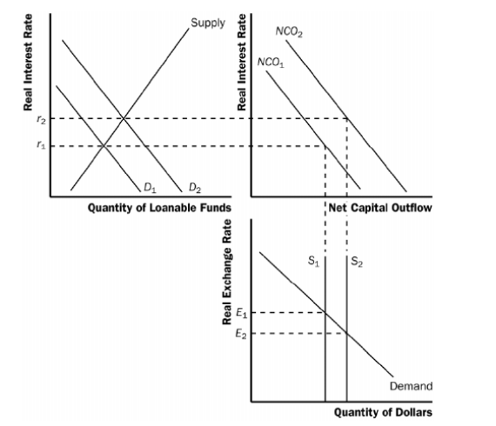

- (15 points)
- When the stock market declines sharply, wealth declines, so the aggregate-demand curve shifts to the left, as shown in Figure 5a below. In the short run, the economy moves from point A to point B, as output declines and the price level declines. In the long run, the short-run aggregate-supply curve shifts to the right to restore equilibrium at point C, with unchanged output and a lower price level compared to point A.

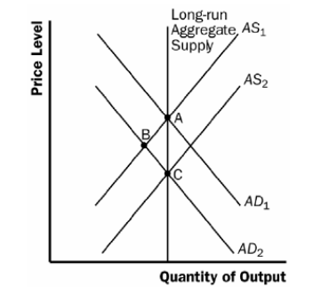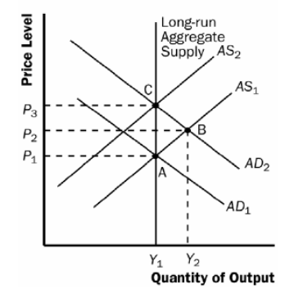

Figure 5a
Figure 5b

- When the federal government increases spending on national defense, the rise in government purchases shifts the aggregate-demand curve to the right, as shown in Figure 5b above. In the short run, the economy moves from point A to point B, as output and the price level rise. In the long run, the short-run aggregate-supply curve shifts to the left to restore equilibrium at point C, with unchanged output and a higher price level compared to point A.
- When a technological improvement raises productivity, the long-run and short-run aggregate-supply curves shift to the right, as shown Figure 5c below. The economy moves from point A to point B, as output rises and the price level declines.
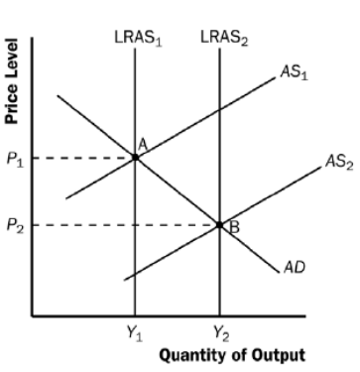
Figure 5c
- When a recession overseas causes foreigners to buy fewer U.S. goods, net exports decline, so the aggregate-demand curve shifts to the left, as shown in Figure 5a above. The effects are similar with that in part a.
- The continuing increase in reserve ratio causes the decrease of money supply. So, the aggregate-demand curve shifts to the left, as shown in Figure 5a above. The effects are similar with that in part a.

- (20 points)
- True. When people change how much they deposit their money in bank, they change money supply. More deposits out of money held by people in bank, more loan and hence more M1 is created.
- False. Depreciation is double counted.
- True. With the increase of the divorce rate, more and more housework originally done by wives or husbands themselves are done by those who are not family members. These services make the measured GDP larger.
- False. Full employment does not mean that the rate of unemployment is zero. Under full employment, the frictional unemployment and structural unemployment may still stand.
- False. Even if the governmental policy be correct, the rate of unemployment could not be reduced to zero. The frictional unemployment and structural unemployment can hardly be eliminated completely.
- False. Aggregate supply curve in the long run is different from that in the short run. The former is vertical and the latter slopes upward to the right.
- False. Increasing consumption and export may cause the economy to grow in the short run. Even so, consumption and export matter only when the capacity is plentiful. They help have the capacity utilized and hence economy grow. But in the long-run, aggregate demand trend to equal capacity. Therefore, the growth of output lies on various production factors that determine the AS side of the economy.

- (20 points)
- A1=10, A2=8, A3=6.4, A4=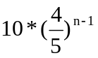, A5=10/(1-4/5)=50;
B1=8, B2=6.4, B3=5.12, B4=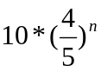 , B5=(10*4/5)/(1-4/5)=40;
C1=8, C2=6.4, C3=5.12, C4=, C5=(10*4/5)/(1-4/5)=40.
- Firstly, the increase of G and TR can make GDP grow, so doe the decrease of T. Secondly, the increase of G directly increase AD and hence the multiplier is 5, while both TR and T indirectly affect AD and the multipliers are -4 and 4 respectively.
- The effects of $10 million increase of private investment are same as that of G. As the increase of private investment is not due to the decline of the interest rate, it is identical to the increase of G, both of which directly affect AD.
- If the government implants balanced budget policy, for example, increasing G and T by $10 million with TR unchanged, AD in the first round will increase $2 million (10-8=2), and the accumulate increase of GDP is $10 million（50-40＝10）. Therefore, the total effect of expansionary policy and contractive policy together on GDP under balanced budget become smaller.

