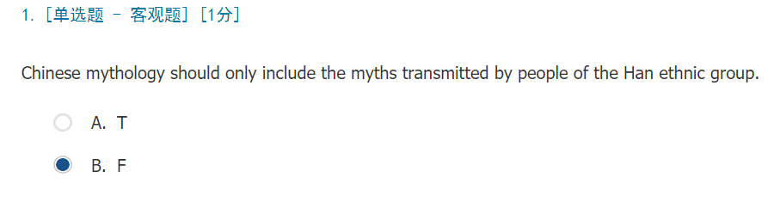

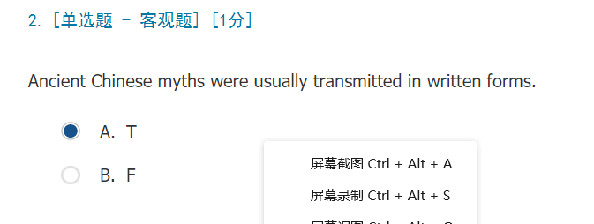

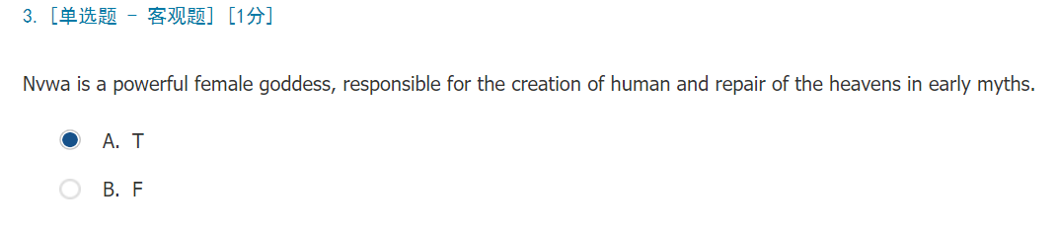

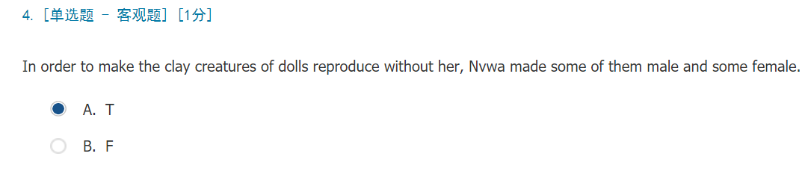

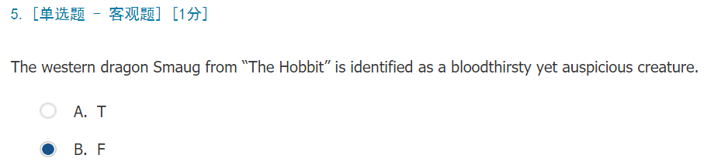

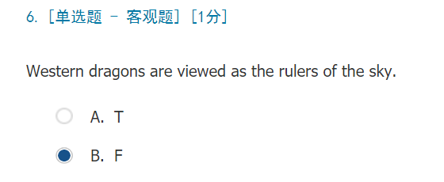

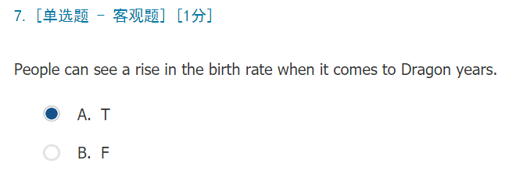

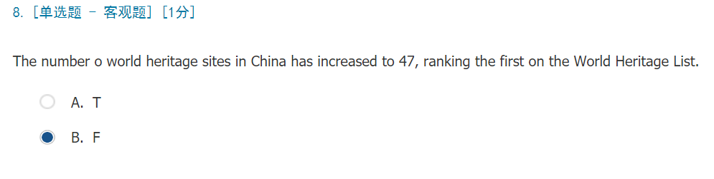

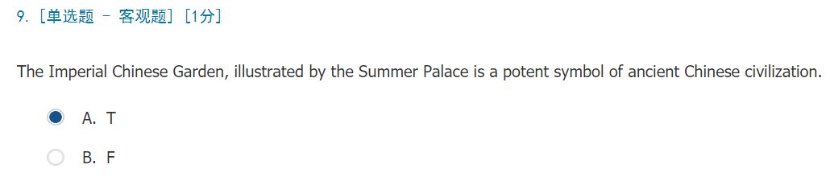

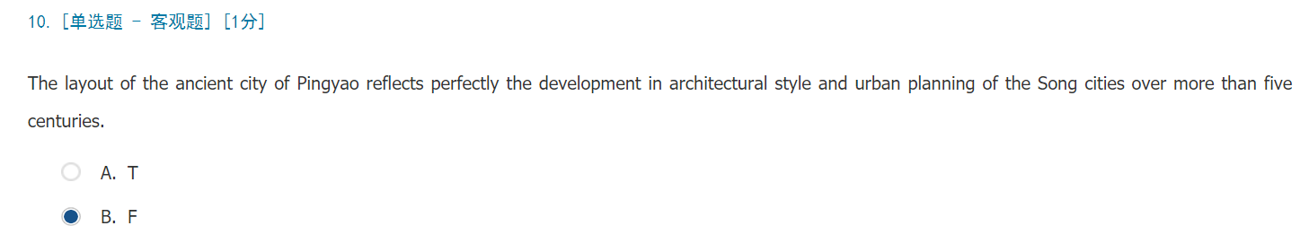

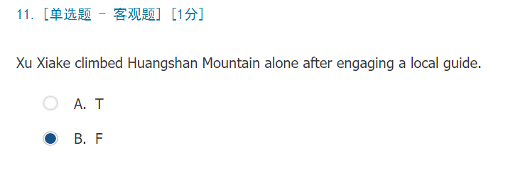

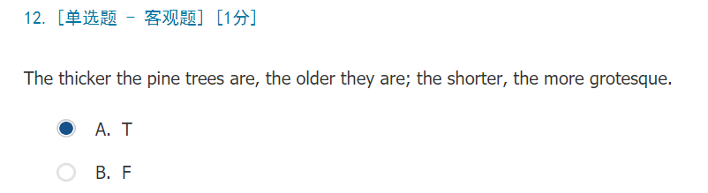

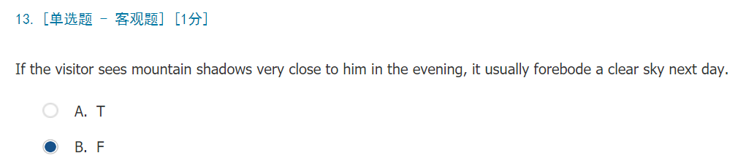

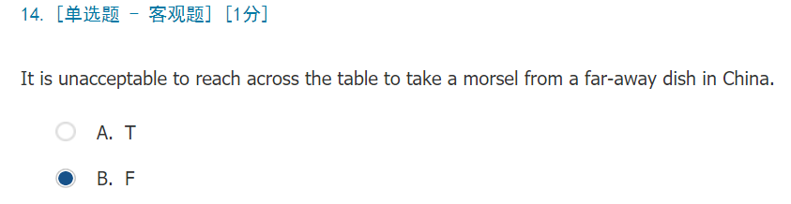

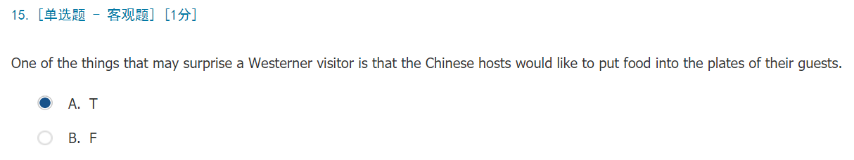

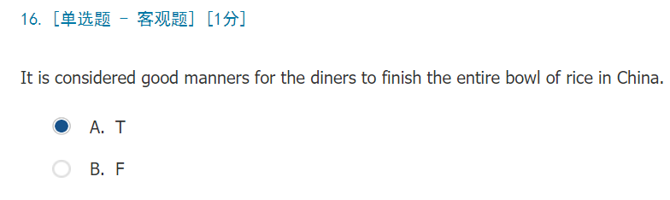

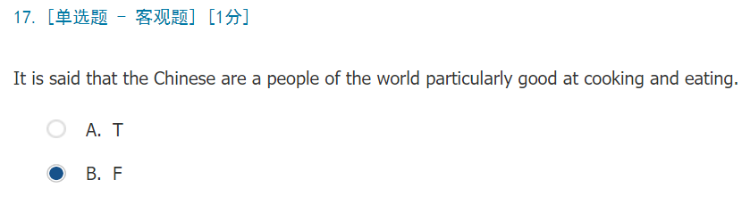

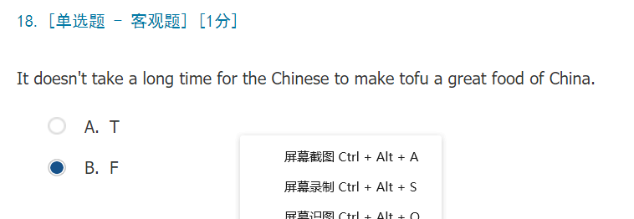

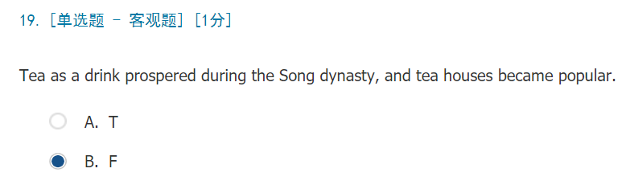

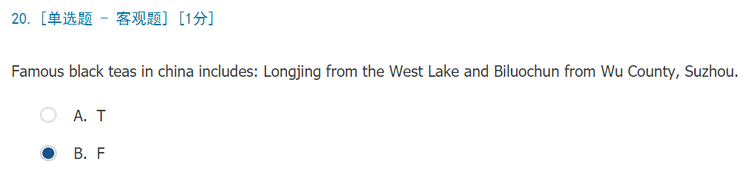

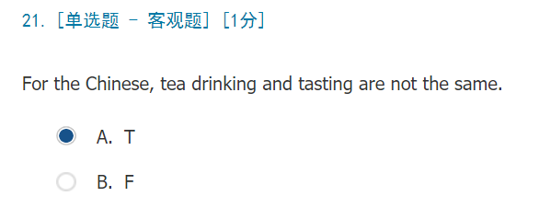

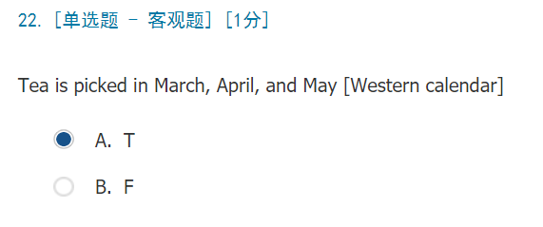

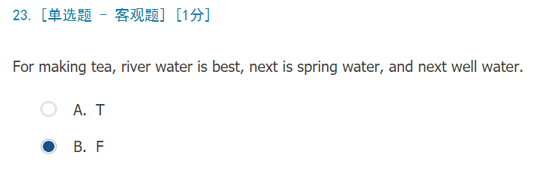

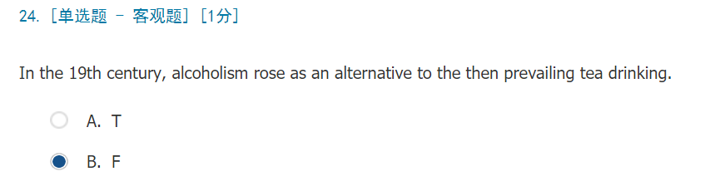

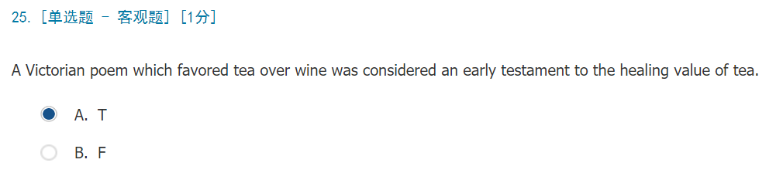

1. 愚公移山

a persistent spirit triumphs over mountainous tasks

1. 八仙过海，各显神通

Eight immortals cross the sea with their unique divine capabilities

1. 精诚所至，金石为开

With whole-hearted dedication, gold and rock will crack open

1. 和西方龙“凶残、邪恶、俗世的”形象不同，中国龙总是被认为是“吉祥、威武、神圣的”动物，它总是和好运、统治力和天空联系在一起。

Different from the fierce, evil and earthly dragon image in the West, the Chinese dragon is often considered to be an auspicious, powerful and heavenly creature, which is associated with good luck, the ruling power, and the sky.

1. 布达拉宫三位一体的历史建筑群是西藏传统建筑的杰出代表。

The three-in-one historic ensemble of the Potala Palace forms an outstanding example of traditional Tibetan architecture.

1. 在清朝，它是一个比邻故宫的繁华的商业区。

In the Qing Dynasty, it was a prosperous commercial district neighboring the Imperial Palace.

1. 黄山归来不看岳。

It is not worth seeing the Five Great Mountains if you have been to Huangshan Mountain.

1. 亭台楼阁

delicately painted and decorated pavilions

34.冬吃罗卜夏吃姜，不用医生开处方

Having radish in winter and ginger in summer, you stay healthy without doctor.

35.回锅肉

twice cooked pork

1. 民以食为天

Food is what matters to the people

1. 杵臼之交

true friendship

1. 消炎祛火，降烧退热

fight off inflammation and relieve fever

1. 茶饭不思

lose one‘s appetite

1. 喝茶是为了提神和滋补。

Tea drinking is for refreshment and tonic effect.

