Create PVC

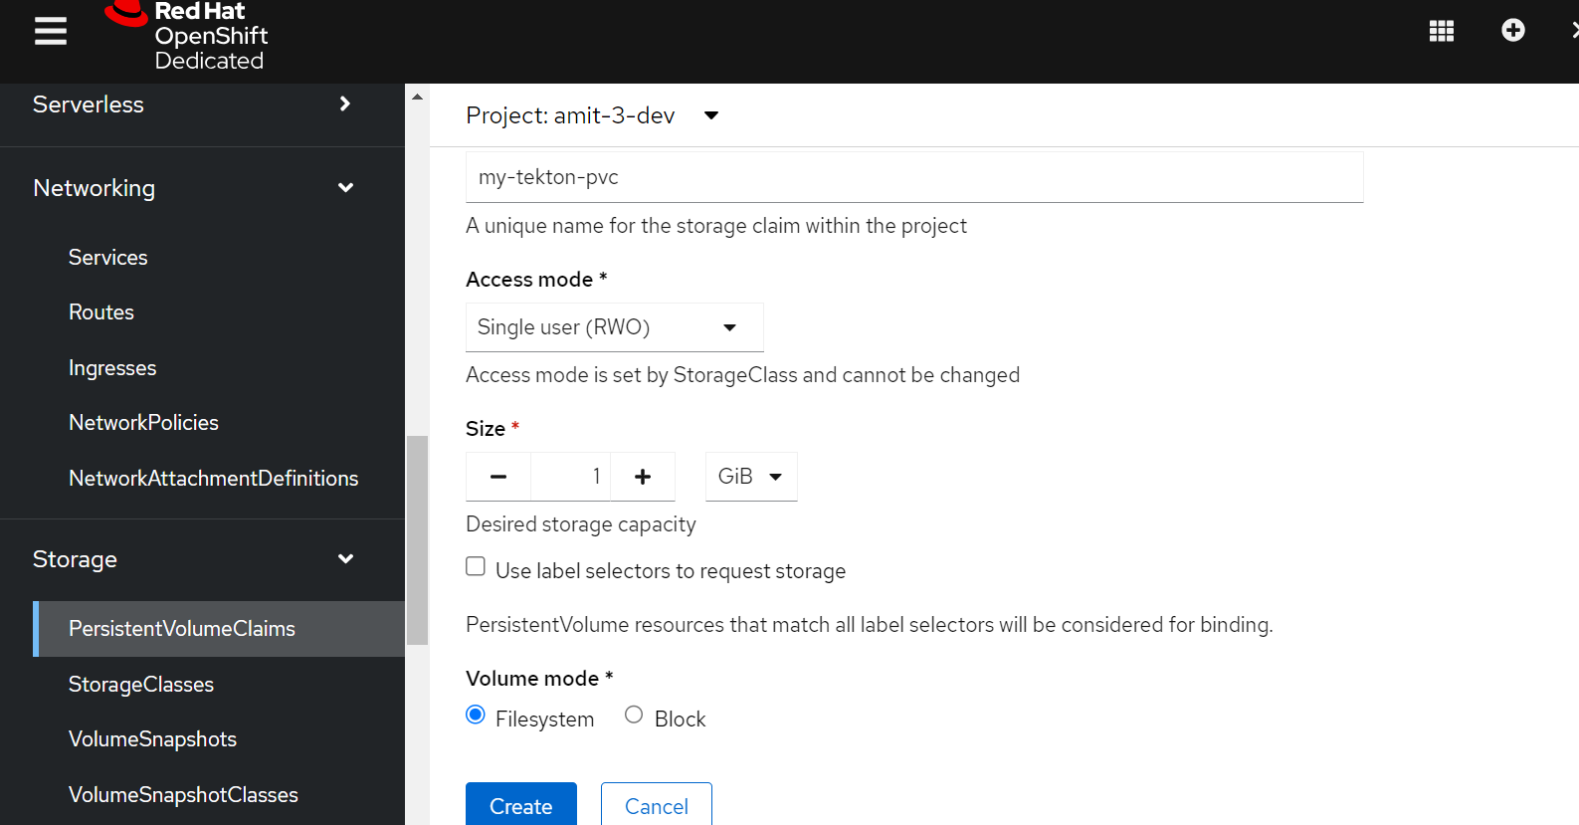

Create ImageStream

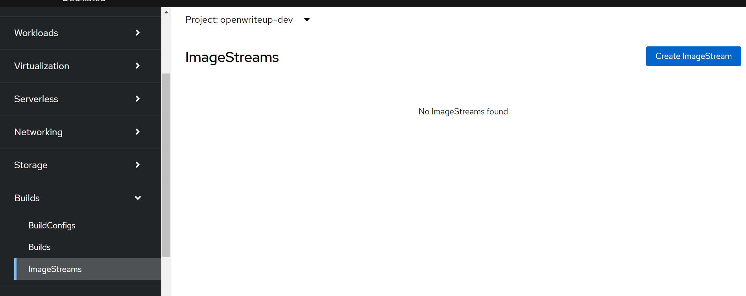

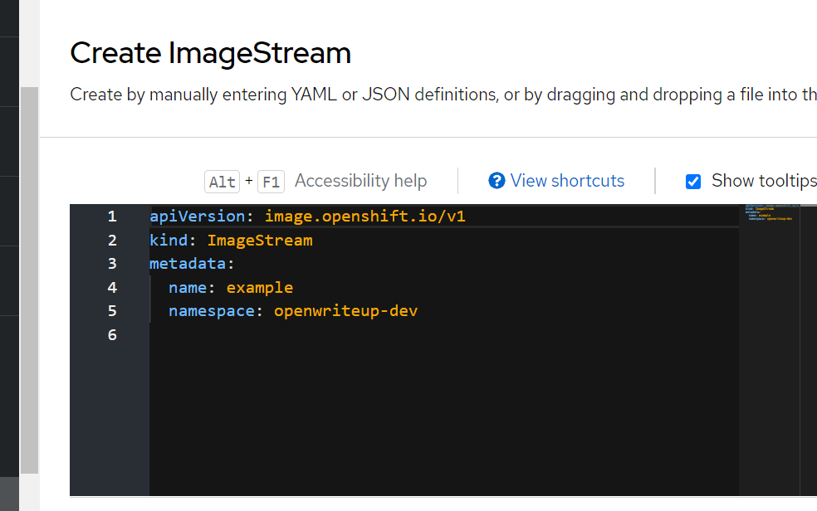

Note down the image repository: image-registry.openshift-image-registry.svc:5000/openwriteup-dev/example

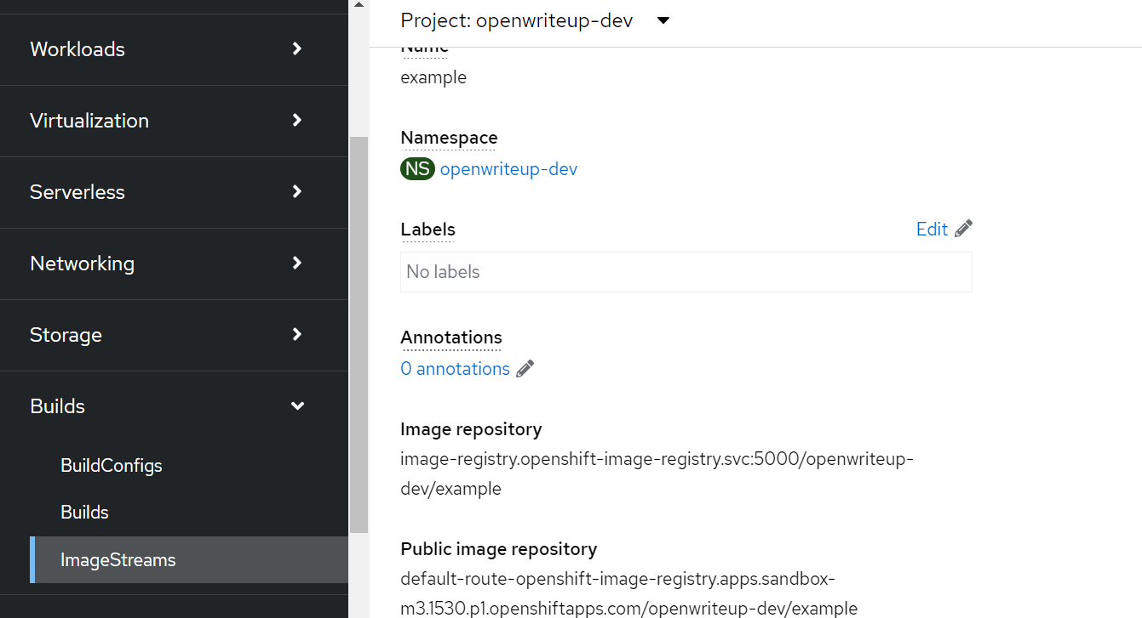

To create a pipeline, choose the “Administrator” view and navigate to Pipelines -> Pipelines and then click on the dropdown button “Choose” and select “Pipeline”.

A pipeline builder form opens, configure the below :

1. For “Configure via”, select the radio button “Pipeline builder”
2. Provide a name of the pipeline (say “java-builder-pipeline”) in the “Name” field.
3. In Parameters, click “Add Parameter” to add 4 parameters :
4. Name: **APP\_NAME**, Description: Name of the application to be deployed, default value: my-java-app
5. Name: **APP\_GIT\_REPO**, Description: Github repo URL for the application source code, Default value : https://github.com/tektutor/spring-ms.git
6. Name: **GIT\_REVISION**, Description: Github repo branch name to deploy, Default value : master
7. Name: **PROJECT\_NAME**, Description: Openshift project where the imagestream will be stored in internal registry, Default value : <Your current Project name>

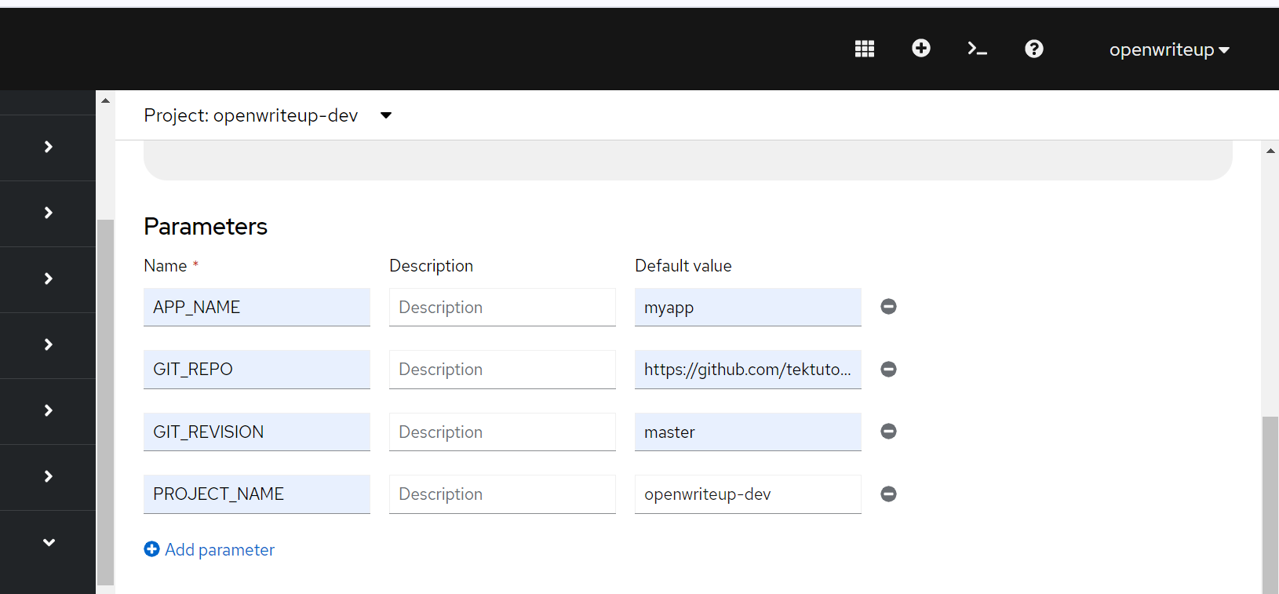

1. For workspace, create a new workspace, by clicking “Add workspace” and provide the name “shared-workspace”

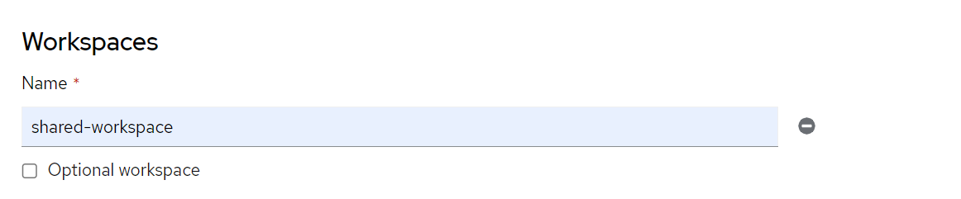

9. **Pipeline Tasks**

**Task 1 : Retrieve source code from github**

On the Pipeline builder, click “Add Task”. Type “git clone”. Select task from Red Hat and click on add.

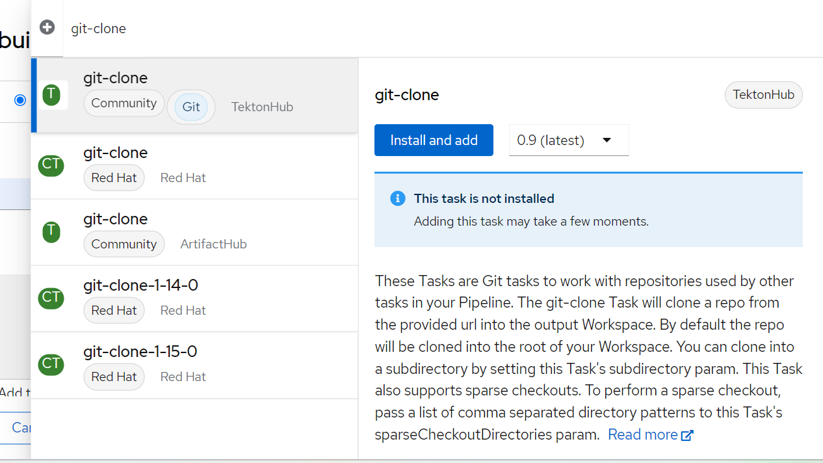

1. Display Name: clone
2. Parameters->url : $(params.GIT\_REPO)
3. Parameter->revision : $(params.GIT\_REVISION)
4. Workspaces->output : shared-workspace

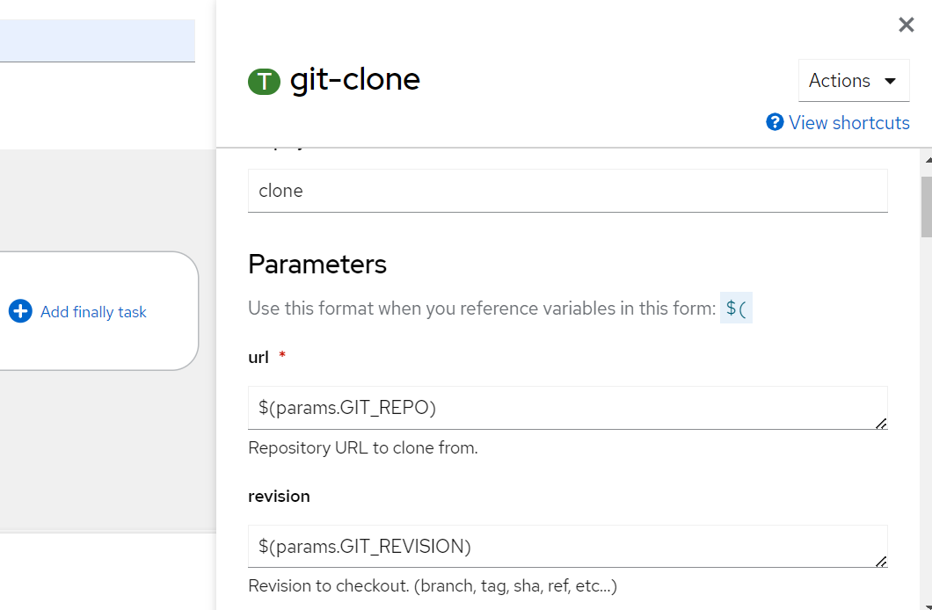

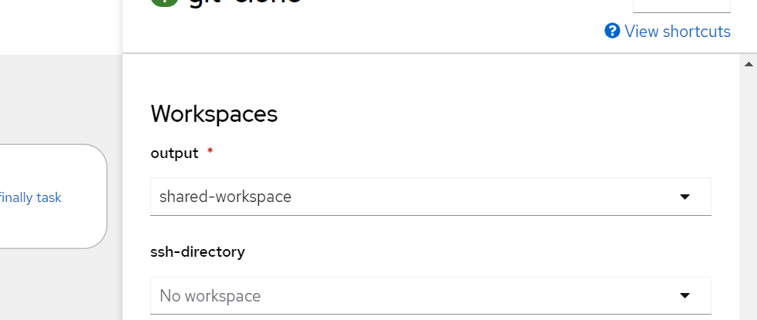

Add another task

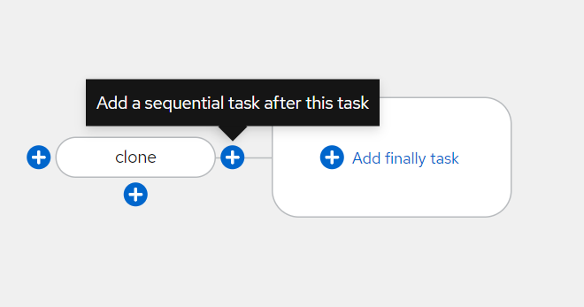

 click on the blue “+” sign on the right side. This adds another task. Click on the new “Add Task” button and type “S2I-Java” in the filter. Select the option from Red Hat and click on “Add”. Click on the task again to open the configuration of the task and then configure it as below :

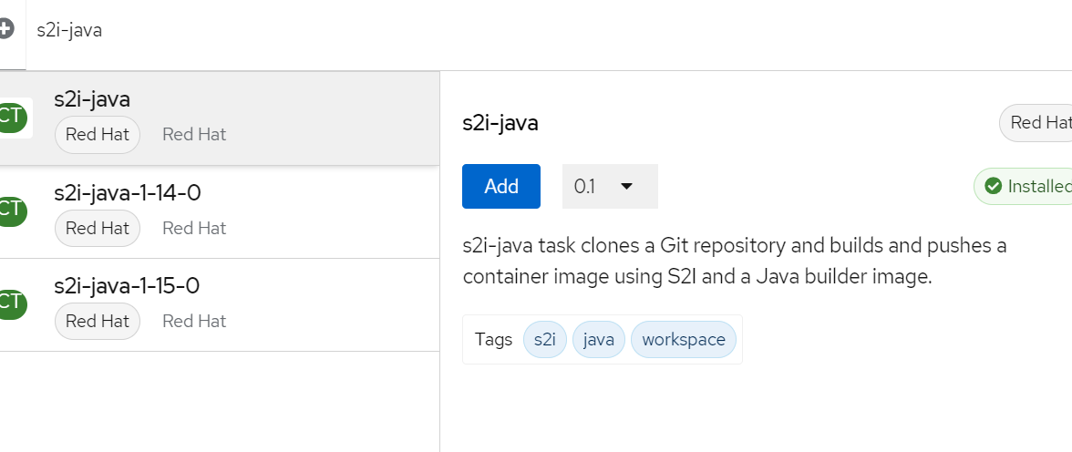

1. Display name: build
2. Parameters->Image : image-registry.openshift-image-registry.svc:5000/$(params.PROJECT\_NAME)/$([params.APP](http://params.app/)\_NAME):dev
3. Workspaces->source : shared-workspace

**Task 3 : Remove existing deployment**

Hover on the “build” task and click on the blue “+” sign on the right side. This adds another task. Click on the new “Add Task” button and type “Openshift Client” in the filter. Select the option from Red Hat and click on “Add”. Click on the task again to open the configuration of the task and then configure it as below :

1. Display Name: cleanup-old
2. Parameters->Script : oc delete all -l app=$([params.APP](http://params.app/" \t "_blank)\_NAME)

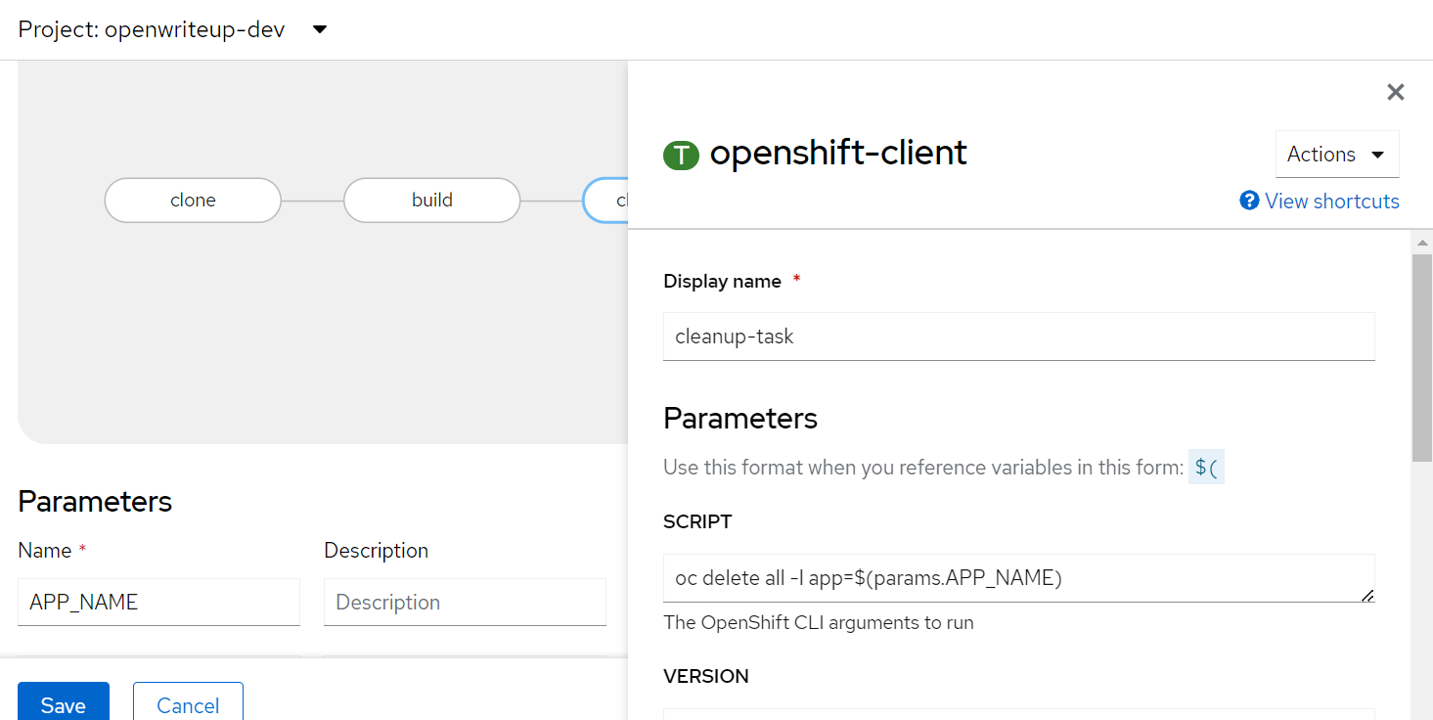

**Deploy the built code**

Hover on the “cleanup-old” task and click on the blue “+” sign on the right side. This adds another task. Click on the new “Add Task” button and type “Openshift Client” in the filter. Select the option from Red Hat and click on “Add”. Click on the task again to open the configuration of the task and then configure it as below :

1. Display Name: deploy
2. Parameters->SCRIPT : oc new-app --name $(params.APP\_NAME) --as-deployment-config image-registry.openshift-image-registry.svc:5000/$(params.PROJECT\_NAME)/$(params.APP\_NAME):dev~$(params.GIT\_REPO)